APO-3
Survivor: Microbiology Island

You are stranded on an island with your fellow classmates. Luckily, you have a vast array of anti-microbial tools at your disposal (any of those included in Tables 7.3, 7.5, and 7.8). Working in groups, use the growth control tools provided to complete the team challenges and triage questions.

TEAM CHALLENGES
1. How would you preserve a special tropical fruit drink without losing color or flavor?

2. How would you sterilize the only knife on the island without using any chemicals or specialized equipment?

3. Your swimming pond is being contaminated with green algae. What would you use to clean up the pond?

4. You have collected water from a stream on the island, which is most definitely contaminated. How could you treat the water to make it potable? Provide two physical and one chemical method.

5. You have isolated a culture of bacteria from your sick teammate. How would you preserve the bacterial culture to study it (alive) once you are off the island?

6. One of your teammates has contracted botulism from some bad canned monkey meat. How would you have treated the contaminated cans to prevent growth and botulism? Provide one chemical and one physical method.

7. You have to do emergency surgery on a teammate to remove a thorn from their foot. What chemical skin disinfectant would you use to disinfect the foot against the widest range of microbial pathogens, including spore formers?

8. One of the cows on the island is acting crazy- quite “mad” actually. Determine the most likely pathogen and then decide how you would sterilize tools that had come into contact with the diseased animal.

BONUS: You have several cooking knives contaminated with the following microbes: Mycobacterium, Candida albicans, Papillomavirus, Pseudomonas, Listeria monocytogenes, and Coronavirus. Considering that you have to rid each knife of the microbe before using it, list the order in which you will be able to kill them, from easiest to most difficult.
SURVIVOR: Microbiology Island
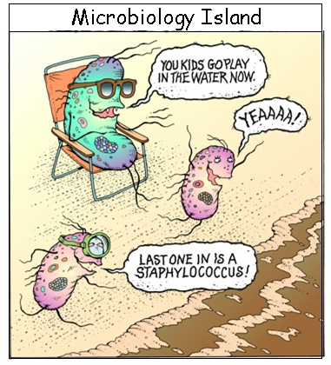
Members: ________________________

________________________

________________________

________________________ © John Pritchett

Challenge # | Method | Mechanism of action (NOT preferred use)
1

2

3 | a.  b.
4 | a.  b.  c.
5

6 | a.  b.
7.
8

BONUS (least to most difficult to kill):

1.
2.
3.
4.
5.
6.

