APO-5: Microbes and you: who will win the war?
Name _____________________________

This APO will encompass several lectures and includes Chapters 15-18. It is due the day of Lecture Exam 3, prior to taking the exam. Please type up your answers, and feel free to expand the document to add space where needed.
Mechanisms of Virulence
Research each virulence factor below and provide the following information:
- A description of how it contributes virulence by being a. invasive b. toxic or c. both invasive and toxic (i.e. choose a, b or c and explain how).
- A description of how it helps the pathogen to overcome a host defense mechanism.
1. Neisseria gonorrhea produces pili and adhesins specific to the human urogenital epithelium.

2. The pilin genes in Neisseria gonorrhea periodically recombine.

3. Many Streptococcus strains coat themselves in a slimy glycocalyx.

4. Staphylococcus aureus can synthesize hemolysins.

5. Chlamydia infects a host phagocyte and prevents lysosome fusion.

6. Clostridium perfringes spores can germinate deep within wounds, where they release a protein that moves along muscle fibers killing all host cells.

Immune Response: Primary and Secondary
The objective of this exercise is to help you distinguish between a primary and secondary immune response, and to identify the cell and antibodies involved with these events.
The following graph represents a typical primary (A) and secondary (B) exposure to a pathogen and the immune response, represented by (a) and (b). Note: the antibody titer represents ALL antibodies produced during those exposures.
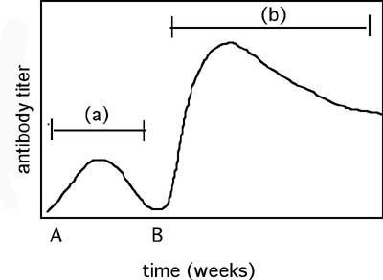

- What does the Y-axis (antibody titer) represent?

- About how long does (a) last?

- What type of white blood cell produces antibodies in (a) and (b)?

- What are the type(s) of antibodies produced in (a)?

- What are the type(s) of antibodies produced in (b)?

- Why is the response in (b) so much higher than the response in (a)?

7. Does the response in (b) occur EVERY TIME you get exposed to the same pathogen twice? For EVERY PATHOGEN? Why or why not?

Immune Response: Humoral
1. Put the following steps in the humoral immune response in order (1=first, 6=last):
__1__ Antibody on surface of B cells binds antigen.
_____ Antigen breakdown products bind major histocompatibility complex- protein and are "displayed" on B cell surface.
_____ T cell secretes cytokines which stimulate B cell.
_____ Antigen-antibody complex is internalized and processed.
_____ Helper T cell binds antigen via its T-cell receptor.
_____ B cell divides and differentiates into plasma cells and memory cells.
B. Which steps ensure that this particular immune response will be specific for the current pathogen, and not some other pathogen?

Immune Response: Antibody Titer and Vaccination
The following questions refer to the measles (but they could be altered to fit most any disease):
1. People who recover from the measles have a high anti-measles antibody titer.
a. What does "high anti-measles antibody titer" mean?

b. Which immune response generates antibody?

c. How do viruses (which are intracellular pathogens) stimulate antibody production?

2. A generation ago, doctors routinely began vaccinating every child against measles.
a. About how long does it take a human host to launch a specific immune response when first exposed to a pathogen or virus?

b. Why does it take so much longer than the nonspecific cellular responses? (What prohibits the specific response from being faster?)

3. How does a measles vaccine prevent us from coming down with the measles disease? Does the vaccine prevent us from being infected, or do vaccines prevent infection from progressing to disease?

4. The measles vaccine is an attenuated strain of the measles virus. What does this mean? Why would an attenuated strain be more effective against a measles infection than a "killed" or inactivated virus?

5. Why are the children of women who have been vaccinated more at risk for getting measles than the children of women who had the measles disease?

6. Women are able to pass antibodies to their newborns through breast feeding. Is this considered passive or active immunity?

7. The measles virus is spread through respiratory droplets. Would you expect that only a few people would need to be immunized to protect the population or most of the population?

8. Doctors are concerned about too little use of the vaccine among pre-school children. What is not being achieved?

