MIRAMAR COLLEGE
WEB SUBCOMMITTEE MEETING

March 24, 2010
2:00 – 3:30 p.m.
Room T-102

Attending: Susan Schwarz; Bill T. Smith; Kurt Hill; Temmy Najimy; Janice Hecksel; Sandi Trevisan; Angela Romero

Meeting called to order at 2:10 p.m.

- Welcome: S. Schwarz welcomed everyone to the meeting and introduced the newest member to the committee, Angela Romero, Political Science Faculty who will be filling in for Rechelle Mojica as Co-Chair for this committee until R. Mojica returns from sabbatical.

- Approval of Agenda: Agenda approved by consensus.

- Approval of October 22, 2009 and February 25, 2010 Minutes: S. Trevisan moved to approve October 22, 2009 and February 25, 2010 minutes and it was seconded by A. Romero. Approved by consensus.

- Reports
    - Calendar- B. Smith reported there is no cost for Drupal calendar. It was mentioned that it would not be a perfect solution because users will not be able to click on a particular date to input an event. But if the committee decides to use an open source calendar besides Drupal, there would be an approximate cost of $50 for the program. B. Smith will continue to find a better open source solution that will fit the campus needs. See below for draft Miramar College master calendar on new webpage. S. Trevisan suggested the “event type” legend should be a drop down menu.
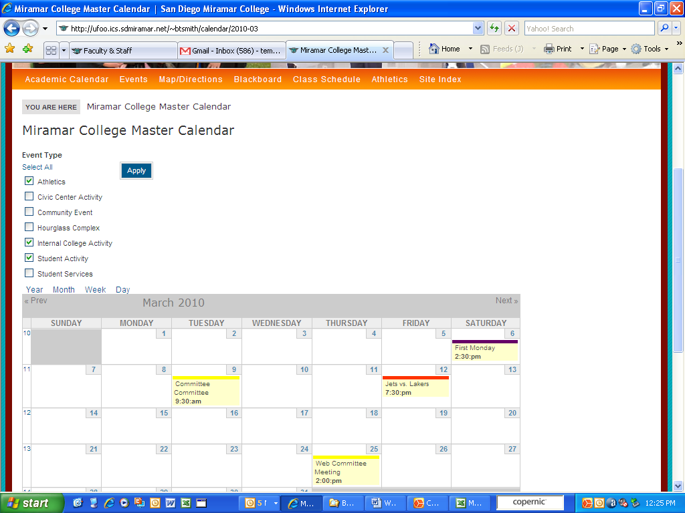
    - Format of committee display- B. Smith reported the format for each committee. See below for format. There are drop down menu for agenda and minutes. Committee suggested adding subfolders for each year (2006, 2007, 2008, 2009, 2010, etc.) as well as an archive folder for anything past 5 years old. Under committee information, B. Smith needs to separate Governance vs. Committee.
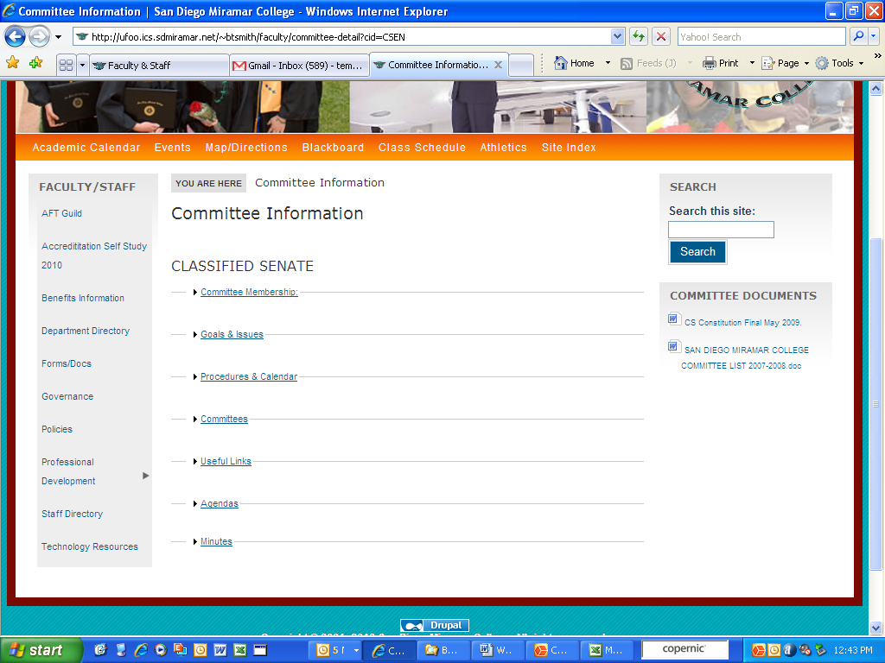

- New Business
    - Virtual addresses on program cards/links- PIO Office created outreach rack cards for each program. These publications indicate a web address to direct students to visit the webpage for more information. Since we are launching the new webpage design, committee recommended redirecting link to the appropriate web link and for any future publication to refer it to www.sdmiramar.edu.
    - Policy for web page- Some Miramar College departments contracts their webpage to outside vendor without consulting with anyone on web subcommittee. Committee will develop draft webpage policy/guidelines to address this issue. Webpage Policy Subcommittee includes:
S. Schwarz, S. Trevisan, A. Romero, T. Najimy, and K. Hill
    - Procedure request- All request for webpage changes will go through assigned administrator. E.g. Dean will identify for content management changes.
    - Projected beta testing of new site- B. Smith reported committee can start beta testing end of April/beginning of May before the new redesign is fully completed.

Timeline for Miramar New Website Redesign
End of April/beginning of May: Beta test
Summer 2010: Redesign website, train persons responsible for areas of content
Fall 2010: Launch new website design
- Other: S. Schwarz reported A. Delozier separated the forms under Faculty & Staff. The information was forwarded to B. Smith.
- Next Meeting: Thursday, April 22, 2010 at 2:00 p.m. in the PDC.
- Adjournment: Meeting adjourned at 2:55 p.m.

