MIRAMAR COLLEGE
WEB SUBCOMMITTEE MEETING

February 25, 2010
2:00 – 3:30 p.m.
Room T-102

Attending: Susan Schwarz; Bill T. Smith; Kurt Hill; Temmy Najimy; Annette DeLozier; Janice Hecksel; Sandi Trevisan

Meeting called to order at 2:00 p.m.

- Welcome: S. Schwarz welcomed everyone to the meeting.
- Approval of Agenda: S. Trevisan moved to approve agenda and it was seconded by K. Hill. Approved by consensus.

- Approval of November 17, 2009 Minutes: S. Trevisan moved to approve November 17, 2009 minutes and it was seconded by S. Schwarz. Approved by consensus. October 22, 2009 minutes are postponed until next meeting.

- Reports
    - Request for updates of current web site- B. Smith reported there are minimal updates to the current website. Mainly cosmetic changes (e.g. Financial Aid scholarship webpage). S. Trevisan reported B. Smith did a good job on the foundation webpage.
The following department will need to update their webpage:
-Financial Aid
-Veterans Affairs
-TRIO (need to announce TRIO will no longer provide services at Miramar-official date will be provided by Adela Jacobson)
S. Schwarz will email department contact person for update.
    - Report on development of new site- B. Smith presented a draft template for the new website redesign. New website redesign can be located at http://ufoo.ics.sdmiramar.net/~btsmith/
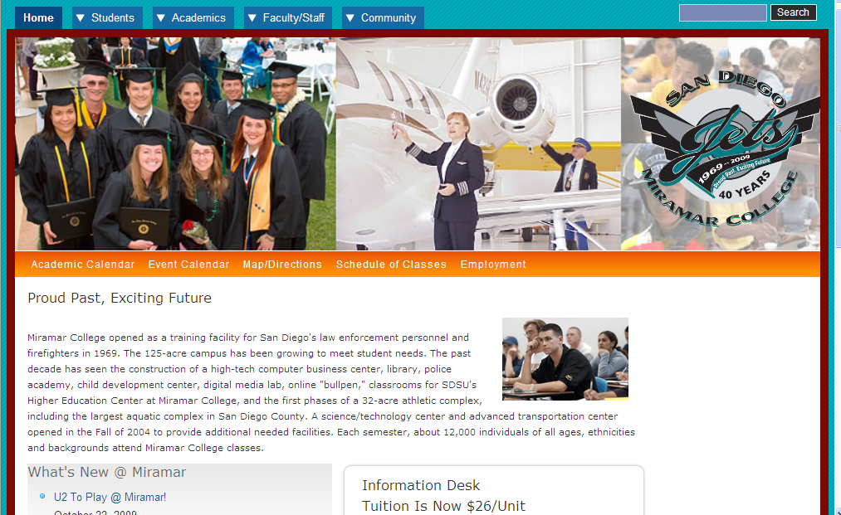

Features include: a content management system, large graphic elements/photo banner, a home page with news and important information, “quick links” (info desk), pop out menus at the left, compressed news segments, hours/contact information by departments. Gateway entries include: Students (includes current and prospective); Academics, Community, and Faculty/Staff

After a long discussion about the new website redesign, committee recommended the following:
    - Drop down menus throughout the webpage
    - For “Committee” under “College Governance” information, add collapse agenda/minutes on sidebar
    - Webpage to fit on single screen to eliminate the need to scroll down as much as possible
    - Create site index/site
    - Better calendar (more attractive, different color, and easier to read)
    - Make sure website is 508 compliance
    - Included employment opportunities webpage
    - Group forms & documents by category
    - Convert forms to PDF fill-in forms
    - Projected beta testing of new site
B. Smith reported the new website redesign will not have a fully completed until Summer 2010. Committee can start beta testing end of April/beginning of May before the new redesign is fully completed.

Timeline for Miramar New Website Redesign
End of April/beginning of May: Beta test
Summer 2010: Redesign website, train persons responsible for areas of content
Fall 2010: Launch new website design

    - Projected roll out of new site- Projected roll out of new website design will be Fall 2010.
- New Business
    - Calendar- S. Trevisan report City of San Diego is using google calendar and the current calendar does not support google calendar. K. Hill and B. Smith will work together to figure out a plan to merge both calendars together. It was suggested the calendar should include different categories and for it to be color coded for each category.
    - Format of Committee Display- It was recommended to add collapse agenda/minutes on sidebar for “Committee” under “College Governance” information.
- Other: S. Trevisan and Joan Mize will work with B. Smith on visuals, color scheme, new photo gallery.

- Next Meeting: Wednesday, March 24, 2010 at 2:00 p.m. in the PDC.
- Adjournment: Meeting adjourned at 2:55 p.m.

