San Diego Miramar College
Technology Committee
February 23, 2010
Room I-105

Present: Susan Schwarz, Kurt Hill, Tom Davenport, Temmy Najimy, Otto Dobre, Namphol Sinkaset, Todd Williams, Wahid Hamidy, Janice Hecksel

The meeting was called to order at 2:03 p.m.

- Welcome
S. Schwarz welcomed everyone to the meeting.
- Approval of agenda
J. Hecksel moved to approve agenda and it was seconded by T. Williams. Approved by consensus.
- Approval of minutes from November 10, 2009 meeting
T. Williams moved to approve November 10, 2009 minutes and it was seconded by T. Davenport. Approved by consensus.
- New Business
  - Office 2007 (Janice Hecksel)
J. Hecksel reported the whole district will be switching to Office 2007. Official email will be sent by Kent Keyser. The district will no longer keep Office 2003. J. Hecksel will be conducting lecture training workshops in person. There will also be online training tutorials available for faculty and staff. See below for free online training tutorial sites:
    - SDCCD Office of Technology Training Resources http://it.sdccd.edu/pages/117.asp
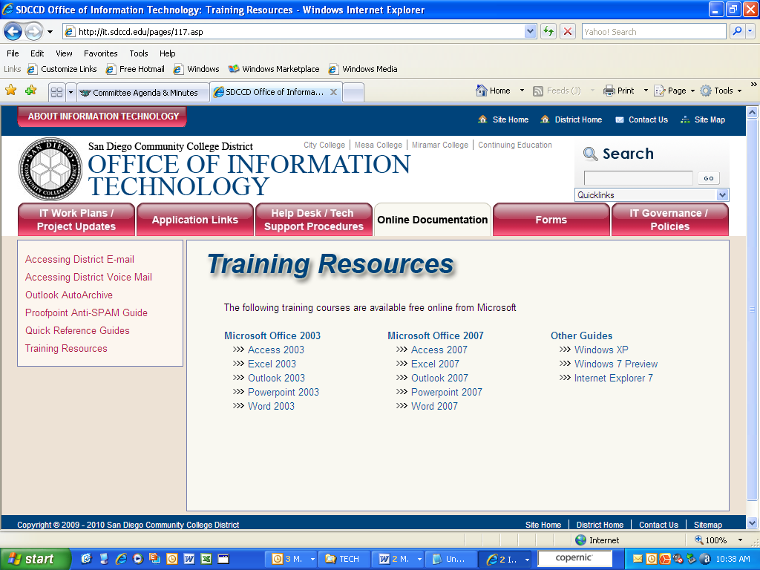

    - Microsoft 2007 Office System training courses http://office.microsoft.com/en-us/training/HA102255331033.aspx
    - Ribbon video +
http://office.microsoft.com/en-us/products/FX102774021033.aspx
A long discussion about Office 2010 was discussed among the members. Currently Office 2010 is on beta right now. A questioned was raised about what will happen when Office 2010 comes out and if faculty uses 2010 instructional materials. Committee recommended for faculty to bring forward to committee about using 2010 textbooks. S. Schwarz will email K. Keyser to see how Miramar should handle this as well as bringing forward to Academic Senate.
  - Power Save Software (Janice Hecksel)
J. Hecksel reported the State Chancellor’s Office offered a power save software for the school to use for free. The power save software is called “Faronics Power Save”. The software delivers desktop computer energy management that doesn't interfere with user or IT needs. Power Save keeps computers running when users need them and accurately determines when computers are inactive so they can be powered down.
T. Williams raised the question if there were any additional fees for this software. He mentioned he attended a conference for this particular software and they said it was free. But to find out there’s a yearly maintenance fee. J. Hecksel will check with district IT and bring back information for next meeting.
- Update on Technology Plan – Next Step
  - Present to Academic Senate- O. Dobre volunteered to present the 2008-2011 Three-Year Rolling Technology Plan to Academic Senate.
  - Present Classified Senate- T. Najimy volunteered to present the 2008-2011 Three-Year Rolling Technology Plan to Academic Senate.
  - Present to CEC- After committee receives recommendation from the two constituencies (Academic Senate & Classified Senate), it will be presented to CEC for approval.

- Other- None
- Next Meeting: Tuesday, March 23, 2010 @ 2pm in I-105
- Meeting adjourned at 2:39 p.m.

