College Governance Committee
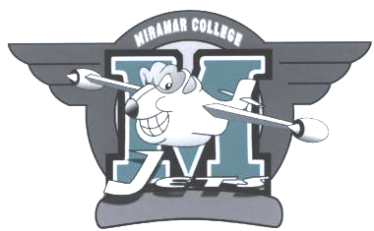
Chair: Darrel Harrison
November 15th, 2010

Room T-101

Minutes

Members Present: Darrel Harrison (Faculty), Daphne Figueroa (Faculty)
Wheeler North (Faculty), Joyce Allen (Classified) Rebecca Bowers-Gentry (Faculty), and Isabella Feldman (Faculty), Sara Agonafer (Classified)

Members Absent: Peter Fong (Admin)

Guests: Henry Banh (Associated Student Counsel Senator) –Student Member

Call to Order: 3:00pm

Item 1: a. Approval of 5/17/10 minutes- Approved

b. Approval of 11/15/10 agenda- Approved

Item 2: New Business -

- Spring Flex Training for Committee members & Chairs: Recommendation that Flex Training needed for all, not just Chairs and Co-Chairs. Recommend that refresher would benefit everyone. Recommendations will be reported at CEC. Flex training T.B.A. for spring 2011.

- Implementing Routing Form: Will try to review form and implement directions during spring 2011 Flex training. Form will be available via online/website.

- Campus rep’s roles in District Governance committees/reporting, etc: Recommendation to be part of Flex training as well for knowledge of process and direction, including Brown Acts.

- I.E.C.(Institutional Effectiveness Committee)-Request for name change:
(1st reading) I.E. requests name and membership change. Name change to P.I.E. (Planning & Institutional Effectiveness Committee). CGC -recommends approval.

Item 3: Old Business -

- Continued Discussion of Proposed Governance Restructure at Miramar:
Restructure proposed for spring 2011. Restructuring model proposed by Daphne Figueroa- will bring something back to next meeting showing model of possible restructuring.

- Status of Governance Handbook: Updated and available online.

Item 4: Committee Reports - None

Item 5: Information items/Announcements - None

Item 6: Adjournment – 4:00pm

Next meeting – Monday, December 13th, 2010

