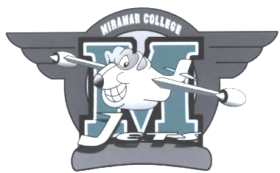Hiring Committee

Kathy Werle & David Navarro - Co-Chairs
Thursday, May 6, 2010
(note time change) 2:00 -2:30 p.m. A-201a

A G E N D A

Meeting called by Kathleen Werle & David Navarro (Co-Chairs)

Members: L. Ascione, G. Beitey, R. Boyd, P, Chlapecka, M. Dinger, D. Figueroa, P. Fong, B. Fritsch, S. Goggle, D. Harrison, M. Hart, P. Hopkins, S. Lickiss, M. McMahon, C. Murphy, S. Nally, D. Navarro, J. Omens, R. Porter, S. Schwarz, D. Short, S. Smith, D. Stack, M. Strobbe, A. Viersen, M. Walsh, D Willkie, J. Young, M. Kjartanson, D. Harrison, D. Buser, D. Figueroa, B. Haidar, B. Haidar, L. Lee, L. Woods, M. Guevarra. F. Bereaud.
Please read: Agenda & Minutes prior to meeting
Please bring: Agenda & Minutes

Item 1: Approval of Agenda – May 6, 2010

Item 2: Review of Minutes – April 8, 2010

Item 3: New Business:
Membership

Item 4: Old Business:
- Process and Forms
- Data for researcher

Item 5: Presentations:

Item 6: Information:

Item 7: Reports: none

Item 8: Other: none

Item 9: Adjournment:

Next scheduled meeting – September 2, 2010 in A-201a

