MIRAMAR COLLEGE
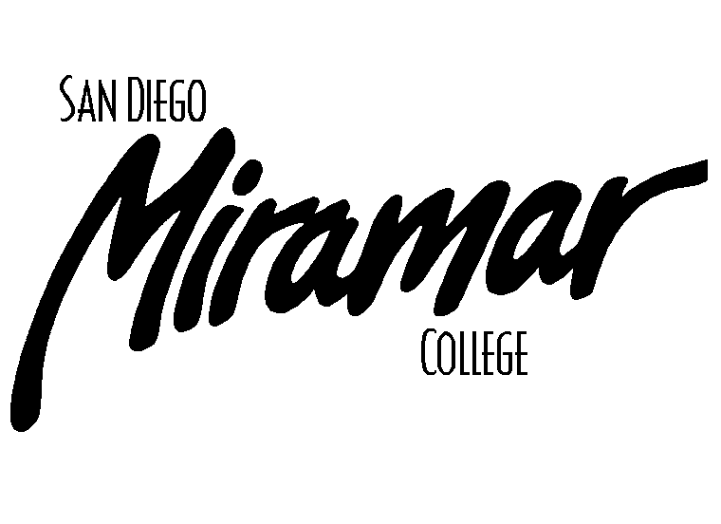
FACILITIES COMMITTEE

July 1, 2010
1:00 p.m., A201a

Committee Members:
Allen Andersen, Brett Bell, Lonny Bosselman, Tom Davenport, Kanchan Farkiya (Student Rep), Peter Fong, Fred Garces, Nick Gehler, Dan Gutowski, Jeff Higginbotham, Dane Lindsay, Kathleen Werle, Dan Willkie

AGENDA

Old Business

- Approval of Past Meeting Minutes
- May 6, 2010

- Parking Task Force Update (B. Bell)

- Campus Smoking Policy (B. Bell)

- PV Project Update (L. Bosselman/J. Bray)

New Business

- Campus Signage (B. Bell)

- Proposed New Administration & Fire Tech Buildings (B. Bell)

Announcements

1)

Next Meeting

Thursday, August 5, 2010, 1:00pm, A201a

