MIRAMAR COLLEGE
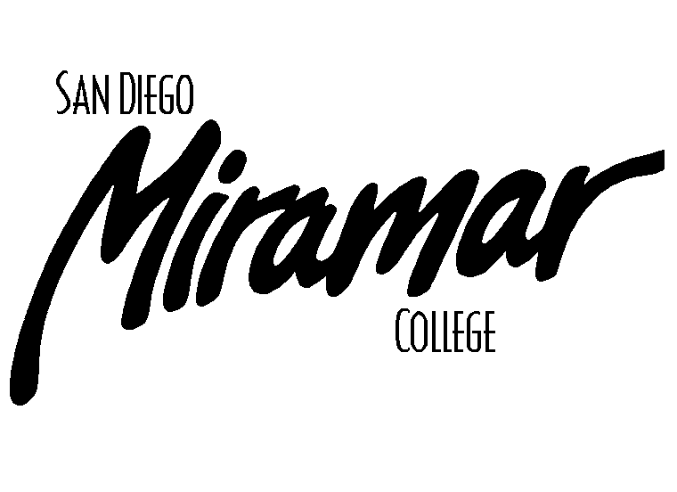
FACILITIES COMMITTEE

May 6, 2010
1:00 p.m., A201a

Committee Members:
Allen Andersen, Brett Bell, Lonny Bosselman, Tom Davenport, Kanchan Farkiya (Student Rep), Peter Fong, Fred Garces, Nick Gehler, Dan Gutowski, Jeff Higginbotham, Dane Lindsay, Kathleen Werle, Dan Willkie

AGENDA

Old Business

- Approval of Past Meeting Minutes
- April 15, 2010

- Parking Task Force Update (B. Bell)

- Motorcycle Parking (B. Bell/D. Picou)

- Campus Smoking Policy (B. Bell)

New Business

- Removal of Trailers: B-300, B-400, C-200, F-301-304, T-100 -300, and T-401-404 (J. Bray)

- Parking – New Temp Student Lot by I-Building and pending closure of Student Lot 3 (J. Bray)

- PV (R. Murphy)

- Drinking Faucet (K. Farkiya)

- ADA Access

Announcements

1)

Next Meeting

Thursday, June 3, 2010, 1:00pm, A201a

