MIRAMAR COLLEGE
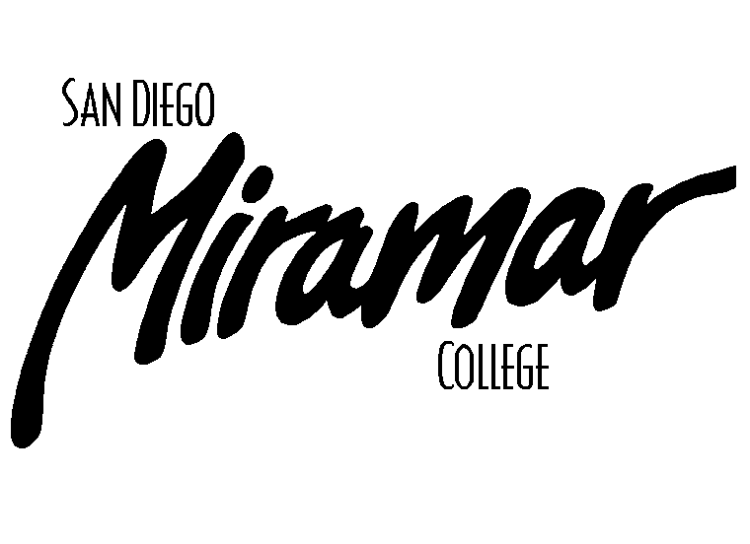
FACILITIES COMMITTEE

April 15, 2010
1:00 p.m., PCR

Committee Members:
Allen Andersen, Brett Bell, Lonny Bosselman, Tom Davenport, Kanchan Farkiya (Student Rep), Peter Fong, Fred Garces, Nick Gehler, Dan Gutowski, Jeff Higginbotham, Dane Lindsay, Kathleen Werle, Dan Willkie

AGENDA

Old Business

- Approval of Past Meeting Minutes
- March 4, 2010

- Parking Task Force Update (B. Bell)

- Identification of I and M Buildings (B. Bell)

New Business

- Standard IIIB (B. Bell/K. Werle)

- Motorcycle Parking (K. Farkiya)

- Locks on Bathroom Stalls in Women’s Restrooms - C400/S500 (K. Farkiya)

- Campus Smoking Policy (Werle/Ascione)

- Repro Drop-off Spaces (Um)

- Faculty/Staff Lot East of A100 & Turn-Around (Bell/Lindsay)

Announcements

1)

Next Meeting

Thursday, May 6, 2010, 1:00pm, A201a

