MIRAMAR COLLEGE
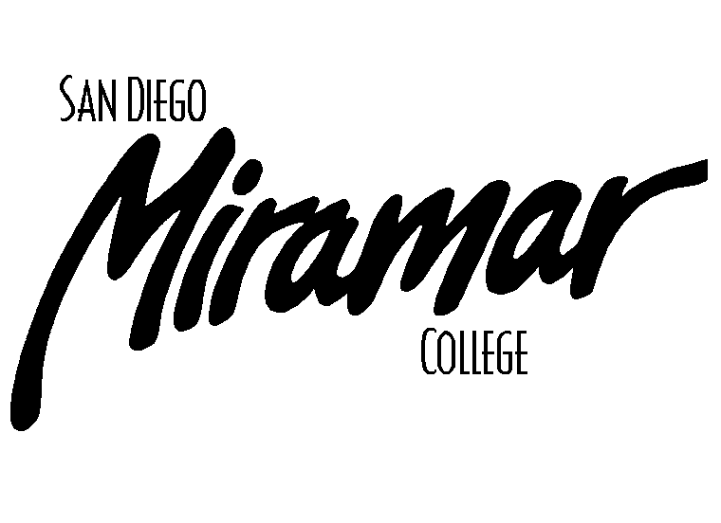
FACILITIES COMMITTEE

December 3, 2009
1:00 p.m., A201a

Committee Members:
Allen Andersen, Alexander Areta, Brett Bell, Dave Buser, Tom Davenport, Peter Fong, Fred Garces, Nick Gehler, Dan Gutowski, Jeff Higginbotham, Dane Lindsay, Kathleen Werle, Dan Willkie

AGENDA

Old Business

- Approval of Past Meeting Minutes
- November 5, 2009

- Parking Task Force Update (B. Bell)

- Signage Task Force (B. Bell)

- Permanent Location of Campus Garden Update (B. Bell/J. Bray)

- Law Library Update (B. Bell)

New Business

- Use of E100 Building (G. Beitey)

- Cable TV Feed (B. Bell)

- Removal of T100, T200 & T300 (J. Bray)

- Area Near U100 (J. Hecksel)

Announcements

