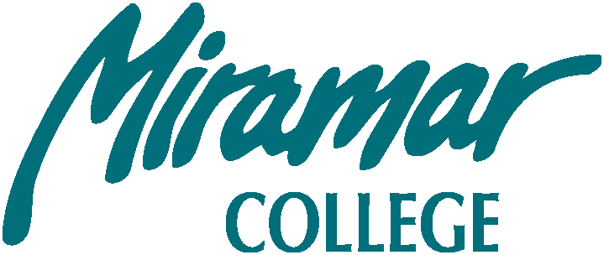

SAN DIEGO MIRAMAR COLLEGE EXECUTIVE COMMITTEE MEETING
J224

Tuesday, April 26, 2011

1:00 – 2:00 P.M.

Members: Hsieh, Bell, Fong, Barnes, Figueroa, Harrison, Gade, Allen & Shooshtary

Attendees: Trevisan, Jacobson and Ascione

- Approval of the Agenda

- Approval of Previous Minutes

- Guests/Introductions

- Updates from the Chancellor’s Cabinet

- New Business *
# | Item | Strategic Goal | Initiator
1 | District supported online Face book Webinar | 6 | Trevisan
2 | Fall Convocation Program | 6 | Hsieh
3 | 2010-2011 Annual Report and 2009-2010 Annual Fiscal Report | 6 | Barnes & Bell
4 | EEO/CDAC Update |  | (Patacsil)
- Old Business *
# | Item | Strategic Goals | Initiator
1 | Accreditation Follow Up Report | 1 | Barnes
2 | Update on IE Meeting | 6 | Barnes
- Reports
(Please limit each following report to two minutes maximum. If you have any handouts, Please e-mail them to Sara Agonafer ahead of time to be included for distribution electronically.)
- Academic Senate
- Classified Senate
- Associated Student Council
- District Governance Council
- District Strategic Planning Committee
- District Budget Committee
H. Announcements:
- Adjourn
Based on the decision from the CEC meeting on 2-15-2011, agenda items for all shared governance committees should relate to college’s strategic goals
* San Diego Miramar College 2007 – 2013 Strategic Goals
Goal 1: Focus college efforts on student learning and student success.
Goal 2: Deliver instruction and services in formats and at sites that best meet student needs.
Goal 3: Provide campus facilities, programs and co-curricular activities at Miramar College that enhance the college experience for students.
Goal 4: Initiate and strengthen beneficial partnerships with business and industry, schools and community.
Goal 5: Enhance Miramar College’s visibility, attractiveness and reputation for quality and student centeredness in a setting that celebrates diversity.
Goal 6: Improve and strengthen Miramar College’s internal processes to include program review, master planning, strategic planning and budget development.
Please also see G:\DATA\College-Wide Master Plan\1011CWMP for San Diego Miramar College 2007-2013 Strategic Plan

Accreditation Standards:
Standard I: A, B, Standard II: A, B, C, Standard III: A, B, C, D, Standard IV: A, B G:\DATA\Accreditation\Prior to Result of 2010 Self Study\Standard Folders

