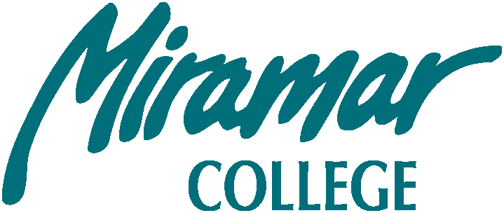

SAN DIEGO MIRAMAR COLLEGE EXECUTIVE COMMITTEE MEETING
President’s Conference Room A102

Tuesday, November 16, 2010

1:00 – 2:00 P.M.

REVISED FINAL AGENDA

Members: Hsieh, Bell, Fong, Werle, Figueroa, Harrison, Gade, Allen, & Cuilty

Attendees: Trevisan, Jacobson and Ascione

- Approval of the Agenda

- Approval of Previous Minutes

- Guests/Introductions

- Updates from the Chancellor’s Cabinet

  - New Business

F. Old Business
- Reorganization (Figueroa, Allen, Ascione)
- Naming of Student Services Building (Bell)
- Enrollment Management (Werle)
- Faculty Driven Outreach and Recruitment Strategy for Spring 2011 supplemental Sections (Trevisan)
- Facilities Committee Recommendation for Naming Café/Bookstore & Student Service Center and C-400 (Bell)
- Prayer in the classroom (Werle)

G. Reports

(Please limit each following report to two minutes maximum. If you have any handouts, Please e-mail them to Sara Agonafer ahead of time to be included for distribution electronically.)
1. Academic Senate
- Classified Senate
- Associated Student Council
- District Governance Council
- District Strategic Plan Committee
- District Budget Committee
- District SLOAC Committee
- District Accreditation Committee
H. Announcements:
  - Jointly sponsored Academic Senate/Classified Senate Holiday BBQ, Thursday, 12/2/10, 12-1:30 pm
(Figueroa)

I. Adjourn

