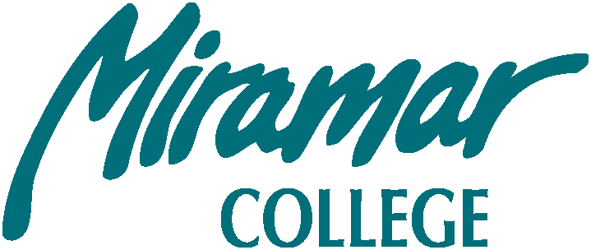

MIRAMAR COLLEGE EXECUTIVE COMMITTEE
PCR

Tuesday, May 19, 2009

1:00 – 2:00 P.M.

FINAL AGENDA
- Approval of the Agenda

- Approval of Previous Minutes

- Guests/Introductions

- Reports

- Academic Senate
- Classified Senate
- Associated Student Council
- Chancellor’s Cabinet
- District Governance Council
- District Strategic Plan Committee
- District Budget Committee
- District SLOAC Committee
- District Accreditation Committee

  - New Business

    - ARRA Grant Proposals (Armstrong)
    - Enrollment Management (Armstrong)

F. Old Business

- Announcements

Adjourn

