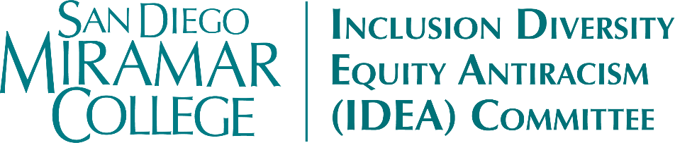
Meeting Minutes
Friday, October 9, 2026
11:15am-12:30pm, Zoom

Members Present: Jennifer Aase, Sara Agonafer, Edgar Alvarez, Carmen Carrasquillo, Joseph Hankinson, Danish Khan, April Koch, Ashlee Lain, Dianika Moore, Heather Paulson, Marcia Sawyer, Sharilyn Wilson,

Members Absent: Tsekani Browne, Claudia Estrada-Howell, Adrian Gonzales (ex officio), Nessa Julian, Bear Wolf

Guests & Support: Maribel Flores, Leslie Marovich, Dan Roberts (proxy for Estrada-Howell), Phuong Vuong

- Call to Order
  - Meeting called to order at 11:17am by co-chair Carrasquillo
- Approval of Agenda
  - MSC (Koch/Alvarez) to approve as presented. (0-N; 0-Abstain)
- Approval of the September 4, 2026 Meeting Minutes
  - MSC (Koch/Sawyer) to approve as presented. (0-N; 0-Abstain)
- Land Acknowledgment and Action
- Action Items
  - Event Proposals
    - Five proposals for event funding for 2026-2027 were received, scored by committee members, and ranked.
    - MSC (Paulson/Alvarez) to approve the requested funding for all five proposals. (0-N; 0-Abstain)
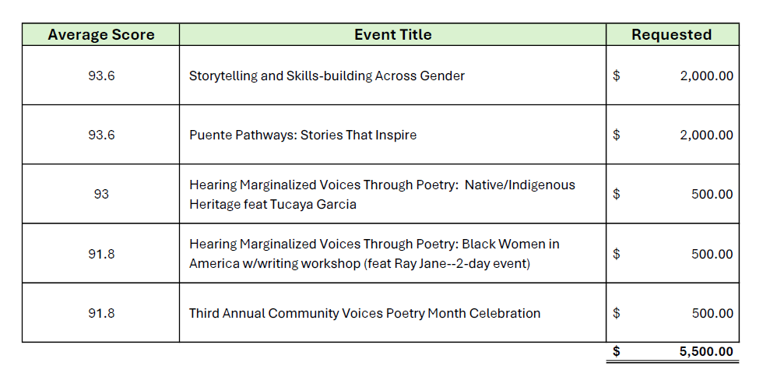
  - IDEA Conference Planning
    - Building off of the success of the Equity Summit, the Committee discussed bringing back Mohammed Soriano-Bilal as the guest speaker for our inaugural IDEA conference.
    - Dr. Soriano-Bilal’s work ties closely to the themes we already developed in May as part of our initial planning (intersectionality; connections; humanizing spaces, polices, and relationships; empathy, etc.)
    - Having him back would also give us a chance to practice dialogue skills. He could also potentially present to some classes, such as Dr. Sawyer’s BLAS classes.
    - MSC (Sawyer/Agonofer) in support of bringing Mohammed Soriano-Bilal back for our IDEA Conference.
    - We will target a date in February to avoid any conflict with the Planning Summit.
- Discussion Items/Reports
  - Voting Matters
    - Joseph Hankinson provided an overview of Miramar’s student voter engagement strategies and our hosting of a polling place for the November 2026 General Election.
    - Student polls worker are being trained and will be able to provide peer support to student voters. Students can register to vote on-site, beginning October 23.
    - Miramar also held or will be holding Rock the Vote events, voter registration drives, and similar engagement events.
    - Discussion: How can we (faculty and staff) encourage students to register, research, and vote?
      - Some students do not want to register. Some don’t want to be called for jury duty, while others might be concerned about the political climate. Still others see not voting as a statement of resistance.
      - Safety concerns: due to the SDCCD policy against immigration action on campus, we expect our campus to be a safe place to vote. Anyone attempting to intimidate voters should be reported; they will be handled in accordance with existing campus policies and state laws around election interference.
      - Multiple members suggested/supported having a counselor available at the polling place. Carrasquillo and Wilson will reach out to VP Gonzales.
  - Campus Free Speech Issues
    - A Turning Point USA student club recently formed at Miramar.
    - As a student club, this group will be subject to the same rules and code of conduct applied to all clubs. Any observed conduct issues related to any club should be reported to Dean Barnard’s office. It is important to keep records/documentation of any issues, including any imagery associated with the event in question.
    - Discussion: how are other Community Colleges handling similar situations? Approaches seem to be mixed across the state.
    - Discussion: what is and isn’t protected speech? Can we arrange campus trainings or workshops to promote clarity? Perhaps with the support of the LEAD Office and/or the District’s legal team? And can we also develop clearer written polices (Board Policies) and reporting mechanisms? Some students have already reported feeling threatened or unsafe.
    - Speaking of trainings, the next UndocuAdvocate Training Opportunity will be held at Mesa College.
  - Cohort Learning Updates & Kaleidoscope: NASSP, PEARL, Puente, Umoja
    - Puente Update – First year of the program has been very successful.
    - FAHM Kick-Off: Halo-Halo & Karaoke Social Mixer held October 8th, with a strong turnout and lots of enthusiasm from the students.
    - Koch reported her Medical Spanish Workshop also had a great turnout. Participants learned important vocabulary to communicate in a medical care context.
    - MESA & STEM Éxito - Showcase next Wednesday in the STEM Center
    - Counseling has a request for a full-time equity counselor working its way through the Contract Faculty Hiring Prioritization process.
  - Other Reports
    - None
- Other
- Adjourn
  - Adjourned by consensus at 12:32pm.

Next Meeting: Friday, October 6, 11:15am-12:30pm

