Human Physiology Lab Manual
Table of Contents

Consult the Course Syllabus for the Weekly Lab Dates

The Chemistry of Physiology . . . . . . . . . . . . . . . . . . . . . . . . . . . . . . . . . . . . . . . . . . . . . . . . . . . . . . . . . . 2

Lab #1: Part 1 - Physiological Solutions: Osmolarity, Diffusion and Tonicity . . . . . . . . . . 7

Lab #1: Part 2 - The Scientific Method: Arm Span and body height . . . . . . . . . . . . . . . . . . . . .15

Pre-Lab Questions: Enzyme Lab . . . . . . . . . . . . . . . . . . . . . . . . . . . . . . . . . . . . . . . . . . . . . . . . . . . . . . 21

Lab # 2: Experimental Enzymology . . . . . . . . . . . . . . . . . . . . . . . . . . . . . . . . . . . . . . . . . . . . . . . . . . . 23

Lab # 2: Enzyme Data Graphing Grids . . . . . . . . . . . . . . . . . . . . . . . . . . . . . . . . . . . . . . . . . . . . . . . . 35

Lab # 3: Lab Data Graphing Exercise . . . . . . . . . . . . . . . . . . . . . . . . . . . . . . . . . . . . . . . . . . . . . . . . 37

Lab # 4: Sensory Lab I: Sensory Receptors Peripheral Nervous System . . . . . . . . . . . . . . 41

Lab # 5: Sensory Lab II: Reflexes and Voluntary Actions; ANS Assignment . . . . . . . . . . . 59

Pre-Lab Questions: Skeletal Muscle Lab . . . . . . . . . . . . . . . . . . . . . . . . . . . . . . . . . . . . . . . . . . . . 67

Lab # 6: Skeletal Muscle Physiology using Physio Ex . . . . . . . . . . . . . . . . . . . . . . . . . . . . . . . . 69

Lab # 7: Part 1 - Introduction to Vernier Lab Pro: Heart Rate . . . . . . . . . . . . . . . . . . . . . . . 79

Lab # 7: Part 2 - Blood and Blood Typing . . . . . . . . . . . . . . . . . . . . . . . . . . . . . . . . . . . . . . . . . . . . 85

Lab # 8: Part 1- Electrocardiogram (ECG) . . . . . . . . . . . . . . . . . . . . . . . . . . . . . . . . . . . . . . . . . . . 97

Lab # 8: Part 2 - The Cold Water Challenge . . . . . . . . . . . . . . . . . . . . . . . . . . . . . . . . . . . . . . . . 106

Lab # 9: Part 1 - Blood Glucose and Blood Pressure Assessments . . . . . . . . . . . . . . . . . . .107

Lab # 9: Part 2 The Effects of Drugs on the Heart . . . . . . . . . . . . . . . . . . . . . . . . . . . . . . . . . . 113

Lab # 10: Human Respiratory Studies - Volumes and Capacities . . . . . . . . . . . . . . . . . . . . . . 122

Pre-Lab Questions: Renal Lab . . . . . . . . . . . . . . . . . . . . . . . . . . . . . . . . . . . . . . . . . . . . . . . . . . . . . . .131

Lab # 11: Human Renal Physiology - Fluid Regulation . . . . . . . . . . . . . . . . . . . . . . . . . . . . . . . 133

Lab # 12: Digestive Enzymes . . . . . . . . . . . . . . . . . . . . . . . . . . . . . . . . . . . . . . . . . . . . . . . . . . . . . . . . 141

Lab # 13: Applying The Scientific Method in Experimental Design . . . . . . . . . . . . . . . . . . . 151

Lab # 13: Sweat Gland Activity . . . . . . . . . . . . . . . . . . . . . . . . . . . . . . . . . . . . . . . . . . . . . . . . . . . . . .153

Lab # 14: Experimental Data Collection and Graphing Assignment . . . . . . . . . . . . . . . . . .158

Lab # 15: Supplemental Lab Exercise: How to Make Butter. . . . . . . . . . . . . . . . . . . . . . . . . . 162

Student Presentation Guidelines . . . . . . . . . . . . . . . . . . . . . . . . . . . . . . . . . . . . . . . . . . . . . . . . . . . 164

Appendix A - Summary of Laboratory Content for Lecture Exams . . . . . . . . . . . . . . . . . . . 166

Appendix B - Select Review Exercises for Course Content . . . . . . . . . . . . . . . . . . . . . . . . . . 167
THE CHEMISTRY OF PHYSIOLOGY – A REVIEW

In order to have a good understanding of the fundamentals of physiology, we need to know some basic chemistry to enable us to see the levels of organization of the human body.

Levels of Organization for the Human Body – the physical building blocks of the body

Atoms > Molecules > Organelles > Cells*(unit of life) > Tissues > Organs > Organ Systems > Organism

Atoms (e.g. C, H, O) are neutral (not charged) and when they combine by forming chemical bonds they create Molecules (e.g. H₂O, C₆H₁₂O₆). Thus, molecules are more complex than atoms, and as we proceed up the levels, it gets more complex yet they are built by the simpler elements. Cells are considered the ‘unit of life’, and humans are composed of about 60 trillion cells.

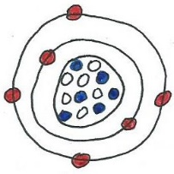
To understand atoms we need to know the basics about the subatomic particles, protons, neutrons and electrons.
1. Proton (positively charged). Location: Nucleus
2. Neutrons (neutral). Location: Nucleus
3. Electrons (negatively charged). Location: Orbitals

Valence electrons (e⁻s) = outer shell e⁻s, responsible for the chemical properties and types of bonds.

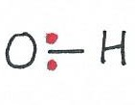
Three types of chemical bonds:
- Covalent bonds – a sharing electrons between atoms, strong bonds.
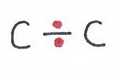
- Polar: unequal sharing of electrons. e.g. H₂O
- Non-Polar: equal sharing of electrons. e.g. C=C

- Ionic bonds – complete transfer of electrons, relatively weak bond (crystals strong), break in water. Ions are charged particles (atoms or molecules). They dissociated in water to form electrolytes in solution. Examples are Na⁺, K⁺, Cl⁻, Ca²⁺, OH⁻, Mg²⁺, HCO₃⁻, and H₂PO₃⁻.
- Hydrogen bonds – weak but significant attractive forces between a H atom in one molecule and an O or an N atom in another molecule. Very weak but important bonds.
Ions are charged particles (atoms or molecules). A positively charged ion is termed a cation and a negatively charged ion is termed an anion. They dissociated in water to form electrolytes in solution. Examples are Na⁺, K⁺, Cl⁻, Ca²⁺, OH⁻, Mg²⁺, HCO₃⁻ and H₂PO₃⁻.
Molecules – atoms or groups of atoms joined together by chemical bonds.
- Inorganic molecules – do not contain chains of carbon (H₂O, NH₃ H₂CO₃). Water (H₂O) is the most important inorganic molecule.
- Organic molecules – contain a central carbon or chains of carbon (CH₄, C₆H₁₂O₆).
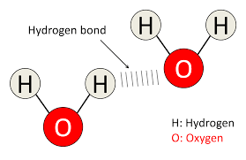
Water is a very important inorganic molecule. Water (H₂O) accounts for 60 to 70% of total body mass in humans. It is a molecule that exhibits many unique qualities stemming from its polar structure. The important properties of water are discussed below. Here is a diagrammatic drawing of some water molecules. Describe the molecule and how it interacts with other water molecules.
Important Properties of Water
Solvency - water is able to dissolve a wide range of substances, particularly polar molecules. Many substances dissolve in water, the reason why it is described as the universal solvent.

Cohesion - H₂O molecules have a high affinity for each other (due to H-bonds) and they cling together. The H₂O molecules on a surface tend to pull one another from below and inward - this causes the 'beading' appearance of water on surfaces and creates surface tension at the fluid to gas interface, giving the surface an elastic surface layer (enough tension for insects to walk on). Water is also able to adhere to many other surfaces other than water, a term called adhesion.

Thermostability - the temperature of water remains fairly stable despite changes in the surrounding temperature, giving water a high heat capacity - the ability to absorb heat energy with only moderate changes in temperature. This special quality of water is used to measure energy in metabolic processes. A calorie is the amount of heat energy required to raise 1g of water 1ºC (from 14ºC to 15ºC). Water also has a high heat of vaporization, because it requires a large amount of energy to go from the liquid to the gaseous phase. When sweat is blown off our bodies in vapor form a great amount of heat energy leaves with it, this is the reason why it is enormously effective in cooling us down.

Reactivity - Water molecules not only dissolve substances but can also actively participate in chemical reactions with many different molecules. Some of the most fundamental reactions in physiology require water as a reactant, or liberate water as a product. For example: Hydrolysis involves breaking chemical bonds using water. Dehydration Synthesis involves removing water in order to synthesize a larger, more complex molecule.

Minerals - these are inorganic elements from soil, plants or animals that account for about 4% of our body mass. The following minerals are typically found in appreciable quantities within the body: Calcium, Phosphorus, Potassium, Sulfur, Chlorine, Sodium, Magnesium, Iron, Manganese, Silicon, Copper, and Iodine. Other minerals are referred to as "trace minerals" because of the minute amounts present in the body, such as Zinc, Selenium and Chromium. All of these minerals play extremely important roles in metabolic, regulatory and enzymatic pathways in the human body.

The pH of Body Solutions
The pH is a measure of the concentration of hydrogen ions in a solution. It is a logarithmic scale ranging from 0 (extremely basic) to 14 (extremely acidic). Neutral is defined as a pH = 7.0.

pH Scale
Very Acidic Very Basic
1 2 3 4 5 6 7.0 8 9 10 11 12 13 14
HCl

stomach acid

lemon juice

tomatoes

coffee

milk

distilled water

egg white

borax

Great Salt Lake

ammonia

oven cleaners

NaOH

What is the pH of blood? __________________.

Organic Molecules Carbohydrates, Lipids, Proteins, and Nucleic Acids
The Carbon atom has 6 protons, 6 electrons and most commonly 6 neutrons. Carbon (C) has 4 outer shell or valence electrons. Thus, it can make 4 covalent bonds, giving it versatile qualities. The general term monomer is used to describe the smallest type, or building blocks, of these organic molecules. The general term polymer describes the larger, more complex molecules.

CARBOHYDRATES = C + H₂O (hydrated carbons) usually have a 2:1 (H:O) ratio. The primary function of carbohydrates is as an energy (E) source; also some E storage; also as a supply of C for cell components and structural elements of some cells.

Monosaccharides – simple sugars (monomers). Here are three common examples:
1. Glucose – the most commonly used molecule as a source of E in the human body.
2. Fructose – a simple sugar found in fruits (fruit sugar).
3. Galactose – a component of milk sugar.

Disaccharides – 2 monosaccharides joined together by a glycosidic bond. Important examples:
1. Sucrose (table sugar) = glucose + fructose
2. Lactose (milk sugar) = glucose + galactose
3. Maltose (grain sugar) = glucose + glucose

Polysaccharides – common examples of complex carbohydrates – all are polymers of glucose.
1. Glycogen - energy storage molecule for glucose in animal cells, found in liver and skeletal muscle.
2. Starch - energy storage molecule for glucose in plant cells, e.g., potatoes!
3. Cellulose - structural component of cell wall in plant cells, e.g., dietary fiber!

LIPIDS = C, H and O but not a 2:1 (H:O) ratio as in carbohydrates, much less O than carbohydrates. In general they are non-polar molecules, not solvent in water. Let’s briefly examine the 4 primary types of lipids in the human body:

1) Fatty Acids – 4 to 24 C’s long with carboxylic acid and methyl group at either end. Rich source of Energy (E). Compare Saturated and Unsaturated (mono and poly) fatty acids (F.A.’s). Typically, the monomers of lipids are fatty acids and glycerol. Make a quick sketch of a fatty acid and glycerol:

2) Mono-, Di- and Triglycerides – Made from 1 glycerol and 1, 2 or 3 Fatty Acids. In the body, triglycerides are storage molecules for Energy (E), it is the most abundant lipid in body and diet. Rich source of E, has at least 2 x the energy as carbohydrates per g.

3) Phospholipids – Similar to triglycerides: 1 glycerol + 2 F.A.’s + Phosphate group (+ N compounds). An Amphiphilic molecule, it has a polar head and non-polar tail region, thus it can mix in both polar and non-polar solutions. This is the most abundant and important lipid molecule in the plasma membrane of cells. Draw a Generalized Phospholipid:

4) Steroids – A lipid with 17 of its C atoms arranged in 4 rings. Most abundant steroid in human body is Cholesterol, very important component of plasma membrane and precursor to many other important steroid lipids e.g., sex hormones (estrogen and testosterone), bile, cortisol, Vitamin D.
PROTEINS = C, H, O, N, S. The most versatile and complex of the organic molecules. Largest range of functions. Amino Acids (AA’s) are the building blocks (monomers) of peptides, polypeptides and proteins. How many amino acids does the human body use? Draw a Generalized Amino Acid:

Levels of Structures of Proteins: Define each of these levels of proteins.
Primary (1º) – linear sequence of amino acids joined together by covalent ‘peptide’ bonds.
Secondary (2º) – the formation of alpha (α) helix or beta (β) pleated sheet due to hydrogen bonds.
Tertiary (3º) – the three dimensional (3D) shape of a protein, due to interactions of functional groups.
Quaternary (4º) – interactions of several polypeptides chains with each other (not all proteins).

Proteins can be either Globular or Fibrous (based on form or shape)
Some functions: Structural, Catalytic, Transport, Contractile, Regulatory and Immunological.

Energy and Thermodynamics
Q: What is Energy? A: Energy is the capacity to do work.

Q: What is Work? A: Work is essentially moving things. There are three basic types of work:

1) Chemical Work - making and breaking chemical bonds; exchanging, storing and releasing Energy.
2) Transport Work - movement of substances across a concentration gradient.
3) Mechanical Work - movement of a 'whole'; organelles inside a cell; flagella; muscle fibers.

There are many forms of energy, two important forms that we encounter in physiology are:
Kinetic Energy (KE) and Potential Energy (PE)
Energy of motion Energy that is stored
(chemical, transport, mechanical) (concentration gradient, chemical bond)

KE and PE can be converted from one form to the other but it is never a 100% efficient conversion.
Work (chemical, transport, mechanical) involves the inter-conversion of these 2 forms of energy.

THERMODYNAMICS - How Energy is converted to Work.

1st Law of Thermodynamics
- Energy can be converted from one form to another but cannot be created or destroyed. Energy (E) in the universe is constant.

2nd Law of Thermodynamics
- In every Energy transfer, some Energy is lost as heat and can no longer do useful work.
or
- Natural spontaneous processes move from a state of order (non-randomness) to a state of disorder (randomness) known as Entropy (S, the degree of randomness). Entropy in the universe is increasing.

Being aware of these 2 laws allows us to see that, 1) energy does not disappear but can change form, and it also indicates that, 2) a lot of work is required in living systems to maintain what we see as order.

Chemical Reactions in the Body
In the body, chemical reactions are used to Store, Release, or Transfer Energy. The term metabolism refers to the chemical processes that occur within living organisms in order to maintain life.

In simple terms, Metabolism has 2 components: Anabolism + Catabolism. These two processes are involved in the transfer of energy in the body, one requiring and one releasing energy, respectively.
- Anabolic reactions build things and are Endergonic, meaning they require Energy (E) input.
- Catabolic reactions break things down and are Exergonic, meaning they release Energy (E).
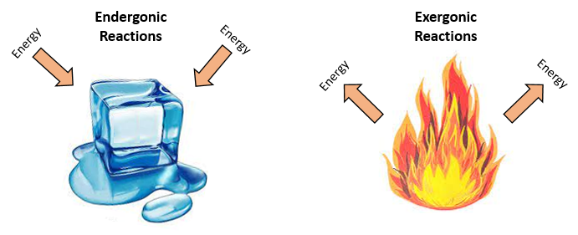

1) Anabolic Reactions – Require Energy (E) input.
The anabolic reactions are endergonic. They require energy input to create more complex molecules.
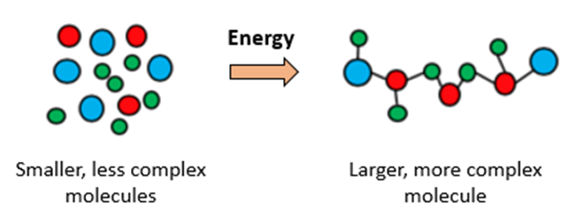

A specific example in the body is when 2 amino acids combine to form a dipeptide. The removal of water (H₂O) to create a larger molecule is called a Dehydration Synthesis reaction.

2) Catabolic Reactions – Release Energy (E)
The catabolic reactions are exergonic. They release energy when complex molecules are broken down.
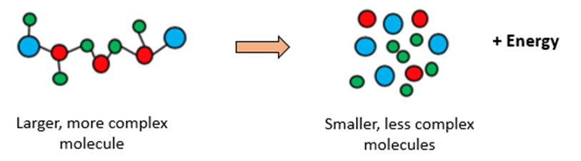

A specific example ion the body is the breakdown of a dipeptide into 2 amino acids. Often in biological systems water (H₂O) is used to break chemical bonds, this reaction is called Hydrolysis.
Laboratory Exercise #1: The Scientific Method

Objectives: After completing these exercises, you should be able to
- Understand the 5 basic steps of the scientific method of investigation;
- Describe the methods used in “Experimental” and "Observational" investigations.
- Apply the 5 steps (below) to the Physiological Solutions experiment that starts on page 11.
Scientific Investigations

Experimental Science

Observational Science

Manipulate one factor, observe response. Observe phenomena; classify.

In "experimental" science, an investigator sets out to see how one factor affects other factors. For example, how changing one factor (pH) affects another factor (enzyme activity). Apply the 5 steps to the experiment in Part 1, where we will set up solutions in beakers to see where water goes.

In "observational" science, an investigator observes phenomena and draws conclusions from them. For example, we could aske, are there specific and consistent ratios within the human body?

Each investigator follows the same basic steps in the scientific process, regardless of his or her research.

The 5 steps of the process are as follows:

1. OBSERVATION
Formulate a question from existing knowledge. This involves searching the Scientific Literature.
e.g. _______________________________________________________________.

2. HYPOTHESIS
Make a prediction by suggesting an answer to the question above.
e.g. _______________________________________________________________.

3. INVESTIGATION
Design experiments to test hypothesis. This is trying to answer the questions posed.
e.g. _______________________________________________________________.
May Revise
Hypothesis

4. ANALYSYS
Collect the data (results) from experiments and assess the results.
e.g. _______________________________________________________________.

5. CONCLUSION
Formulate possible conclusions from your data, compare to other studies. May revise hypothesis.
e.g. _______________________________________________________________.
Laboratory Exercise #1: Part 1 - Physiological Solutions
Objectives: When you finish this exercise, you should be able to:
1. Define terms mole, molarity, electrolytes, osmolarity, tonicity, diffusion, osmosis, & % solutions.
2. Calculate molarity, osmolarity and predict direction of water movement (osmosis) in solutions.
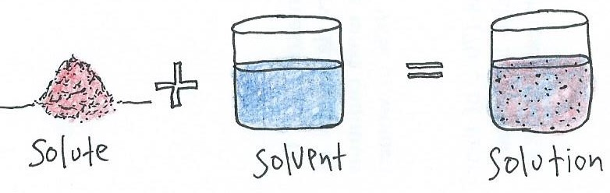
Introduction to Solutions
What is a solution?

A solute is added to a solvent to make a solution. Various molecules can be solutes (including liquids) and the solvent is distinguished by being present in greater abundance than the solute. In physiology, the solvent is always water (H₂O). In fact, approximately 70% of the body is water!

The 3 Tissue Compartment Volumes of the Body
Physiologists divide the solutions of the body into different ‘compartments’ of intracellular fluid (ICF) and extracellular fluid (ECF). The ICF is the solution found inside cells, and ECF is the solution in which cells are bathed in. The ECF can be further divided into a) plasma, which is the fluid component of blood; and b) interstitial fluid, which is the fluid found in the interstitial spaces of the body (see drawing below). These fluids function to provide the body’s cells with the vital elements they need and to protect cells from changes in their environment.

Shown in the image below are the 3 tissue fluid compartment volumes: Where are they found?
1) Plasma is fluid found: _____________________________________________________.
2) Interstitial fluid is found: _____________________________________________________.
3) Intracellular fluid is found: _____________________________________________________.
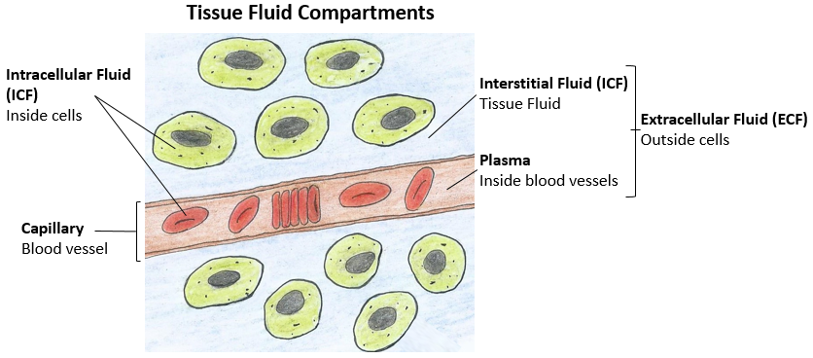
The important reason for the distinction between the 3 tissue compartment volumes (plasma, interstitial and intracellular fluid) is because each is very different from the other and we need to know how they are different in order to determine the way that cells function within them.

Concentrations of Solutions
As we study various solutions in human physiology, we will examine the conventional methods of expressing concentrations, such as Molarity, Osmolarity, Tonicity and Percentage (%) of solutions.

Electrolyte Solutions
All body fluids (e.g., blood, lymph, cerebrospinal, interstitial fluid, etc.) are electrolyte solutions, meaning they contain ions which are charged particles. Common examples are Na⁺, K⁺, Cl⁻ and Ca²⁺ dissolved in water. Electrolytes are a very important concept in physiology, electrolyte solutions are necessary to maintain water balance, stabilize pH of body fluids and allow for electrical communication.

Here is our Solutions Checklist
We will be examining the categories of solutions listed below and how they are related. The exercises set in Appendix B at the end of this lab manual are designed to show how all of these solutions interconnect as we make calculations starting from % solutions and arrive at osmolarity.
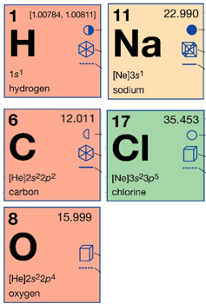

Molar Solutions and Molarity
Calculating Osmolarity

Assessing Tonicity of Solutions

Converting from % Solutions to Molarity and then to Osmolarity

1. What is a Mole?
A mole of any substance = 6.02 x 10²³ particles of that substance, e.g., 1 mole of sodium (Na) atoms = 6.02 x 10²³ Na atoms. To which one might say, “Whatever”. The reason we need to understand the basic chemistry is so we can apply it to solving problems related to physiological solutions.

2. What is Mole Weight or Molecular Weight (MW)?
By agreement, the mass of 1 mole of atoms or ions or a molecule or an ionic compound is numerically equal to the atomic mass of that atom in grams. To find these values, we consult a periodic table of the elements, found in the back of textbooks or easily online. There we will see that Na has an atomic mass of 23.0. Therefore 1 mole of Na = 23.0g.

Now find the following:
1) Cl has a molecular weight of __________, therefore 1 mole of Cl = ______________________.
2) NaCl has a molecular weight of __________, therefore 1 mole of NaCl = ___________________.
3) Water (H₂O) has a molecular weight of __________, therefore 1 mole of H₂O = _______________.
4) Glucose (C₆H₁₂O₆) has a molecular weight of ________, thus 1 mole of C₆H₁₂O₆ = ______________.
3. What is Molarity (M)?
Molarity is the concentration of a substance in a solution. Put simply, it is the # of moles in solution. It is the ratio of the number of moles in a liter of solution: e.g., a 1.0 M NaCl solution means 1 mole of NaCl for every 1 liter of solution. In science and medicine, concentrations of solutions are often defined in terms of molarity (M), moles/liter; or mM = millimoles/liter.

If you had to make a 1M solution of NaCl, you don’t need to measure out 6.02 x 10²³ molecules of NaCl, all you need to do is find out how much a mole of NaCl weighs in g. That is, look up the MW of NaCl and see that it is 58.5g. Therefore, dissolve 58.5g of sodium chloride in enough water to equal 1 liter of total solution at that will be a 1M solution of NaCl. [Note: up to 1 L, not in 1 liter of water!]

4. What is Osmolarity?
If Molarity is the # moles of a substance in 1 liter of solution, then Osmolarity is the total # of particles in solution. Since NaCl in water breaks up to Na⁺ and Cl⁻, there are actually twice as many dissolved particles in that solution compared to a molecule that does not dissociate (ionize) in solution. The normal osmolarity of the various fluids in the body should exist in between the range 295 to 310 mOsM. Solutions of the body in this range are considered “isotonic”.

Quick Exercise: What is the Osmolarity for each of the following solutions?

- 1.0 Molar Glucose (C₆H₁₂O₆) solution:

- 1.0 Molar Saline (NaCl) solution:

What is the key element to determining the Osmolarity from the Molarity of a solution?
Ans: ______________________________________________________________________________.

5. What is Tonicity?
In general, tonicity means the “strength” of a solution. In physiology, water is the solvent, and solutes are dissolved in it. Therefore, the more solutes dissolved in water, the ‘stronger’ the solution is. Conversely, the fewer solvents dissolved in water, the ‘weaker’ the solution is. The tonicity of physiological solutions is very important because it can impact the direction of water movement. After accounting for all permeabilities, the simplest definition for tonicities are as follows:

- In an isotonic solution, the extracellular fluid has the same osmolarity as the cell. There will be no net movement of water into or out of the cell. (iso = same, tonic = strength)

- In a hypotonic solution, the extracellular fluid has lower osmolarity than the fluid inside the cell. The net flow of water will be into the cell. (hypo = lower, tonic = strength)

- In a hypertonic solution, the extracellular fluid has a higher osmolarity than the cell’s cytoplasm. The net flow of water will move out of the cell. (hyper = higher, tonic = strength)

In the human body, homeostatic regulation of tonicity of body fluids is critical. The tonicity of body fluids will normally fall within the range of 295 to 310 mOsM, thus this range is “isotonic”! The body is in constant flux but typically maintains this range in order to protect all tissues. See beakers next page.

Treatment of Dehydration
Examine the solutions in the beakers below and answer the questions. For osmolarity report a numeric value. For tonicity use the words hypo-, iso-, or hypertonic. Replacement of fluids or solutes must be done without damaging the tissues or red blood cells.

Exercise 1: Examine the solutions in following beakers and determine the effect on the ‘normal’ cell.
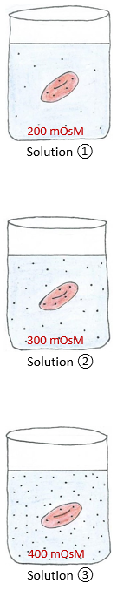
What is the osmolarity of solution ① ________________________________.
What is the tonicity of solution ① ___________________________________.
What net direction would water move? _______________________________.
What would happen to the cell in solution ① __________________________.

Select the best answer for treating a person with Hypotonic Dehydration:
1) To correct the problem, treatment should ___________ ECF osmolarity.
a) increase b) maintain c) decrease

2) Therefore, a (an) ___________ solution should be given.
a) hypotonic b) isotonic c) hypertonic

What is the osmolarity of solution ②_________________________________.
What is the tonicity of solution ② ___________________________________.
What net direction would water move? _______________________________.
What would happen to the cell in solution ② __________________________.

Select the best answer for treating a person with Isotonic Dehydration:
1) To correct the problem, treatment should ___________ ECF osmolarity.
a) increase b) maintain c) decrease

2) Therefore, a (an) ___________ solution should be given.
a) hypotonic b) isotonic c) hypertonic

What is the osmolarity of solution ③_________________________________.
What is the tonicity of solution ③ ___________________________________.
What net direction would water move? _______________________________.
What would happen to the cell in solution ③__________________________.

Select the best answer for treating a person with Hypertonic Dehydration:
1) To correct the problem, treatment should ___________ ECF osmolarity.
a) increase b) maintain c) decrease

2) Therefore, a (an) ___________ solution should be given.
a) hypotonic b) isotonic c) hypertonic
As seen in the previous page, below are brief descriptions of the three (3) Types of Dehydration which can cause significant changes in body fluid tonicity.

1. Isotonic Dehydration: Results when both electrolytes (solutes) and fluids (water) are lost at the same rate. Plasma osmolarity hasn’t changed.
Causes: Decreased fluid intake; Hemorrhage; Excessive urine loss; Excessive vomiting.

2. Hypertonic Dehydration: Results when more fluid is lost than solutes.
Plasma osmolarity increases.
Causes: Pure water loss with high fevers; Watery Diarrhea; Diabetes Insipidus.

3. Hypotonic Dehydration: Results when more solute is lost than water.
The solute is usually sodium. Plasma osmolarity is decreased.
Causes: Heat Stroke or Heat Exhaustion; Extreme physical exertion.

While continuing to wait for the results of Experiment #1, complete the following exercises:

Define Diffusion: ____________________________________________________________________.

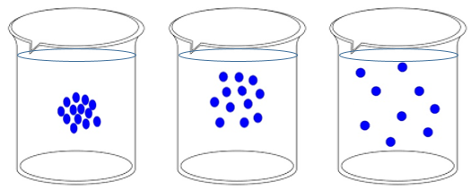

Q: Briefly describe 5 (+) important factors that influence the rate of diffusion.

1) ________________________________________________________________________________

2) ________________________________________________________________________________

3) ________________________________________________________________________________

4) ________________________________________________________________________________

5) ________________________________________________________________________________

* _______________________________________________________________________________

Define Osmosis: _____________________________________________________________________.
Experiment
We will examine the movement of molecules through a semipermeable membrane from one solution in a bag to another solution in a beaker that the bag sits in.

Procedure:
1. Using the dialysis tubing, double knot tie three 8" bags at one end with dental floss but leave one end untied so you can fill the bags with 20 ml of various solutions (see below) located in the lab.

2. Using the pipettes supplied for the specific solutions in the lab, fill the dialysis bags (which represent cell membranes) with the solutions specified below and place them in the beakers as directed - make sure bags are completely submerged.

3. When tying the other end of the bag, ensure it is tight with no leaks prior to placing bags in the beakers. Also, don’t tie the bags such that they are too rigid (full), as this may disrupt your results.
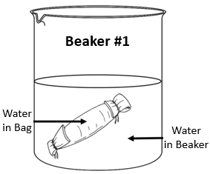

Beaker # 1: This serves as the control experiment.
Pipette 20 ml of distilled water into the dialysis bag.
Place this bag into the empty control beaker #1.
Measure out 100 ml of distilled water in a graduated cylinder and pour this into the control beaker #1.
Start your timer as soon as the dialysis is fully submerged in the solution in the beaker.

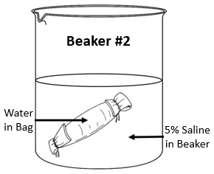
Beaker # 2:
Pipette 20 ml of distilled water into the dialysis bag.
Place this bag into the empty beaker #2.
Measure out 100 ml of 5% Saline solution in a graduated cylinder and pour this into beaker #2.
Start your timer as soon as the dialysis is fully submerged in the solution in the beaker.

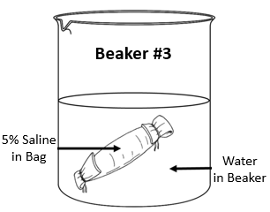

Beaker # 3:
Pipette 20 ml of 5% Saline solution into the dialysis bag.
Place this bag into the empty beaker #3.
Measure out 100 ml of distilled water in a graduated cylinder and pour this into beaker #3.
Start your timer as soon as the dialysis is fully submerged in the solution in the beaker.

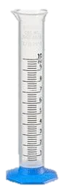
4. Leave the dialysis bags in the beakers for a minimum of 1 hour.

5. Complete the other exercises and questions in the lab manual for this section while the beakers sit on the lab bench for at least an hour.

6. At the end of the experiment, remove each bag very carefully from the beaker and let the beaker solution drip off the bag back into the beaker as much as possible, then empty the contents of each bag separately into a 50 ml graduated cylinder (see right) in order to measure the final volumes.

7. Finally, empty contents of each beaker into a 100 ml graduated cylinder to measure the final volumes. Record all final volumes in the results Table 1 below.

Results from Experiment

Table 1. Calculate and record the changes in volume of solutions in bags and beakers.
Beakers  Record start time | Beaker #1  Water in bag in water | Beaker #2  Water in bag in 5% saline | Beaker #3  5% saline in bag in water
ml of fluid in bag at start  start time = | 20 | 20 | 20
ml of fluid in bag at end
end time =
ml change in bag content (+/-)
ml of fluid in bag content
(Control Corrected)
ml of fluid in beaker at start | 100 | 100 | 100
ml of fluid in beaker at end

ml change in beaker content (+/-)
ml of fluid in beaker content
(Control Corrected)
direction of water movement
(into or out of the bag)

“Control Corrected” applies only if the control beaker or bag gained or lost any volume. If the controls did change volume, then add or subtract that volume value to the changes seen in the other experimental bags or beakers. Any changes to the controls represent an artifact change from lost volumes in bad of beaker or errors in transfer of volumes.

While waiting for the results of Experiment #1, complete the exercises on the previous pages.
Laboratory Exercise #1: Part 2 - Observational Science
Objectives: After completing Part 2 exercises, you should be able to:
- Apply the 5 basic steps of the scientific method to our "Observational" investigations.
Scientific Investigations

Experimental Science

Observational Science

Manipulate one factor, observe response. Observe phenomena; classify.
Experiment ② Observational Science

Now let’s use the Scientific Method for Observational Science and conduct an experiment!
Scientific investigation involves a series of logical steps to arrive at explanations for various biological phenomena. As we know, this technique is called the Scientific Method and is used in all disciplines of science. It allows investigators to draw logical and reliable conclusions about phenomena.

An important attribute of any hypothesis is that it must be testable. The testing of the hypothesis involves performing carefully controlled experiments to obtain data that can be used to support, disprove, or modify the hypothesis.

Exercise #1: Arm Span to Body Height Relationship
1. Observation: “Is there a relationship between arm span and the body height of an individual?”

2. Hypothesis: “The arm span will be equivalent to the body height of an individual.”
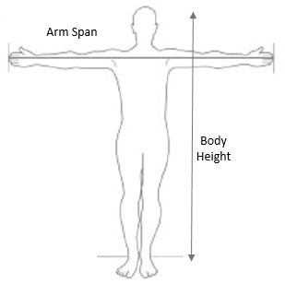
3. Investigation:

OK, let’s take some measurements!

In this lab, we can investigate this relationship and compare our findings to what the literature shows. This is a way to take a hypothesis and test it. As a map for following the scientific method, fill in the 5 steps on the next page as we examine the possible relationship of arm span and body height.

List the specifics of the 5 steps for the proposed Body Height to Arm Span relationship.

- Observation: ________________________________________________________________.

- Hypothesis: ________________________________________________________________.

- Investigation: ________________________________________________________________.

- Analysis: ________________________________________________________________.

- Conclusion: ________________________________________________________________.

In this country, when we think of our height we usually think in terms of “feet and inches”, but we will be using the metric system in this experiment. Therefore, we must make conversions from the English or “Empirical” system to the metric system. A reference table for the conversion of English units of measure to metric units for length, mass, volume, and temperature should be located inside any textbook. For this exercise, all you really need to know is that 1 inch = 2.54 cm, so just multiply any value in inches by 2.54 to obtain a conversion of inches to centimeters.

Materials Needed: Meter stick; calculator.
Procedure for Experiment:
- Work in pairs to make measurements and record them in your lab manual in Table 2 (below) as well as on the computer spreadsheet in the lab.

- Use the meter stick to measure the arm length of your partner in centimeters (cm). For the arm length measurement, place the meter-stick in the axilla (armpit) and record the length in centimeters to the end of the longest finger.

- Again, use the meter stick to measure arm span length, which is also called ‘wing span’. For the arm span length measurement, have the subject raise both arms parallel to the ground at shoulder height and at a 180 degree angle to the body. Then measure the arm span length from the longest fingertip of one hand to the longest fingertip of the other hand.

- Obtain the height of each person in centimeters by measuring them without shoes against a wall. The arm lengths and height of each person should be reported and recorded in centimeters.

- Record all your measurements in centimeters (cm) in Table 2 (below).

4. Analysis:

Table 2. Record your values for all your measurements in centimeters (cm) in below.
Subject | Arm Length | Arm Span | Body Height | Ratio  Arm Length to  Body Height | Correlation  Arm Span to  Body Height
5. Conclusions:

- Enter your individual data from Table 2 into the computer spreadsheet for the entire class.

- Using the class data for arm span versus body height, create a graph of all the class data on the grid below. Graphs are an excellent way to express and analyze large amounts of data.

- Can you see a pattern, or a ‘correlation’ in the data presented in the graph below?

A figure legend is required at the bottom of each figure in a report. A graph is a figure and should be accompanied by a figure legend underneath it that contains the pertinent information necessary to interpret the graph. This allows the reader to easily understand what was done in the experiment, what materials or techniques were used, and the number of subjects (sample size, n) involved.

Write a Figure Legend for the graph above here. See page 161 of this lab manual as a helpful reference.

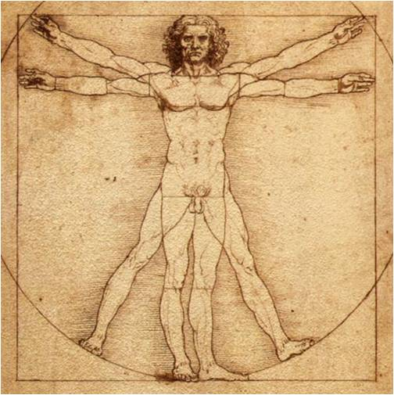
Other Ratios of the Human Body
Can you predict any other human body ratios?

What’s the name of this famous drawing shown at the right?

The _____________________________________________.

Who drew this picture? _____________________________.
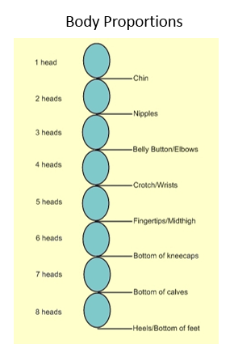

In the human body, the length of the head (called the ‘Ratio of Head-Body Proportions’) is a commonly recognized body ratio for the entire length of the body in fully grown adults. As seen in the drawing to the left, the total length (height) of the human is usually proportional to 8 heads, with a distinct landmark of the body (like the belly button or wrists) serving as an indicator for the proportion’s ratio.

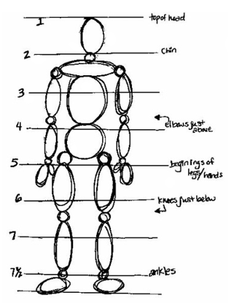

Additionally, there are other body region that are in proportion with each other. Look at the drawing to the right and notice different sizes of different body regions, for example, compare the relative size of the neck to the size of the wrist. What do you notice?

Other proportions may be harder to see on such a drawing, but they can be measured!!!

For instance, there is a relationship between the length of the foot and the length of the forearm. There is also a proportional relationship between the circumference of the waist and the circumference of the neck.
Exercise #2: Finger Digit Ratio

Body proportions can differ on individuals, although it still fits into a pattern. The ratio of the length of the index finger (digit #2, or 2D) and the ring finger (digit #4 or 4D) is an example of this.
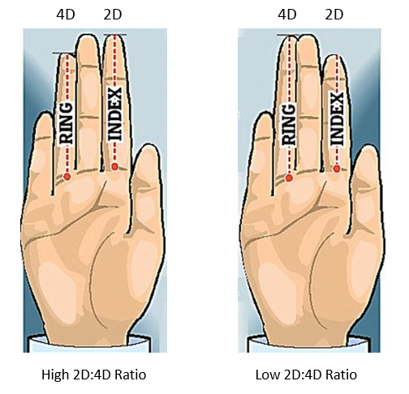

See the examples above: On the left side is a high 2D to 4D finger ratio, meaning the index finger is longer than the ring finger. On the right is a low 2D to 4D finger ratio, meaning the ring finger is longer than the index finger.

The finger digit ratios are computed by dividing the average (mean) length of the index finger by the average length of the ring finger for both hands.

Procedure:
- Straighten out your fingers and look at the palm of your hand.

- Examine the base of your index and ring fingers, notice the flexion creases. Often the index finger has one crease, and the ring finger has a band of creases (see images above).

- The crease to measure is the one closest to the palm. Select a point on the crease that is midway across the base of the finger. This will serve as the starting point for length-wise measurement.

- Using the calipers (or tape measure) measure the distance from the base to the tip of the finger in centimeters (cm) and record this in Table 3 on the next page and on the lab computer spreadsheet.
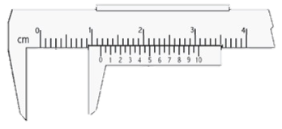
After measuring your finger lengths from the base of the palm to the tip of each finger with the calipers in lab, make sure to get the average for the fingers of both hands.

Then, to calculate your digit ratio, simply divide the length of your index finger (“2D”) by that of your ring finger (“4D”) as follows, such that Index Finger Length/Ring Finger Length = Digit Ratio. The same can be expressed by different terminology: 2D/4D = Digit Ratio.

Table 3. Record the average of your finger lengths measurements in cm below. Then calculate the finger digit ratio based on those averages. Compare the ratio with the standard curves for males and female shown below and tick yes or no if the value is within 1 standard deviation (SD) of the curve.
Name | Index Finger (2D) in cm | Ring Finger  (4D) in cm | Ratio  (2D/4D) | Within 1  SD
 |  |  |  | Yes No
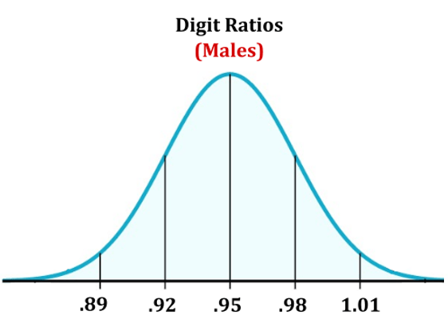
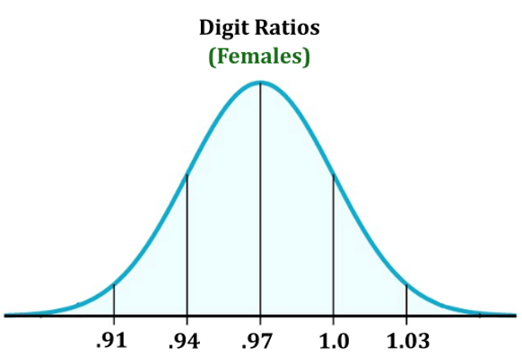
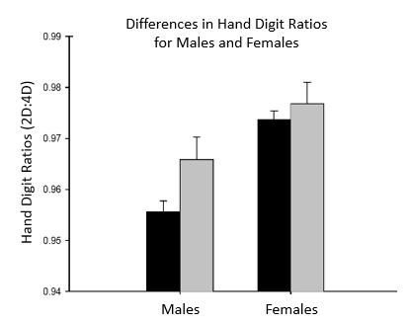
To the right and below is a graph from a study of hand digit ratios measured for males and females.

Conclusions:
What are any conclusions you can make from the data gathered in the lab and the graph shown here?

PRE-LAB QUESTIONS: ENZYME LAB
Name: ___________________________________________________ Date_______________.
Please fill in, or circle best answer to questions and submit this paper at the start of the Enzymology Lab session. All page references are for the Physiology Lab Manual.

1. Enzymes are (p23) ___________________ that act as biological _____________________________.

2. Enzymes increase the __________ of a chemical reaction without ___________________________.

3. The _____________________ on the enzyme is an area into which the substrate molecule fits.

4. Briefly define competitive inhibition in terms of enzyme action:

5. Briefly define non-competitive inhibition in terms of enzyme action:

6. Read Part 1: Urease Activity and Diffusion Dish (p24) and answer these questions:
Side A will always have __________________________________ in it.
Side B will always have the ___________________________ and __________________________ in it.

7. Bromothymol blue is an ‘indicator’ solution that changes color when the pH of the solution changes.

Bromothymol blue is ________ at a basic pH, ________ at neutral pH, and ________ at an acid pH.

If the bromothymol blue in your supply basket is at a neutral pH, its color would be ________________.

8. In the reaction that is catalyzed by urease (p24), the products generated are:

____________________ and ____________________.

9. What changes in the indicator solution (bromothymol blue) will you look for to indicate the end point of all the urease reactions? ____________________________________________________________.

10. In Exercise 1, Expt. B, only one drop of _______________________________ was added to Side B.
If the one drop of this substance inhibited the reaction, but not by directly acting on the active site, then the type of inhibition would be called ________________________ _______________________.

Read the exact experiments listed below and list the specific (detailed) contents in your answer:
11. In Exercise 2, Experiment B, what goes in Side B? ________________________________________.

12. In Exercise 3, Experiment A, what goes in Side B? ________________________________________.

13. In Exercise 4, Experiment C, what goes in Side B? ________________________________________.
14. The enzyme amylase (p29) digests the specific starch called _____________, which is a large molecule called a _________________. The monosaccharide released during digestion is ___________.

15. For Amylase Activity (p30): Adding one drop of __________________________________ to the reactants in the cell well chamber is used to determine if a reaction has occurred. A dark blue-black color indicates the presence of _________________. Whereas a clear yellow/brown color indicates that no __________________ is present, because it has all __________________________________.

16. For the image below, in what way could we increase the rate of the reaction taking place in C.
a) add more substrate b) add more enzyme c) remove enzymes d) remove substrate e) all of these
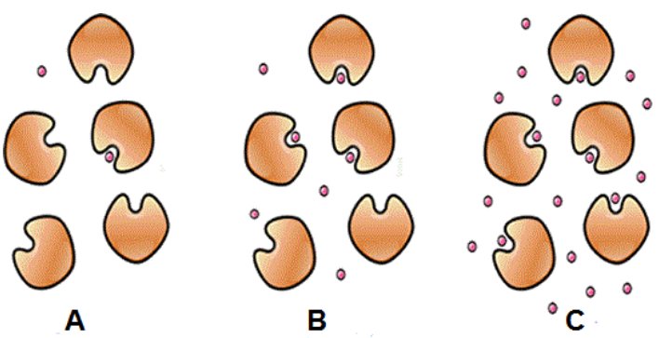

17. Some people cannot digest the sugar lactose in milk due to the lack of which enzyme?
a) alcohol dehydrogenase b) maltase c) peroxisomes d) lactase e) lactose

18. Referencing the two graphs below, which statement best describes the one enzyme represented?
a) This enzyme works best at a temperature of 35°C and a pH of 8.
b) This enzyme works best at a temperature of 50°C and a pH of 12.
c) Temperature and pH have no effect on the action of this enzyme.
d) This enzyme works best at a temperature above 50°C and a pH range from 7 to 9.
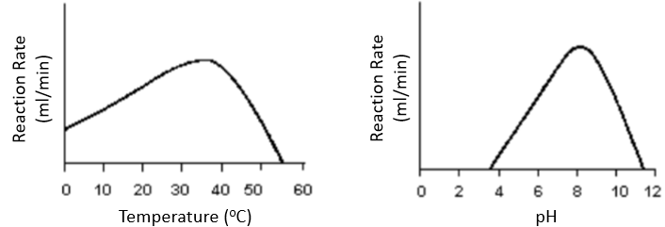
e) The pH is the only factor that alters this enzyme’s activity.
19. The best description of a coenzyme is:
a) an ion or metal b) always a protein c) often a vitamin d) an inorganic compound e) all of these

20. An enzyme minus its cofactor would be known as:
a) a coenzyme b) a metalloenzyme c) an isoenzyme d) a holoenzyme e) an apoenzyme
Laboratory Exercise #2: Experimental Enzymology
*PRE-LAB due at start of this Lab
Objectives: After completing this lab exercise, you should be able to:
1. Define the role of enzymes and how enzyme activity can be influenced.
2. Carry out enzymatically catalyzed experiments and calculate the reaction rate time.
3. Graph the data generated in these experiments and make valid comments on these results.

Enzymes are proteins that act as biological catalysts. They increase the speed of a chemical reaction without themselves being consumed or changed. The basic enzymatic reaction is represented below.
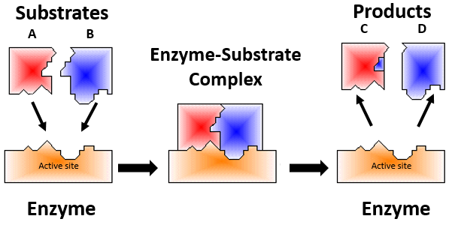

Figure 1. The substrates (A and B) combine with the enzyme at the active site to form the enzyme-substrate complex. This allows for a reaction to take place and upon alteration of the substrates, these are quickly disassociated or released by the enzyme, and the newly formed products C and D are present.

All organisms are capable of carrying out an amazing range of complex chemical reactions. Organic compounds can be built up, broken down, or otherwise altered. Only by the use of enzymes can these reactions occur at the rate, degree of efficiency, temperature, and pH found in living cells.

All presently known enzymes are proteins, consisting of one or more chains of polypeptides. Each enzyme molecule has a particular three-dimensional (3-D) shape. When enzymes denature their shape is changed and they are usually no longer active and cannot function properly. Sometimes enzymes are irreversibly disrupted by excessive heat, pH changes, or the presence of certain salts or metal ions. When an enzyme is denatured, it cannot adequately catalyze reactions.

An enzyme's activity is determined by its 3-D structure and the distribution of electrical charge on the molecule. The active site of an enzyme is often a small region within the larger binding site. In some cases, the active site is not part of the binding site but is adjacent to it or is in a position that allows it to interact with the substrates once they're bound to the binding site.

Within the active site there must be a correspondence of electrical charge between the enzyme and the substrate. Thus, the substrate molecule must be of a correct shape and have a correct distribution of electrical charge if it is to be acted upon by a given enzyme. This means that each enzyme is specific for a particular substrate molecule or class of substrate molecules.
Enzyme Inhibition
In some cases, there are molecules that are similar in size and shape to the true substrate molecule and they may fit into the enzyme's active site, even though they are not acted upon. This is competitive inhibition, which is when molecules similar to the true substrate prevent them from occupying the site, and being acted on, thus slowing (inhibiting) the rate of enzyme action on the true substate.

Another type of enzyme inhibition is called non-competitive inhibition, this occurs when a substance combines with the enzyme away from the enzyme's active site but change the shape of the active site of the enzyme, hence its affinity for the true substrate declines (is inhibited). This type of inhibition is not directly related to the active (binding) site. These include allosteric and covalent modulators.

Enzyme Exercises
Each lab group will do all of the exercises in Part 1 involving urease, (exercises 1 through 4, experiments A, B and C for each). After all groups have completed the Urease experiments, the lab groups will then proceed to Part 2 with the experiments involving amylase (exercises 5 and 6).

Part I: Urease Activity and use of the Diffusion Dish
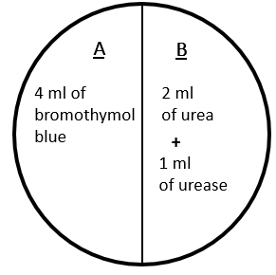

Side A: Will always have bromothymol blue in it.

Side B: Will always have the substrates and enzymes in it.

Figure 2. The diffusion dish will always be set up with 4ml of the indicator solution (bromothymol blue) on side A of the dish. The enzyme urease and various substrates will be placed on side B of the dish. Remember, once you have added substrates and enzyme together, the reaction will have started.

Hydrolysis of Urea
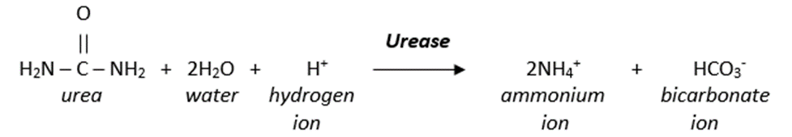
The enzyme urease hydrolyses the substrate urea to generate the products of ammonium ions (NH₄⁺) and bicarbonate ions (HCO₃⁻). As shown in the equation below, when the substrates urea, water and protons are catalyzed by the enzyme urease, the products ammonium ions and bicarbonate ions are generated. It is the production of NH₄⁺ that triggers the color change of bromothymol blue!
We will be using the indicator solution bromothymol blue to detect the presence of the ammonia (NH₄⁺) which will result from the successful hydrolysis of urea.

When urease catalyzes the reaction on previous page, it is the ammonia gas (NH₄⁺) produced (which is basic) that travels over from side B to side A where the indicator solution bromothymol blue is. When the lid is properly on the diffusions dish this gas will turn the bromothymol solution from green to blue in color. Thus, when the indicator solution turns blue by the liberated ammonia gas, we know that the substrate urea has been acted on by the enzyme urease. When measuring the time for the reaction to occur, make sure the bromothymol blue solution has turned completely blue throughout the solution.

*LAB SAFETY*

For the experiments using thiourea (a low-level carcinogen), the contents of the diffusion dish must not be poured down the sink! Place any dish with thiourea in the biohazard container on the counter.

Test Experiment – Instructor Demonstration

Using a diffusion dish set on a white piece of paper (it needs to sit on a white surface in order to see the color change), the lab instructor will demo how to use the labeled dish (side A and B as seen in Fig. 2 and in the image below).

The bromothymol blue solution is blue at a basic pH, green at neutral pH, and yellow at an acid pH.

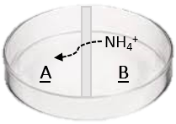
When the enzyme urease in introduced to the solution containing the substrate urea, the products of ammonium and bicarbonate ions are produced (shown on p 24 and at right).

In the reaction shown at right, as ammonium NH₄⁺ is produced by the reaction and released as ammonia gas, it is vaporized out of solution and diffuses across the central divider and dissolves into the bromothymol blue indicator solution. The ammonia produces a basic solution causing the bromothymol blue indicator to go from green to blue.

As you conduct these experiments with the diffusion dishes, wait for a consistently dark blue color of the solution, without any trace of green. In other words, use the same color blue for all, this will be used as the end point of the reaction and recorded as the time taken for the reaction to be completed.

Clean up and Reuse of Diffusion Dishes
After each set of experiments, empty the diffusion dish in the lab sinks (except for any experiments using thiourea which go into the biohazard bucket) and rinse three times with deionized or distilled water and dry before reusing.

Part 1: UREASE EXERCISES

Exercise #1. Specificity and Noncompetitive Inhibition
Solutions needed: Urease, 0.75 M Urea, 1.0 M thiourea, bromothymol blue, and iodine-potassium iodide. There are three experiments to be completed in this exercise.

In the experiments involving urease the time taken for a positive reaction is recorded in seconds, and normally should not exceed 15 minutes. Therefore, if there is no positive reaction after 15 minutes, we can determine there was no reaction and it should be recorded as X in the results in Table 1 (page 30).

Diffusion Dish Lab Procedure

Experiment A. Pipet 4 ml of bromothymol blue into side A of the dish. Pipet 2 ml of 0.75 M urea solution into side B of the dish, then, to start the reaction, pipet 1 ml of urease solution into the B side of the dish. Immediately place the lid on the dish. Gently agitate the dish with a rotary motion to distribute the urease. Be careful that none of the bromothymol blue spills into the B side. Continue calmly agitating the dish.

Record the time in seconds below (and in Table 1 on page 30) required for the bromothymol blue to change color.
Time in sec = ____________.

Experiment B. Pipet 4 ml of bromothymol blue into side A of the dish. Pipet 2 ml of 0.75 M urea solution into side B of the dish. Add one drop of iodine-potassium iodide to side B, then pipet 1 ml of urease solution into side B. Replace the lid on the dish, note the time, and begin gently agitating the dish with a rotary motion.

Did the bromothymol blue change color? If there is no sign of any color change after 10 minutes, it is likely there will be no change in the experiment. Contemplate why there may be no reaction in this experiment.

Record the time in seconds below (and in Table 1) required for the bromothymol blue to change color. Time in sec = ____________.
LAB SAFETY!

Experiment C. Pipet 4 ml of bromothymol blue into side A of the dish. Pipet 2 ml of 1.0 M thiourea solution into side B of the dish, then pipet 1 ml of urease solution into side B. Replace the lid on the dish, note the time, and begin calmly agitating the dish with a rotary motion.

Did the bromothymol blue change color?
Again, if there is no sign of any color change after 10 minutes, it is likely there will be no change in the experiment. Contemplate why there may be no reaction in this experiment.

Record the time in seconds below (and in Table 1) required for the bromothymol blue to change color. Time in sec = ____________.
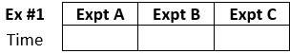

Exercise #2. Competitive Inhibition
LAB SAFETY!
LAB SAFETY!
Solutions needed: Urease, 75:25 thiourea:urea, 50:50 thiourea:urea, 0:100 thiourea:urea, and bromothymol blue. There are three experiments to be completed in this exercise.

Diffusion Dish Lab Procedure

Experiment A. Pipet 4 ml of bromothymol blue into side A of the diffusion dish. Pipet 2 ml of 75:25 thiourea:urea solution into side B of the dish, then pipet 1 ml of urease into side B. Replace the lid on the dish, note the time, and begin gently agitating the dish with a rotary motion. Record the time required for the bromothymol blue to change color. Time in sec = ____________.

Experiment B. Pipet 4 ml of bromothymol blue into side A of diffusion dish. Pipet 2 ml of 50:50 thiourea:urea solution into side B of the dish, then pipet 1 ml of urease solution into side B. Replace the lid on the dish, note the time, and begin gently agitating the dish with a rotary motion. Record the time required for the bromothymol blue to change color. Time in sec = ____________.

Experiment C. Pipet 4 ml of bromothymol blue into side A of the diffusion dish. Pipet 2 ml of 0:100 thiourea:urea solution into side B of the dish, then pipet 1 ml of urease solution into side B. Replace the lid on the dish, note the time, and begin gently agitating the dish with a rotary motion. Record the time required for the bromothymol 2 blue to change color. Time in sec = ____________.
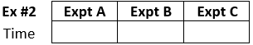

Exercise #3. Effect of Substrate Concentration
Solutions needed: Urease, 0.75 M urea, 0.075 M urea, 0.015 M urea and bromothymol blue.
There are three experiments to be completed in this exercise.
Diffusion Dish Lab Procedure

Experiment A. Pipet 4 ml of bromothymol blue into side A of the dish. Pipet 2 ml of 0.75 M urea solution into side B, then pipet 1 ml of urease into side B. Replace the lid on the dish, note the time, and begin gently agitating the dish with a rotary motion. Record the time required for the bromothymol blue to change color. Time in sec = ____________.

Experiment B. Pipet 4 ml of bromothymol blue into side A of the dish. Pipet 2 ml of 0.075 M urea solution into side B, then pipet 1 ml of urease into side B. Replace the lid on the dish, note the time, and begin gently agitating the dish with a rotary motion. Record the time required for the bromothymol blue to change color. Time in sec = ____________.

Experiment C. Pipet 4 ml of bromothymol blue into side A of the dish. Pipet 2 ml of 0.015 M urea solution into side B, then pipet 1 ml of urease into side B. Replace the lid on the dish, note the time, and begin gently agitating the dish with a rotary motion. Record the time required for the bromothymol blue to change color. Time in sec = ___________.
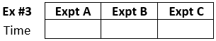

Exercise #4. Effect of Enzyme Concentration
Solutions needed: Full-strength urease (0.75 M), half-strength urease, quarter-strength urease, urea (0.75 M), and bromothymol blue. Three experiments to be completed in this exercise.
Diffusion Dish Lab Procedure
Experiment A. Pipet 4 ml of bromothymol blue into side A of the dish. Pipet 2 ml of 0.75 M urea solution into side B of the dish, then pipet 1ml of full-strength urease solution into side B. Replace the lid on the dish, note the time, and begin agitating the dish with a rotary motion. Record the time required for the bromothymol blue to change color. Time in sec = ____________.

Experiment B. Pipet 4 ml of bromothymol blue into side A of the dish. Pipet 2 ml of 0.75 M urea solution into side B of the dish, then pipet 1 ml of half-strength urease solution into side B. Replace the lid on the dish, note the time, and begin agitating the dish with a rotary motion. Record the time required for the bromothymol blue to change color. Time in sec = ____________.

Experiment C. Pipet 4 ml of bromothymol blue into side A of the dish. Pipet 2 ml of 0.75 M urea solution into side B of the dish, then pipet 1 ml of quarter-strength urease solution into side B. Replace the lid on the dish, note the time, and begin agitating the dish with a rotary motion. Record the time required for the bromothymol blue to change color. Time in sec = ____________.
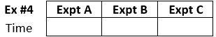

Individual and Summary Data for Urease Expts
Table 1. Record Your Lab Table’s times (sec) for a positive result for the urea catalyzation with urease.
Urease Exercise | Expt. A | Expt. B | Expt. C
Exercise #1
Specificity

Exercise #2
Competitive Inhibition

Exercise #3
Substrate Concentration

Exercise #4
Enzyme Concentration

Table 2. Record Class Averages for times (sec) for a positive result for the urea catalyzation with urease. When all groups are done, class average data is to be used to make the graphs for these experiments.
Urease Exercise | Expt. A | Expt. B | Expt. C
Exercise #1
Specificity

Exercise #2
Competitive Inhibition

Exercise #3
Substrate Concentration

Exercise #4
Enzyme Concentration

Part 2: AMYLASE EXERCISES

Amylase Activity: The enzyme amylase digests the substrate amylose, which is a type of starch (a polysaccharide), made up of many molecules of glucose (a monosaccharide). Therefore, when amylose is digested (broken down), the molecules that are liberated in this chemical reaction are ____________.

⑤ Exercise 5. Effect of pH on Amylase
In this exercise we will examine the effects of using buffers with a range of different pH.

Solutions Needed:
Amylose, amylase, iodine-potassium iodide, and various pH buffer solutions (as shown below): pH 4 buffer, pH 5.9 buffer, pH 6.5 buffer, pH 7 buffer, pH 7.9 buffer, pH 8.3 buffer, and pH 9 buffer. There are seven (7) experiments to complete in this exercise, one for each different buffer solution below. Typically, however, we do not test the lowest (pH 4) or the highest (pH 9) as they rarely react.
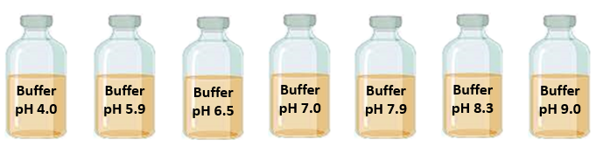

Amylase and pH Buffer Lab Procedure
1. Obtain reaction vials with dropper top (see below right), there are lots of them at your lab bench.
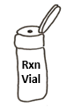
2. In each of the 5 reaction vials that are pre-labeled (A through G), you will add the 3 following components:
1) 2 ml of amylose solution.
2) 2 ml of a buffer solution from one of the seven (7) different buffers (see range above).

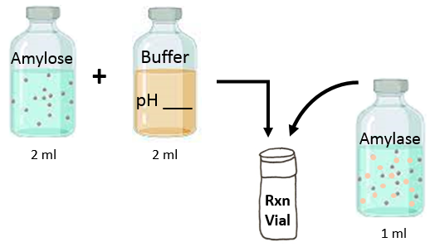

3) Now add 1 ml of amylase to the reaction vial that already has the amylose and a buffer solution in it to start the reaction. Once the enzyme amylase is added the reaction will start, so start the timer!

3. Once the timer has been started, cap the vial and shake it to mix the contents for 1 minute only.
4. As shown in the diagram below, at minute 1 (that is, 1 minute after adding the amylase), deliver three (3) drops from the reaction vial (one on top of the other) into a single cell of the well chamber (see below). That is the sample of how the reaction is going after 1 minute.
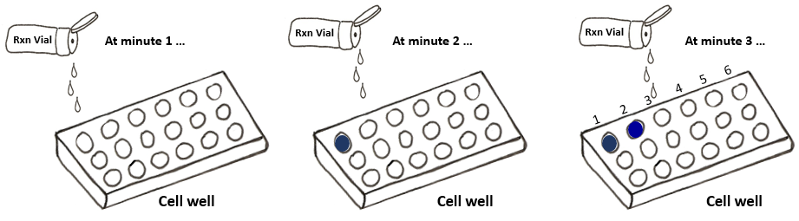

5. Now quickly add one (1) drop of iodine-potassium iodide to the sample in that same cell well chamber. The addition of this is to determine whether starch is present or not. Place the cell well over a white surface (the blank piece of paper provided) and observe the color of the sample.

6. If that cell well is now dark blue-black, it indicates the presence of starch; If a cell well isa yellow/brown color, it indicates that no starch is present because it has all been digested. In the first cell well the sample will be dark blue/black, as starch will still be present. So keep repeating the process.

7. Continue to test 3 drop samples from the same reaction vial every minute (at one-minute intervals) in a new cell well each minute (as shown in diagram above). In the control reaction vial (pH 7.0) the samples delivered to the next few cell wells will begin to change to a clear light brown, then to clear yellow. When the addition of the iodine results in cell wells that have a clear yellow color, that is confirmation that the reaction is complete and therefore a positive result. If you think you have a positive result, test one more sample in the next well (as always) to ensure the color is consistent.

8. Now count the # of wells that were used in order to obtain a positive result color (yellow) for the complete digestion of amylose in that specific reaction vial, and that is the number of minutes the reaction took to be complete. Record that number in Table 3 below.

9. Now repeat the above procedures for each of the vials with different pH buffers solutions in them.

10. Some experiments will never show any color change from the initial dark blue-black, because the pH of the buffer is too high or too low for the enzyme to work. If there is no change in the color at all after 10 minutes, you can stop testing that vial sample! Initially, only start the reaction in 1 vial at a time! Once you get the hang of it, you can have several reactions going at once. N

Table 3. Enter the times measured for your group for the pH of buffer for amylase.
pH of Buffer | pH 4 | pH 5.9 | pH 6.5 | pH 7 | pH 7.9 | pH 8.3 | pH 9
Exercise 5. | Expt. | Expt. A | Expt. B | Expt. C | Expt. D | Expt. E | Expt.
Time (min)

⑥ Exercise 6. Effect of Heating Amylase
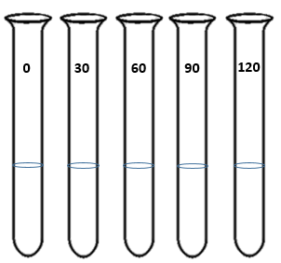
Solutions needed: Amylose, amylase and iodine-potassium iodide. There are five (5) test experiments to be completed in this exercise.

Here on the right are shown the 5 test tubes that will all have 2ml of the enzyme amylase in them. The purpose of this experiment is to have each test tube experience a different amount of time being heated. The test tube marked “0” will have no time in the hot water beaker, while the other 4 will have 30, 60, 90 and 120 seconds in the hot water beaker (as labeled).

All test tubes will be cooled before using the amylase they contain.

Amylase and Heat Lab Procedure

1. Set hot plate @ 300 for 2 minutes so it is heating while you place 2 ml of amylase
in each of the five (5) test tubes.

2. One test tube with amylase is not heated – this is the control.
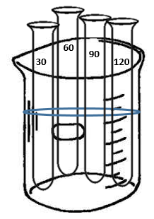
3. Place the remaining four (4) test tubes in the hot water beaker.

4. Remove one test tube every 30 seconds so that you have four test tubes that contain amylase heated for 30, 60, 90 and 120 seconds respectively. Put the test tubes in the ice bucket on the lab table and allow them to cool.

5. Now add the various heat-treated amylases to the five (5) prepared reaction vials.
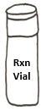
6. In each of the 5 vials, add the following 3 components:
1) 2 ml of amylose solution
2) 2 ml of pH 7 buffer
… be sure you are ready to start as you add the 3rd ingredient 3) amylase.
Hot Water Beaker

7. Now, to start the reaction, start step 3) add 1 ml of one of the heat-treated amylase to the reaction vial. Until you get the hang of it, only start the reaction in 1 vial at a time! This will be repeated in 5 separate reaction vials, one for the control (no time being heated), and for each of the 4 heat-treated amylase test tubes.

8. Once all three components are added to the vial (the amylose, the pH 7 buffer and the amylase), note the time, cap the reaction vial and shake it to mix the contents thoroughly for 1 minute only.
9. At one (1) minute after adding the amylase, withdraw a sample by placing three (3) drops, one on top of the other, into a single cell of the well chamber.
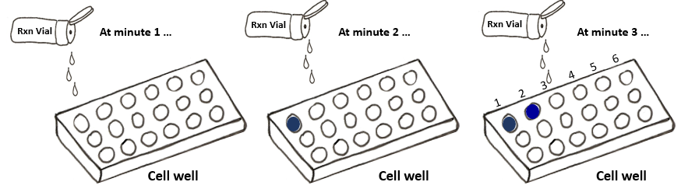

10. Add one drop of iodine-potassium iodide to the sample in the one cell well chamber. The addition of this is to determine whether starch is present or not. Place the cell well over a white surface (the blank piece of paper provided) and observe the color of the sample.

11. If the color of the well is dark blue-black, this indicates the presence of starch; and if the color of the well is a clear yellow/brown, this indicates no starch present because it has all been digested. Colors that are in between these that appear dark purple to dark brown indicate that starch is still present but being digested! Initially, the first samples should be dark blue/black.

12. Continue testing the samples from each reaction vial at one-minute intervals in a new cell well each minute. The goal is to continue testing the sample in the vial in successive cell wells until a yellow/brown color results, which indicates that all of the starch has been digested. This way, the time (in minutes) for a positive yellow/brown color will be recorded by the number of cell wells used to get a positive result.

13. Note that it may take more than 5 minutes for some sample colors to become positive yellow/brown, and also that some samples may remain dark blue-black and never change color. If there is no change in the color at all after 10 minutes, you can stop testing that vial sample!

14. Now repeat the above procedures for each of the reaction vials with the amylase that was heated for different amounts of time in the hot water bath.

15. In Table 4 below, record the time it took for each of reaction vial to have a positive result.

Table 4. Enter the times measured for each experiment your group conducted for the heat exposure to the amylase enzyme.
Heat Exposure | 0 sec | 30 sec | 60 sec | 90 sec | 120 sec
Exercise 6. | Expt. A | Expt. B | Expt. C | Expt. D | Expt. E
Time (min)

Summary of Amylase Experiments – Collection of Data Class Averages

pH of Buffer | pH 4 | pH 5.9 | pH 6.5 | pH 7 | pH 7.9 | pH 8.3 | pH 9
Exercise 5. | Expt. | Expt. A | Expt. B | Expt. C | Expt. D | Expt. E | Expt.
Time (min)

Table 5. Enter the class data (averages from all lab groups) for the times (min) to reach a positive result for starch catalyzation with amylase for the changes in pH of buffer for the amylase enzyme.

Heat Exposure | 0 sec | 30 sec | 60 sec | 90 sec | 120 sec
Exercise 6. | Expt. A | Expt. B | Expt. C | Expt. D | Expt. E
Time (min)

Table 6. Enter the class data (averages from all lab groups) for the times (min) to reach a positive result for starch catalyzation with amylase for heat-treated amylase enzyme.

Helpful tips for making great graphs from your enzyme data

- The graph title should be descriptive: Use the formula “The Effect of X axis on Y axis”.

- All key words need to be capitalized.

- Do not use any abbreviations in the title or axis labels.

- Units need to be stated in parenthesis (brackets) after the term, e.g., Reaction Time (sec).

- Label all axes appropriately, do not use “A” or “B” as a label, those would be meaningless!

- Only use standard abbreviations where applicable, with appropriate units.

- Directional conventions: On the x-axis, values increase from the left to the right, and on the y-axis, values increase from the bottom to the top.

- Visual Aesthetics – make the scale appropriate to adequately and effectively present the data.

- Know when to use a Column graph and when to use a Line graph.

- Create consistent and even intervals and spacing on the graphs axis.

Lab Notes for Enzymology Experiments

Graphs Grids for the Rate of Enzymatically Catalyzed Reactions
Name: ___________________________________________________ Date _____________
Graph results from the enzyme lab using the Class Averages. Label and scale both the x and y axis, with specific titles and numbers (including units). Your instructor will indicate which experiments to graph.

Title: ____________________________________________________________

Title: ____________________________________________________________

Title: ____________________________________________________________

Title: ____________________________________________________________

Laboratory Exercise # 3: Graphing Assignment from Lab Data
Constructing Graphs 101
A graph is a tool for expressing large quantities of data in a clear and easily understood fashion. After data is collected, it must be analyzed and making graphs is a way of doing this. A properly constructed graph helps people see trends in the data, and it helps others understand what has been found.

There are four (4) basic Graph Formats:
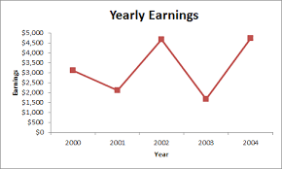
1) Bar or Column graph (categorical): This is used when the data is comparative. One or more independent variables can be compared on the same graph when making the same measurement. Multiple dependent variables can also be compared on the same graph when there is only one independent variable. Column graphs are similar to histograms, however histograms have a numeric x-axis, whereas column graphs use separate categorical groups.
2) Line graph (continuum): If your independent variable is increasing with regular intervals, then you will want to use a line or scatter graph with a connected dots line to show the trend. These graphs are generally used to show a trend over an increasing independent variable with a continuum, like time, temperature, age, etc. Parallel lines can be used to show multiple sets of data on the same graph.
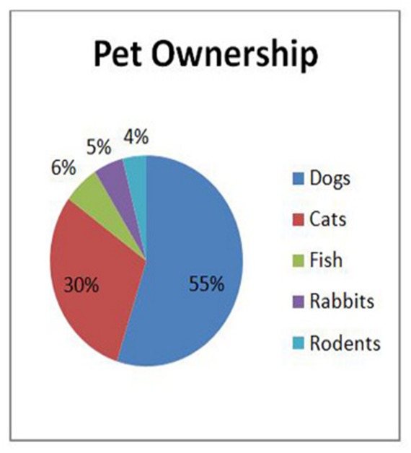
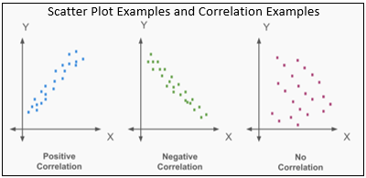
3) Pie chart (per 100 or % of the total): Some data is intended to show the fractional or percentage data from a whole population. If presenting data from surveys for example, a pie chart would be suitable for this type of data.

4) Scatter plot (two variables/correlation): A scatter plot could also be used to show a correlation between two sets of data. You can use a scatter plot to show multiple dependent variables on the same graph. Analysis of data in this arrangement may indicate a correlation between the factors compared (negative, positive or none).
Constructing a Graph

The Independent Variable vs. the Dependent Variables.

A researcher sometimes deliberately changes something about one factor to see if the change will affect another factor. The factor being intentionally varied is the independent variable. The factor being watched for a response is the dependent variable. This correlates with the x-axis and the y- axis.

"The effect of ___________________________ variable on __________________________ variable"
(goes on the horizontal or x axis) (goes on the vertical or y axis)

For example, look at the first graph on page 1 (above), it could be stated like this:

"The effect of _______________________________ on ____________________________________"

What a good Graph Should Include:

- Appropriate Titles for the Graph, and the X and Y Axes: Graphs need a title and labels for the axes (with units). When creating a graph, the independent variable is plotted on the x-axis (horizontal) and by convention, values increase from left to right. The measured variable is the dependent variable and will be plotted on the y-axis (vertical).

- Series Legend: There may be multiple factors measured in an experiment. If this is the case, then more than one column or line of data can be added to the graph. If there are several columns or lines on one graph, then they will need to be identified with a series legend, which acts as a type of ‘key’ for the graph’s data groups.

- Figure Legend: In a report or paper, a graph is a figure, and all figures need a figure legend. A figure legend is the text that accompanies each figure and is placed immediately below it. Its purpose is to explain the figure clearly and thoroughly, providing readers with enough information necessary to understand the figure without having to read the methods or other text of the report or paper.

- Sample size (N or n): This is the number of subjects participating in an experiment, or the number of samples measured, or observations being made in an experiment. Sample size is a portion of the whole, a ‘sample’ of it, thus it is a representation of the larger entire population. Therefore, the larger the sample size, the more accurate the reflection of the larger population. Experiments require a minimum sample size of n = 5 in order to apply statistics to the data, therefore , when we construct graphs we want to have at least n=5 for all groups. The sample sizes for any data presented should be either on the graph or in the figure legend.

Analyze your Graph after you have constructed it:
- Analysis involves examining the graph you have constructed and describing the trends you can identify (if any). Try to offer an explanation of any pattern or relationship that can be seen in the graph.
Name: ___________________________________________________ Date_______________.
Your Lab Group will make two Graphs from the Data collected in previous semester’s Labs

Graph # 1. Body Position and Heart Activity
Using the Excel program, graph data collected in previous labs regarding the effect of body position on heart rate and/or mean arterial pressure (MAP). Subjects were in three body positions: 1) sitting; 2) fully reclines (supine); and 3) standing upright. Submit the graph as a separate paper attached to this one. Answer the following questions about your final graph #1 here below:

1) On average, does body position effect the heart rate of the subjects?
If so, describe the effects of those changes the body position on the heart’s activity.

2) If a person goes from standing to laying down, their hear rate will usually _____________. This occurs because the level of work the heart has to do is _____________. In terms of MAP, when a person stands up from laying down, MAP will _____________, this is because MAP was _____________ when they were laying down compared to standing. The receptors that detect changes in blood pressure are called _____________ and they are located in these two places, the _____________ and the_____________.

Graph # 2. Blood Glucose Tolerance Test
Using the Excel program, graph data collected in lab regarding blood glucose levels after drinking 250 ml of grape juice. Submit the graph as a separate paper attached to this one.
Answer the questions below about your final graph #2:

1) Did the consumption of the beverage have an effect on blood glucose? Describe any effects.

2) Is there a difference between males and females in this data? Note any trend.

3) If blood glucose increases after consuming simple carbohydrates, a hormone ______________, released from the ______________ of the pancreas acts to help cells in the body take up glucose from the blood, therefore it ______________ blood glucose. The opposite effect occurs if the blood glucose decreases. It is then the hormone ______________, released from the ______________ of the pancreas, that triggers the liver to release glucose into the blood, thus ______________ blood glucose.

Laboratory Exercise #4: Sensory I - Sensory Receptors

Sense Organs - Sensory Receptors
A sensory receptor is a specialized ending of a sensory neuron that detects a specific stimulus. Receptors can range from simple nerve endings of a sensory neuron (e.g., pain, touch), to a complex combination of nervous, epithelial, connective and muscular tissue (e.g., the eyes).
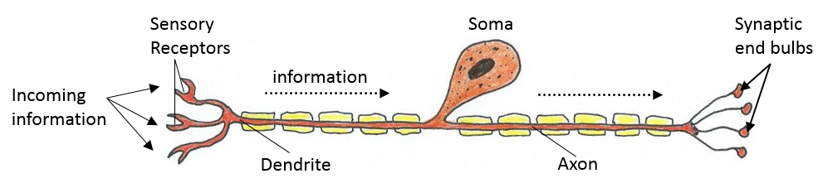
Figure 1. Above is a diagram of a sensory neuron with sensory information being detected by sensory receptors, which are the specialized endings of a sensory neuron located at the incoming end of this neuron. They transduce the energy detected from a stimulus and convert it to an electrical signal (an action potential). This travels along the axon and delvers this information to the central nervous system at the synaptic end bulbs.

The function of a sensory receptor is to act as a transducer. Transducers convert one form of energy into another. In the human body, sensory receptors convert stimulus energy into electrical impulses called action potentials. The frequency and duration of action potential firing gives meaning to the information coming in from a specific receptor.

The nervous system helps to maintain homeostasis in the body by monitoring the internal and external environments of the body using receptors to achieve this. Changes in conditions can be detected by receptors and relayed to the central nervous system (CNS) by way of sensory nerve fibers (axons). Incoming information is used to formulate a response which is then sent out via motor neurons that innervate muscles or glands of the body to orchestrate any necessary responses.

Sensations are things in our environment that we detect with our 5 senses. The 5 basic senses are:

Sight Hearing Touch Taste Smell
Sensations are relayed through sensory receptors. They are constantly detecting important information, even when we are not consciously aware of them. For instance, blood glucose is meticulously regulated and often we are not consciously aware of it.

Perception is conscious awareness of the stimulus, or how we interpret these sensations in our mind.

An adequate stimulus is a particular form of energy to which a receptor is most responsive. For example, thermoreceptors are more sensitive to temperature. Receptors can respond to most other forms of energy, if the intensity is high enough.

The threshold of a receptor is the minimum stimulus required to activate that receptor.
Information about Receptor Transmission
Sensory receptors transmit four kinds of information - modality, location, intensity and duration.

1. Modality - describes the type of sensation it produces, e.g., mechanoreceptors for touch, or photoreceptors for light. This sensation is then a perception in the brain.

2. Location - the ability of the brain to identify the site of the stimulation. The precision with which the location of a stimulus is perceived is called acuity.

3. Intensity - refers to the strength of the signal detected by receptors. A stimulus intensity increases by: 1) increasing the action potential rate; and 2) recruitment of more nerve fibers.

4. Duration – describes how action potential firing changes over time. Receptors may be; ① phasic (fast to adapt), meaning they stop firing once the stimulus is constant; or ② tonic (slow to adapt), meaning they constantly fire for the duration of a stimulus.

Adaptation occurs when the receptors continue to be stimulated over a long period of time and in response to this, the frequency of action potential firing declines. Some receptors fire briefly when a stimulus begins and then become 'silent' and fire again briefly when the stimulus ends, like the touch sensation. Other receptors fire more continually, but all sensory receptors exhibit adaptation.

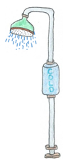
① Phasic receptors are fast to adapt, they generate a burst of action potentials when first stimulated; then they quickly adapt and stop transmitting impulses even if the stimulus continues.
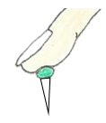
Thermoreceptors, touch receptors of the skin, and olfaction are examples of phasic receptors. Adapting to the cold or hot water of a shower is an example of sensory receptor adaptation. Or when we forget we are wearing a backpack. This is phasic adaptation.

② Tonic receptors are slow to adapt, so they generate nerve impulses continually. These receptors exist in tissues that need to constantly be aware of conditions, even if they are not changing. In this way, this type of receptor always sends a signal (information).
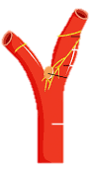

Proprioceptors (for balance), baroreceptors (for blood pressure), nociceptors (for pain) and muscle spindles (within muscle tissue) are common examples of tonic receptors.

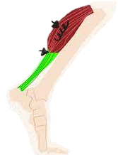

Various Ways to Classify Sensory Receptors

- By Modality: The type of stimulus energy that is detected.

- Thermoreceptors - stimulated by changes in temperature (heat and cold).

- Mechanoreceptors - stimulated by the physical deformation of the tissue caused by touch, pressure, stretch, tension or vibration. Also called stretch receptors.

- Nociceptors - pain receptors, stimulated by physical or chemical damage to tissue. Damage can result from trauma, ischemia (reduced blood flow), excessive heat or chemicals.

- Photoreceptors - stimulated by color of light or changes in light intensity (in retina of the eyes).

- Chemoreceptors - stimulated by chemicals, including food, odors, and molecules in body fluids.

- By Origin of their stimuli: Where the stimulus is coming from.

- Exteroceptors - detect changes that originate externally from the body.
  - Body surface receptors for touch, pressure, temperature and cutaneous pain.
  - Also receptors for vision (light), hearing (sound), taste/smell (chemicals).

- Interoceptors - detect stimuli that originate in the internal organs (viscera) of the body. Includes sensations such as visceral pain, nausea, stretch and pressure.

- Proprioceptors - detect changes in the position of the body relative to the head and other body parts. They are located within muscles, tendons, ligaments, joint capsules and the inner ear.

C) By General or Special categories: Either general or highly specialized detection.

- General Senses
  - Receptors widely distributed around the body (skin, muscles, organs), for detecting touch, pressure, heat, cold and pain using simple receptors. They also detect stimuli we are not consciously aware of, such as blood pressure and chemistry of body fluids.

- Special Senses
  - Receptors which are complex, limited to the head and innervated by cranial nerves. There are 5 special senses:
- Vision
- Hearing
- Equilibrium (Balance)
- Gustation (Taste)
- Olfaction (Smell)
Summary of the Combined Classification of Sensory Receptors

Table 1. Shows another way to summarize how sensory receptor are classified and naming them using the modalities (sensation or type of energy detected) for the general receptors they stimulate, and also the specific names for these receptors.

Classification | Sensory Modality  (Sensations Detected) | General Receptor Activated | Specific Name  of Receptor
Cutaneous Senses | Heat  Cold  Touch  Pressure  Pain  Tickle and Itch | Thermoreceptor Thermoreceptor Mechanoreceptor Mechanoreceptor Nociceptor (Chemoreceptor)  Mechanoreceptor | Ruffini's End Organ  Krause's End Bulbs  Meissner's Corpuscles  Pacinian Corpuscles  Free Nerve Endings  Free Nerve Endings
Proprioceptors | Muscle stretch  Muscle contraction  Limb position | Mechanoreceptor Mechanoreceptor Proprioceptor | Muscle Spindles  Tendon Organs  Joint Receptors
Special Senses | Low intensity of Light  High intensity of Light  Sound  Equilibrium  Smell (olfaction)  Taste (gustation) | Photoreceptor  Photoreceptor Mechanoreceptor  Chemoreceptor  Chemoreceptor  Chemoreceptor | Rods (Black and White)  Cones (Color)  Inner Ear (Hair Cells)  Inner Ear (Vestibular)  Nasal Mucosa  (Vomeronasal Organ)  Taste Buds  (Papillae of Tongue)
Visceral Senses | Blood Pressure  Blood Chemistry  Plasma Oncotic Pressure  Plasma Temperature  Pain | Mechanoreceptor Chemoreceptor Chemoreceptor  Thermoreceptor Nociceptor (Chemoreceptor) | Aortic Arch, Carotid Sinus  Aortic and Carotid Bodies  Osmoreceptors (Hypothalamus)  Hypothalamus  Free Nerve Endings

From the information about receptors in this manual (p 42 to 44), fill in the table below regarding the types of receptors we are going to examine in lab. List the sensation (modality), general receptor activated, and the specific name if applicable. Use the example provided in 2) below as a guide.

Stimulus Sensation Detected General Receptor Name of Specific
(Modality) activated Receptor

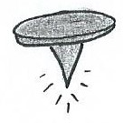

1)
Ouch

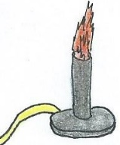
Ruffini’s end organ
Heat
Thermoreceptor
2)
Heat

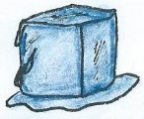

3)
Cold

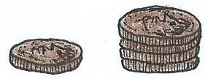
4)
Stacks of pennies

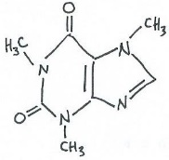

5)
A chemical

High intensity

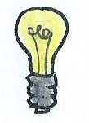
6)

Low intensity

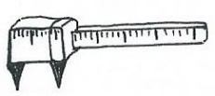
7)
2-Point sensitivity

Sensory Lab I - Activities
Objectives: When you have completed the following laboratory, you should be able to:
- Be familiar with various types of receptors and the stimulus to which each receptor responds.
- Explain the concept sensory modality; stimulus location; and adaptation of sensory receptors.
- Describe the sensations of taste and olfaction and examine the relationship between them.

Part 1. Receptive Field Two-Point Sensitivity Test: In this test, you and your partner will examine how sensitive the skin is on different areas of the body. You will do this by using touch calipers set at different widths, on the palm, the fingertip, the back of the neck, and the inside of the forearm. From the data, we can make determinations about the receptive fields of that body area.
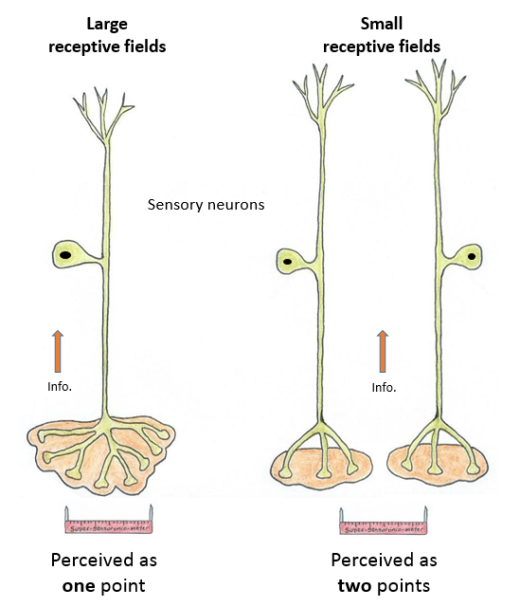

Touch Calipers

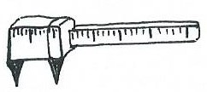

Procedure
- The subject sits and looks straight ahead, not watching what the partner is doing. If necessary, the subject will close his or her eyes to avoid seeing the width of the calipers points being used.
- One partner will pick up the calipers and touch an area, making sure to bring both points down evenly.
- The subject will immediately say if they feel one point or two points. Without telling the subject whether they detected the correct number of points, one partner will record the response in the table below and move on to another width.
- At least a few times, the calipers should be randomly closed so that only one point is touching the skin. This is so the subject won’t try to second guess the examiner, and acts as a control.
- Continue this process until it has been determined what the smallest distance between the caliper points is that is detectable as two points in each of the four areas. That distance is called the Two Point Threshold for that area.
Table 2. For each area of the body, fill in the smallest distance (mm) at which two points can be identified as separate. Compare your results to the class average.
 | Palm | Fingertip | Back of Neck | Inside Forearm
Individual Data:
Class Average:

1. From the class average data:
a) Which of the areas tested is the least sensitive? _______________________.

b) Which of the areas tested is the most sensitive? _______________________.

c) The fingertips would have _________________ receptive fields and the nape of the neck would have ________________ receptive fields.

d) What would be a benefit of that specific area being so much more sensitive than the others?

Part 2. Sensory Modality: Read p42-44 of this lab manual to help you answer these questions.
1. Define adequate stimulus (p41):

2. Define the threshold of a receptor:

3. See Table 1 on page 44 to answer these questions:

a) What do nociceptors detect? ______________.

b) What specific type of receptor detects pain in the skin __________________________________.

c) Which specific receptors detect heat in the skin? ______________________________________.

d) Which specific receptors detect cold in the skin? ______________________________________.

e) Which specific visceral receptor detects blood chemistry? _______________________________.

f) Which specific special receptor detects taste (gustation)? ________________________________.

4. List 2 special senses that use the timing of the arrival of external stimuli to determine the location/origin of the signal.
1) _____________________, and 2) ______________________.

5. If you were to press on your closed eyes with your fingers just enough to elicit a visual response (e.g., see ‘stars’), use the terms modality, adequate stimulus and threshold to help explain your perceptions.

Part 3. Cutaneous Receptors
There are several different types of receptors in the skin. Specialized sensory organs and free nerve endings in the skin can be categorized into four independent modalities of cutaneous sensation - Heat, Cold, Touch and Pain. The acuteness of sensation depends on the density of the cutaneous receptors. Thus, the more receptors, the greater the acuity (or sensitivity) of the sensation.

A. Adaptation of Cutaneous Temperature Receptors
Many of our sensory receptors respond strongly to acute changes in our environment and then cease responding when these stimuli become constant - this phenomenon is known as sensory adaptation. For example, our sense of smell quickly adapts to the odors in the lab and our touch receptors soon cease to inform us of our clothing etc., until these stimuli change in intensity. Find info on rapidly adapting receptors (phasic) and slowly adapting receptors (tonic).
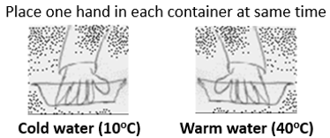

Procedure
- There are three containers of water in the lab: container A with warm water (about 40º C), container B with cold water (about 10º C) and container C with lukewarm water (about 22º C).
- The subject places one hand in the warm water, and the other hand in the cold water at the same time and leaves them in the water for approximately 10 seconds (longer if you can!).
- Then the subject places both of their hands in the lukewarm water container C in the middle.

8. Describe the sensations felt in each hand when they were both placed in container C. Be specific and describe the sensations relative to which containers the hand was in originally.

Container A hand:

Container B hand:

6. What general classification of receptor detects changes in temperature? ______________________.

7. Define rapidly adapting (phasic) receptors (give an example).

8. Define slowly adapting (tonic) receptors (give an example).

9. With regard to adaptation (that is, phasic or tonic), what general type of receptor is used to
detect changes in temperature? ______________________.
B. Adaptation of Touch Receptors
In this test, you will again examine the concept of adaptation, the ability of the body to "ignore" certain types of stimuli after a period of time. The "touch" receptors of the surface of the skin (as tested in the two-point discrimination test) detect gentle touches and are called Tactile or Meissner's ('touch') corpuscles. The weight of the pennies will be the stimulus in this exercise.

Procedure
- The subject sits quietly with eyes closed and holds out his/her arm, inside facing upwards.
- One partner places a warm (with hands) single coin on the arm and begins timing in seconds.
- The subject indicates when they cannot feel the coin any longer. Record results below.
- This process is repeated with the one coin, so that an average can be calculated.
- The process is then repeated two times with four of the same coins, one on top of the other.
- All data will be calculated so we can get a class average. Fill these values in Table 3 below.

Table 3. Adaptation of touch receptors using coins on the forearm.
Trial (time in sec) | One Coin | Four Coins
Trial 1
Trail 2
Individual Average:
Class Average:

10. For experiments with the water and coins (part 3A and B), name the specific type of receptors:

a) Cutaneous light touch (vibration) ________________________________.

b) Cutaneous touch (pressure) ____________________________________.

c) What kind of receptors are these in terms of adaptation? ____________________. From this answer, what are the important consequences of the ways these receptors function?

11. In the body, blood pressure is detected by baroreceptors that are located in specific blood vessels. Look up baroreceptors. In terms of adaptation, hypothesize if they are phasic or tonic. Ans: They are _______________________. Suggest a reason why this would be.

What is Arterial Blood Pressure?
- Arterial Blood Pressure is recorded in mmHg as systolic pressure over diastolic pressure.
- Systolic blood pressure is the highest pressure in the artery, produced during the heart's contraction (systolic) phase; a common value is 120 mm Hg.
- Diastolic blood pressure is the lowest pressure in the artery, produced during the heart's relaxation (diastolic) phase; a common value is 80 mm Hg. Hence the typical reading for blood pressure (BP) at rest is often 120/80.
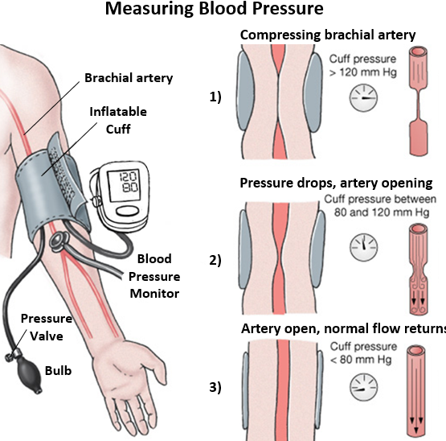

Tools for Measuring Blood Pressure: The three steps are shown above and described below.

- Arterial blood pressure is measured with a sphygmomanometer which is composed of an inflatable cuff placed around the left arm, inflated by a bulb pump with enough pressure to completely restrict blood flow through the brachial artery.

- As pressure in the cuff is released (automatically or by using the pressure valve), the blood pressure monitor detects the resumption of blood flow in the compressed artery as it begins to open up again. That value is recorded as systolic pressure.

- As the pressure becomes lower, the artery fully opens and blood again flows normally. This is when turbulent blood flow is no longer detected and is recorded as diastolic pressure.
Part 4. Olfaction and Vital Signs: In this section you will work in pairs and we will examine the sense of smell (olfaction) and investigate whether it has an effect on blood pressure, heart rate and mood of the subjects. There are sets (pairs) of fragrances that will be tested together. Every student will be a subject and each pair of students needs to test a different set of fragrances from each other.

Procedure
- Have the subject sit comfortably with his/her eyes closed for a few minutes.
- As the experimenter student, place an automated blood pressure cuff around the subject's arm and take a baseline measurement of heart rate and blood pressure before any fragrance is presented. Record this data below in Table 4.
- The subject is then presented with a small plastic bottle containing a specific unknown fragrance. Have the subject remove the lid and hold the bottle approximately 2 inches (5 cm) from their nose and gently inhale the fragrance continually for 2 minutes. As the subject continues to inhale, get them to rate the fragrance on a scale of 1 to 10, where 1 is very unpleasant and 10 is very pleasant. Also ask them to identify the substance, if possible. Record this data in Table 4 (below).
- At the end of the second minute, measure the subject's blood pressure and heart rate again with automated cuff and record in Table 4. At the end of the experiment, also record any change in mood perceived by the subject themselves in Table 4 below. After 5 minutes rest from the first fragrance, repeat the exact procedures (2 to 5) with the other paired (contrasting) fragrance in that set, starting with a new baseline measurement for blood pressure and heart rate before the subject is presented with the second fragrance.
- At the end of the experiment, check the fragrance key to determine if the subject correctly identified the substance. Also, remember to fill in the code # of the bottle in Table 4 (below).

Table 4. Fill in results for vital signs before and after olfaction for the two contrasting fragrances tested.
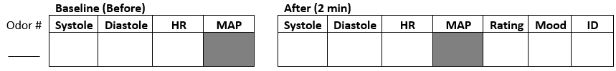

Important:
Also record the subject's personal rating of the various fragrances in Table 4 (above). Ratings for the fragrances are 1 being very unpleasant and 10 being extremely pleasant. Changes in mood felt from before and after two minutes of inhaling each of the fragrances are also recorded. Ratings are -1 being a negative mood and +1 being a positive mood. Finally, record whether the subject correctly identified the fragrance. Ratings are 1 = yes, 0 = no.

*Allow 5 minutes in between testing for the two different fragrances.
Key for subject's rating (in terms of liking or not) and mood for olfaction experiment.
Fragrance | Rating  1 to 10 | Change in Mood?  - 1 0 +1 | Subject’s Guess | Correct?  1=yes, 0=no
# _____

# _____

Key to identification of fragrances: Available at the front lab bench.
1A
1B
2A
2B
3A
3B

Q12. Do you think fragrances can affect a person’s mood? Why or why not?

Part 5. Taste Discrimination With and Without Olfactory Sensation
The sensations of taste (gustation) and smell (olfaction) are detected by chemoreceptors. The epithelial surface of the tongue contains taste receptors which are specialized cells grouped into barrel-shaped structures called taste buds. The receptors for the sense of smell are located in the olfactory cells in the mucous membrane lining of the upper portion of the nasal cavity. Only volatile substances (gaseous molecules) in solution can stimulate these receptors.
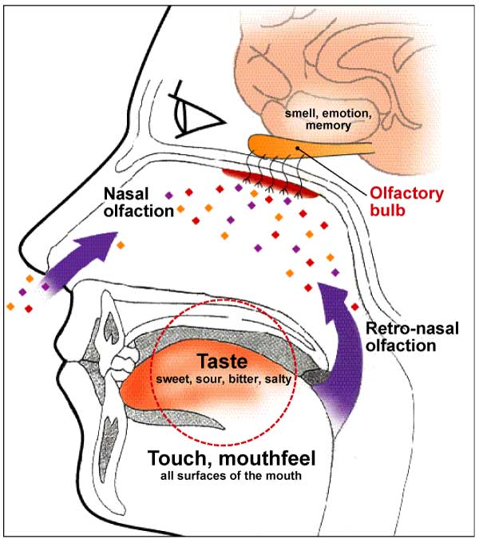
The gaseous particles enter the nasal cavity by diffusion from the circulating air in the external environment. Glands that surround olfactory cells secrete fluid in which the particles dissolve and this solution acts as a chemical stimulus to a nerve impulse (see illustration at left).

Does taste sensation depend on the ability to smell? If a person bites a lemon, the solution in the mouth stimulates chemoreceptors on the tongue. The chemicals act as the stimuli to activate chemoreceptors. Once activated, they send signals to specific regions of the brain that recognize and interpret the stimulus.

Although there are only five basic modalities for taste (sour, sweet, salt, bitter and umami), the combination of these together with the sense of olfaction, provides a wide variety of different sensory experiences regarding gustation or taste.

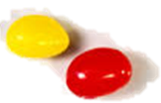
Students will work in pairs and test their ability to identify various sweet tastes of jellybeans, and also compare and identify two unknown food items.

Procedure
- Have your lab partner sit comfortably with their eyes closed and nostrils shut with nose plug.
- Your lab basket will contain a particular flavor of a food item of unknown flavor.
- Select the sample and have the subject place one of the food items on their tongue.
- Instruct your partner (the subject) not to swallow the item but they can move the item around in their mouth to try to identify the taste of material placed on the tongue.
- Note whether the identification is correct (+) or incorrect (-) and record data in Table 6 below under “nostrils closed”. But do not have subject remove food item from mouth at this stage.
- Now, have the subject release the nose plug and again ask them to identify the flavor.
- Note whether the identification is correct (+) or incorrect (-) and record data in Table 6 below under “nostrils open”.
- Have your partner rinse his or her mouth with water in between each sample.
- Repeat the randomized test for each item, first with nostrils closed and then open before discarding food item (repeat parts 3-7 above).
- For unknown food items X and Y, each person will try both items, first with nostrils closed (try to identify the item) then with nostrils open (again try to identify item).
- Record results in Table 6 below in the rows marked X and Y.

Table 6. Taste Discrimination. Fill in the subject's results to the taste test in table below.
Food Item | 1. Nostrils Closed | 2. Nostrils Open
Jelly Belly # ___ A
Jelly Belly # ___ B
X

Y

13. a) In terms of adaptation (p42), olfactory receptors are ___________________________________.

b) In terms of modality classification (p43) olfactory receptors are __________________________.

c) In terms of the origin of their stimuli (p43), olfactory receptors are ________________________.

14. From your results, is there any difference in taste discrimination with or without olfaction? ______.
What other factors might contribute to taste discrimination, and can your ‘tastes’ change?

Part 6. Bleaching of Photoreceptors and the After-image
Procedure
- You will have a selection of colorful images on white paper to work with.
- Stare at the center of the colored image for about 30 seconds at a comfortable range (like reading a book). Then look at a white sheet of paper. Let your eyes relax. You should see an after-image.
- Describe the afterimage color of all the different colors in Table 7 below.

Table 7. Afterimages due to Bleaching of Cones.
Original Colors of Images | Colors in After-Image
Flag: 1)  2) | 1)  2)
Fish bowl: 1)  2) | 1)  2)

The Electromagnetic Spectrum
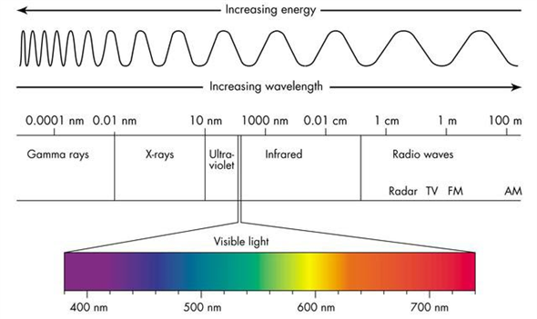

15. The electromagnetic spectrum ranges from long radio waves of ________ m long to very short waves of gamma rays of _____________ nm in length.

16. What is the range of wavelength for visible light? ________________________________________.

17. The two types of photoreceptors in the eye are: 1) _________ for black and white vision, and 2) ________, for color vision. There are more ________ than _________, except in a specific area called the ___________ _____________, where there are the highest density of cones.
Part 7. Sound and Your Ears
Sound has qualities of pitch (wavelength) and loudness (amplitude).

Pitch describes how high or low a tone is and depends upon the frequency of vibration. Higher frequencies give higher tones, and lower frequencies give lower tones. It is measured in wave lengths.

Loudness of a sound depends upon the amplitude (size) of vibration. The greater the amplitude of the sound wave, the louder the sound. It is measured in decibels.

Vibrations create sound waves which move through mediums such as air and water before reaching our ears. Since the ability to conduct sound depends on the density of the medium, solids are better conductors than liquids and liquids are better conductors than gases. The speed of sound in air is around 767 miles per hour or 1,230 kilometers per hour. When traveling through water, sound moves about four times faster than they move in air.
Sound Waves of Different Wavelengths
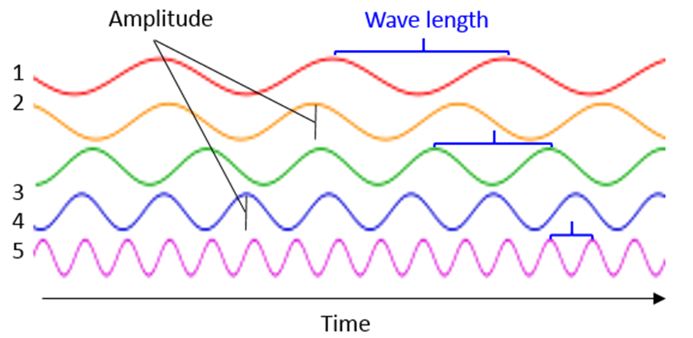

The hearing apparatus of our ears vibrate in a similar way to the original source of the vibration, allowing us to hear many different sounds. Dogs can hear higher frequencies than humans, thus they hear noises we can’t. It is believed the loudest sounds made by any animal are the whistles of the blue whale, measured at up to 188 decibels – that’s a million times more intense than a jet engine, which is only about 120-140 decibels, since the decibel scale is exponential!

Some Questions about Sound:
a) Which of the 5 wave forms in the figure above would have the highest tone? ____. The lowest? ____.

b) What is the speed of Sound as it travels through air? = _________________ per hr.

c) Can sound travel through water? _____. Does it travel faster or slower than through air? _________.

d) Why? ___________________________________________________________________________.

e) What is the speed of Sound as it travels in water? = __________________ per hr.
f) Dogs can hear __________ frequencies than us, and blue whale make sounds as loud as _______ dB.

Sound Perception and Hearing
Hearing (auditory perception) is the ability to perceive sound by detecting vibrations - changes in the pressure of the surrounding medium through time. The ear is our organ of sound.
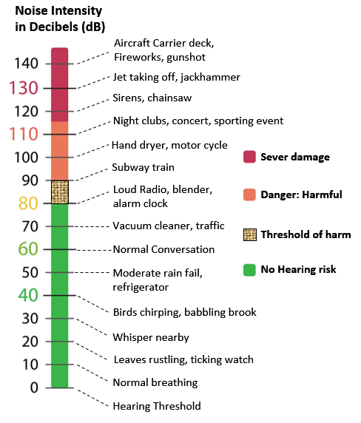
The vibration pattern of sound is transferred to the middle ear which contains three small bones known as the auditory ossicles. They transfer and amplify the vibrations from the tympanic membrane (ear drum) into the inner ear, which contains the cochlea, a spiral shaped, fluid filled tube that is the organ of auditory transduction.

Motion in the inner ear causes the movement of specialized auditory receptors (hair cells). The space-time pattern of vibrations is converted to a spatial–temporal pattern of firings within the cochlea transmitted to the auditory nerve, which sends information about the sound to the brainstem and temporal lobe.

The inability to hear is called deafness; it can be mild or profound, temporary or permanent.

Using the information above, list the dB levels ((loudness) for these common sounds around us
Environmental Noise Decibel Level (dB)

- Alarm clock = ______ dB

- Subway train = ______ dB

- Jet engine = ______ dB

- Softest sound heard = ______ dB

- Normal conversation = ______ dB

- City traffic (inside car) = ______ dB

- Loud rock concert = ______ dB

- Whisper in quiet library = ______ dB

- A babbling brook = ______ dB
What decibel is the threshold of harm to your ears and hearing typically begin? ______ dB.
The drawings below show the basic anatomy of the eyes and ears.

a) Label the structures indicated in the diagram of the main layers of the eye and the light fixing apparatus. See chapter 11 (page 261) of OER Physiology textbook for information.

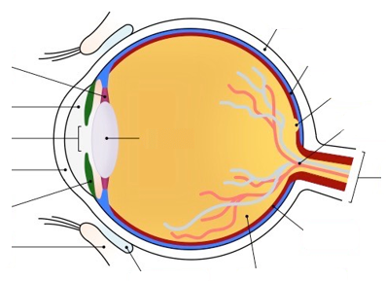

b) Label the structures indicated for the diagram of the ear below. See chapter 11 (page 271) of OER textbook for information.

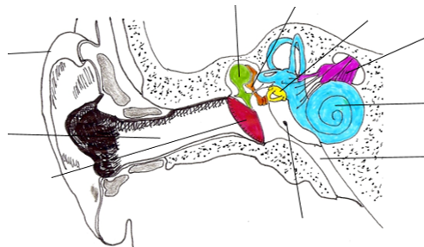

Lab Exercise #5: Sensory II - Reflex & Voluntary Reactions

Introduction
This lab is designed to familiarize you with the mechanisms of reflex actions and how they compare to the mechanisms of voluntary actions.

Reflexes are rapid, automated, stereotyped responses to sensory stimuli that are usually protective.

Reflexes do not require higher brain activity, that is, they can be considered a "subconscious" or “involuntary” action.

Voluntary responses follow the same basic neural pathway but with varying integrations centers that enable conscious control.

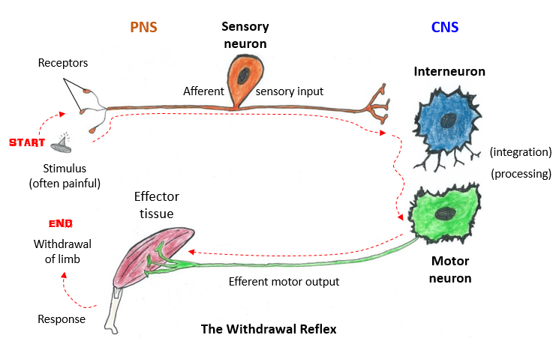
In this section we return to the concept of feedback mechanisms because both reflex and voluntary actions are feedback mechanisms. Keep in mind the basic parts of the ‘reflex arc’ (which is just an automated feedback loop) from the first section of this class. Here are the basic components below.
The Feedback Loop above shows the basic components of a stimulus being processed for a response at the end of the loop. Use this drawing as an opportunity to identify all of the steps in a typical negative feedback loop by recognizing the names for all of the elements shown in the diagram.

Part 1. Pupillary Reflexes
A. Adaptation to changes in light intensity.
The pupil is the hole in the iris (the colored portion of the eye) and it controls the amount of light that can enter the eye (shown to the right). The iris is complex and is composed of two different arrangements of contractile tissue in order to change the diameter of the pupil. The pupillary light reflex regulates the intensity of light entering the eye and we will be testing it.
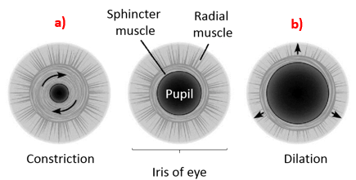

Procedure

- As you sit in the lab, your pupils will adjust to the light. Place an index card in between your eyes, so that one eye is not able to directly view the same things as the other eye.

- Shine a pin light into one of your partner's eyes at a close distance so that the other eye is not exposed to the light. What happens to that eye? _______________________________________.

- As you shine the light in one eye, examine what the other eye (getting less light) does.

- Draw in the pupil sizes below.

Questions
Normal Light Bright Light

1. What happens to each eye when you shine light on one eye? _______________________________.

2. Which cranial nerve is responsible for this response? _____________________________________.

3. What is the stimulus for the dilation/contraction of the iris muscles? ________________________.

4. What are the specific receptors for that stimulus? _______________________________________.

5. Look up the contractile structures involved in the pupillary light reflex (shown in labeled drawing at top). Name the structures that act in the drawing for a), and then b) below.

a) ________________________________ and b) ___________________________________.

In terms of medical terminology with reference to the pupil of the eye:

- Myosis means: __________________________ of the pupil.

- Mydriasis means: __________________________ of the pupil.
B. Other Pupillary Reflexes
The size of the pupil also changes when the eyes are engaged in either distant or near focus. The same structures are involved, and we want to determine how this is controlled and why.

Procedure

- While watching your partner's pupils, have your partner focus on an object across the room.

- Now have your partner shift his/her gaze to some fine print in a book that is close up and observe any change in pupil size from distant to near focus.

Distant Focus Nearby Focus
Questions

6. What is the sympathetic control of the iris? What's the purpose of this?

7. What is the parasympathetic control of the iris? What's the purpose of this?

C. The Blind Spot
Procedure for locating the Blind Spot
- Keep your head steady. Close your left eye, and focus on the cross with your right eye.
- Slowly move this paper towards your face, keeping it level with your eyes, until the circle disappears. You have now located the blind spot!
- Repeat this procedure using for your other eye. This time, however, focus on the circle until the cross disappears.
+
8. Why can no image be detected at the optic disc or blind spot? (look up ‘blind spot’)

9. Why do you think we are not normally aware of this blind spot?

10. There are other eye reflexes that are protective in nature. For instance, the “corneal reflex” is also known as the __________________________. It is triggered by stimulation of the ___________ and can also be stimulated by loud sounds!
Part 2. Spinal Reflexes
A. Patellar Reflex.

Procedure
- Have your partner sit on the table with his/her leg dangling freely.

- Gently tap patellar tendon of the upper leg with the hammer. Record what happens below.

- Repeat the process with the other knee. Record what happens below.
- This time, repeat the process with what is called the Jendrassik's maneuver. The subject's hands are clasped in front of them, as if both pulling in opposite directions. Have the subject try to pull his/her hands apart at the same time as the tendon is tapped. Record what happens below.

Review the topic of monosynaptic reflexes to help answer the questions below.
Questions

11. What is a monosynaptic reflex? Explain the knee-jerk reflex as a monosynaptic reflex arc.

12. Why is it called a stretch reflex? __________________________________________________.

B. Biceps and Triceps Reflexes - Inhibition of Antagonistic Muscle Groups.

Procedure
- Have the subject sit in a chair and bend his/her arm at the elbow 90 degrees. Then have the subject place the palm of their hand under the table and try to lift table. An observer should palpate (feel) the biceps and triceps muscle while this is happening and describe which one is contracting below.

- Instruct the subject to contract the triceps and maintain the pressure on the table. Was the subject successful? Why or why not?

Review the topic of polysynaptic reflexes to help answer the questions below.

13. What is an antagonistic muscle group? What is the purpose of this arrangement?

14. What is meant by reciprocal inhibition? Illustrate with a good example of where it is seen.

Part 3. Voluntary Reaction Time

A. Measuring Voluntary Reaction Times with a Reaction Time Ruler.
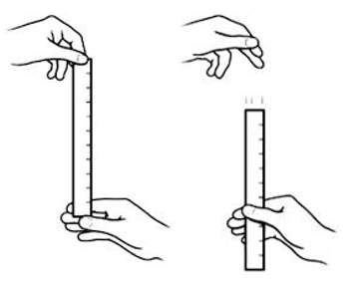
In contrast to a reflex, a voluntary reaction is a conscious motor response to a sensory stimulus. To measure voluntary response to a visual stimulus, we can use a reaction time ruler. This ruler is calibrated in milliseconds (msec), beginning with 50 msec at the "thumb-line" and going up to 400 msec at the "release" end. The ruler is marked in intervals of 10 msec, with the 50 msec intervals indicated in bold numbers.

The subject watches the ruler and grabs it the moment they detect movement. The time taken is measured by the placement of the thumb on the calibrated ruler line (see right).

Procedure
- The subject should sit in a chair. Another person, the releaser, should stand facing the subject.
- The releaser should hold the ruler at the "release" end at eye level or higher between the thumb and first finger of either hand.
- The subject should position his/her thumb and first finger around the "thumb-line" on the ruler while not touching the ruler. There should be a space of about 1 inch (2.54 cm) between the index finger and thumb with the ruler in between.
- The releaser should not be watching the subject and the subject should not be watching the releaser. The releaser should be looking at the release line only and the subject should be looking at the thumb line of the reaction time ruler only.
- When ready, the subject tells the releaser to start. Randomly, within ten seconds, the releaser will let go of the ruler and the subject will catch it with the finger and thumb.
- Estimate from the location of the finger and thumb how many milliseconds passed from the time of release until the ruler was caught.
- Practice three times. Then, record the next three trials below (next page).

These trials will provide the Baseline values for Reaction Time Ruler Experiment with Drink A or B

Trial Number 1) ___________ msec
2) ___________ msec
3) ___________ msec

Ave Baseline Reaction Time = ___________ msec

B. The Effect of a Consumed Stimulant on Reaction Time.
It has been established that reaction time can be influenced by several factors, such as age, gender and other factors. Reaction time can also be altered by what you ingest. In this experiment, subjects will measure their baseline reaction time (using a reaction time ruler on previous page) followed by drinking 250 ml of either a decaffeinated (control) or a caffeinated (experimental) beverage. Then, 30 minutes after drinking it, the subject’s reaction time will be measured again with the same method.

Below, record reaction time 30 minutes after consuming either beverage A or B. Get the average of three trials. Your baseline values for Reaction Time have already been recorded on the previous page.
1) ___________ msec
2) ___________ msec
3) ___________ msec
Ave Reaction Time 30 minutes after drink = ___________ msec

15. Make a specific hypothesis about reaction time and consuming a caffeinated beverage.

________________________________________________________________________________
C. Measuring Voluntary Reaction Times with an Electronic Reaction Timer.
We will use an electronic reaction timer (Hubbard Scientific, 6027) to measure reaction times to two different cues; visual (red light) and audio (buzzer sound).

Procedure
1) Visual Cue: Set the electronic reaction timer to “light” and time to hundredths. Subject sits comfortably and places their foot over the top of the footpad on the floor next to them. The light display of the timer faces the subject. Randomly, the experimenter presses the hand switch to signal the light and starts the timer. The subject steps on the footpad as soon as they see the red light. Repeat three times, record the values below and calculate the average for visual cue reaction time.
1) ___________
2) ___________
3) ___________
Average Reaction Time for Visual Cue = ___________

2) Auditory Cue: Set the electronic reaction timer to “sound” and time to hundredths. The subject sits in same arrangement for visual cue, and now the randomly pressed hand switch signals the sound and starts the timer. Again, the subject steps on the footpad as soon as they hear the sound. Repeat three times, record the values below and get the average for auditory cue reaction time.
1) ___________
2) ___________
3) ___________
Average Reaction Time for Auditory Cue = ___________

Table 1. Record your “self -report” data here, then enter it in the lab computer for this experiment.
 |  | Caffeine Level | Alcohol Use | Exercise Level | Reaction Time | Reaction Time
Name | Age | 0 to 5 | 0 to 5 | 0 to 5 | Baseline | After Drink
Reflexes are rapid, automated, stereotyped responses to sensory stimuli that are usually protective.

There are cranial reflexes, where the brain is the integration center), and spinal reflexes, where the spinal cord is the integration center. Examine the monosynaptic spinal reflex which is shown as the patellar reflex (knee jerk) below.
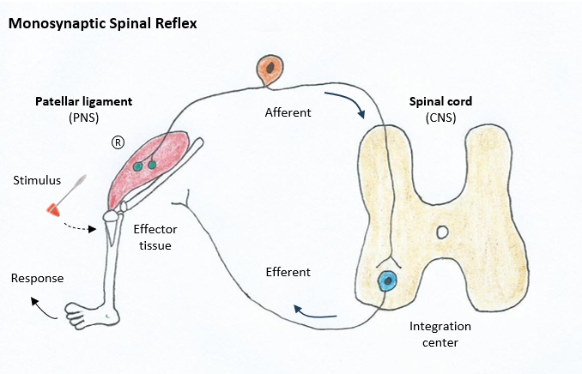

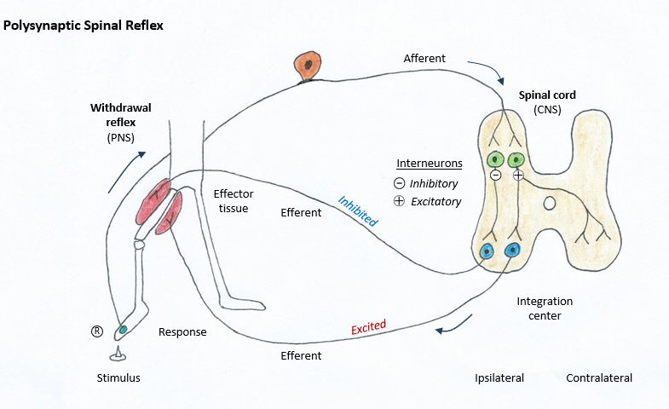
We Examine the polysynaptic spinal reflex which is shown as the withdrawal reflex below.
Name: __________________________________________________ Date _____________.
Nervous System ANS Questions

1. The ion that is most permeable in plasma membranes of neurons is:
a) phosphate b) calcium c) sodium d) anions e) potassium

2. Which best describes what occurs at an excitatory adrenergic synapse?
a) NE binds to ligand-gated ion channels b) the postsynaptic neuron is hyperpolarized
c) IPSPs occur d) a second messenger system, such as cAMP, is activated
e) acetylcholine is removed from the synapse by reuptake rather than by enzymatic degradation

3. The effect of GABA on a postsynaptic neuron is:
a) all-or-none b) hyperpolarization c) repolarization d) depolarization e) excitation

4. Which of these neuropeptides act as analgesics?
1. CCK 2. monoamines 3. enkephalins 4. amino acids 5. endorphins
a) 1, 2 b) 3 only c) 3, 5 d) 5, 4, 3 e) 2, 4

5. The biogenic monoamines include all of the following neurotransmitters except:
a) serotonin b) norepinephrine c) dopamine d) GABA e) histamine

6. The neurotransmitter serotonin is derived from which precursor amino acid?
a) Dopamine b) Tyrosine c) Tryptophan d) Glutamine e) Glycine

7. The neurotransmitter dopamine is derived from which precursor amino acid?
a) Dopamine b) Tyrosine c) Tryptophan d) Glutamine e) Glycine

8. When a neuron is hyperpolarized, which of these membrane potentials would it most likely be?
a) 0 mV; b) -65 mV; c) -55 mV; d) -72 mV; e) +35 mV.

9. The effector tissue for the somatic motor nervous system is:
a) cardiac muscle b) smooth muscle c) glands d) skeletal muscle e) all of these

10. Which of these characteristics describe the somatic motor nervous system?
a) has one neuron from CNS to skeletal muscle b) its effect can be excitatory or inhibitory
c) for pain sensation on the surface of the body d) receptors can be nicotinic or muscarinic

11. In the ANS, the preganglionic neurons synapse with postganglionic neurons in the
a) autonomic ganglia b) brain stem c) spinal cord d) dorsal root ganglia e) skeletal muscle cells

12. Stimulation of the adrenal medulla by sympathetic innervation predominantly causes release of
a) acetylcholine b) epinephrine c) cortisol d) norepinephrine e) none of these

13. Which of the following characteristics apply to the ANS?
1. always under conscious control 2. There are two neurons between the CNS and effector tissues
3. all neural axons are myelinated 4. neurotransmitters can be acetylcholine or norepinephrine
a) 1, 2 b) 1, 3 c) 1, 4 d) 2, 3 e) 2, 4
14. All preganglionic neurons of the sympathetic and parasympathetic divisions are
a) adrenergic b) cholinergic c) myelinated d) unmyelinated e) both b and c

15. The membranes of all postganglionic neurons in autonomic ganglia & the membranes of skeletal muscle have: a) adrenergic receptors b) muscarinic receptors c) nicotinic receptors

16. Effector cells that respond to acetylcholine released from postganglionic neurons have:
a) adrenergic receptors b) muscarinic receptors c) nicotinic receptors

17. Most postganglionic neurons of the sympathetic division are
a) adrenergic b) dopaminergic c) cholinergic d) a and c e) all of these

18. Approximately 75% of all parasympathetic axons are located in the
a) facial nerve VII b) glossopharyngeal nerve IX c) oculomotor nerve III d) vagus nerve X

19. When acetylcholine binds to nicotinic receptors,
a) Na⁺ ion channels open b) G proteins are activated c) K⁺ channels open d) Cl⁻ channels open

20. The sympathetic division of the ANS includes which of these descriptions?
1. has long postganglionic fibers 2. increases heart rate 3. dilates bronchioles (air ways)
4. decreases pupil diameter 5. has short postganglionic fibers 6. decreases heart rate
a) 2, 3 and 5 b) 1, 4, 2 and 3 c) 4, 6 and 5 d) 3, 2 and 1 e) 6, 3 and 5

21. Which of the following statements about catecholamines is false?
a) they include epinephrine, norepinephrine and dopamine
b) their effects are increased by action of the enzyme catechol-O-methyltransferase
c) they are inactivated by monoamine oxidase
d) they are inactivated by re-uptake into the presynaptic
e) they may stimulate the production of cAMP in the postsynaptic membrane

22. Hyperpolarization of the postsynaptic cell from glycine or GABA is produced by the opening of:
a) Na⁺ channels b) K⁺ channels c) Ca⁺²⁺ channels d) Cl⁻ channels e) K⁺/Na⁺ channels

23. If the drug Benzodiazepine (valium) calms people down, then which of these would be true?
a) it’s a GABA antagonist b) it’s a GABA agonist c) it blocks glutamate
d) it’s a substance P antagonist e) it’s a glutamate agonist

24. When acetylcholine binds to nicotinic receptors, the response is
a) always excitatory b) always inhibitory c) either excitatory or inhibitory

25. Which of the following statements about ACh is false?
a) skeletal muscles contain nicotinic receptors for ACh
b) the heart contains muscarinic receptors for ACh
c) G-proteins are needed to open ions channels for nicotinic receptors
d) stimulation of nicotinic receptors results in the production of EPSP’s

PRE-LAB QUESTIONS: SKELETAL MUSCLE LAB
Name: ___________________________________________________ Date _____________.
Hand in the fill-in questions AND the multiple choice on the next page at the start of the lab session.
1. On p 69 the graph of the single muscle twitch has 3 periods (or phases) to it, they the:
1) __________________, 2) __________________, and 3) __________________ periods (or phases).

2. What is a latent period? ____________________________________________________________.

3. Typically, what is the range in duration of a latent period? ___________________.

4. The three ways to vary the force of muscle contraction in skeletal muscle (p69) are:

1) ________________________ 2) ________________________ and 3) ________________________.

5. A motor unit is (p69) _______________________________________________________________.

6. Are all motor units the same size? ______. Do all motor units have the same sensitivity? ______.

7. Typically, _____________motor units are more sensitive than _____________ motor units.

8. In Skeletal Muscle Experiment #1 (p70), the parameter being changed is ______________________.

9. Spatial summation is also called: ______________________________________________________.

10. In Skeletal Muscle Experiment #2 (p71), the parameter being changed is _____________________.

11. Temporal summation is brought about by (p73) _________________________________________.

12. If skeletal muscle is stimulated at very high frequency, ___________________________ will ensue.

13. If skeletal muscle continues to be stimulated at high frequency but can no longer generate adequate force, then _________________________ has occurred.

14. In Part 3 (p74), the specific muscles tested for fatigue are: _________________________________.

15. List 3 causes of muscle fatigue (p74) __________________________________________________.

16. How will blood flow be restricted to flexor muscles? _____________________________________.

17. Should the order in which 3A and 3B are done be varied? ______. Why or why not?

Multiple Choice Questions for Skeletal Muscle Physiology Pre-Lab
For the questions below, please answer on a scantron and submit it at the start of the lab session.

1. The term skeletal muscle fiber refers to:
a) an individual skeletal muscle cell b) an individual myosin fiber
c) an isolated skeletal muscle, like the biceps brachii, or the triceps brachii
d) the sarcomere of the skeletal muscle e) the muscle fascicle bundle

2. A “motor unit” for skeletal muscle refers to:
a) all of the muscles that affect the movement of any given joint.
b) a single muscle fiber and all of the motor neurons that innervate it.
c) all of the motor neurons supplying a single muscle.
d) a pair of antagonistic muscles.
e) a single motor neuron and all the muscle fibers it innervates.

3. Motor unit recruitment means which of the following?
a) a decrease in the number of activated muscle fibers, increasing the force of contraction.
b) an increase in the number of activated muscle fibers, increasing the force of contraction.
c) a decrease in the number of activated somatic neurons, decreasing the force of contraction.
d) an increase in the frequency of stimulation of muscle fibers, increasing the force of contraction.
e) an increase in the voltage that decreases the force of contraction.

4. In skeletal muscle, calcium ions (Ca²⁺) facilitate contraction by binding to ______.
a) tropomyosin b) actin c) troponin d) myosin e) the thick filament

5. During contraction of a skeletal muscle fiber the _______________.
a) A bands shorten b) I bands shorten c) Z discs lengthen d) b and c

6. What purpose would a creatine phosphokinase (CPK) blood test be used for? To:
a) measure the size of the sarcomere b) determine Ca²⁺ levels in muscle
c) assess muscle activity d) assess muscle damage

7. In the experiment of increasing the frequency of stimulation, if there were periods of muscle relaxation in between the step-wise increase in force, this can be called:
a) unfused tetanus b) fused tetanus c) complete tetanus d) incomplete tetanus e) a and d

8. In the experiment of increasing the frequency of stimulation, when there was no relaxation of the muscle fiber at all and it was generating maximum force, this can be called:
a) treppe b) a twitch c) incomplete tetanus d) complete tetanus e) hypertrophy

9. The T-tubules are an invagination of which membrane in skeletal muscle? The _______________.
a) sarcolemma b) sarcoplasmic reticulum c) lysosomes d) sarcomere e) mitochondria

10. The Slow Twitch skeletal muscle fibers have which of the following properties?
a) slow onset, glycolytic, fast to fatigue b) fast to fatigue, oxidative, myoglobin rich
c) slow to fatigue, oxidative, myoglobin rich d) fast onset, oxidative, myoglobin poor
e) fast onset, glycolytic, myoglobin poor
*PRE-LAB due at start of this Lab
Laboratory Exercise #6: Skeletal Muscle Physiology

Objectives: When you have completed the following laboratory, you should be able to:
1. Describe a muscle twitch and identify its three phases;
2. Examine motor unit recruitment in skeletal muscle contraction and analyze the data;
3. Examine temporal summation in skeletal muscle contraction and analyze the data;
4. Test skeletal muscle fatigue and examine factors that contribute to it.

Introduction to the three types of Skeletal Muscle Contraction
The somatic nervous system controls skeletal muscle. When acetylcholine (ACh) is released into the neuromuscular junctions, skeletal muscle fibers (the cells that make up whole muscle) are stimulated to contract. This muscle contraction generates force or tension, which is usually measured in grams (g). As we will see, there are three ways to vary the force of contraction of skeletal muscle.

The Single Muscle Twitch
The simplest kind of muscle contraction is the individual muscle twitch. Any twitch is comprised of three phases or periods: 1) the latent period - a short delay period (1-4 msec) after stimulation but prior to contraction, as the muscle prepares to contract; 2) the contraction period – when the muscle is generating force; and 3) the relaxation period – when force generated by muscle is decreasing.

Table 1. From the graph above, record the values for the single skeletal muscle twitch.
 | Latent Period | Contraction Period | Relaxation Period
Duration (msec)
Force of Phase (end) (g)
Varying the Force of Muscle Contraction - There are three important ways to vary the force of contraction of skeletal muscle: 1) Spatial Summation; 2) Temporal Summation; and 3) Length of the resting sarcomere. We will be examining experimental data for Spatial and Temporal summation.

Part 1. Spatial Summation (Motor Unit Recruitment)
Skeletal muscles are comprised of motor units, and a motor unit is one somatic motor neuron and all of the muscle fibers it innervates. See the drawing below showing two different motor units.

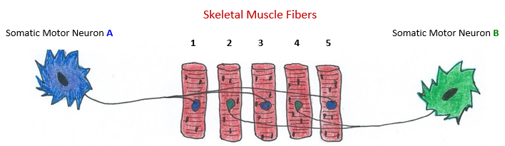
When a motor unit is stimulated, all of the muscle fibers in it contract with maximum force. In other words, all of the muscle fibers in an active motor unit contract completely, or they do not contract at all. Motor units vary in their level of sensitivity. That is, some respond to a weak stimulus, while others require a stronger stimulus to contract. Typically, smaller motor units are more sensitive (require lower levels of stimulation) than larger motor units. The net strength of a whole muscle contraction is the summation of the forces of each of the independent motor units acting at a given time.
Motor Unit A = Motor Unit B =

Spatial summation in skeletal muscle is achieved by an increase in the strength of the stimulus (in these experiments the parameter being changes is voltage), when increased, more motor units become involved, and therefore more force is generated. This process is also called motor unit recruitment.

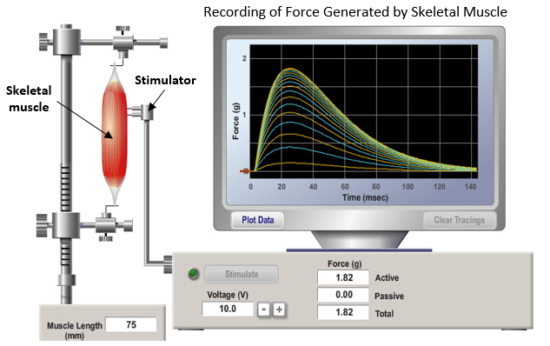

Skeletal Muscle Experiment Part 1: The Effect of Stimulus Voltage on the Strength of Contraction.

Data Set for Skeletal Muscle Experiment #1
Voltage Applied (mV) | 0 | 1 | 2 | 3 | 4 | 5 | 6 | 7 | 8 | 9 | 10
Force Generate (g) | 0.0 | 0.0 | 5.5 | 12.2 | 16.1 | 27.2 | 33.7 | 35.8 | 36.0 | 36.0 | 36.0
Procedure
- The parameter being changed is the voltage applied by the stimulator, which goes on the x-axis because this causes a change in the muscle force generated, which goes on the y-axis.
- Using the data set for Skeletal Muscle Experiment #1 (above) plot the coordinates on the blank graph provided below.
- After completing the graph, answer the related questions immediately below graph.

Questions for Completed Voltage Graph (Expt. #1) Use units in answers.

1. What is the minimum voltage required to generate force in the muscle? _____________.

2. What is the strength of the threshold contraction? Force = _____________.

3. At what voltage is the maximum strength of contraction 1st reached? _____________.

4. What is the maximum strength of contraction? Force = _____________.

5. What is the force of contraction for a single stimulus 4 mV? _____________.
Part 2. Temporal Summation
Skeletal Muscle Experiment #2: The Effect of Frequency of Stimulus on the Force of Contraction.

Data Set for Skeletal Muscle Experiment #2
Procedure

- The parameter being changed is in these experiments is the frequency of the stimulus being applied by the stimulator, which goes on the x-axis because this causes a change in the force generated, which goes on the y-axis.

- Using the data set for Skeletal Muscle Experiment #2 (at the left) apply these data points to the blank graph grid on the next page entitled “Muscle Force Generated from Increasing Frequency of Stimulation”.

- After completing the graph, answer the related questions immediately after the graph. Always include the appropriate units for any answer.

- Conventionally the frequency of stimulation is calibrated as the number of milliseconds (msec) in between successive stimuli. However, in this data set the frequency of stimulus is expressed as the number of stimuli per second (sec), as seen on the graph.

Frequency Stimulus | Force Generated
0 | 0.0
1 | 0.4
2 | 0.7
3 | 1.4
4 | 1.3
5 | 2.8
6 | 2.6
7 | 3.1
8 | 4.3
9 | 4.2
10 | 4.9
11 | 5.7
12 | 5.4
13 | 7.6
14 | 7.4
15 | 8.1
16 | 8.5
17 | 9.0
18 | 9.0
19 | 9.0
20 | 9.0
21 | 9.0
22 | 9.0
23 | 9.0
24 | 8.6
25 | 8.4
26 | 7.6
27 | 7.0
28 | 6.5
29 | 5.2
30 | 5.0
31 | 4.2
32 | 4.2
33 | 4.1
34 | 3.8
35 | 3.4

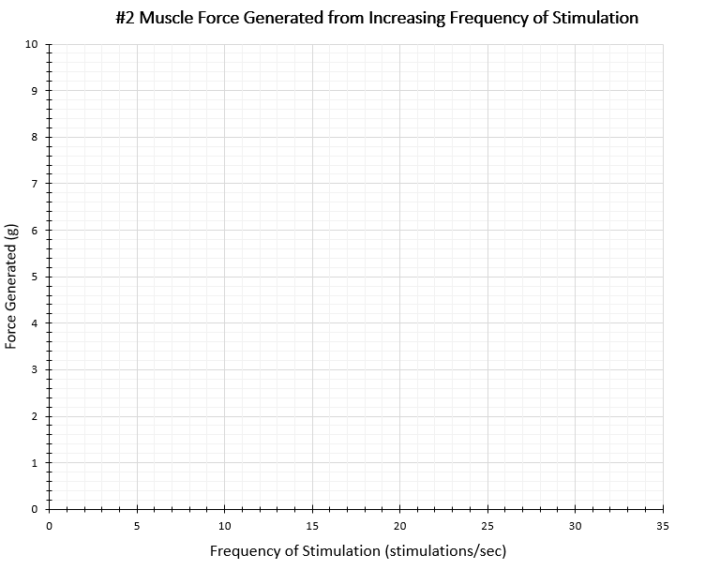
Questions for Completed Frequency of Stimulus Graph (Expt. #2) Use units in answers.

1. What value of stimulus frequency is contraction threshold? _____________.

2. At what stimulus frequency is maximum force 1st reached? _____________.

3. Complete tetanus occurs at what stimulus frequency range? _____________.

4. On the filled in graph above, mark the regions of: a) incomplete tetanus
b) complete tetanus
c) muscle fatigue

5. What is the % increase in contraction force from 5 to 10 stimuli per second? _____________.
(To calculate this, get the difference between the two forces,
then divide by the original value and x 100)

What is Temporal Summation?
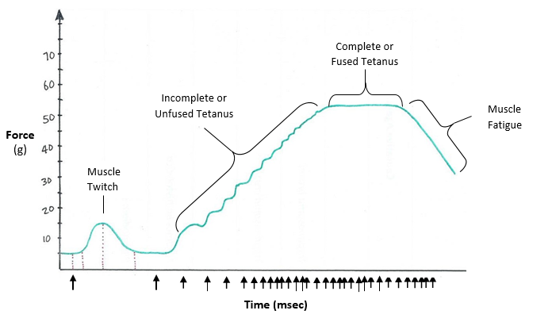
Temporal summation is brought about by increasing the frequency of stimulation to one muscle so that the same muscle fiber is contracting again before it has an opportunity to completely relax. A muscle fiber contracts with greater force when several stimuli arrive in rapid succession than when the muscle fiber only receives a single stimulus (see the graph below as an example).
Temporal Summation – as the frequency of stimulation increases, there is an increase in Force (g).

The illustrative graph above shows how a single stimulus causes a single muscle twitch. As the frequency of stimulation increases the muscle does not have time to relax completely before the next contraction begins and the force of each successive contraction sort of ‘piggybacks’ in terms of tension, generating greater and greater force than a single muscle twitch.

As the frequency of stimulation increases further, there are only slight periods of rest (and thus no added muscle tension) between stimuli, this creates Incomplete or Unfused Tetanus. This is different from treppe (a German word for staircase) where relaxation occurs between the wave summation.

If the frequency of stimulation is so high that there is no muscle relaxation in between successive stimuli, then this is called Complete Tetanus, or fused tetanus. The term tetanus just means a steady state of fused (complete) muscle contraction and is not associated with any condition that may occur with the bacteria Clostridium tetani.

As the frequency of stimulation continues to increase and stimulate the skeletal muscle to contract, muscle fatigue will begin to occur, as can be seen in the illustration above as the muscle cannot maintain a constant force toward the end of the experiment. Muscle fatigue is defined as the state when the muscle can no longer generate adequate force due to overuse.
Part 3. Muscle Contraction and Fatigue
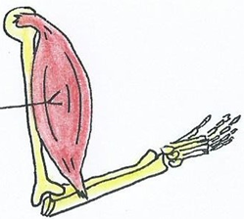
In this last section students will perform repetitive skeletal muscle exercises (fist clenches) of their dominant (the hand you most often use) and non-dominant hands and see how many can be done before fatigue sets in. Muscle Fatigue is the inability to generate adequate force due to overuse.

Muscle fatigue is primarily caused by the depletion of oxygen (O₂), depletion of glucose (C₆H₁₂O₆) and other raw materials that muscle tissue needs to operate. It can be also caused by the accumulation of waste products, such as lactic acid, which lowers the pH. All of the materials mentioned are brought to or removed from the muscle by blood flow. Therefore, the rate of fatigue will depend on the supply of blood to a given muscle, as well as the rate and force of muscle contraction (i.e., muscle activity).
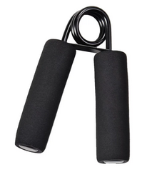
In this lab you will examine how the blood supply to a muscle effects that muscle’s rate of fatigue. We will use handgrips to contact the muscles of the fist, which are flexor muscles of the forearm and hand, predominantly the flexor digitorum muscles.

These flexors in the dominant and non-dominant hand will be fatigued during periods of both normal and restricted blood flow. The rate of flexion (‘clenching’) by each subject needs to be carefully maintained so that the work done will be consistent throughout all procedures.

Note: It is important to randomize the order of procedures 3A and 3B below so as not to pre-fatigue any hand condition. See details on next page.

Procedure 3A. Normal Blood Supply to Forearm Muscles:

- First warm up your hands by clenching and opening them in the air for at least 30 seconds. For this experiment, one complete contraction is achieved by squeezing the handgrip until the two handles touch, then fully release the tension. There must be no more than one second in between each contraction, any longer is used to indicate the onset of fatigue.

- Begin the exercise by clenching and fully releasing the handgrip with your dominant hand as many times as you can before the onset of muscle fatigue.

- Keep count of how many hand clenches you can do before the muscles of the forearm fatigue. Also keep track of the total time (in seconds) it takes for muscle fatigue onset.

- Continue until you can no longer maintain rhythmic contractions, then stop.

- Record the number of contractions and the time taken (with a stopwatch) for muscle fatigue to occur. Record your values in data Table 2 below and data spreadsheet on the lab computer.

Procedure 3B. Restricted Blood Supply to Forearm Muscles:

- Have the subject rest their arm for at least 5 minutes if they have just used the handgrip.

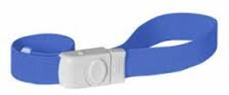
- Place the elastic band that will act as a tourniquet around the subject’s contracting arm just above the elbow reducing flow through the brachial artery supplying the hand muscles. Secure the band tight enough to restrict blood flow but not so tight that it is uncomfortable or too restrictive. We do not want to stop blood flow to the forearm muscles, only restricted it!

- Then, using the handgrip with the subject’s dominant hand, squeeze the handgrip as described above in the procedure for 3A and parts 2) through 6) and record values in the data Table 2 below.

- Now repeat the entire process (procedures 3 A and 3B) with subject’s non-dominant hand.

Important Reminder About the Order of Exercises Before Starting the Experiment:
In order to randomize the sequence of the two parts of the experiments 3A and 3B above, all lab tables will need to alternate the order of activities for each subject so that some subjects do part 3A first, then 3B, while the next subject does 3B first, then 3A.

This means that some students will do the fatigue exercise with the elastic band procedure first, then without the elastic band (i.e., do part B first, then part A). This is to ensure that the muscles are not already fatigued each time we measure fatigue in part B, in which the blood supply is restricted.

Data Table 2. Record your results in the tables below and in the Excel data sheet on lab computer.
Normal Blood Flow
Dominant Hand |  | Non-Dominant Hand
Number of Contractions | Time to Fatigue (sec) | Number of Contractions | Time to Fatigue (sec)

Restricted Blood Flow
Dominant Hand |  | Non-Dominant Hand
Number of Contractions | Time to Fatigue (sec) | Number of Contractions | Time to Fatigue (sec)

Skeletal Muscle Questions to be Completed During the Skeletal Muscle Lab
- What 4 properties do all muscle tissues have? Give a brief definition of each of these below:
  - ______________________________________________________________________________.
  - ______________________________________________________________________________.
  - ______________________________________________________________________________.
  - ______________________________________________________________________________.
- The ______________________________________ controls skeletal muscle.
- It is primarily _______________ _______________ Control that regulates cardiac muscle.
- The muscle in the walls of the bladder are _______________ muscle.
- Give two other examples of smooth muscle in the body: 1) _____________ and 2) ______________.
- Do skeletal muscle cells have action potentials? Yes No
- What is a motor end plate of skeletal muscle? What does it contain?
________________________________________________________________________________.
①
- Looking at the diagram below, start with being when ACh is released from a _______ motor neuron.
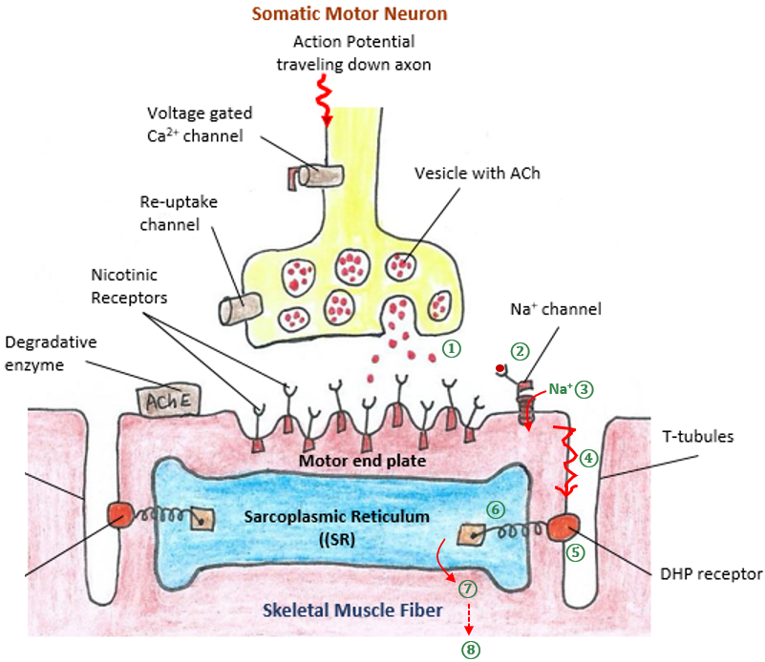

- Now, describe in adequate detail what happens in each numbered sequence in drawing above:
- _______________________________________________________________________________.
- _______________________________________________________________________________.
- _______________________________________________________________________________.
- _______________________________________________________________________________.
- _______________________________________________________________________________.
- _______________________________________________________________________________.
- _______________________________________________________________________________.
- In the drawing on the previous page, the sarcoplasmic reticulum (SR) is located over the __________________, a structure which is called the “functional unit skeletal muscle”.

- The sarcomere contains two contractile proteins __________________ and __________________. It also contains two regulatory proteins _______________________ and _________________________.

- It is the _______ released from the SR that bind to _________________. This then causes the other regulatory protein _____________________ to be moved away from the active site on ____________.

- The ‘removal of inhibition’ that occurs in Q 12 (above) sets the stage for the pivoting ___________ head to bind with the thin filament ___________ to create what is called a _______________ (a type of bond). Now the power stroke can commence - this is when myosin pulls the actin toward the M-line, going from its _______ energy to its _______ energy state. The result is both z-discs are both pulled inward toward the ___________, causing the muscle to shorten and generate ___________.

- Briefly list the 3 sources of ATP Skeletal Muscle uses to contract, including the order they are used, the amount of ATP provided, how long it can be used for, and any drawbacks involved.
- _____________________________________________________________________________.
- _____________________________________________________________________________.
- _____________________________________________________________________________.
- Complete the table below with details found in your notes or the textbook regarding the comparison between slow and fast twitch skeletal muscles for the properties listed. See OER Ch 13, p 381.
Muscle Type | Contraction Onset (Speed) | Contraction Duration | Primary  Metabolism | Myoglobin  Content | Glycogen Content | Blood Supply | Diameter and Color | Function  Use
Slow
Twitch
Fast
Twitch

Laboratory Exercise #7: Part 1 - Heart Rate and Physical Fitness
Introduction to Lab Computer Hardware and Software

The Goals and Objectives of this lab exercise are to:
1. Determine the effect of body position on heart rate.
2. Determine the effects of exercise on heart rate and your fitness level.
3. Suggest correlations to the fitness level of individuals with various factors.

Introduction
As you will see in later sections, the cardiovascular system, which includes the heart, blood vessels, and blood, is responsible for the transportation of blood throughout the entire body. This involves the delivery of oxygen (O₂) and nutrients, and the removal of carbon dioxide (CO₂) and waste.
It is the beating of our hearts today that we will monitor in Part 1 of this lab. The heart’s activity will change depending on what we are doing and how we are feeling. When we are lying down and taking it easy, the heart rate is low. If we get up and run around, it will increase.
Since each heartbeat results from an electrical stimulation originating from within the cells of the heart called the pacemaker (at the sinoatrial (SA) node), we can measure the electrical activity radiating from the skin of our hands and record the changes in heart rate.
The pacemaker of the heart is also influenced by extrinsic nerves and hormones. Many things can affect heart rate, including physical fitness of the individual, the presence of drugs such as caffeine or nicotine in the blood, and the age of the person.
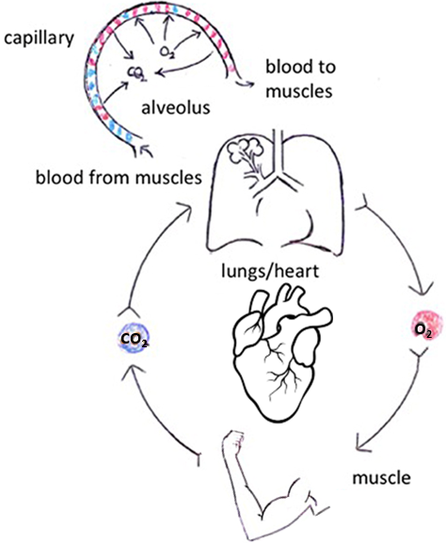
In general, the maximum heart rate of individuals of the same age and sex is about very similar. However, the time it takes individuals to reach that maximum level while exercising varies greatly.

Physically fit people not only have less of an increase in their heart rate during exercise, but their heart rate recovers to the resting rate more rapidly than less fit people. In this experiment, you will evaluate your physical fitness.

An arbitrary rating system will be used to “score” fitness during a variety of situations (see Table 6). Heart rate will be measured in 3 body positions:
- While in a standing position and;
- In supine position (lying on back).

Measurements will be taken before, during and after physical exercise.

Important: Do not attempt this experiment if physical exertion will aggravate a health problem. Inform instructor of any possible health issues that may be affected if you participate in exercise.

MATERIALS
We will be using our laptop computers together with Vernier sensors to interface with computer and the Logger Pro software. Usually, the correct file automatically pops up on the laptop once we plug in our probes. We will set a mild form of exercise.

Procedure
- Working in pairs or rotating within your lab table, students will take a turn at being the subject and the tester. When it is your turn to be the subject, your partner will record your lab data.

- The Hand-Grip Heart Rate Monitor determines a person’s heart rate while they are mobile or stationary, that is, it can be used before, during and after exercise.

- The heart rate sensor consists of wireless hand grips and a receiver module (see Fig 1. below) that plugs into the Logger-Pro computer interface. The hand grips have a hand pattern on them and a directional arrow. When the hand grip and receiver module have the arrows pointed in the same direction (Upward), you will usually get the best signal.

- Connect the receiver module of the Heart Rate Monitor to the Vernier computer interface. As your clean hands contact the hand grips, they detect the electrical signals generated by the heart, much like the recording of an ECG. For each pulse detected, a signal is transmitted to the receiver module, and the individual pulse or heart rate is calculated.

- Have the subject hold the hand grips comfortably in front of their body. Remember, the subject must not be looking at the computer screen showing their heart rate! The receiver module must be within 2 to 3 feet of the subject. Also, try to ensure that it is free from crossing wires which may cause interference to the signal.

- Once the sensor is plugged into the laptop, the program file that collects the data should pop up automatically. If not, select file “27 Heart Rate & Fitness” from Physiology with Computers folder of Logger Pro on laptop. When we have the correct file open, this prepares the computer for data collection. When ready to start a test run, click the  button to begin monitoring heart rate.

- Determine that the sensor is functioning correctly. The readings should be consistent and within the normal range of the individual, usually between 55 and 80 beats per minute. Click 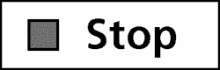 when you have determined that the equipment is operating properly.
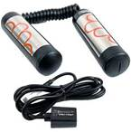
Hand Grips with hand pattern to follow!
Directional Arrows are on both the Hand Grips and Receiver Module.

Receiver Module that plugs into the sensor probe on the Logger-Pro interface.

Figure 1. The lab equipment used to measure heart rate while stationary and during exercise consists of the hand grips and the receiver module shown above.
For the next 3 segments, continue recording without stopping the data recording.
Standing Heart Rate

9. Click  to begin monitoring subject’s heart rate while standing still and upright for 2 minutes.
10. After 2 minutes, record the resulting heart rate in Table 6 on page 83. All data will be recorded into Table 6 to determine the point value awarded. Use Table 1 below to compare the recorded heart rate of subject, and then assign fitness points based on the value recorded in Table 6. Record the points (from Table 1) in Table 6 also.

Table 1. Standing Heart Rate
Beats/min | Points | Beats/min | Points
60–70 | 12 | 101–110 | 8
71–80 | 11 | 111–120 | 7
81–90 | 10 | 121–130 | 6
91–100 | 9 | 131–140 | 4

Reclining Heart Rate

11. Fully recline on a clean surface or table for 2 minutes and then record the heart rate in Table 6.
12. Again, compare the heart rate to Table 2 below and assign fitness points on that basis and record the heart rate and point value in Table 6 (on page 83).
Table 2. Reclining Heart Rate
Beats/min | Points | Beats/min | Points
50–60 | 12 | 81–90 | 8
61–70 | 11 | 91–100 | 6
71–80 | 10 | 101–110 | 4

Heart Rate Change from Reclining to Standing Position

13. From the reclined position, stand up next to the lab table and look for the peak heart rate immediately after standing. Record that value in Table 6. Click  to end data collection.
14. Subtract the reclining rate from the peak heart rate after standing to find the heart rate increase after standing. Do not record this value in Table 6, just consult points by comparing in Table 3.
15. Locate the row corresponding to the reclining heart rate from Table 3 and use the calculated heart rate increase after standing (from Step 14) to locate the proper column for fitness points in Table 3. Record the fitness points in Table 6.

Table 3. The increase in heart rate from reclining to standing upright.
Reclining rate | Heart rate increase after standing
beats/min | 0–10 | 11–17 | 18–24 | 25–33 | 34+
50–60 | 12 | 11 | 10 | 8 | 6
61–70 | 12 | 10 | 8 | 6 | 4
71–80 | 11 | 9 | 6 | 4 | 2
81–90 | 10 | 8 | 4 | 2 | 0
91–100 | 8 | 6 | 2 | 0 | 0
101–110 | 6 | 4 | 0 | 0 | 0

16. After completing this section, have subject rest for 2 minutes in preparation for the moderate exercise activity. When the rest period is over, click to begin data collection.

Exercise Activity Test

17. Click to begin data collection. Before performing the exercise activity, record the subject’s heart rate (Pre-Exercise) in Table 6.
18. Perform the exercise activity as directed by your lab instructor. This is not supposed to be a heavy, strenuous exercise activity. The aim is to create a light workload for your cardiovascular system, one that most people would comfortably recover from in about two minutes. Typically, this can be achieved by doing 10 basic squats! This can be modified to 5 if needed, but allow the instructor to figure out which value to use so that all groups are consistent.

19. When appropriate squats are completed, record the heart rate in Table 6. Quickly move to Step 20.

Recovery Rate

20. With a stopwatch or clock, begin timing to determine the subject’s recovery time. During the recovery period, the subject should remain standing and relatively still. Monitor the heart rate readings and stop timing when the readings return to the pre-exercise heart rate value recorded in Step 19. Record the recovery time in Table 6.
21. Click to end data collection.
22. Locate the subject’s recovery time in Table 4 and record the corresponding fitness point value in Table 6. If the subject’s heart rate did not return to within 10 beats/min from their pre-exercise heart rate, record a value of 6 points.
Table 4. Time for heart rate recovery.
Time (sec) | Points
0–30 | 14
31–60 | 12
61–90 | 10
91–120 | 8

Brief Exercise Test for Endurance

23. Subtract the subject’s pre-exercise heart rate from his or her heart rate after 10 squats. Record this heart rate increase in the endurance row of Table 6.

24. Locate the row corresponding to the pre-exercise heart rate in Table 5 and use the heart rate increase value to determine the proper fitness points. In Table 6, record the fitness points.

Table 5. Comparison of pre-exercise heart rate to the increase after exercise.
Pre-Exercise | Heart rate increase after exercise
heart rate | 0–10 | 11–20 | 21–30 | 31–40 | 41+
60–70 | 12 | 12 | 10 | 8 | 6
71–80 | 12 | 10 | 8 | 6 | 4
81–90 | 12 | 10 | 7 | 4 | 2
91–100 | 10 | 8 | 6 | 2 | 0
101–110 | 8 | 6 | 4 | 1 | 0
111–120 | 8 | 4 | 2 | 1 | 0
121–130 | 6 | 2 | 1 | 0 | 0
131+ | 5 | 1 | 0 | 0 | 0

25. Total all the fitness points recorded in Table 6. Determine the subject’s personal fitness level using the scale below.

Table 6. Record data in this table and tabulate points.
Circle your Fitness Level
Condition | Rate or Time | Points
Standing Heart Rate | beats/min
Reclining Heart Rate | beats/min
Reclining to Standing | beats/min
Pre-Exercise Heart Rate | beats/min | (no points here)
After Physical Activity | beats/min | (no points here)
Recovery time | Seconds
Endurance | beats/min
 |  | Total points:

25 35 45 55 +

QUESTIONS - Answer the following questions in the spaces provided below.

- How did heart rate change after moving from a standing position to a reclining position?

- Is this what you expected? _______. Briefly account for this result.

- How did heart rate change after moving from a reclining position back to a standing position?

- Is this what you expected? _______. Try to explain this result.

- Define Orthostatic Hypotension:

- How does your body protect you from orthostatic hypotension? ____________________________.

- What receptors detect changes in blood pressure in the body? _____________________________.

- Below, sketch out the important elements of the baroreceptor reflex (feedback loop).

- Now, from the sketch above: a) Where in the body are the receptors that detect changes in blood pressure located in the body? b) What are the 2 the effector tissues acted on to restore equilibrium?

a)

b)
Laboratory Exercise #7: Part 2 - Blood and Blood Typing

Objectives: When you finish this exercise, you should be able to:
1. Discuss the components of blood with an emphasis on the cells of blood;
2. Describe the ABO Blood Grouping System;
3. Understand the various functions of blood;
4. Test your own blood and determine its type.

Do you know what your blood type is? Do you know what blood types are? Or even what blood is?
Blood is a specialized body fluid that transports nutrients, O₂, CO₂ and waste products around the body inside blood vessels. Your body constantly circulates blood to ensure growth, repair, protection, and to maintain homeostasis across the entire body.

Below is a blood sample a) drawn and b) spun in a centrifuge to show the 2 major components.
a) b)
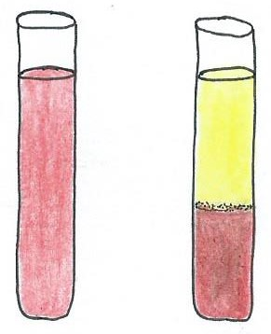
Blood consists of two major portions:
1) The liquid portion is called plasma (~55% of blood volume).
This fluid portion contains glucose, amino acids, protein, hormones,
Buffy Coat
(WBCs)
ions (electrolytes), etc. as well as dissolved O₂ and CO₂.

2) The formed elements or blood cells (~45% of blood volume). The
vast majority of cells are red blood cells (RBCs) or erythrocytes, and
white blood cells (WBCs) called leukocytes and platelet cells.

There are also white blood cells (WBCs) which are called leukocytes and platelet cells. RBC’s are special for many reasons. They are the most abundant type of blood cell, in fact more than 99% of cells in blood are RBCs! Each RBC contains about 250 million hemoglobin molecules, which helps transport O₂ and CO₂ in the body. And, it is the RBCs that determine your blood type.

Looking at Blood down the Microscope
As we may know, most of the cells in blood are red blood cells (erythrocytes); therefore, when looking at blood down the microscope mostly what we will see is RBCs. The view of healthy RBCs will display as cells being freely separated from one another, as shown in the image on the left below. Rouleaux is a term used to describe the appearance of RBCCs when they are stacked on top of one another like a role of coins, as seen in the image to the right below. The rouleaux formation usually results from abnormal amounts of certain proteins like globulins and fibrinogen in the blood. Rouleaux formation is a non-specific indication of the presence of a pathology.

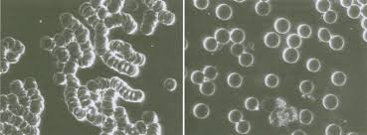

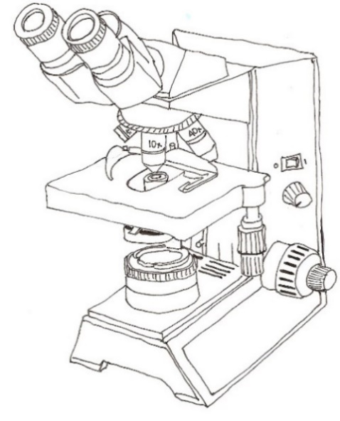
Review Exercise 1: Examining and describing Blood Cells!
1) Get the microscope out and examine the prepared blood slide (Wright’s stain blood smear) and view at the 40x objective lens (do not use oil immersion).

2) With the aid of websites, the OER textbook, and the display in the class, identify all of the blood cells represented in Table 1 below. Be as accurate as possible when describing the characteristics such as the colors of granules, nuclear shapes, relative sizes, etc., as all of these are important factors used to identify the various cell types.

All blood cells (red and white) are made in the red bone marrow by a process of hematopoiesis.

Table 1. Fill in this table with information about each blood cell shown in the first column. Information can be found in Ch 14 of the OER text for physiology, page 402.
Blood Cell Histology  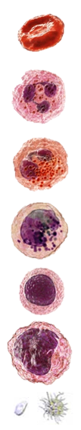 | Name: % of all blood cells | Cell Diameter (um) Life Span | Shape Nucleus | Granules  Yes  No | Basic  Functions
 | Erythrocyte
 | Neutrophil
 | Eosinophil
 | Basophil
 | Lymphocyte
 | Monocyte
 | Platelets

Blood Cell Formation Overview
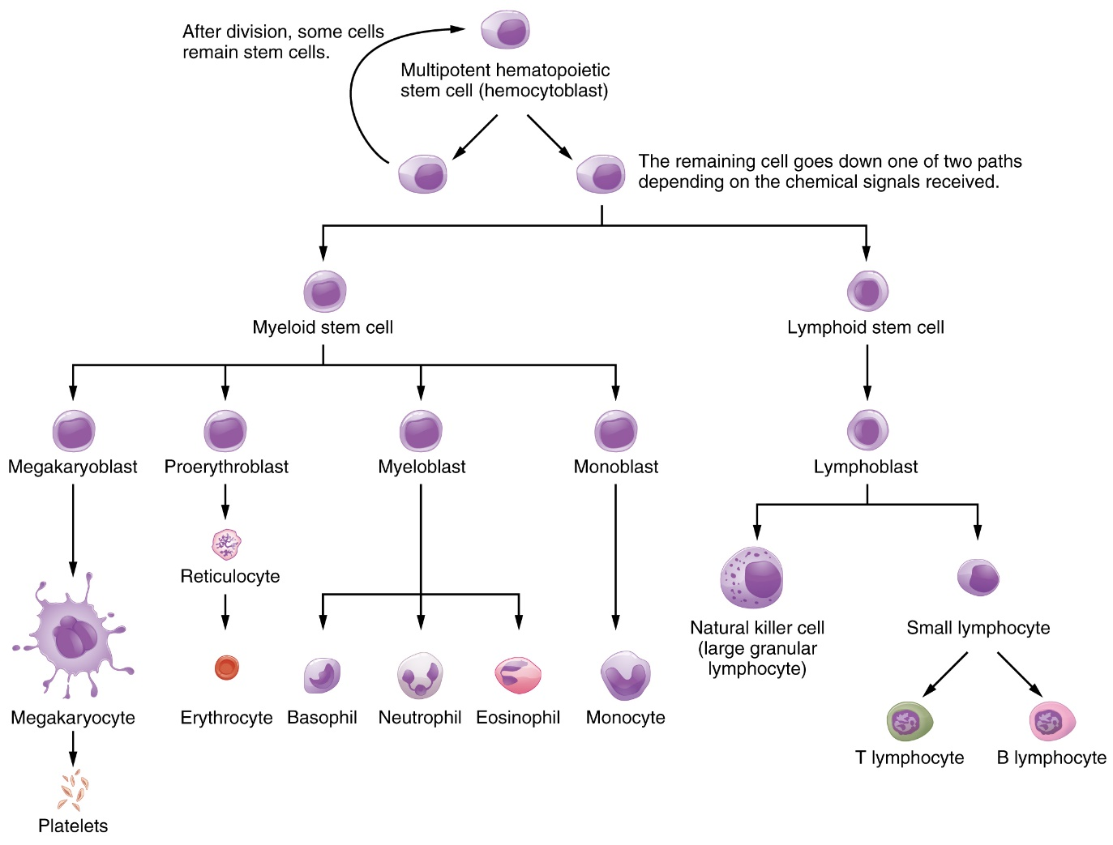
All blood cells (red and white) are made in the red bone marrow by a process of hematopoiesis. Hematopoietic stem cells are capable of differentiating into red blood cells, white blood cells and platelets. The figure below shows how the multipotent hematopoietic stem cell (hemocytoblast) generates all blood cells!

The Life Span of Blood Cells
Red blood cells (RBCs) have a life span of about 120 days and in general white blood cells (WBCs) have a life span that typically ranges from 13 to 20 days. Platelet cells have a shorter lifespan, normally just from 7 to 10 days in humans, predominantly because they are expended in clotting and do not carry on extensive metabolic activity.

The Erythrocytes or Red Blood Cells (RBC’s)
As seen in the figure above, the myeloid stem cell generates 4 cells, one of which is the pro-erythroblast, the stem cells for RBC. As these cells mature they begin to extrude the nucleus and fill with hemoglobin and they become reticulocytes - which are immature red blood cells. They become bright red erythrocytes ready to squeeze from the red bone marrow and enter into the circulation via capillaries to begin their journey around the body.
In a blood sample, the reticulocytes can be distinguished from mature RBCs because they still contain portions of their nucleus. Within a few days they become full-fledged RBCs. Therefore, a reticulocyte count of your blood will indicate your rate of erythropoiesis, or RBC production. The values for normal RBC count in blood ranges from 4.2 to 5.4 million/µL for females and 4.7 to 6.1 million/µL for males. The range for children is generally from 4.6 to 4.8 million/µL.

Erythrocyte Sedimentation Rate (ESR) is a measure of how fast red blood cells or erythrocytes sediment (settle) to the bottom of a tube over a given period of time. It is a test used to detect and monitor inflammation in the body. Normal sedimentation rates are 0-15 mm/hr for males and 0-20 mm/hr for females. Inflammation will increase sedimentation rate (i.e., RBCs will fall faster) while polycythemia will decrease sedimentation rate (i.e., RBCs will fall more slowly).

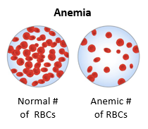
Anemia is a condition in which there is a deficiency in the O₂ carrying capacity of blood that is due to a decrease in RBCs or hemoglobin. There are many forms of anemia, but it commonly results in pallor (paleness) and weariness.

Hematocrit is the volume percentage of red blood cells in blood. It is often referred to as packed RBC volume and can be measured when a sample of blood is spun at high speeds and separates into its 2 main components. As seen earlier, normal packed RBC volume is 45% of total blood volume.

Exercise 2: There are 3 basic Categories of Anemia
Anemia is a general term that means there is a decreased oxygen carrying capacity of the blood, but there are three broad categories we can distinguish. Briefly describe them below. Use the OER text, pages 399 to 400, to assist in defining these examples and providing a specific example for each.

1) Inadequate Erythropoiesis -

A specific example is: _________________________________________________________________.

2) Hemolytic Anemia -

A specific example is: _________________________________________________________________.

3) Hemorrhagic Anemia -

A specific example is: _________________________________________________________________.

Exercise 3: Compare Normal Hematocrit and Variations from Normal

W X Y Z

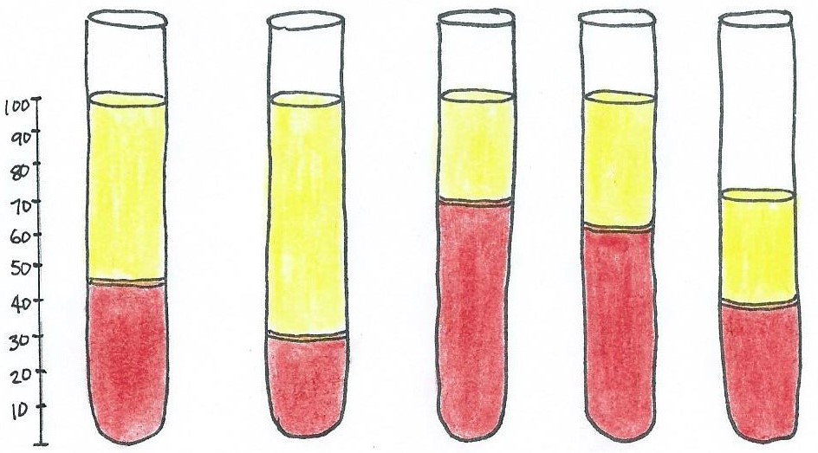

Hematocrit
(% RBC)

45% 30% 70% 60% 40%

Suggest the likely conditions based on the blood samples above?

W = _________________________________________________.

X = _________________________________________________.

Y = _________________________________________________.

Z = _________________________________________________.

Exercise 4: Using the OER text (p 400) or any other source, give a brief description of what the terms listed below mean.

Hypoxia:

Hypoxemia:

Oxyhemoglobin:

Carbaminohemoglobin:

Polycythemia:
The Leukocytes or White Blood Cells (WBC’s)

Granular Leukocytes – these cells contain granules with powerful protective enzymes.

- Neutrophils make up 60-70% of total leukocyte count in human blood. These are very active in phagocytosing bacteria and are present in large amounts in the pus of wounds. They have multi-lobed (3 to 5) nuclei and many granules. These cell ‘de-granulate’ when defending against infections. Their activity and death in large numbers forms pus in healing wound areas.

- Eosinophils have orange staining granules and a bi-lobed nucleus and are the least common WBC . They primarily deal with parasitic infections and are also predominant inflammatory cells in allergic reaction (e.g. asthma, hay fever and hives). They engulf and destroy foreign cells.

- Basophils have dark staining granules and a bi-lobed nucleus. They are responsible for allergic and antigen response by releasing histamine at site of tissue injury causing vasodilation and release heparin (a blood thinner) to limit size of a forming blood clot.

Agranular Leukocytes – these cells do not contain any granules within their cytoplasm.

- Lymphocytes are the second most common WBC, and are predominant in the lymphatic system. In general, they engulf and destroy things and release antibodies. These cell differentiate into three types of lymphocytes: B cells; T cells; and Natural killer cells.

- Monocytes are the largest of the WBC’s and act to engulf and destroy microorganisms and toxic cells in the body, other dead leukocytes and cellular debris. They present pathogens to T cells for recognition and antibody responses. Eventually some monocytes leave the bloodstream to become tissue macrophages which remove dead cell debris, as well as attack microorganisms within the tissues of the body.

Leukocytosis is used to describe a high WBC count, whereas leukemia is caner of the WBCs.

Leukopenia is low WBC count, which is almost always related to a decrease in neutrophils

The normal number of leukocytes (all WBCs) in the blood is 5,000 to 10,000 cells per cubic millimeter (mm³) or micro liter (µL).

Platelet Cells
The very small platelet cells are also called thrombocytes because they are involved in blood clotting (thrombus means ‘blood clot’). They are called cells even though they are not actually cells, but are actually fragments of very large cells called megakaryocytes. These very small 2 to 3 μm, disc-shaped cell fragments have many granules but no nuclei. Between 150,000 and 400,000 are found in each cubic millimeter (mm³) or micro liter (µL) of blood.

The function of platelet cells is to prevent blood loss by starting a chain reaction often called “platelet cell aggregation” that leads to initiation of blood clotting. Platelets signals for more platelets to arrive, degranulate and adhere together to form a protective hemostatic plug at sites of vascular injury.
Information about Blood Groups
The Antigens - these determine blood type.
The ABO blood group is based on two antigens called A and B (see examples in drawing below). Individuals whose red blood cells display only antigen A, have blood type A. Individuals who display only antigen B have blood type B. If both A and B antigens are displayed, the result is type AB blood. The absence of both A and B antigens results in type O blood.

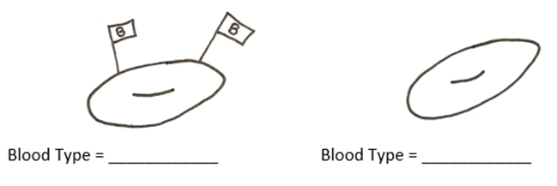
Exercise 5: Fill in the blood types for the RBCs, and the specific plasma antibodies below:
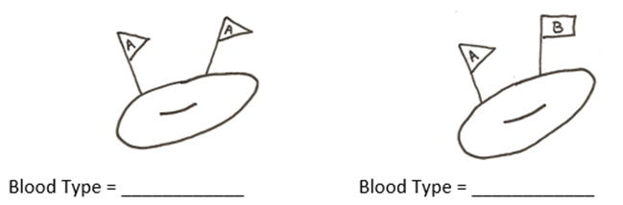
Plasma antibodies = _____ Plasma antibodies = _____ Plasma antibodies = _____ Plasma antibodies = _______

The Natural Antibodies
There are natural antibodies in blood plasma. The anti-A antibody reacts with antigen A, and the anti-B antibody reacts with antigen B. Therefore, a person cannot have antibodies in their plasma that match their blood type because the antibodies would bind the antigens of their own red blood cells. Hence, if you have an A on your RBC, then your plasma has only B antibodies, no A antibodies. If a RBC were to mix with plasma that contains its corresponding antibodies - agglutination or ‘clumping’ of blood would occur. This is bad if you want blood to flow and help keep you alive. If a RBC with an A ‘flag’ or antigen is mixed with the A antibodies, what would happen? ___________________________.

Antigens and antibodies are of critical importance in blood transfusions. If certain bloods are mixed, agglutinated cells can lodge in small capillaries in body and even rupture, releasing hemoglobin into the blood, this is called hemolysis. Therefore, certain blood types cannot be mixed!

The Rh System
The Rh system is the second most significant blood-group system that is commonly used. It is much more involved than this, but simply put the Rh factor is another RBC marker and you either have the Rh antigen (Rh positive or Rh⁺), or you do not (Rh negative or Rh⁻).

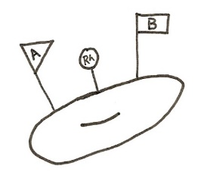
Together with the ABO blood typing, the absence or presence of the Rh factor is also included in the comprehensive blood grouping. For instance, if a person has type A antigen on their red blood cell and no Rh factor, then their blood type is A⁻ (A negative).

How would you name the Blood Type shown at right? = ____________

Rh Blood Group
The Rh factor was designated because the blood of the Rhesus monkey was used in the first research and development. The designation Rh⁺ (Rh positive) is given to those that have the antigen, and Rh⁻ (Rh negative) is for those that lack the antigen.

Look up “Hemolytic Disease of the Newborn (HDN)” and briefly describe it.

Lab Exercise: ABO and Rh Blood Grouping Test

CAUTION! Important General Safety Precautions and Procedures: When working with whole blood, wear tight fitting surgical gloves and safety goggles if available. Avoid any kind of contact with an open sore, cut, or wound. Always place all items which may have been have blood on them in the biohazard container in the lab. Read the experiment thoroughly before you perform them, to be sure that you understand all the procedures and safety precautions.

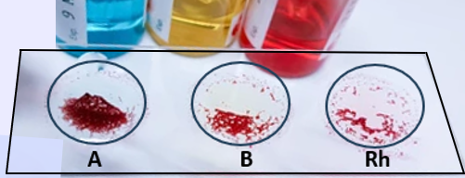

PROCEDURE
- Obtain a glass slide and using a sharpie or wax pencil, make 3 circles on a glass slide and mark them, A, B and Rh as shown in the image above.

- Then place one large drop of anti-A serum in the A circle, anti-B serum in the B circle and anti-Rh serum in the Rh circle.
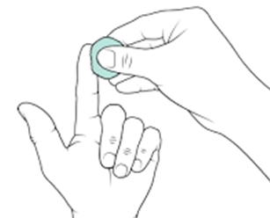
- Using the ‘finger prick’ lancet device, draw a sample of your own drop of blood from one of your fingertips as seen in the drawing. The details and advantageous techniques will be demonstrated in lab. You will need 3 drops of blood, one for each anti-serum. It is important to have warm hands before you try to get your sample.

- Once you have a drop of blood ready, add one drop of blood to each circle that already contains an anti-serum and mix each using a different mixing stick (toothpick) for each sample.

- If your blood displays agglutination or ‘clumping’, this means the sample has reacted with one of the antibodies and is a positive reaction for that antibody.

- The warmer the slide is the faster it will react. Let the samples stand for at least 1 minute and then examine them closely and carefully to observe any reaction. You are looking for ‘clumping’ (agglutination) as a positive, or no clumping (where the solution remains clear), as a negative.

*Caution! Always dispose of the toothpick, slide, lancet and alcohol wipes in the appropriate biohazard container provided in the lab.

- Record your results, using "+" for clumping and “–” for no clumping in Table 2 below. Also, record your blood type on the computer spreadsheet in lab. We can then record the class data for all blood groups in Table 3 and compare our class results with averages in the country.

Recording ABO Blood Grouping Test Results:

Table 2. For your ABO blood grouping test, indicate which sample exhibited clumping or a positive reaction when your blood was added.
Based on your observations recorded at left, your likely
ABO grouping is: ________
Blood Sample Reaction | Clumping ?  Yes = +  No = -
Anti-A serum only
Anti-B serum only
Both anti-A and anti-B sera
Neither anti-A or anti-B sera

a) What antigens are present on your erythrocytes (RBCs)? __________________________________.

b) What antibodies are present in your plasma? ___________________________________________.

For your Rh factor, which were you? Rh⁺ ____ or Rh⁻ _____: Thus, your blood type is: __________.

Table 3. Class Results for ABO (+/-) Blood Group. Compare to other sources.
Blood Type | Number of Students | % of  Class | % in the USA | Rh⁺ | Number of Students | % of  Class | % in the USA
A⁻ |  |  |  | A⁺
B⁻ |  |  |  | B⁺
AB⁻ |  |  |  | AB⁺
O⁻ |  |  |  | O⁺

Multiple Choice Questions: Select the best answer. Use lab manual, internet and Ch 14 of OER text.

1. The process by which all blood cells are formed is called
a) hemocytoblastosis b) erythropoiesis c) hematopoiesis d) leukocytosis e) monocytosis

2. An inability of body cells to receive adequate amounts of oxygen may indicate a malfunction of
a) neutrophils b) leukocytes c) lymphocytes d) eosinophils e) erythrocytes

3. Megakaryocytes are derived directly from
a) myeloid stem cells b) monoblast c) megakaryoblast d) thrombocytes e) myeloblast

4. The name of the test procedure giving information about the rate of erythropoiesis is called the
a) differential WBC count b) reticulocyte count c) hemoglobin count d) sedimentation rate

5. Normal RBC count per cubic millimeter (mm³) or micro liter (µL) in males is between ___million
a) 200 to 250 b) 10 to 15 c) 2.5 to 4.5 d) 4.7 to 6.1 e) 4.2 to 5.4

6. The normal number of leukocytes per cubic millimeter (mm³) or micro liter (µL) is
a) 5,000 to 10,000 b) 8,000 to 12,000 c) 2,000 to 4000 d) over 15,000 e) 4,000 to 6,000

7. Under the microscope, red blood cells appear as
a) circular discs with a central nucleus b) circular discs with lobed nuclei
c) oval discs with many nuclei d) biconcave discs without nuclei e) bi-lobed nucleus cells

8. The term for a high white blood cell count is:
a) leukocytosis b) hematocrit c) polycythemia d) leukopenia e) leukemia

9. Platelets are formed from small fragments of a special cell called
a) eosinophils b) hemocytoblasts c) monocytes d) platelets e) megakaryocytes

10. Hemolysis produced by fetal-maternal incompatibility of blood cells is called
a) infantile necrosis b) hemolytic disease of newborn c) newborn polycythemia d) fetal hemolysis

Fill-in Questions: Complete the following statements.
11. Another name for red blood cells is ________________________.
12. Blood gets its red color from the presence of ____________________________.
13. The lifespan of a red blood cell is approximately _________________________.
14. A good simple method for assessing anemia is_____________________________.
15. The normal value for RBC sedimentation rate of adult males is _______________________.
16. The term used for caner of the WBCs is _____________________.
17. The life span of WBC’s range from ______________________ days.
18. The number of platelets per mm³ or µL found normally in blood is _________________________.
19. The blood type showing the highest incidence in the United States is ____________.
20. In blood groups, the genetically determined structures on the RBC surface are called __________.
Matching Columns: 1. Match the statements or names in Column A with the descriptions in Column B, using each answer only once.

Column A

- A high eosinophil count
- Reticulocytes
- Serum
- Polycythemia
- Megakaryocytes
- Monocyte
- Leukopenia
- Anemia due to decrease hematocrit
- Myeloblasts
- Plasma

Column B
___ All granular leukocytes are derived directly from this cell.
___ An increase in the normal red blood cell count.
___ Immature cells that develop into mature red blood cells.
___ These cells differentiate into macrophages.
___ Liquid portion of blood without the formed elements and without clotting substances.
___ An allergic reaction, such as asthma, hay fever and hives, involves this.
___ A decrease in the normal white blood cell count.
___ Fluid portion of blood containing proteins, minerals and nutrients but no cellular elements.
___ A decrease in the normal red blood cell count.
___ This large cell breaks into small fragments that then become platelet cells.

More Blood Typing Questions

Complete the following statements:
1. The part of the cell where the antigen (aka agglutinogens) are located is the ____________________.
2. How many possible combinations of all antigens are there for any one person’s blood (?) ______ .
3. Type A blood contains antigen __________. Type B blood contains antigen __________.
4. Type A blood contains antibody ______ and type B blood contains antibody ______ in the plasma.
5. Persons with ABO blood type_______________ are often called universal recipients.
6. Persons with ABO blood type _______________ are often called universal donors.
7. The Rh blood group was named after the _____________ _____________.
10. What was the Rh type of the blood tested in the demonstration? _______________.
Lab Notes for Blood Lab

Laboratory Exercise #8: Part 1 - The Electrocardiogram (ECG)

Objectives: When you are finished with this laboratory exercise, you should be able to:
1. Calculate heart rate from the ECG;
2. Label the waves, segments and intervals of a normal ECG;
3. Recognize arrhythmias and other pathologies from the ECG;
4. Recognize abnormalities in duration and orientation of waves, segments, and intervals.

INTRODUCTION
An electrocardiogram (ECG or EKG) is a recording of the electrical activity of the heart. It is used to monitor and assess issues s with heart muscle tissue, valves, and the electrical conduction system of the heart. As the electrical signals sweep over the heart, the ECG detects these changes in the electrical currents on the surface of the skin (remember that the body contains electrolyte solutions which can conduct electricity). By placing recording electrodes on the surface of the skin, we can record the electrical activity of the heart.

The typical major components of a normal ECG recording are shown in Figure 1 below. Displayed are the characteristic set of "waves". “segments”, and “intervals” that appear in a regular pattern. Abnormalities in cardiac muscle and the ability of cells to conduct the signal can be picked up by looking for alterations in the patterns.
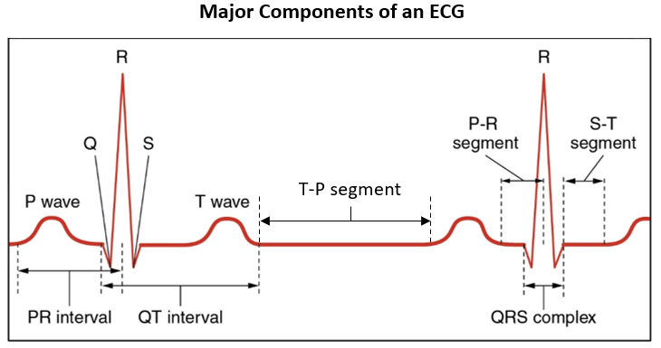
Figure 1. Shown above is a standard normal trace of an electrocardiogram (ECG) for a healthy person. The major segments, waves, intervals and complexes are labeled on this trace. Use this trace as a guide to fill in the unlabeled ECG grid on the next page.

Give a brief description of each of these components of the ECG (ask instructor) see OER Ch 15, p 437.
- Segment -
- Wave -
- Interval -
- Complex -

Lab Exercise 1: Use indicators to label the following components of the ECG onto Figure 2 below.
- PR Segment
- PR Interval
- QRS Complex
- QT Interval
- ST Segment
- T-P segment
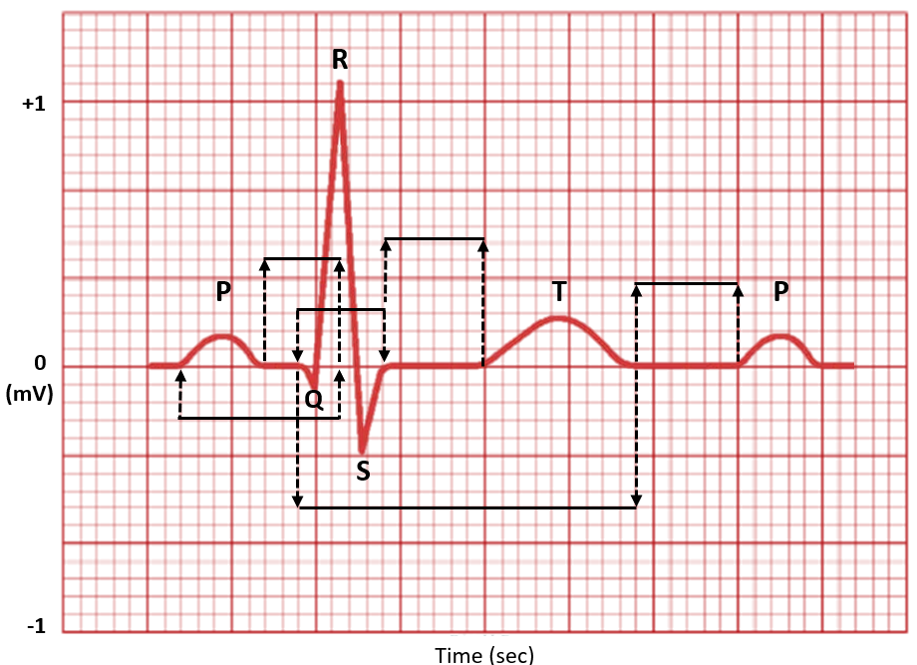
Figure 2. Provides a normal trace of an electrocardiogram (ECG) of a healthy person with only the major waves labeled. Use Figure 1 above as a guide to place the 6 components listed above onto this unlabeled ECG trace.

Your Lab table is going to take an ECG reading of all members at rest, and then immediately after low level moderate exercise. Students will then analyze the ECG trace as described below.

Note: Diagnostic ECGs are also analyzed for the height of the waves. Our system does not allow for accurate measurement of heights. For numerous reasons, this exercise is not a clinical or diagnostic tool!
Lab Exercise 2: Resting ECG
Record an ECG as the subject sits upright and still. Measure the intervals for each section of the ECG as shown in Figure 1. Be very careful and precise in your measurements. Record data in Tables 1 and 2.

Procedure
- Calculate the subject’s heart rate by the amount of time it takes to complete one heartbeat. You will be instructed how to calculate this using the ECG graph. Use several cycles in your calculation.
- Assessing Normal or Abnormal rhythms. By observation of the patterns of the ECG trace, determine whether the heart rate is fairly constant throughout the reading or whether it is irregular.
- Make note of the identifiable presence or absence of the P wave, the QRS complex, and the T wave.
- Are you able to detect each of the waves/complexes in each cycle? Is there more than one P wave in a cycle?
- Assess the trace for the correct orientation of the P wave, the QRS complex, and the T wave. Are the P wave, the R, and the T wave all in the same direction?
- For steps 2 through 5, fill in the data in Table 1 below.
- Measuring the duration of each wave, segment, and interval.
- Measure the duration (in seconds) of each portion of the ECG that is listed in Table 2 below on the next page.
- Use the cursor to block the various sections on the ECG trace, moving horizontally along the x-axis (showing time in seconds) to measure the duration of these components, that is, how long they take to occur.
- Record this data in Table 2 which provides values of the normal range for these durations as a comparison guide.
- Look for portions that are too short or extended beyond the normal range.

Exercising ECG
Record an ECG at rest and then immediately after the subject has done some relatively vigorous exercise for two minutes (determined in lab). Record data in Tables 1 and 2 below.

Table 1. Start by making a quick check of the ECG trace and scan for the appropriate range for heart rate, and the pattern for rhythm and orientation of the waves detected from the ECG.
Tick Yes or No: | Resting ECG | Exercising ECG
Heart Rate (normal range)

 | Yes or No | Yes or No
Rhythm (regular)

Correct Number of waves per Cycle?

Correct Orientation of Waves?

Table 2. Record the Duration (in sec) of the Waves, Segments and Intervals of your ECG.
 | Normal Range (sec) | Subject at Rest | Subject after Exercise
P Wave | 0.08 to 0.10
QRS Complex | 0.08 to 0.12
T Wave | 0.16 to 0.27
PR Interval | 0.13 to 0.16
QT Interval | 0.3 to 0.34
PR Segment | 0.03 to 0.06
ST Segment | 0.08 to 0.12

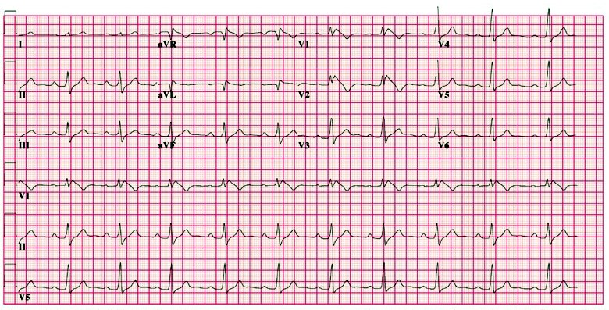
Note: In clinical settings, a 12 lead ECG is conducted on specialized ECG paper and looks something like below.

Sequence of Electrical Events in the Cardiac Cycle
Use your OER textbook to fill in the electrical and mechanical events of the cardiac cycle in Table 3 on the next page. The relevant information will be found in Chapter 15 (The Heart), and table 15.2 on page 444 will be very informative.

Also, study Figure 1 to see if you can estimate where on the ECG the various mechanical events of the cardiac cycle would fit. By filling in Table 3 (on next page), it will help to identify the electrical events that then instigates the mechanical events. For example, the P-wave on the ECG is a recording of atrial depolarization. This is a signal for myocardiocytes to begin to contract, but it precedes (comes before) atrial systole (contraction), as there is always a slight delay between the electrical signal and contraction or relaxation.

Table 3. Fill in the Electrical and Mechanical events for the various portions of a normal ECG. See OER text on website, OER Ch 15, p 444, Table 15.2.
Segment, Wave or Interval | Electrical  Event | Mechanical  Event
P-Wave
PR Interval

QRS Complex
ST Segment
T-Wave
TP Segment

Various ECG Traces - Here (below) is a normal ECG trace and some examples of pathologies on ECG traces. Compare the normal ECG trace showing the typical pattern of rate and rhythm, to the various arrhythmias and myopathies (disease states) below it. See OER text on website, Ch 15, p 437.
Normal ECG Traces

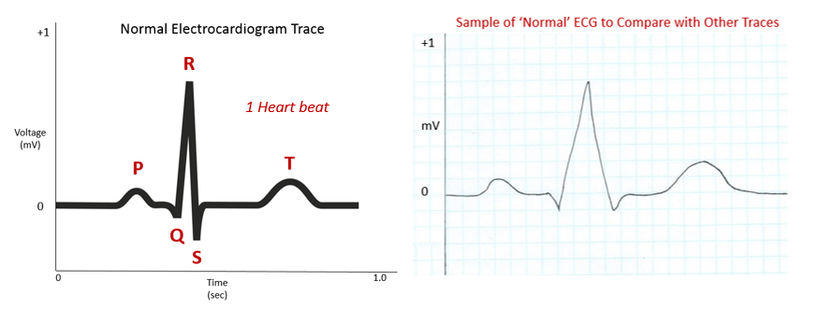

Since we are familiar with ‘normal’ ECG traces (shown on previous pages), now let’s examine several different ECG traces that have an obvious abnormal component to them.

For each of the example ECG traces a) to j) circle the abnormal portion or condition of the ECG. Then suggest what this feature might indicate about the condition of the heart.
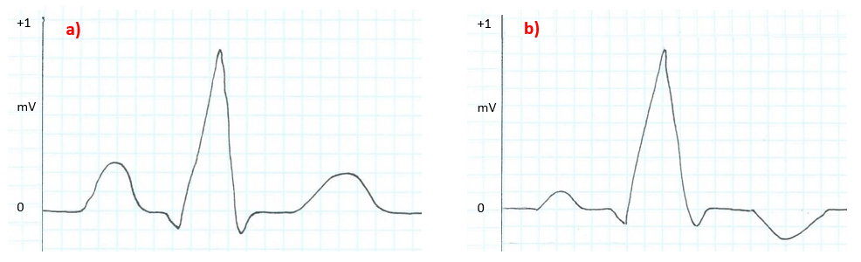

a) The abnormal component is ___________________. It may indicate ________________________.

b) The abnormal component is ___________________. It may indicate ________________________.

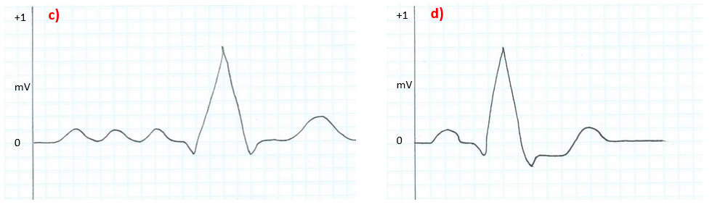

c) The abnormal component is ___________________. It may indicate ________________________.

d) The abnormal component is ___________________. It may indicate ________________________.

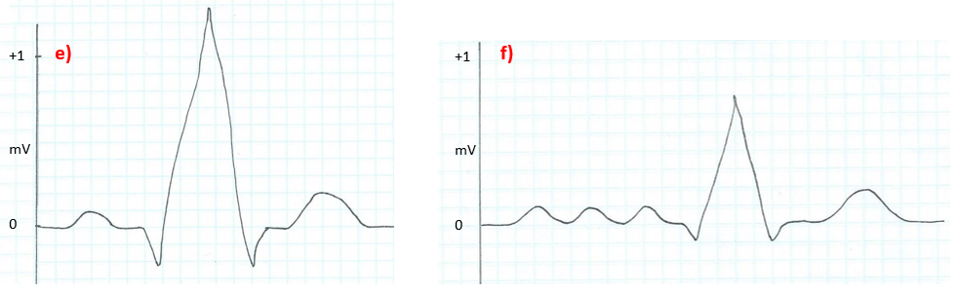
e) The abnormal component is ___________________. It may indicate ________________________.

f) The abnormal component is ___________________. It may indicate ________________________.
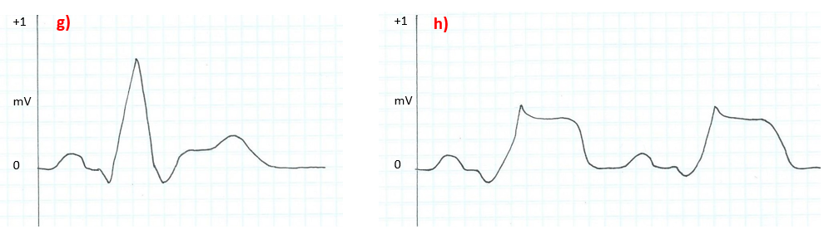

g) The abnormal component is ___________________. It may indicate ________________________.

h) The abnormal component is ___________________. It may indicate ________________________.

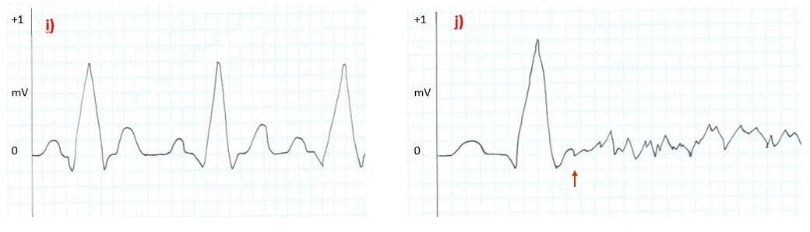
i) The abnormal component is ___________________. It may indicate ________________________.

j) The abnormal component is ___________________. It may indicate ________________________.
Lab Exercise 3: Use your OER text or internet to answer these questions regarding ECG tracings:
1. What was the main difference between the resting ECG and exercising ECG seen in this lab expt.?

- a) Define tachycardia:
b) The typical value to indicate tachycardia is at or above __________ bpm.

- a) Define bradycardia:
b) The typical value to indicate bradycardia is at or below __________ bpm.
c) From the example ECG traces from a) to j), which letter represents a trace of tachycardia? _______.

- a) What could cause an enlarged P wave on an ECG?

b) Which ECG trace (letter) shows an enlarged P wave? ________. enlarged QRS complex? ________.

- a) Define myocardial ischemia.

- How can myocardial ischemia appear on an ECG? _______________________________________.
- Which letters show it? _______.

- a) Define myocardial infarction.

b) How might myocardial infarction appear on an ECG? _________________________________.
c) Which letters show it? _______.

7. If repeated P waves occurred on an ECG, what might this be indicative of? Which letter shows it? _____.

8. a) Which letter ECG trace shows ventricular fibrillation? _______.
b) An elevated S-T segment may indicate _______________________. Which letter shows it? ______.

c) An depressed S-T segment may indicate ______________________. Which letter shows it? ______.

9. a) On an ECG trace, what heart condition does the “Tombstone” effect indicate?
b) Which letter ECG trace shows the “Tombstone” effect? _______.

10. a) Compare cardiac arrhythmias to cardiac myopathies.

b) Give two (2) different examples for each (2 heart arrhythmias, and 2 heart myopathies).
1)

2)

Laboratory Exercise #8: Part 2 – Cold Water Challenge

Cold Water is Physiologically Good for You
Getting totally submerged into cold water, especially natural sources of cold water like rivers, lakes and the ocean, are extremely good for human health. The human body, mind and spirit all tangibly benefit from routine practices involving cold water.

The Diving Reflex - This is only triggered specifically by cold water contacting the face – and it must be cold, below 60 °F (15 °C). It triggers beneficial optimization of respiration allowing us to stay underwater for extended periods of time. It also induces mild bradycardia (slowing of the heart rate).

Daily Cold Showers – Taking a cold shower, every morning (cold only), for at least 2 minutes under the cold-water stream, and for at least 7 consecutive days, can instigate many health improvements. Below are listed the main benefits that have been gathered from various types of studies.

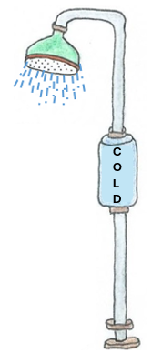
- Improves Circulation
- Increased Alertness and Energy
- Improves Mood and Emotional Resilience
- Increases Metabolism and Reduces Anxiety
- Reduces Dry Skin
- Improves Blood Glucose Handling
- Reduces Inflammation and Muscle Soreness
- Relieves Localized Pain and Improve Recovery Time
- Improves Deep Restorative Breathing

Are you ready for the Cold Shower Challenge?

Things to Consider about a Cold Shower Challenge
Taking a cold shower can feel uncomfortable, even painful for some, so it must be contemplated and attempted with caution and care. If you have any health issues that are of any concern, then by no means try this challenge. However, if you are interested, you can give it a try.

A key point about cold showers is that you may be surprised at how quickly your body adapts. The 7 consecutive days is an effective length of time to examine the reactions and effects of this challenge.

Almost universally, the immediate response to being in cold water is to quickly breathe in very deeply. The shock of the cold triggers deep breathing which actually calms us down physiologically and counters the ‘fight or flight’ sympathetic division. As you may see, the use of deliberate cold exposure can shift a person’s mental state, and this shift can be used in any setting – outside of the shower - as a tool to better cope with any type of stress in life. Most will become desensitized to the cold within a few minutes or days and begin to tolerate it more easily. Maybe some will even look forward to their cold shower.

COLD Shower Physiology Challenge
Name: ___________________________________________________ Date __________
Optional Exercise Complete this form, then visit me in my office to talk about it for a few minutes.

Requirements:
- Every morning for 7 consecutive days the participant must take a cold shower.
- The water must be cold, no other tap turned on but the cold one. It should be lower than 60ºF.
- The willing participant must remain in the water stream of that cold water shower for a minimum of 2 minutes, always under the water, not to the side, not to the front!
- Your face and head must have cold water exposure too. If you have long hair, you can tie it back or up to avoid it getting soaked, but your head and face must have that cold water!
- Once this form is completed, student needs to visit professor in office hours to briefly discuss.

A. Prior to taking the challenge, answer these questions:
1. Investigate and list any important benefits to Human Physiology from being in cold water.

2. Describe with some detail what you anticipate it being like Before you try it:

B. After taking the challenge, answer these questions:
3. Was it what you expected? Why or why not? Give examples to convey what you mean.
What surprised you about it, and what did not surprise you?

4. Select at least 2 of the 9 possible benefits from the previous page and describe any changes after having done this practice for 7 days in a row. Was there any benefit or detriment not discussed above?

Laboratory Exercise #9: Part 1 - Blood Glucose & Blood Pressure

Measuring Blood Glucose Levels in Lab
Exercise 1. Measurement of Blood Glucose

LAB SAFETY: Students will only test their own blood! All items and test strip samples with blood must be disposed of in the biohazard container on the counter, not in the trash can.

Materials: McKesson, TRUE METRIX® monitors will be used to measure glucose levels in your blood. Ideally, the best baseline (control) results will be gained when subjects (you) have fasted overnight, however, this is often not possible in class. The next best option is for subjects to have not eaten anything for at least 2-3 hours prior to test. The spring loaded lancet device will be used to make a pin prick on your finger to produce a drop of blood required for the test strip.

Table 1. Typical values for blood glucose levels in various conditions.
Condition | Blood Glucose
Fasting blood glucose | 70–100 mg/dL
2 hours after eating (postprandial) | 70–145 mg/dL
Random (casual) | 70–125 mg/dL

Methods: The instructor will demonstrate the devices you will be using in lab before you begin. With the meter off, insert code key into the slot on the side until it snaps into place.

*For best results, clench hand repeatedly and soak in warm water for a few minutes to get the blood flowing.

Procedure
- Wash and dry your hands and insert a test strip into monitor, with correct side facing up, until it can go no further. Make sure the code on the meter matches the code on the test strip bottle.
- When you see the flashing icon of a drop of blood on the screen, hold the lancet device against the side of your fingertip and press the release button.
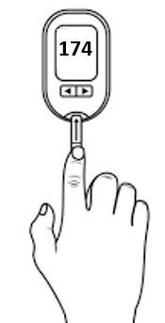
- Gently squeeze your fingertip to get a drop of blood. Touch the drop to the top of the square pad, being careful not to not to get blood anywhere else on the monitor.
- An hourglass symbol will appear on the screen within a short time, the test result will then appear on the display (as seen in the image to the right). Record your values in Table 3 on the next page.
- Be sure to remove the used lancet. Slide out the ejector to discharge the lancet into the biohazard (sharps) container on the counter.
- If using a test beverage, e.g., for an Oral Glucose Tolerance Test (OGTT), then repeat procedures 1-5 at 30 minute intervals for 2 hours after consuming the test beverage.

Data Collection

Table 2. Record individual subject's blood glucose before (baseline), and every 30 minutes for 2 hours after consuming 250 ml of the test assigned beverage.
Parameter | Beverage Consumed | Baseline  (Control) | After 30 min | After 60 min | After 90 min | After 120 min
Blood
Glucose

Table 3. At the end of the experiment after all students have entered their data, record the class averages gathered for the entire class for changes in blood glucose before (baseline), and every 30 minutes for 2 hours after consuming 250 ml of the test assigned beverage. The sample size is n = _____.
Parameter | Baseline  (Control) | After 30 min | After 60 min | After 90 min | After 120 min
Blood
Glucose

Exercise 3. Creating a Graph from Lab Data

Graphing Procedure
- Use the data set collected for the entire class (the averages of all subjects) recorded in Table 4 to create a graph on the effect of drinking a high blood glucose solution on blood glucose.

- The baseline (control) value is at time 0, prior to subject’s consuming any beverage. The blood glucose values continue to be measured every 30 minutes, up until 120 minutes after consuming the drink.

- After filling in the blank graph grid on the next page with the data from Table 4, then create a figure legend for the graph entitled “The Effect of Drinking a High Glucose Solution on Blood Glucose”. See information in Lab #3 (Constructing Graphs 101), page 38. There is also helpful information in Lab #14 (Data Gathering) on page 161.

Review: What is a Figure Legend?
A figure legend is written text that accompanies a figure, and a graph is considered a figure. The figure legend is numbered and typically displayed underneath the graph in papers and reports.

The Purpose of a Figure Legend: Is to enable the reader to understand the results of an experiment and how it was conducted. A good figure legend would include all the necessary information, such as; the subjects or trials involved and their number (sample size or n); various techniques used; for how long; in what order; the type of equipment used (including make and model if applicable); etc. All of this information is so the reader could replicate the same process or experiment shown in the graph.

Use the space below to create a Figure Legend for the completed graph above:

Information on Various Methods for Testing Blood Glucose Levels

Hormones Regulating Blood Glucose
The regulation of blood glucose involves the endocrine system and two important hormones with opposing (antagonistic) actions, Insulin and Glucagon.

- Insulin is made by beta cells in the pancreatic islets (pancreas). When blood glucose rises (e.g., after a meal), insulin is released and acts to decrease blood glucose by inserting Glut-4 transporters into cells, causing them to import glucose thereby lowering glucose levels in blood. The release of insulin promotes fat storage in the body.

- Glucagon is made by alpha cells in the pancreatic islets (pancreas). When blood glucose decreases (e.g., in between meals), glucagon is released and acts to increase blood levels by inducing glycogenolysis (breaking down glycogen) which liberates glucose into the blood. It also breaks down lipids and protein for gluconeogenesis (‘making new glucose’).

The Oral Glucose Tolerance Test (OGTT) measures the body's ability to use glucose. This test can be used to diagnose diabetes mellitus and prediabetes, or gestational diabetes associated with pregnancy.

The glucose tolerance test is a medical test in which a weight-standardized dose of glucose is given orally and blood samples are taken over time to determine the rate of glucose clearance from the blood. Samples may be taken every 30 min, or only once after either one hour or 2 hours.
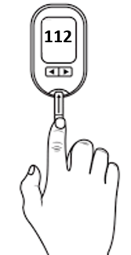
In general, after an overnight fast (8 hours) normal blood glucose typically ranges from 70 to 100 mg/dL.

In this lab students will measure their blood glucose using a blood glucose meter before and for at least 1 hour after drinking a grape juice beverage. We will collect the class data and then graph the results on the blank graph grid provided on page 114.

Examples of Commonly used Glucose Testing:
- Random Glucose - measured anytime regardless of last meal. Range: 70-120 mg/dL, normal.

- Fasting Plasma Glucose - measured at least 8 hours post meal. Range: 70-100 mg/dL.
If fasting levels from 110 and 125 mg/dL, considered ‘impaired fasting glycaemia’.
If fasting levels repeatedly at or above 126 mg/dL, diagnostic of diabetes mellitus.

- 1 hour GTT (Glucose Tolerance Test) - measured 60 mins post glucose ingestion.
Range: Below 180 mg/dL, considered normal.

- 2 hour GTT (Glucose Tolerance Test) - measured 120 min post glucose ingestion.
Range: Below 140 mg/dL, normal.
Range: Higher from 140 to 200 mg/dL, indicates hyperglycemia.
Range: Above 200 mg/dL at 2 hours, confirm "impaired glucose tolerance" diabetes mellitus.

The A1C Test for Glycated Hemoglobin
The A1C test, or the hemoglobin A1C, HbA1c. or glycated hemoglobin test gives information of the average blood glucose levels over the past 3 months! Used to diagnose Type 2 diabetes and prediabetes.

The A1C test measures the amount of hemoglobin (Hb) with attached glucose (as a %), as glucose attaches non-enzymatically to Hb with in RBCs. The higher the %, the higher the blood glucose levels have been over the last 3 months. The illustration of this concept is shown below.

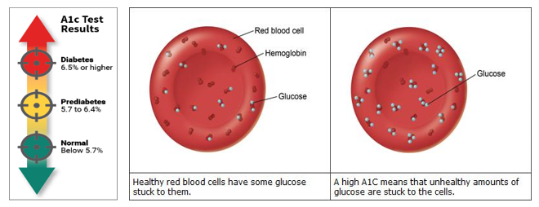
Scale:
Below 5.7% = normal.
From 5.7 to 6.4% = pre-diabetes.
At 6.5% or higher = diabetic.

Content Check:
1) Which of the following hormones is needed during exercise due to glucose depletion?
a) Oxytocin b) Insulin c) Glycogen d) Glucose e) Glucagon

2) Insulin:
a) facilitates the transport of glucose into most brain cells.
b) increases blood glucose levels to ensure adequate nourishment for the brain.
c) promotes fat storage in the body. d) secretion is stimulated by a lowered blood glucose level.
e) stimulates the hydrolysis of glycogen in the liver to increase blood glucose levels.

3) The normal overnight fasting value for blood glucose is:
a) 200 mg/dL b) 100 mg/dL c) 70 to 120 mg/dL d) 70 to 100 mg/dL e) 140 to 200 mg/dL

4) What does the A1C test measure?
a) blood glucose b) the % of glucose attached to Hb c) the density of RBC’s d) the % of RBC’s in blood

5) The hormone glucagon is made in the pancreas by __________ cells in the pancreas.

Measurement of Blood Pressure
Exercise 2. Measurement of Blood Pressure as Influenced by Position of Body
For normal perfusion of body tissues, arterial blood must have sufficient pressure to overcome the resistance to flow. Since arterial blood pressure is directly dependent on cardiac output, when we change our body position, blood pressure and flow will also change. This experiment is to measure how the activity of our heart makes adjustments to maintain equilibrium in terms of mean arterial pressure (MAP).

Materials
An automated blood pressure cuff will be used to measure blood pressure and heart rate of subjects.

Methods
Work in pairs and record your lab partners data in your lab manual when they are the subject. The subjects will be in three body positions for the measurement of blood pressure and heart rate (pulse) as follows:

1) Sitting comfortably in a chair;
2) Reclined in a supine position, that is, lying on their backs on the lab table; and
3) Standing erect with both feet on the ground.

Make these measurements in this order and fill data in on Table 1 below. Allow subjects to be seated and lying down for at least 2 minutes before taking these measurements to establish a baseline reading. However, take the measurements for standing immediately upon them standing. We will go through an outline of the sequence of events for these methods in class.

Table 4. Record subject's blood pressure and heart rate for various positions in this table. Perform this experiment in the order presented in methods.

 | 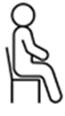  Sitting (1) |   Reclining/Supine (2) | 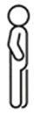  Standing (3)
Systolic Pressure
(mm Hg)
Diastolic Pressure
(mm Hg)
Pulse Pressure
(mm Hg)
Mean Arterial Pressure
(mm Hg)
Heart Rate
(bpm)

Write the equation for calculating Mean Arterial Pressure (MAP): ________________________________.
Write the equation for calculating Pulse Pressure: ____________________________________________.
Why is the formula not a straight “average”?
Laboratory Exercise #9: Part 2 - Effects of Drugs on the Heart

Objectives: When you are finished with this laboratory exercise, you should be able to:
1. Understand the ways that various drugs effect the heart’s function;
2. Explain and describe the specific effects of the following drugs on heart rate and force of contraction: 1) Atropine, 2) Caffeine, 3) Digitalis, 4) Epinephrine, 5) Nicotine, 6) Pilocarpine, 7) Propranolol, 8) Sodium Ions (Na⁺), 9) Calcium Ions (Ca²⁺), and 10) Potassium Ions (K⁺).
3. Define the terms chronotropic and inotropic, agonist and antagonist.

A drug is a substance that affects some aspect of physiology when it is given to the body. Drugs may be identical to substances found in the body (endogenous compounds) such as hormones, vitamins, minerals, or they may be molecules that are derived from plants or other organisms.

The effects of endogenous compounds can vary depending on their concentrations. For example, at normal levels K⁺ is required for homeostasis, but too high a concentration can be fatal. Also, if concentrations of hormones become abnormally high, they may be deleterious. Therefore, it is important to distinguish between the physiological effects (normal effects) and the pharmacological effects (effects when administered as drugs).

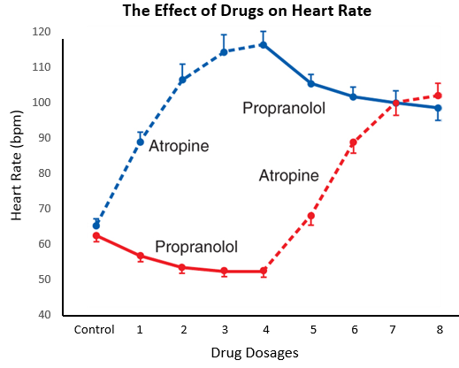

Figure 1. This graph shows the effects of two drugs, atropine (a muscarinic blocker) and propranolol (a beta blocker), on heart rate. It is important to understand the actions of various drugs on the activity of the heart.

The Effects of Various Drugs on the Heart

A. Effect of Atropine on the Heart
Atropine is a parasympathetic antagonist, meaning it blocks the actions of this ANS division. It is an alkaloid drug derived from the nightshade plant (belladonna). Atropine blocks muscarinic receptors for acetylcholine on postganglionic parasympathetic neurons. Thus, atropine inhibits the parasympathetic innervation of the heart, smooth muscle, and glands. Normally the heart rate is decreased from vagal stimulation, but the administration of atropine will increase heart rate.

Drug Use: Clinically, atropine is used in ophthalmology to dilate pupils of the eyes (parasympathetic nerves constrict pupils). Atropine is also used prior to surgery to dry the mouth, pharynx, and trachea (parasympathetic stimulates glandular secretions, keeping these mucous membranes wet normally).

B. Effect of Caffeine on the Heart
Caffeine is a mild central nervous system stimulant that also acts directly on the myocardium to increase heart rate and increase the force of contraction. Caffeine inhibits phosphodiesterase, the enzyme that breaks down cyclic AMP (cAMP). As a result, cAMP levels in heart cells increase, replicating the action of epinephrine. Caffeine's usefulness as a central nervous system stimulant is limited since high doses can promote the formation of ectopic focus resulting in arrhythmias.

C. Effect of Digitalis on the Heart
Derived from the plant Digitalis purpurea, forms of digitalis (like digoxin) increase the force of contraction of the heart, which increases stroke volume. The effects of digitalis are believed to be due to its inhibition of the Na⁺/K⁺ pump and results in an increased influx of Na⁺ and an efflux of K⁺. This is then accompanied by a slowed removal of Ca²⁺, leading to increased intracellular Ca²⁺, which increases the force of contraction of myocardiocytes. The effects of digitalis on the heart are very similar to that of increased extracellular Ca²⁺.

Drug Use: Digitalis is frequently used clinically for congestive heart failure, atrial flutter, and atrial fibrillation. Digitalis: 1) increases the force of contraction; 2) decreases cardiac rate directly by inhibiting the SA node, and indirectly by stimulating the vagus nerve (which in turn inhibits the SA node); and 3) slows electrical conduction through the bundle of His, thus increasing the P-R interval, which enhance the AV nodal delay.

D. Effect of Epinephrine on the Heart
Epinephrine (E) is a hormone secreted by the adrenal medulla. Sympathetic postganglionic neurons release norepinephrine (NE) triggering release of E into the bloodstream (called the sympatho-adrenal system). Epinephrine acts to increase heart rate and force of contraction by activating the cAMP second messenger system, this also causes an influx Na⁺ and Ca²⁺. Exogenous epinephrine is a sympathomimetic drug, since it mimics the effect of sympathetic nerve stimulation.

Drug Use: The drug propranolol (see below) is a beta-blocker that inhibits the effects of E and NE on the heart and blood vessel. For these reasons, it is often prescribed to reduce hypertension.
E. Effect of Nicotine on the Heart
Nicotine stimulates nicotinic receptors for ACh on postganglionic neurons. When nicotine is administered systemically (in the blood as with smoking), it can stimulate sympathetic ganglia and the adrenal medulla (part of the sympatho-adrenal system) resulting in an increase in heart rate, via sympathetic activation. If nicotine is applied directly to the heart, the major effect is stimulation of parasympathetic ganglia that are located within the epicardium, this will decrease the heart rate. Since both divisions of the ANS are activated by nicotine, the result is a both a stimulating and calming effect!

F. Effect of Pilocarpine on the Heart
Pilocarpine is a parasympathomimetic drug, that is, it mimics or enhances the effect of parasympathetic nerve stimulation. Pilocarpine acts to facilitate the release of ACh from the vagus nerve, resulting in a decrease in cardiac rate. This drug can also be used to treat glaucoma (excessive pressure in the eye) by dilating vessels that drain fluid from the eye.

G. Effect of Propranolol on the Heart
Propranolol is a type of beta blocker, meaning it inhibits NE and E from binding to β receptors, therefore blocking sympathetic innervation and hormonal effects of E and NE. It acts to slow down the heart rate.

Drug Use: Used to treat high blood pressure and irregular heartbeat (arrhythmia), like atrial fibrillation. Also promoted as a remedy to reduce symptoms of anxiety, such as sweating and shaking. Like other beta blockers, propranolol works by inhibiting your body’s natural responses intense situations.

H. Effect of Calcium ions (Ca²⁺) on the Heart
The normal concentration range of Ca²⁺ in blood is from 8.6 and 10.2 mg/dL, increases in Ca²⁺ above this will have an effect on both the electrical properties and the contraction strength of heart muscle. Specifically; 1) it results in an increased force of contraction; 2) it decreases heart rate; and 3) it can result in the appearance of ectopic pacemakers in the ventricles, producing abnormal rhythms.

I. Effect of Potassium ions (K⁺) on the Heart
Since the resting membrane potential requires a higher concentration of K⁺ inside the cell than outside, an increase in extracellular K⁺ results in a decrease in the resting membrane potential (it becomes more positive). This can result in a decrease in the force of contraction, and decrease the conduction rate of action potentials. In extreme hyperkalemia (high blood potassium) the resting potential of cardiac cells is closer to threshold for action potentials, cells become more electrically excitable, and ectopic pacemakers may appear in the ventricles and fibrillation may develop. High extracellular K⁺ also slows down repolarization so the heart rhythm becomes slow and erratic.

J. Effect of Sodium ions (Na⁺) on the Heart
Extracellular sodium has no significant influence on heart activity, yet the heart rate depends on intracellular Na⁺. The limiting time for repolarization is the transport capacity of the Na⁺/K⁺ pump, which ejects Na⁺ from the cell. Since this capacity is limited, the presence of more Na⁺ creates prolonged repolarization and thus causes a slower heart rate.

The Effects of Drugs on the Heart

After reading the previous pages (114-115) now answer the following questions. Also use the information in lecture, our OER text, internet, etc. regarding the effects of drugs on the heart.

Part 1: Multiple Choice and Fill In Questions:

1. The drug Digitalis inhibits the Na⁺/K⁺ pump in cardiac cells. What effect will this have on the heart?
a) increases Ca²⁺ in myocytes b) increases force of contraction c) decreases force of contraction
d) both a and b will occur e) no effect on the heart

2. As I sip my piping hot cup of freshly brewed Coffee in the morning I experience an increase in Caffeine systemically. What effect will this have if it is in direct contact with my heart?
a) increase heart rate and force of contraction b) decrease heart rate
c) decrease force of contraction d) both b and c will occur e) no effect on the heart

3. The drug Pilocarpine mimics the parasympathetic division of the Autonomic Nervous System, therefore, it
a) increases heart rate b) increases force of contraction c) decreases heart rate
d) increases endocrine output of NE & increases heart rate e) has no effect on heart rate

4. If, while enjoying my Laramie cigarette, some Nicotine is introduced into my blood stream, what effect will this stimulant have on the heart?
a) no effect b) decrease heart rate c) decrease stroke volume
d) increase stroke volume e) increase heart rate

5. The drug Atropine is a cholinergic _____________________.
a) receptor b) agonist c) antagonist d) sympathomimetic e) parasympathomimetic

6. The effects of Caffeine on the heart are very similar to the effects of _______________________.
a) pilocarpine b) acetylcholine c) epinephrine d) nicotine e) digitalis

7. If preparing for oral surgery, what blockers and/or agonist would you administer to the patient?
1. pilocarpine 2. acetylcholine 3. epinephrine 4. atropine
a) 1 and 3 b) 2 and 4 c) 4 and 1 d) 4 only e) 2 only

8. In the previous question, what would be the desired effect?
a) dilation of pupils b) reduction in salivary activity c) constriction of pupils
d) decrease in gastric secretion and motility e) temporary paralysis of tongue is achieved

9. The function of a phosphodiesterase is to
a) break down cAMP b) stimulate Ca²⁺ ATPase activity c) generate cAMP
d) add phosphates to substrates e) stimulate the parasympathetic response of the heart

10. In a reaction that is catalyzed by __________, the second messenger cAMP is made from _____.
a) cAMP; Ca²⁺ b) ATPase; ATP c) adenylyl cyclase; ADP d) cAMP; K⁺ e) adenylyl cyclase; ATP

Virtual Heart Lab – The Effects of Drugs on the Heart

Background
We have already seen that the control systems of the body are the nervous and endocrine systems. They exert their control by releasing endogenous signal molecules (ligands) which act upon target cells that contain receptors for those ligands. These endogenous substances are made in our body to regulate essentially all functions homeostatically. Drugs are exogenous substances that are delivered in to the body and have pharmacological effects on various functions. Drugs may stimulate the actions of endogenous secretions, while other may act uniquely.

This virtual lab will demonstrate the effects of chemical modifiers on the heart. The effects of several commonly used drugs have been described. We will examine the effects of cholinergic and adrenergic modifiers on the heart and relate them to the parasympathetic and sympathetic activation.

Heart rate is an intrinsic property, controlled within the heart itself and it is due to the activity of the sinoatrial (SA) node. The parasympathetic (Para) and sympathetic (Sym) divisions of the ANS exert control over the heart and act to modify the rate that the heart beats. The strength of the hearts contraction is its force (which exhibits as stroke volume) and this is primarily determined by the amount of intracellular Ca²⁺. The more intracellular Ca²⁺ the more forceful the contraction. It is the Sym division that modulates the force of the heartbeat.

Agonists are substances that bind to target receptors and produce a response similar to the true ligand.
Antagonists bind to receptors but do not stimulate them, thus they do not produce a response.

When the Effector Tissue is the Heart:
- Postganglionic Parasympathetic neurons release acetylcholine (ACh) onto muscarinic receptors. Receptors are cholinergic if they bind ACh.

- Postganglionic Sympathetic neurons release norepinephrine (NE) and epinephrine (E) and onto α and β receptors. Receptors are adrenergic if they bind NE or E.

Direct Application of Drugs to the Heart:
Modifiers that effect the heart can be categorized as either chronotropic or inotropic.

- Chronotropic drugs change the heart rate and rhythm of the beating heart by affecting the electrical conduction system of the heart and the nerves that influence it. If the heart rate increases, they are positive chronotropes; if the heart rate decreases, they are negative chronotropes.

- Inotropic drugs alter the force or energy of heart's muscular contraction. If the heart beats more strongly, they are positive ionotropes; if the heart beats more weakly, they are negative ionotropes.

We will examine the effects of cholinergic and adrenergic modifiers on the heart and relate them to activation. Any drug or modifier that affects a pathway is either an agonists or antagonists of the cholinergic or adrenergic pathway.
In the Virtual Experiment, the drugs are dropped onto the frog heart and the changes in heart rate and size of contraction waves (thus force) are measured on the myogram (shown below). After each intervention, Ringers solution (an isotonic saline solution) is used to rinse the drugs off of the frog heart.

Drugs Applied to Heart
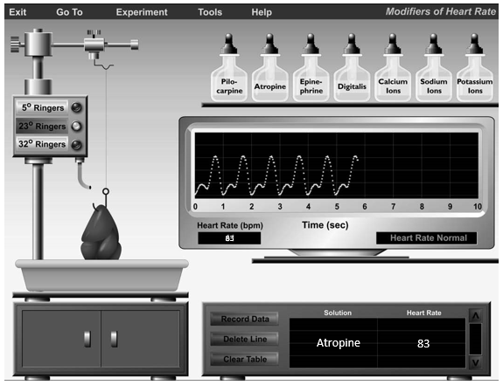

Figure 1. The virtual experimental set up seen above shows how various solutions can be applied to a heart and the changes in heart rate (in beats per minute or bpm) can be measured in response to those solutions.

Table 1. Results from the Virtual Experiment of the listed drugs on the frog heart are shown below.
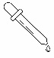  Drug  Applied | Effect on  Heart Rate (bpm) | Other Observations:  (Changes in amplitude compared to Normal)  (Changes in rhythm compared to Normal)
Normal | 70 | Normal
Pilocarpine | 53 | No changes in the amplitude waves (force)
Atropine | 83 | No changes in the amplitude waves (force)
Epinephrine | 92 | Increased amplitude waves (force)
Digitalis | 52 | Increased amplitude of waves (force)

The Effects of Ions on the Heart
As we have seen in physiology, the ions calcium (Ca²⁺), potassium (K⁺), and sodium (Na⁺) and have effects on the heart. Calcium ions are important for contractility and also play a role in heart rate. Sodium and potassium are important in the electrical signaling of the heart.

Table 2. Results from the Virtual Experiment of the listed drugs on the frog heart are shown below.
Drug  Applied | Effect on  Heart Rate (bpm) | Other Observations:  (Changes in amplitude compared to Normal)  (Changes in rhythm compared to Normal)
Normal | 70 | Normal
Calcium Ions (Ca²⁺) | 84 | Increased amplitude waves (force)
Potassium Ions (K⁺) | 32 | Decreased amplitude waves (force)  Erratic rhythm of heart rate
Sodium Ions (Na⁺) | 38 | Decreased amplitude waves (force)  Erratic rhythm of heart rate

Incorporating the results shared above, along with the information provided in this lab manual (pages 108-109), use Table 3 below to summarize the specific characteristics of the drugs and ions applied in the virtual heart experiments and their effects on the heart.

Table 3. Use the experiments and information provided (and consult websites or textbooks) to fill in the specific nature of each drug or ion, and the listed results for each of the drugs applied below.
Drug  Applied | Adrenergic/  Cholinergic  Other | Agonists/  Antagonists  Other | Increase/  Decrease  Heart Rate | Increase/  Decrease  Force
Pilocarpine
Atropine
Epinephrine
Digitalis
Calcium Ions (Ca²⁺)

Potassium Ions (K⁺)

Sodium Ions (Na⁺)

Questions Part 2: Fill-in and Short Answers:

1. The effect of digitalis on the force of heart contraction is: __________________________________.

2. What is the theory for how digitalis has its effects on myocardiocytes?

3. What is the effect of digitalis on the SA node?

4. What is the effect of digitalis on the AV node?

5. Compare the actions of atropine and propranolol on the heart, include receptors and divisions of the ANS that are involved and how they affect the heart’s activity.

6. Often calcium channel blocking drugs are applied to people with high blood pressure. Consider that someone asks how the drug works. Explain how the heart cells may be influenced. Also contemplate how blood vessels may also be impacted by these blockers, and the consequences of that.

7. List the 3 factors contributing to resistance (R) of flow in a tube as described by Poiseuille’s Law. Circle the one factor that is the most influential.

1)
2)
3)
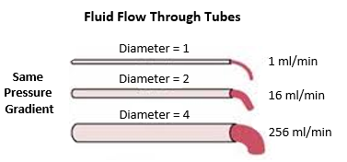

8. Blood flow through a vessel depends on the pressure gradient and resistance. Write a simple formula for Blood Flow.

_________________________________.

9. a) Resistance (R) is explained by Poiseuille’s Law. Write the full formula for Poiseuille’s Law below.

_________________________________.

b) Since one factor is most significant and influential for resistance to flow, use a simplified version of Poiseuille’s Law to describe Resistance (R) to flow.

_________________________________.

10. Use the information above to calculate the Flow of blood through the vessels A and B below.
Since this is a simplified formula, it is not necessary to show units in the final answers for flow.

Vessel A: Vessel B:
P₁ = 35 mm Hg P₁ = 90 mm Hg
P₂ = 15 mm Hg P₂ = 20 mm Hg
ΔP = ΔP =
Vessels radius (r) = 2 mm Vessel radius (r) = 1 mm
R = R =
Flow = Flow =

Laboratory Exercise #10: Human Respiratory Studies

Objectives: When you have completed this exercise, you should be able to:
- Define the different lung volumes, reserves, and capacities;
- Perform the various pulmonary function tests using Vernier sensors and peak flow meters;
- Describe the diagnostic value of the different tests.

INTRODUCTION
Physiologists and pulmonary specialists have developed some simple tests for determining proper lung function. As you can imagine, having a person breathe in and out under different circumstances is the basis of the tests. In this laboratory exercise you will learn how to use a spirometer and a peak flow meter. With these pieces of equipment, you can measure lung volumes and capacities. From the results of these tests, certain pulmonary disorders can be detected.

The following is an illustration of a trace from a recording spirometer. We will be using a spirometer in these experiments and this will give us a spirogram. The upward movement of the recording pen occurs during inspiration and downward movement of the pen occurs during expiration. Using calibrated paper, we will be able to determine the volumes of air inhaled or exhaled from these recordings.
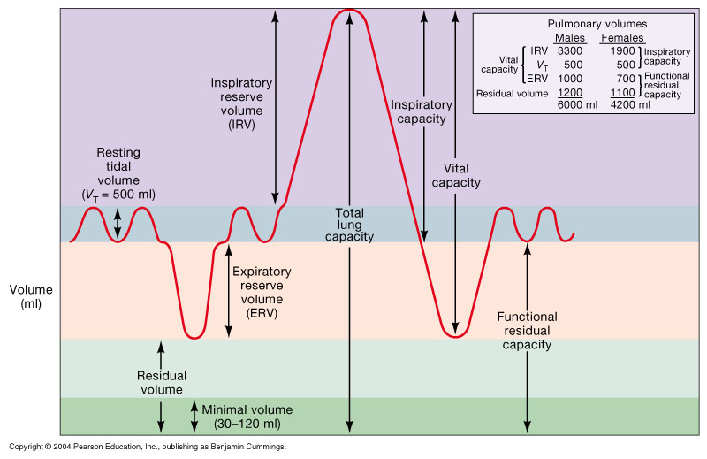

Figure 1. This is an example of a spirometer recording, showing the various lung volumes and lung capacities (ml) for a 70Kg male subject. Note that the volumes are typically recorded in ml.

Part I. A: Definitions of Pulmonary Volume Tests
Before you begin the lab experiments, it is useful to become familiar with what these tests measure and how to perform the tests. Use websites or textbooks to help you fill in the table below.

Table 1. Give the definitions of and the typical values for the following lung volumes and capacities.
Pulmonary Function Formula, Units, Values | Description of Pulmonary Test
Respiratory Rate
(RR)
Values:
Tidal Volume
(V_{T})
Values:
Inspiratory Reserve Volume
(IRV)
Values:
Expiratory Reserve Volume
(ERV)
Values:
Residual Volume
(RV)
Values:
Inspiratory Capacity
(IC) = V_{T} + IRV
Values:
Vital Capacity
(VC) = V_{T} + IRV + ERV
Values:
Total Lung Capacity
(TLC) = V_{T} + IRV + ERV + RV
Values:
Functional Residual Capacity
(FRC) = ERV + RV
Values:
Total Pulmonary Ventilation
(Total Minute Volume)
Values:
Forced Expiratory Volume
(FEV₁)
Values:
Part I. B: Measurement of Respiratory Rate and Volumes at Rest
For this section, you will work in table groups. The instructor will demonstrate how the Vernier spirometer is set up and how to access and read the volumes off the computer screen. Select your first subject from your group and have them sit comfortably. The subject must be instructed not to observe the graphical chart on the computer while performing any of these tasks. Important: Do not attempt this experiment if you are currently suffering from a respiratory ailment such as the cold or flu.

Materials: Disposable mouthpiece and bacterial filter; computer interface; nose clip; Spirometer set.

Procedure
1. Connect the Spirometer to the Vernier computer interface. It should automatically open to the file “19 Lung Volumes” from the Human Physiology with Vernier folder.
2. Attach the larger diameter side of a bacterial filter to the “Inlet” side of the Spirometer. Attach the disposable mouthpiece to the other end of the bacterial filter as shown below.
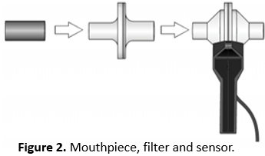

Figure 2. Mouthpiece, filter and sensor.

3. Hold the Spirometer in one or both hands and brace your arm(s) against a solid surface, such as a table. Have your lab partners click “zero” to zero the sensor. Note: The Spirometer must be held straight up and down, as in the Figure above, and not be moved during data collection.

4. Click to commence data collection:
a. Put nose plug on subject. Lab partners click “collect” to begin.
b. Taking normal breaths, begin with an inhalation and continue to breathe in and out. These will show on the trace as examples of tidal volume (V_{T}).
c. After about 2 cycles of normal inspirations and expirations fill your lungs as deeply as possible for a maximum inspiration, this will be your inspiratory reserve volume (IRV). Then exhale as fully as possible for a maximum expiration this will be your expiratory reserve volume (ERV). It is essential that maximum effort be expended when performing tests of lung volumes. Follow this with at least one additional recovery breath.

5. Have your lab partners click “stop” to end data collection.

6. This is Important: In order to see the lung volume data, click the “Next Page” button.

It will display the volumes (shown in the graph on the next page) for easy measuring.

If the baseline on your graph has drifted, use the Baseline Adjustment feature to bring the baseline volumes closer to zero (as seen in the Figure shown on next page).
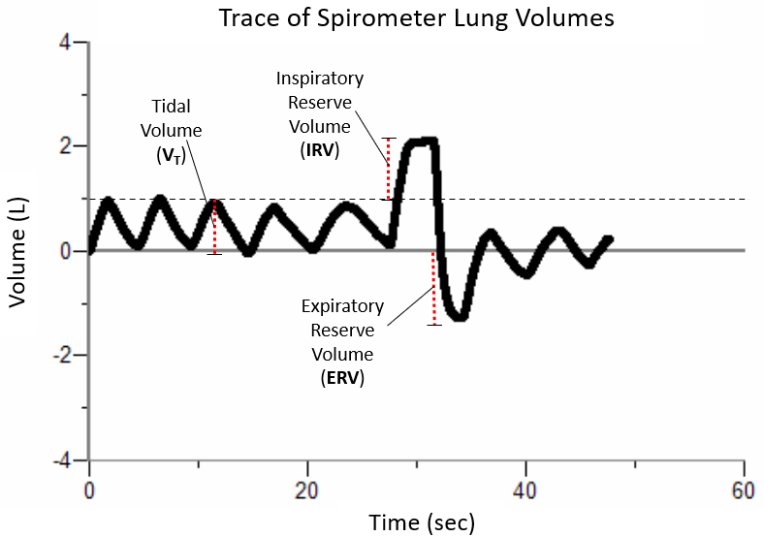
7. The trace on the computer should look something like the spirometer lung volumes shown above. All that is needed on the trace are 3 lung volumes: 1) tidal volume (V_{T}), 2) inspiratory reserve volume (IRV), and 3) expiratory reserve volume (ERV). The lung capacities can then be calculated from these three.

To measure the volumes on the computer screen, select a representative peak and valley for the Tidal Volume (V_{T}) portion of your graph. Place the cursor on the peak, click and drag cursor down to the valley that follows it. Examine the ∆y value displayed in the lower left corner of the graph to the nearest 0.1L, that will be the tidal volume that can be recorded in Table 2 (next page).

8. Now for the other measurements: Find the Inspiratory Reserve Volume (IRV) by moving the cursor to the peak that represents your maximum inspiration. Click and drag down the side of the peak until you reach the level of the peaks graphed during normal breathing. Again, note the ∆y value displayed in lower left corner of the graph to the nearest 0.1 L as IRV in Table 2.

9. Finally, find the Expiratory Reserve Volume (ERV) by moving the cursor to the valley that represents your maximum expiration. Click and drag up the side of the peak until you reach the level of the valleys graphed during normal breathing. Note and enter the ∆y value displayed in lower left corner of the graph to the nearest 0.1L as ERV in Table 2 (next page).

10. Calculate the Vital Capacity (VC) and enter the total to the nearest 0.1L in Table 2. VC = V_{T} + IRV + ERV.

11. Calculate the Total Lung Capacity (TLC) and enter the total to the nearest 0.1L in Table 2. As shown in the bale, the value of 1.5 L for the RV is used. The other calculations for capacities can be seen in Table 1, e.g., TLC = VC + RV. Record your data on the spreadsheet on the lab computer to help create the Class Average columns in Table 2 (next page).
Table 2. Fill In: Using the table below, record the subject's data for respiratory rate, the various lung volumes and lung capacities at REST. You will also record the class averages in this table (ml).
 | Individual | Class Average | Class Average
Lung Volume or Capacity | (Your Data) | (Male) | (Female)
Respiratory Rate (RR) (breaths/min)
Tidal Volume (V_{T}) (ml/breath)
Inspiratory Reserve Volume (IRV) (ml)
Expiratory Reserve Volume (ERV) (ml)
Residual Volume (RV) (ml) | 1,500 ml | 1,500 ml | 1,500 ml
Inspiratory Capacity (IC) (ml)
Vital Capacity (VC) (ml)
Total Lung Capacity (TLC) (ml)
Total Pulmonary Ventilation (ml/min)
[multiply RR by V_{T}]

Q: What is the Peak Flow Meter measuring? What can this tell you?

Part I. C: Calming Breathing Exercise and other Physiological Challenges – Optional!
The respiratory cycle is controlled by complex mechanisms involving neurons in the cerebral cortex, brain stem, and peripheral nervous system, as well as central and peripheral receptors. Central respiratory control (respiratory drive) occurs in the pons and medulla, which responds directly to chemical influences.

Chemoreceptors for respiration (located in the carotid and aortic bodies, and the medulla), are most responsive to CO₂, though pH and O₂ also have an impact. An increase in CO₂ levels stimulate breathing, while decreases inhibit it. At rest, the average adult male produces approximately 200ml of CO₂ each minute, but this may increase to over 2,000ml with exercise or heavy work. Hyperventilation lowers CO₂ levels and holding one’s breath or re-breathing air (such as breathing into a paper bag) raises CO₂ levels, which is an important signal to the body to continue breathing.

In this optional experiment, you will alter CO₂ levels by performing rapid breathing exercises (hyperventilation) safely (while seated), and then measure the amount of time you can hold your breath after performing these breathing exercises (described on the next page).

Important: Do not attempt this experiment if you are currently suffering from a respiratory ailment.

Calming Breathing Exercise – Use a stopwatch to time breath holding in this exercise.

Procedure
1. First, without any breathing exercises, time how long you can hold your breath. Breath in and hold your breath recording with a stopwatch the time until you breath in. Enter this time (in min and sec) in Table 3 below.
Tick the time range you achieved: 30 to 45 sec , 45 to 60 sec , over 60 sec .

2. Now perform the simple breathing exercises outlined below and then time your breath holding.

3. While sitting comfortably in a chair, facing the lab table, breathe in deeply through your nose, slowly but deeply. Expand the in-breath first below your diaphragm, as if into your stomach, then lungs, expanding your chest, and finally filling up to your collar bone.

3. Then breathe out through your mouth, letting go of all the air, but not an overly forceful expiration.

4. Repeat breathing in deeply, then exhaling 10 times (that is one 1 round). Then at the 11th breath, breathe in deep again but now try to hold your breath for at least 45 seconds.

Tick the time range you achieved: 30 to 45 sec , 45 to 60 sec , over 60 sec .

5. Finally, repeat steps 3 through 4 again (that is complete round 2) but this time on the final breath, hold your breath for as long as you can. Use a stopwatch to record this time and enter it in Table 3 below.
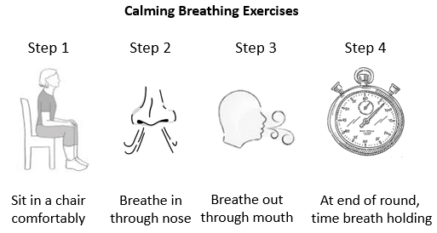

Table 3. Record the maximum breath holding time (min and sec) before and after breathing exercises.
 | Normal Breathing  (Before Any Exercises) | After 2 Rounds  (of Breathing Exercises)
Breath Holding Time
(maximum)
Class Average

Part II: Pulmonary Ventilation Compared to Alveolar Ventilation
For this section, we will make estimations of total minute volume, which is also called Pulmonary Ventilation, and compare it Alveolar Ventilation in two states: a) at rest, and b) immediately after exercise.

Formula for calculating Pulmonary Ventilation = RR x V_{T} (Respiratory Rate x Tidal Volume)

Formula for calculating Alveolar Ventilation = RR x (V_{T} -150 ml)

Anatomical dead space is the volume of air in the airways that will never get to the alveoli. The standard volume for dead space is 150 ml. Alveolar ventilation subtracts this volume of air from the tidal volume.

Use the values below for respiratory rate and tidal volume to calculate the two ventilations, first at rest, and then calculate the two ventilations immediately after exercise using the numbers provided below.

Be sure to show work and include all the units for these calculations.

a) Calculations at Rest

Respiratory Rate = 12; Tidal Volume = 500.

Pulmonary Ventilation Alveolar Ventilation

= =

b) Calculations Immediately After Exercise

Respiratory Rate = 35; Tidal Volume = 2,890.

Pulmonary Ventilation Alveolar Ventilation

= =

Q: Which of these calculations more accurately reflects the amount of air that can participate in gas exchange in the lungs? ____________________________.

Q: Therefore, __________________ ventilation will always be less than __________________ ventilation.
Part III: Applications to Clinical Situations
1. Give a brief definition for the following terms:

Eupnea -

Apnea -

Hyperpnea -

Dyspnea -

Tachypnea -

Ventilation -

Hyperventilation -

Hypoventilation -

For the disorders listed below, describe what characterizes them, what lung volume measurements would be abnormal, and whether it is an obstructive or restrictive lung disorder.

1. Asthma.

2. Pulmonary Fibrosis.

3. Emphysema.

4. Bronchitis.

5. Pulmonary Edema.

Lab Notes for the Respiratory Studies

PRE-LAB QUESTIONS: RENAL LAB
Name: ___________________________________________________ Date_____________
Answer the following questions and submit at the start of the Renal Physiology lab session.

1. The osmolarity of body fluids ranges from __________ mOsM to __________ mOsM.

2. Should you limit your intake of fluid prior to the lab? ___ Yes or ___ No.

3. In terms of the experimental procedure, Group 1 will drink what beverage? ___________________.

4. Students in Group 2 will drink ___________ ml of _______ % Saline solution.

5. And Group 3 will drink ____________________, and Group 4 will drink_______________________.

6. How many times do you drink the 500ml of solution? ____________.

7. How many times will you collect your own urine sample? (See Table 1 page 136) ______________.

8. In measuring the amount of NaCl in your urine sample, the lab manual directs students to place _______ drops of urine into a test tube. Then add 1 drop of 20% _______________________ to the urine sample. Then add 2.9% _____________________ solution drop by drop, shaking the mixture after each drop. Test the number of drops of ________________________ required to change urine to a brick red color.
9. After measuring the NaCl concentration, use the ___________________ to measure specific gravity.

10. The specific gravity (SG) of a solution is directly related to the amount of ___________________in a solution.

11. Pure water has a specific gravity of ________________ and the specific gravity of urine normally ranges from _____________ to ________________.

12. The average pH of urine is about ______. Normal urine is aseptic, circle true or false. T or F
13. From the info the renal lab, how many nephrons are in the 2 kidneys? ___________________.
14. Glucosuria is: ______________________________________________________________________.
15. Phenylketonuria is: __________________________________________________________________.
16. Cystitis is:__________________________________________________________________________.
17. What is the normal Blood Urea Nitrogen (BUN) range? From __________ to __________ (mg/dL).
18. What can an elevated BUN indicate? ____________________________________________________.
Multiple Choice Questions for Renal Pre-Lab

For the questions below, please answer on a scantron and submit it at the start of the lab session.

1. The hormone released by the posterior pituitary to increase fluid re-absorption by the body is
a) aldosterone b) antidiuretic hormone c) angiotensin d) renin e) erythropoietin

2. The blood vessel which carries blood to the glomerulus is the
a) renal vein b) peritubular capillaries c) renal artery
d) afferent arteriole e) efferent arteriole

3. Which electrolyte is most abundant in urine?
a) magnesium b) potassium c) sodium d) calcium e) chloride

4. Which one of these statements is false? The nephron
a) is the functional unit of the renal system b) is completely contained within the renal cortex
c) acts to filter and reabsorb substances with the blood d) has endocrine functions

5. A urine sample of a person in the state of rhabdomyolysis, would:
a) have bacteria present and have a foul pungent odor.
b) be extremely dilute with a very low osmolarity.
c) have a fruity odor and a bright yellow color.
d) be high in glucose, proteins and ketone bodies, and have a green-ish color.
e) have a very dark color, ranging from red to brown or black.

6. Which of the following is not a function of the urinary system?
a) maintaining blood pressure b) excreting metabolic wastes
c) elevating and reducing blood sugar balance d) maintaining acid-base balance

7. What is the structure that carries urine from the urinary bladder to the outside of the body?
a) the ureter b) the urethra c) the renal pelvis d) the glomerulus e) the nephron

8. The osmolarity of urine can range from _______ to _______ mOsM.
a) 295 to 310 b) 100 to 1,200 c) 50 to 1,000 d) 50 to 1,200 e) 10 to 1,200

9. Comparing the nephrons of a Beaver and a Kangaroo Rat (who never drinks water), you’d find that
a) The nephron structure is the same, but the kangaroo rat has twice the number of nephrons.
b) In the beaver, the distal convoluted tubule is longer.
c) In the kangaroo rat, the loop of Henle is shorter.
d) In the beaver, the loop of Henle is longer.
e) In the kangaroo rat, the loop of Henle is longer.

10. Which of these substances are normally found in both Plasma and Urine?
1. small cells 2. urea 3. amino acids 4. glucose 5. sodium
a) 5 and 2 b) 5 only c) 2, 3 and 5 d) 4, 5 and 2 e) 1 and 5

Laboratory Exercise #11: Renal Physiology – Fluid Regulation
*PRE-LAB due at start of this Lab

Objectives: After completing this exercise, you should be able to:
1. Measure and calculate urine volume and osmolarity;
2. Understand the meaning of specific gravity and NaCl content in urine and how to measure these;
3. Using a Labstix test to perform urinalysis.

Part I: Kidney Regulation of Body Fluid Osmolarity
The renal system has several important roles in human physiology. The 2 kidneys contain about 2.5 million nephrons, and these are the structures that filter our blood. A central role of the renal system is to regulate the osmolarity of our body fluids in a range between about 295 to 310 mOsM. The regulation of body fluid osmolarity will be demonstrated in this experiment by presenting the renal system with an excess load of either water, salt or caffeine and recording its response as reflected in the volume and concentration of urine produced.

Experimental Procedure for Urine Volume and Osmolarity:
1. Limit your fluid intake on the day of the experiment. Try not to empty your bladder immediately before the laboratory.

2. On entering the laboratory, please be ready to start the lab as soon as possible, as it will require the entire laboratory time. You will be assigned a group letter and this will determine which solution you will drink. Then you will take a urine collection bottle (labeled with your name on it) to the restroom and void into the bottle, emptying the bladder completely. Record the exact time. This will be designated the "control" urine.

3. After voiding and collecting your control urine sample, bring it back to the laboratory. As soon as you can, drink the solution assigned to you as quickly as possible. Once you have had your single drink - only drink the beverage once - you can perform the urinalysis on your control urine sample.

The class will be divided into four groups as follows:

Group 1 drinks 500 ml of water.

Group 2 drinks 500 ml plus 4.5g of NaCl (salt tablets*) or 0.9% saline solution = _____mOsM
*Please DO NOT dispose of the container with the salt tablets – put it back on the counter!

Group 3 drinks 500 ml of a caffeinated iced-tea beverage.

Group 4 drinks 500 ml of a non-caffeinated iced-tea beverage.

Caution: Any student with health issues or concerns, please check with a physician and the instructor before ingesting the saline solution or salt tablets. We can make appropriate accommodations.

4. Every 30 minutes after drinking the solution, go to the restroom and empty your previous sample into the toilet. Wipe the container dry with a paper towel and empty your bladder into your clean collection bottle. If you are unable to void, retain the urine in your bladder until the next 30 minute collection time. Another plastic cup may be required to collect large urine volumes, while still measuring the volume with the collection cup.

5. Analyze the urine from each collection (including the control) for the following:

a) Volume Voided. Measure the total volume of urine voided from the bladder using the calibrated collection bottle and record in milliliters excreted. Record values in Table 1.

b) Sodium Chloride (NaCl) Concentration. WEAR GOGGLES! Place 10 drops of urine into a test tube (use the standard medicine dropper supplied, 20 drops/ml). Add 1 drop of 20% potassium chromate to urine sample. Add 2.9% silver nitrate solution drop by drop, shaking the mixture continuously while the silver nitrate is being added. Count the number of drops of silver nitrate required to change the bright yellow solution to a brick red/brown color. Each drop of 2.9% silver nitrate added to produce the brown color represents 1 g/L (1 mg/ml) of NaCl in the urine. Calculate the total grams of NaCl in the urine collected at each 30 minute period and record the NaCl concentration in mg/ml in Table 1.

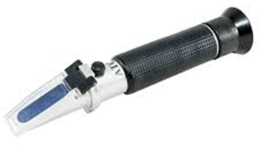
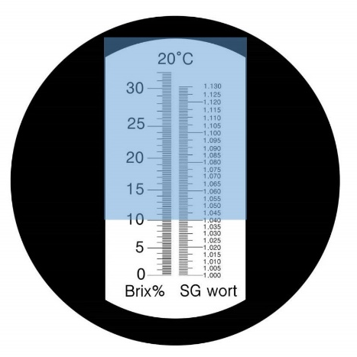
c) Specific Gravity (SG). After measuring the total volume of urine voided and the NaCl concentration, then use the refractometer (see below) to measure specific gravity. Carefully lift the lid of the refractometer and use a pipette to transfer 2-3 drops of urine onto the blue glass space. Gently lower the lid and look through the back eyepiece of the refractometer. There will be two scales (see right), look at the scale with numbers going from 1.000 to 1.050. Identify where the blue/white interface meets the scale and this is your specific gravity. Record this value Table 1. below, as described in the section below. Use tap water or alcohol to clean the refractometer when you are done.

6. Record your individual data in Table 1 along with the specific solution you drank and your assigned letter. All participants will put their data on a group data sheet. We can then calculate average values for each experimental group and graphs can be prepared from these results.

Table 1. Fill in the table below with your individual data (over the 120 minutes). In total, you will collect 5 urine samples, the first one is the control (Con) and the next four are taken every 30 min for 2 hours. Indicate the specific group you were in and the letter you were assigned as a participating subject.
Volumes Excreted (ml/min)
Sodium Chloride (mg/ml)
Specific Gravity
Bev | Con | 30 | 60 | 90 | 120 | Con | 30 | 60 | 90 | 120 | Con | 30 | 60 | 90 | 120

Note on Specific Gravity
The specific gravity (SG) of a solution is directly related to the amount of solutes in a solution. Pure water has a specific gravity of 1.000. The specific gravity of urine normally ranges from 1.010 to 1.035, the higher the value, the more solutes in solution. Readings above or below the normal limits may indicate a pathological condition. For example, a low reading is found in chronic nephritis.

Part II: Urinalysis
The kidneys regulate the internal environment of the body by constantly filtering the blood to maintain homeostasis of water, ions and pH in the various body fluids. Waste products, such as urea and uric acid, are eliminated in urine. The nephron (right below) is the functional unit of the renal system with about 1.25 million nephrons in each kidney. The nephron has two main structures: 1) the renal corpuscle where blood is filtered; and 2) the renal tubules, where 99% of the material is reabsorbed back into the body and a small amount of urine produced.
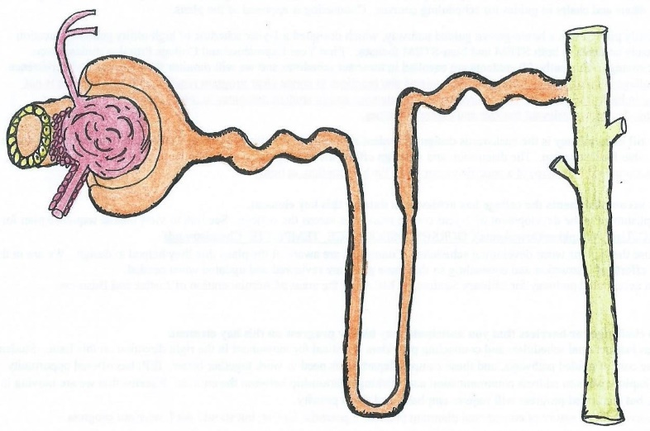
Blood is filtered at the glomerulus (big arrow) and that filtrate (a fluid similar to plasma, but without the proteins) is passed along the renal tubules to be reabsorbed by the body. Any, toxic by-products of metabolism, foreign or excess substances are excreted in the urine (small arrow). Thus, the final composition of the urine is reflective of the metabolism of the blood and the body as a whole. In this way, an analysis of urine (urinalysis) can yield valuable information about the health of the kidneys and the state of the body in general.

Pathologies found in Urinalysis
Various diseases are characterized by abnormal metabolism, which causes abnormal by-products of metabolism to appear in the urine. Here are just a few examples:

- For people with phenylketonuria (PKU), a disease that involves a decreased metabolism of the amino acid phenylalanine resulting in mental retardation, phenylpyruvic acid appears in the urine when normally it does not.

- In diabetes mellitus type 1I, deficient production of insulin by the pancreas results in the appearance of glucose in the urine (glycosuria). The volume of urine produced and its specific gravity give information on the state of hydration or dehydration of the body.

- In those with glomerulonephritis, which is inflammation the glomeruli, proteins get into the filtrate when normally they do not, and protein will then be found in the urine (proteinuria).

In this experiment you will analyze your own urine for some of its clinically important constituents. There will also be “Unknown” urine samples containing abnormal quantities of these constituents which you will test in order to predict the potential pathology as well as comparing it to your urine.

Experimental Procedure for Urinalysis:
Take your control sample of urine and the assigned unknowns and perform urinalysis on all.

Chemstix or Labstix Test - To be performed on your first urine sample only.
Recent advances in urinalysis techniques have made it possible to perform tests in a few seconds when previously it took hours.

The Labstix test or Clinitest strips are a combined test of urinary pH, protein, glucose, ketones and occult blood (trace amounts of blood in urine). Abnormally low pH, along with a high level of glucose and ketones, indicates diabetes mellitus. Alkaline urine is found in many conditions, an example in cystitis, where urine decomposes in the bladder with the production of ammonia.

The pH of urine can range from 4.5 to 8.0, but typically has an average of around 6.0, which is slightly acidic. Urine pH may be lowered by a diet rich in proteins or citrus fruits, so the pH of urine is not very informative in itself.

Protein and occult blood in the urine are much more definite, indicating nephritis, a disease in which the glomeruli are damaged and plasma proteins and erythrocytes leak into the kidney tubules.

Obtain the reagent strip and bottle with the color standards. Examine the strip carefully before making the test so you will know which portions to read first. There may be several different types of strips in the lab, so we will examine them and follow the directions on the container. When ready, dip the reagent portions into the well-mixed urine specimen, wetting all of the reagents completely.
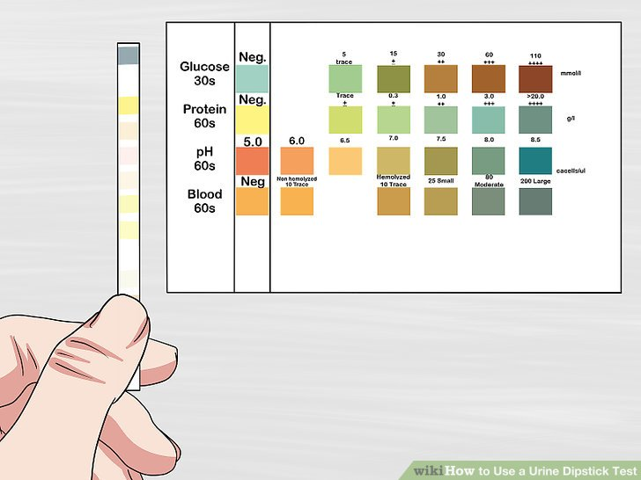
Wipe the excess urine off on the lip of the urinalysis bottle. Typically, you will need to read the glucose test portion first, followed by the ketone portion, and the occult blood portion (at the end of the strip).

The pH and protein portions are usually read after this at your leisure, because time is not so critical with these two. Again, we will follow the specific instruction on container.

If the urine glucose or pH is found to be beyond the normal range, make a more accurate analysis for glucose by using the Clinitest strips for only glucose and test for pH by using the pHydrion paper on your lab bench or on the side counter.

Obtain the assigned samples of the abnormal “Unknow Urine” samples (A, B and C) and run the Labstix test on them so you can compare your urine results with some non-normal “pathology” results.

Measurements of Blood Urea Nitrogen (BUN) become elevated when kidneys are damaged and are not able to effectively filter urea waste from the blood, leading to its buildup, a condition called azotemia.
Record your results in Table 2 on next page.
Urinalysis Results for the 3 Unknown Urine Samples
The three unknown urine samples (A, B and C) will be on the counter in the lab, and each lab table will perform urinalysis on one of the unknown samples to be assigned in lab.

NOTE: The Unknown Urine Samples are Not Real Urine! Each one of the unknowns is a solution created by our lab techs to exhibit certain characteristics of a disease state. Please do not discard the unknown urine samples at the end of the lab.

Individual Data Table
Record the values obtained for the urinalysis of your control urine sample from the Labstix test in Table 2 below. That is the control sample first collected from the beginning of the class, the one that serves as the control for the solutions experiment. Students will also perform urinalysis and run these same tests on the “unknown urine” sample assigned. Record the results for both the control sample (at start of lab) and one of the unknown urine samples (A, B or C) in Table 2 below.

Table 2. Urinalysis table for the results from the Labstix or Chemstix test strip of your control urine sample and the unknown urine sample assigned to your lab table (A, B or C).
 | Color | Odor | Clarity | Glucose | Ketones | Blood | Pro⁻ | pH | WBCs | SG
Subjects
Control Urine
Unknown Urine (#____)
*Important: Do not discard the unknown urine sample.
- Pro⁻ = Proteins
- WBCs = White blood cells
- SG = Specific Gravity (has no units)

Class Average Data Table
For the unknown urine samples, students will also enter their results into the lab data sheet on the instructor’s computer in the front of lab. Once the class averages have been calculated, copy the results for the class average in Table 3 below.

Table 3. Record the class results (averages) for the urinalysis of all three unknown urine samples using the Chemstix or Labstix test strips. Note: These are not urine! Just solutions to mimic various urine samples.
 | Color | Odor | Clarity | Glucose | Ketones | Blood | Pro⁻ | pH | WBCs | SG
Unknown A

Unknown B

Unknown C

*Important: DO NOT discard the unknown urine sample.
DATA ANALYSIS AND CONCLUSIONS
Use websites, textbook, lecture notes, or any other material to answer the following:
1. For the four different drink groups in the renal experiment today, formulate a good hypothesis regarding the volume of urine output that subjects for each group are likely to display.

2. If the osmolarity of body fluids increase due to excessive sweating, outline how antidiuretic hormone (ADH) would be released, and then how it would work to help rectify this situation.

3. What causes diabetes mellitus type 1, and what causes diabetes mellitus type 2?

4. Briefly describe the cause and consequences of diabetes insipidus.

Define the following terms: (-emia refers to blood and -uria refers to urine).
5. Glycosuria:

6. Proteinuria:

7. Ketonuria:

8. Polyuria:

9. Hyperbilirubinemia:

10. Bilirubinuria:

11. Hyperglycemia:

12. Briefly describe the likely pathologies indicated by urinalysis results for the unknown samples:

A B C
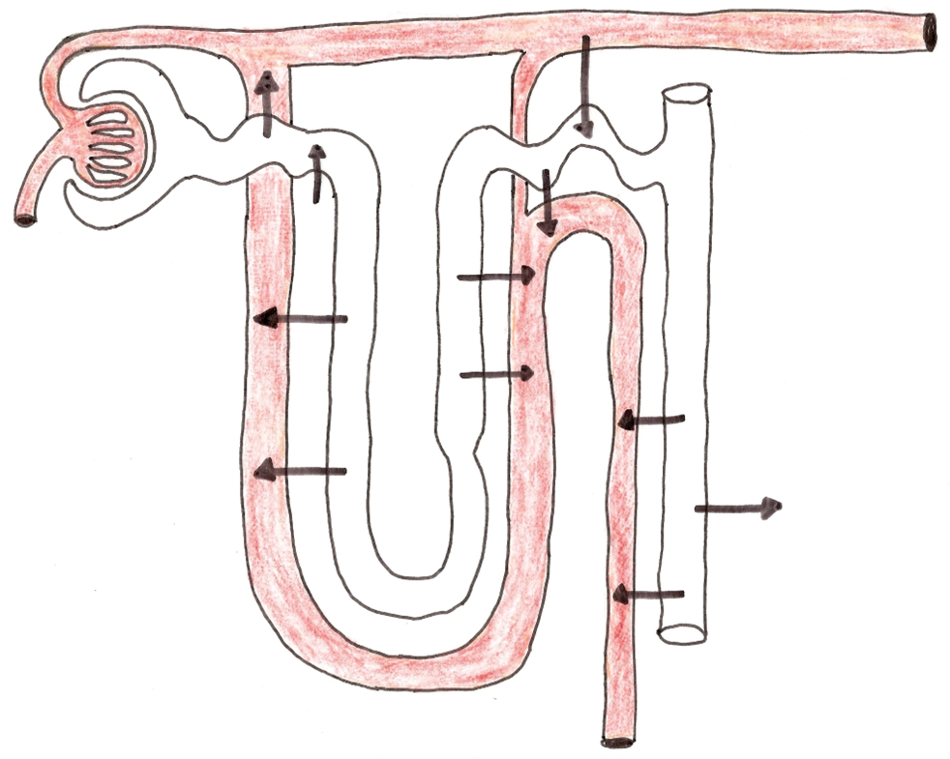
The Nephron – Function Unit of the Kidney
Figure 1. Diagrammatic drawing of the nephron in the renal system. Arrows indicate the direction of solute and fluid movement. Label the major anatomical parts shown in the diagram above and identify which of the 4 renal processes is occurring at each arrow. Indicate what substances are moving into and out of the renal tubules.

13. The 4 renal processes are: 1) Filtration, 2) Reabsorption, 3) Secretion and 4) Excretion. For the arrows in the diagram above, identify and label which renal processes are taking place on the drawing. Write the specific definition for each (including where they take place and the forces involved) below. See OER text Chapter 21, page 589.

1) Filtration
2) Reabsorption
3) Secretion
4) Excretion

Lab Notes for the Renal Studies

Laboratory Exercise #12: Digestive Enzymes

Part 1 Objectives: After completing this exercise, you should be able to:
1. Explain the location and activity of specific digestive enzymes in the gastrointestinal system;
2. Examine the optimal conditions for enzyme activity (temperature, pH, and concentration); and
3. Review the process of conducting controlled experiments using enzymes including data analysis.

Introduction
Digestion begins in the mouth with mastication (chewing) of food which reduces the size of the food particles and mixes them with saliva. This puts the substance in solution and increases the surface area for the action of enzymes. The enzyme lingual amylase, which breaks down starches, is present in saliva, there are more enzymes in the stomach, and the pancreatic juices contain pancreatic amylase and other enzymes, all of which break chemical bonds. The mechanisms of gastric and intestinal digestion and absorption will be investigated in this laboratory session.

Materials
There will be four different experiments carried out in today's lab. All of the supplies needed for this lab will be found in the container on your individual lab table or on various counter tops in the lab. There will be one glass stirring rod in each of the lab table containers. There will be several experiments that require dissolving a powder into a liquid in a test tube. Use the glass stirring rod to mix the powder in as thoroughly as possible. Always clean the stirring rod after each use. There will be various solutions used for these experiments found in the basket on your lab table. There will also be some solutions found in the common area (side counter) counter. Please do not remove solutions from the common area but rather dispense your solutions there.

Lab Safety and Clean Up
- Warning: Please use caution and wear goggles when handling the 0.1% hydrochloric acid in the gastric digestion experiment. The Benidict’s and Biuret’s solutions are considered biohazards and must not be disposed of down the sink but need to be placed in the Biohazard Bucket on the counter near the sink. Caution, as Iodine reagents can stain your skin or clothing. Students are to rinse their test tubes, using alcohol to remove any markings and then place them in the wash bucket. Please discard the plastic pipettes in the collection container and discard the dialysis tubing and floss in the trash. Thank you!

Methods
Immediately prior to the laboratory period, the starch, sugar, litmus milk and pepsin solutions will be prepared and labeled on your lab tables and on the counter tops in the lab. Each of the lab tables will perform all four experiments collaboratively. One person at each lab table will do one of the four experiments listed below:

#1 Gastric Digestion

#2 Intestinal Digestion - Part A

#3 Intestinal Digestion - Part B

#4 Absorption in the Small Intestine
#1 GASTRIC DIGESTION
When food is swallowed, it travels down the esophagus into the stomach for gastric digestion. Gastric juice is secreted from glands in the mucous membrane of the wall of the stomach by reflex and chemical mechanisms. This fluid is very acidic (pH of 2) due to the presence of hydrochloric acid (HCl). Gastric juice also contains pepsinogen, an enzyme that aids in the digestion of protein.

Elevated levels of HCl convert the enzyme pepsinogen (inactive) into the enzyme pepsin (active), which then starts the process of protein breakdown in the stomach. The principal action of gastric juice is to transform protein into peptides with the catalytic activity of pepsin and HCl. With the combined influence of gastric juice, contraction of the muscular walls of stomach and body temperature, the food is reduced to a semi-liquid condition called chyme.

In this exercise albumin (egg white) which is almost pure protein, will be used to demonstrate the action of pepsin. Write out how Pepsinogen is converted to Pepsin.

The Biuret test is used to detect protein in a solution, as the compound biuret is formed by the reaction with proteins. When the Biuret’s reagent is added to solutions in order to determine if any the proteins are present. In the presence of protein, a clear light pink or cloudy color is produced. In the absence of protein in solution, a clear pale color results. Note: Any Biuret's solution cannot be poured down the drain and must go into the Biohazard Bucket!

Procedure
- With a sharpie marker, number three test tubes, 1, 2, and 3, also add a unique group or table name to each tube as these will be in the water bath with test tubes from all the other groups.

- Place one scoop of albumin (rich in protein) in each test tube. Then prepare them as follows:

Test tube #1: add 5 ml 0.4% pepsinogen solution.

Test tube #2: add 5 ml 0.1% hydrochloric acid.

Test tube #3: add 5 ml pre-made gastric juices (0.4% pepsinogen and 0.1% hydrochloric acid).

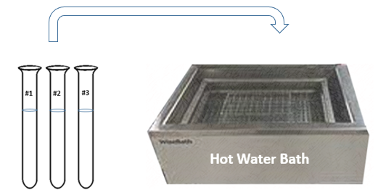
- Stir each test tube to mix the contents well. Place all of these test tubes in the warm water bath at 37° to 40° C (99° to 104° F) for one hour.

- After 1 hour, remove the three (3) test tubes from the water bath.

- Now, to test for the presence of proteins or peptides, add 3 drops of Biuret’s reagent to each test tube and shake.

Observe your test tubes and record any color changes below.

Test tube #1 ______________________________________________________________________.

Test tube #2 ______________________________________________________________________.

Test tube #3 ______________________________________________________________________.

Note: The Biuret reagent contains copper sulfate and is used to detect the presence of proteins in a sample. If the solution contains protein molecules, the copper in the reagent reacts with it and forms a complex compound. In this case, the Biuret reagent reacts with the products of gastric protein digestion (which are peptides and proteoses) to give a pale pink or light blue color (more often a ‘purple’ color). This color change indicates that the digestion of the protein has occurred, in other words it, it indicates that there are no proteins in the solution.

If whole proteins remain present in the solution, then the test tubes give a clear or faint pink color.

- What is the difference between a protein and a peptide? ________________________________.

- In which test tubes did protein digestion occur? ________________________________________.

- Why is the water bath at 37° to 40° C? ________________________________________________.

- Look up the term “proteose” and define it below:

- Write out the chemical equation for the change in pepsinogen caused by the effects of pH.

- What is the process in the question above called - when the activity of an enzyme is activated by being cut (shortened), the process is called: ___________________________________________.

#2 INTESTINAL DIGESTION - PART A
Digestion begins in the mouth and stomach and is completed in the small intestine. The pancreas releases many enzymes which complete the digestion of carbohydrates, lipids (fats and oils) and proteins. The semi-liquid chyme produced in gastric digestion passes through the pylorus into the small intestine. This stimulates production of alkaline (basic) intestinal fluids. As soon as the liquid becomes alkaline, gastric digestion is arrested and intestinal digestion takes over.

Pancreatic juice is secreted by the pancreas into the duodenum (upper small intestine). This juice contains the enzymes amylase, lipase and protease. Starches are broken down into simple sugars by amylase (also found in saliva). Lipids (fats) are digested by lipase, yielding glycerol and fatty acids. Protease enzymes act on proteins, such as albumin, to break them down into peptides and amino acids.

In the presence of starches, a solution of iodine-potassium-iodide changes from yellow to blue-black. If starches are absent, a colorless solution will result. Litmus milk is used as a source of protein and fats in a neutral emulsion (mixture). The litmus in the milk indicates the presence of acid by turning from blue in basic conditions to red in acidic conditions.

Procedure for Intestinal Digestion - Part A
- With a sharpie marker, label three test tubes with your group initials and number them 1, 2 and 3. Add 5 ml of 0.5% starch solution to each test tube. Then prepare them as follows:

- Test tube #1: add 5 ml pancreatic solution.

- Test tube #2: add 5 ml water.

- Test tube #3: 5 ml boiled pancreatic solution.

- Shake all test tubes gently to mix the contents. Place the test tubes in the warm water bath at 37° to 40° C (99° to 104° F) for 30 minutes.

- Then remove the test tubes. Add 3 drops iodine-potassium-iodide solution to each test tube. Shake gently to mix the contents.

- The presence of starch is indicated by a dark blue/black-purple color.

- The absence of starch is indicated by a clear light brown color.

Observe your test tubes and record any color changes below.

Test tube #1 ________________________________________________________________________.

Test tube #2 ________________________________________________________________________.

Test tube #3 ________________________________________________________________________.

Assessment of Experiment Questions for #2 Intestinal Digestion - Part A:

- Make predictions as you wait for the results:
  - Which of the three test tubes will have a positive result: _________________________.
  - Why?

  - Which of the three test tubes will have a negative result: _________________________.
  - Why?

- Define what a “control” is an experiment:

- Which of the three test tubes in this experiment serves as the control? ______________________.
- Why is having a valid control in an experiment important?

- What has happened to the starch in test tube 1? ________________________________________.

- What kind of molecule is starch? __________________. Is it large or small? __________________.

- When starch is broken down, what is the product? ______________________________________.

- What is pancreatic solution? What enzymes are contained within in?

- Suggest the specific enzyme in pancreatic juice that breaks down starch: ____________________.

- What results do you expect from test tube 3? __________________________________________.

- Why might the results in test tube 3 differ from test tube 1?

- If test tube 3 had results indicating no starch was present, offer some possibilities for these results.

#3 INTESTINAL DIGESTION - PART B
Milk and milk products have a good balance of many key nutrients, including these organic molecules; proteins, lipids (fat) and carbohydrates. They also contain essential vitamins (A, B₃, B₁₂, D, K2) and minerals, such as calcium, sodium, magnesium, potassium, zinc, and phosphorus.

In terms of the processes of digestion, Part B of intestinal digestion looks at the digestion of milk, which contains several organic molecules (outlined above). When these large constituents of milk (polymers) are digested, they are broken down into their monomers, and the solution becomes more acidic.

Litmus Paper and Litmus Milk
Most are familiar with litmus paper, a strip of paper that is chemically treated with the dye litmus and helps determine the pH of a solution. In general, litmus paper placed in a liquid will turn red (or pink) at any pH less than 5 (acidic) and will turn blue at any pH greater than 8 (basic), thus allowing a general determination of whether a solution is acidic or basic.

The use of litmus milk in this experiment uses that same litmus dye in a milk medium. This litmus milk is alkaline and will change from pale cloudy lavender color to a clear dark purple if it becomes acidic. The pancreatin powder used in this experiment contains enzymes that aid in the digestion of proteins and lipids. A dark clear purple color of this solution suggests that the proteins and lipids in the litmus milk were broken down into simpler forms.

Note: The accumulation of acid in certain litmus milk solutions will act on the casein in milk. Casein is a protein in milk that is responsible for its white color. Acidic conditions result in the precipitation formation of casein as calcium caseinate.

Procedure for Intestinal Digestion - Part B
- With a sharpie marker label two test tubes with your group initials and number them 1 and 2.

- To each test tube add 10 ml of litmus milk solution. Then prepare them as follows:

Test tube #1: Add one scoop of pancreatin powder.

Test tube #2: Add one scoop of flour.

- Use the glass stirring rod to thoroughly dissolve both of the powders into the litmus milk within each test tube.

- Always clean the stirring rod after each use, so as to avoid contamination.

- Shake the test tubes gently to mix the contents. Place test tubes in the warm water bath at 37° to 40° C (99° to 104° F) for one hour.

- Then remove the test tubes from the water bath and place on lab table test tube rack.

- Acid production is indicated by a color change to clear dark purple.

- If test tube remains a cloudy pale purple color, the solution is still basic.
Observe your test tubes and record any color changes below.

Test tube #1 ________________________________________________________________________.

Test tube #2 ________________________________________________________________________.

More Assessment of Experiment Questions for #3 Intestinal Digestion - Part B:

- Which test tube represents the “control” experiment? __________________________________.

- Which test tube would you expect no reaction or change from? ___________________________.

- Why?

- What kind of organic molecules does milk contains?

- Why would the digestion of these nutrients cause an increase in acidity of a solution?

- From information presented in the lab manual and elsewhere answer these questions

a. In which region of the upper digestive tract does food transition into chyme? _________________.

b. Where (what location) does most of the chemical digestion take place? _____________________.

c. In the stomach, the chief cell secretes ___________________________.

d. What is the purpose of microvilli in the small intestine? __________________________________.

e. What does the liver do to directly aid the digestive system? _______________________________.

f. Where is bile stored when digestion is not occurring? ___________________________.

g. Which of the following is secreted by the pancreas into the duodenum? __________________.
a) bicarbonate b) lipases c) bile salts d) pepsin e) insulin f) pepsinogen

# 4 ABSORPTION IN THE SMALL INTESTINE
To provide nourishment useful to the cells of the body, digestion must occur first, followed by absorption. Absorption is the passage of substances through the intestinal mucosa into the blood or lymph. Proteins, starches and fats cannot be absorbed across cells and into the body, they are too large, they must be broken down.

Enzymatic digestion (breaking chemical bonds) must occur prior to absorption because it is the smaller digestion by-products (e.g., amino acids, mono and disaccharides, and fatty acids) that are capable of being absorbed by the body. Absorption uses both active and passive transport processes.

In this exercise the dialysis tubing represents the plasma membrane barrier that molecules must pass in order to enter the body. Here the dialysis tubing is used to demonstrate passive absorption via diffusion. The mixture of starch and glucose illustrates the importance of molecular size in the absorption process.

In this experiment, Benedict's solution will be used as a test for the presence of reducing sugars, such as glucose. By adding Benedict's reagent to a solution and heating it, the solution will change color if reducing (simple) sugars are present, in this case if glucose is present it will turn a brick red color.

Note: Benedict's solution cannot be poured down the drain and must go into the biohazard bucket!
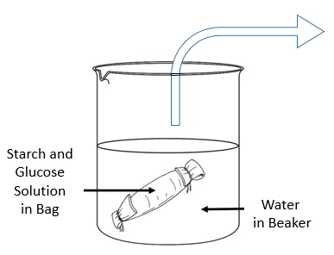
The purpose of this experiment is to let the dialysis tube, which contains a mixture of starch and glucose solutions in it, sit in the beaker of distilled water for at least 30 minutes and then test the beaker water for the presence of starch or glucose. This will indicate if either of these substances (glucose or starch) was able to move across the bag into the beaker.

Procedure for Absorption in the Small Intestine
- Locate the dialysis tubing on the lab bench, and if it is dry, soak an 8" piece of dialysis tubing in water for 30 seconds. Then rub it between your thumb and index finger to open it.

- Tie off one end of the dialysis tube with dental floss, using a double knot to ensure no leakage, and quickly test for leaks, leaving about ½ inch of tubing at the end.

- Now fill the dialysis tubing with 10 ml of the 0.5% starch solution and 10 ml of the 15% glucose solution. Tie off the other end of the tube tightly but leave some slackness so that the tube can bend and fit in the beaker.

- Rinse the outside of the tubing in tap water and wipe it dry to remove any traces of the two solutions contained within the dialysis tubing.

- Place the filled tube in a labeled beaker containing 200 ml of distilled water at room temperature for at least 30 minutes.

- While this is proceeding, use the hot plate stored in each lab table to heat a baker of tap water, brings it to a gentle boil.

- Remove the dialysis tubing from the beaker after 30 minutes.

- Label two test tubes #1 and #2. In both test tubes, transfer 5 ml of the water from the beaker (not from the dialysis tubing) into each test tube.

- For Test tube #1: Test for presences of Glucose:
Add 20 drops of Benedict solution to this test tube and place it in the beaker on the hot plate, so that the test tube is in the beaker of boiling water for five (5) minutes.

- For Test tube #2: Test for presences of Starch:
Add 3 drops of iodine-potassium-iodide to the test tube containing water from the original beaker.

Observe your test tubes and record any color changes below.

Test tube #1 ______________________________________________________________________.

Test tube #2 ______________________________________________________________________.

In the presence of a simple sugar, the heated Benedict solution becomes a rust colored brick red. This would be a positive result for the presence of a simple sugar, such as glucose. The absence of a color change (remaining blue) indicates the absence of simple sugars.

Using the iodine-potassium-iodide solution, the presence of starch is indicated by a dark blue-purple color. If the solution is a light yellow (hay) color, this indicates the abscess of any starch.

More Assessment of Experiment Questions for #4 Absorption in the Small Intestine:

- In this experiment, what was the dialysis bag representing? _______________________________.

- Describe the basic differences between Glucose and Starch.

- Was glucose present in the sample from the beaker? ____________________________________.

- Was starch present in the sample from the beaker? _____________________________________.

- Explain what your results indicate.

Lab Notes for Digestive Enzymes

Laboratory Exercise #13: Applying the Scientific Method

Objectives: After completing this exercise, you should be able to
- Understand the basic steps of the scientific method of investigation;
- Describe the methods used in "experimental" investigations;
- Describe the methods used in "observational" investigations.

Science and Nature
* Natural phenomena (such as chemical reactions or animal behavior) follow natural laws;
* We can begin to understand those laws through scientific investigation;
* Our understanding will change as we gain more knowledge through continued research.
Scientific Investigations

Experimental Science
Observational Science

Manipulate one factor, observe the response. Observe phenomena; classify.

In "experimental" science, an investigator sets out to see how one factor affects other factors. For example, a biochemist might investigate how a change in pH affects the action of digestive enzymes. Scientist focus on how changing one factor (acidity) affects other factors (enzyme activity).

In "observational" science, an investigator primarily observes phenomena and draws conclusions from the observations. For example, a botanist might gather plant specimens never identified before and try to classify them according to known species. We will encounter both experimental and observational scientific investigation. Each scientist follows the same basic steps in the scientific process, regardless of his or her research. The process is as follows:

1. OBSERVATION
Formulation of a question from existing knowledge. This involves searching the Scientific Literature.
2. HYPOTHESIS
Make a prediction, that is, suggest an answer to the question posed above.

3. INVESTIGATION Design experiments in an attempt to answer the questions proposed.

4. ANALYSYS
Collect the data (results) generated from experiments and assess the results of the experiment.

5. CONCLUSION
Formulate possible conclusions from your data collected, compare to other studies. This may involve revising prediction.
Revise
We are going to look into different types of investigations that will illustrate the Scientific Method shown above. We will analyze experiments and then devise an experiment.
Part 1: Analysis of Experimental Science
Examples of Experimental Science
In experimental investigations, a researcher devises a way to test the effect that changing one factor will have on another. The factor being varied is the independent variable and the factor or factors being observed for a response is (are) the dependent variable(s). In the following scenarios, identify the independent and dependent variable in each case.

Scenario # 1: A researcher is interested in the effect of the amount of fertilizer applied to a fruit tree on the amount of fruit produced by the tree.

Independent variable:
Dependent variable:

Scenario # 2: A researcher is interested in finding out if a daily dosage of Vitamin B₁₂ will affect the heart attack rate in men.

Independent variable:
Dependent variable:

As long as a researcher has only one independent variable, he/she can measure several responses. What other things might a researcher want to know about the effects of daily use of Vitamin B₁₂ on men?
Other possible dependent variables for scenario #2:

While one factor is being deliberately varied, all other conditions need to be held constant from one experimental group to another. These are called controlled factors (or variables). If more than one factor is varied, the researcher will not know what caused a response. List 2 controlled factors for each scenario:

Controlled Factors for Scenario # 1:
Controlled Factors for Scenario # 2:
Every experiment also has a control group. This is a group that will be treated identically to the experimental group except that it will lack the independent variable. This provides a basis of comparison to determine whether the independent variable had any effect. Below, suggest control groups for the experiments in the scenarios discussed.

Control group for Scenario # 1:
Control group for Scenario #2:

To increased safeguards for integrity when studying the effects of a drug or a vitamin supplement, etc., the best human studies will be double-blind studies with placebos.

What is a placebo?
What does a ‘double-blind study’ mean?
What is the nocebo effect?
Part 2: Sweat Gland Activity
Objectives: When you finish this exercise, you should be able to:
1. Describe the types, activity and density of sweat gland for various locations of the skin;
2. Define the reasons for such variations;
3. Discus the roles of sweat glands in body homeostasis.

Sweat glands cover almost every part of the surface of the skin, with the exception of the genitals and the lips. In total, there are about 3 million sweat glands in the skin (see drawing below).

The density of sweat glands vary, the range can be as high as 3,000 sweat glands per square inch in some areas to zero in others. Are they all active at the same time? What are their roles? The two basic types of sweat glands and other important structures are shown in the image below.
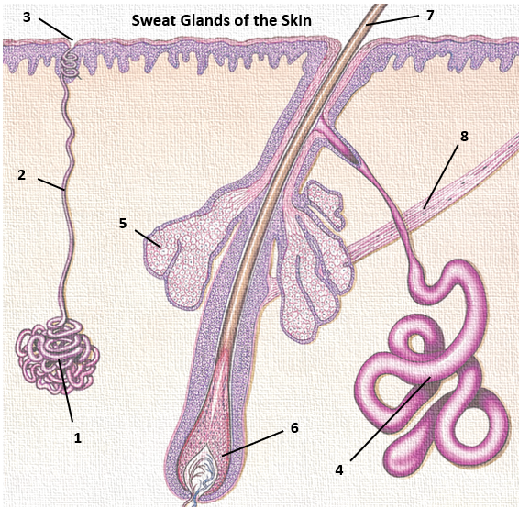

Name the specific structures indicated in the drawing above.

1. ______________________________
2. ______________________________
3. ______________________________
4. ______________________________
5. ______________________________
6. ______________________________
7. ______________________________
8. ______________________________

In this lab activity you will form a hypothesis about the relative distribution of sweat glands in various locations of the body. Our experiment will involve observing the presence of active sweat glands by using a simple chemical test. We will examine sweat gland activity at rest, and then after physical activity to determine if we can detect the effects of body temperature changes on sweat gland activity.
Materials and Methods
Bond paper (pre-ruled and cut in 1 x 1-inch squares), cotton swabs, alcohol swabs, iodine (Betadine) or Lugol's iodine, paper towels and adhesive tape. Remember to be cautious when using lab materials, iodine will stain your clothes if applied.

Part 1: The Variation in Density of Sweat Gland Activity
- Work in pairs to help each other set out the paper squares in the 3 locations of the body being tested. Do this experiment for two different states: First at rest (see below), and then repeat the activity after the set exercise (see Part 2).

- There are three (3) areas we will test. The first two are areas on the skin where sweating occurs readily: 1) the forehead, 2) the forearm, and finally 3) the palm the hand of will be tested.
Use the precise areas outlined below:

  - Forehead - select the midline area just below the hairline.
  - Forearm - select the medial (inner) region of your left forearm.
  - Palm - select the medial (inner) proximal aspect of your left palm (avoid crease lines).

- For the selected regions, first clean all the regions with alcohol swabs, creating an area for each region of about 3 square inches, and allow all areas to dry thoroughly.

- Using a cotton swab, dip it into the iodine solution and then liberally apply a 2” x 2” inch patch of this iodine solution on each of these 3 areas and let it dry completely. The painted iodine area in each case should be slightly larger than the paper squares to be used.

- Now, gently press a 1-inch square piece of bond paper on to the generously painted area, have your lab partner securely tape the paper square completely over the area covering each iodine-painted area. Leave these 3 taped-on paper patches in place on each area for at least 6 minutes (and up to 10 min). If it’s warmer in the lab while this test is being conducted, good results may be obtained within 6 minutes.

- After at least 6 minutes, carefully remove the paper squares and look closely for staining with a brown tinge of fine dots that may be present, which are caused by the reaction of the iodine moistened by an active sweat gland. The iodine in the sweat pores is dissolved in the sweat and reacts chemically with the starch in the bond paper to produce the color on the paper.

- Place your 3 square paper samples patches for sweat gland activity before exercise (during rest) in this lab manual on page 155/156, in alignment with the location tested, and tape them face up so they can be observed for the staining density which indicates the activity of the gland.

- Use the scale from the example samples provided on the next page as a general guide to the value you might assign to each test patch in terms of density (activity). Use a lower number if there are not as a heavy color or density of staining on your paper patch, and use higher numbers if there are more heavily stained patches.

- Fill in Table 1 (on next page) with your assessment numbers (using a scoring scale from 1 to 10).

Use the Examples of Sweat Gland Activity Results below as a Comparison Key
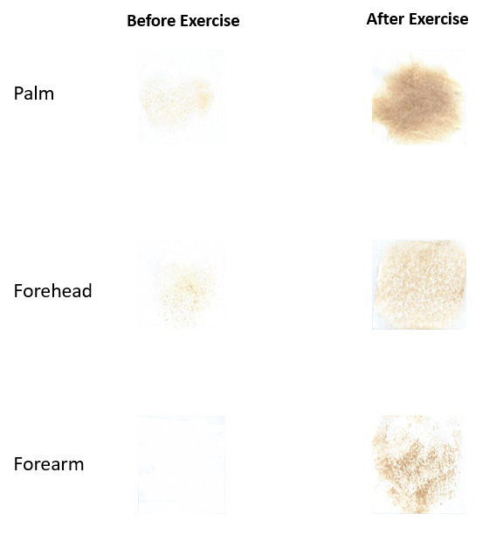

Forehead

Forearm

Palm

3 10

4 8

0 9

Scoring Scale 0 to 10 0 to 10______

Table 1. Fill in data table with the scores for sweat gland activity based on the iodine staining density of the bond paper (see examples above for reference). Enter scores for those three different locations in the body, for the baseline (before exercising, or the control), and after exercise.

 | Forehead |  | Forearm |  | Palm
Condition | Baseline | After  Exercise | Baseline | After  Exercise | Baseline | After  Exercise
Individual Data
Class Average (n= ____ )
Arrange your results here: Use tape to place your sweat squares below for comparative analysis.

Before After

Forehead

Forearm

Palm

Part 2: The Effect of Exercise on Sweat Gland Activity

- After completing the ‘control’ experiment for the baseline (resting) sweat gland activity, now re-do the experiment by repeating steps 1 through 5 done in part 1 (page 154), but as soon as the bond paper is adhered, have the subject perform a brief substantial exercise, something that will raise body temperature, for example, 10 squats, or 5 times up/down the stairs (depending on weather). The exercise activity determined should be consistent for the entire class.

- After subject completes the exercise activity, leave the bond paper on for at least 6 minutes, then resume the same protocol and repeat steps 6 through 9 for readings patches and placing patches in the after-exercise location, and enter data in Table 1 in the “After Exercise” column.

- When you have finished with the experiment, clean up your materials, wash your hands and, as always, clean the experimental areas thoroughly before leaving the lab.
Analysis and Discussion: Answer the following questions.

- The major component of sweat is ____________. It accounts for about ______ % of sweat.

- Usually, the tonicity of sweat as a fluid is __________________. Explain simply why this is.

- What is the most abundant electrolyte (salt) in sweat? ________________. List 3 other electrolytes that are prominent is sweat:

- a) The 2 types of sweat glands are: 1)____________________, and 2)________________________.
b) List how they different from each other. Which is more abundant in the body and why?

- Describe Evaporative Cooling and state how sweating cools the body.

- a) What causes flushing (turning red) of the skin? ________________________________________.

b) What is the function of this? _______________________________________________________.

- So how does flushing of the skin, together with sweating maintain homeostasis?

- What is:

a) Hyperhidrosis: ____________________________________________________________________.

b) Hypohidrosis: ____________________________________________________________________.

- Sweat glands/sq inch for Palm = ___________, Forehead = ____________, Forearm = ____________.
How does this info relate to your data?

- Describe how our sweat gland activity is controlled. [Hint: Think of T_{b} and fight or flight!]

- What fluid does sweat originally come from? That is, what is its source? Ans = __________________.
Laboratory Exercise #14: Data Analysis & Graphing Lab

Objectives: After completing this exercise, you should be able to:

- Construct graphs (bar and column charts, and line graphs) with the use of a data program (like Excel) on PC or on Mac computers;
- Calculate averages (means) and identify trends in data based on graphical presentations;
- Answer critical questions about the experiments, the data, the graphs created and the results.

Instructions

Use the data tables provided in this lab manual to collect the experimental data during this lab. You will also examine data gathered from previous labs from earlier in the semester.

Each student will create and submit four (4) different computer-generated graphs with appropriate axis labels and figure legends and from the data collected in class. It is also necessary to answer all of the numbered questions in this lab that correspond with the various graphs you have generated. The four graphs and the answers to the questions must be turned in together. Remove the pages with the questions from your lab book or re-write them - do not turn in the lab book.

Graphs can be in color or black and white, whichever you prefer. Every graph is considered a figure and therefore must be accompanied by a figure legend directly beneath the graph. You can have two graphs on one page, as long as all information can be clearly seen.

Introduction
A graph is a tool for expressing large quantities of data in a clear and easily understood fashion. The foundation of any research project is the careful collecting of information (data) from which conclusions can be drawn. After data is collected, it must be analyzed. To begin analysis, most researchers graph their data (including bar charts and line graphs). A properly constructed graph helps a researcher see trends in the data, and it helps others understand what the researcher has found.

Part 1: Basic Graph Formats
There are four basic graph formats:

1) The Bar or Column graph:

2) The Line graph:

3) The Pie chart:

4) The Scatter plot

Our focus will be on the first two types of graphs, the Bar/Column and the Line graph. They are the most commonly used in scientific research and the data we have collected is best suited to these types. There are several variations for these graphs, each appropriate for a particular kind of data and visual impact.

1) The Bar or Column Graph
This graph that is used when presenting data that describes the number of times (the frequency) that certain events occur. An event could be a day with a certain amount of rainfall, or a fly with a certain eye color, or the reaction time of various subjects, or participants in a study who take a drug or do not.
See Figure 1 on the next page as an example of a column graph.

2) The Line Graph
This type of graph is used by a researcher when he/she wants to investigate a possible relationship between two sets of data or variables. There are three general situations in which it would be appropriate to use a line graph as described below:

1. Independent Variable vs. Dependent Variables. A researcher sometimes deliberately changes something about one factor to see if the change will affect another factor (Review The Scientific Method handout). The factor being intentionally varied is the independent variable. The factor being watched for a response is the dependent variable.

For example, suppose you are investigating the effect that changing the temperature of a chemical reaction will have on the rate of the reaction. Your independent variable (what you are intentionally varying) is the temperature and the dependent variable (what you are watching for a response) is the rate of the reaction. You could use the line graph to present your data, see Figure 2 on the next page as an example of a column graph.

2. Following Events Over a Period of Time. A researcher might be watching a phenomenon over a certain amount of time. For example, a researcher might be watching the time it takes a species of plant to reach its mature height.

3. Establishing a Relationship between Two Observed Sets of Data. A researcher might be observing events or phenomena without directly manipulating anything. For example, a researcher might be studying the relationship, if any, between infant birth weights and infant mortality.

Figure 1. This graph shows subject’s heart rate (bpm) in either in a standing position after 5 minutes or after a moderate 5 minute walk for both the control group (n=21), and the experimental group (n=4) who were injected with 10 ml of 50 mg/ml of Klecozarpt prior to standing for 5 minutes. The control subjects received a 10 ml injection of saline (placebo). Heart rate was measured with a Digi-hartz monitor near the brachial artery.

Figure 2. The effects of antidiuretic hormone (ADH) on urine output (ml) over time (min), before (baseline) and after subjects drank 500ml of either water only (control), or the same water volume with a 100mg tablet of AHD. The volume (ml) of urine output was measured with a graduated specimen cup every 30 min for 120 min after baseline.
Graph Element Checklist!
- The correct type of graph is made for the type of data presented (column, line, pie, or scatter).
- Graph dimensions are well organized in proportions and easy to read.
- For the x-y axes of the graph:
  - The x-axis should be labeled with the Independent (manipulated) Variable and the y-axis should be labeled with the Dependent (responding) Variable.
  - Units are in brackets, correctly identified and abbreviated along the x and y-axes.
  - The x and y-axis unit intervals are consistent and correct.
  - The graph axes are spread proportional to the data (not clumped or scrunched).
  - All data points are plotted clearly and correctly with averages, not individual data.
- Create a specific Title for the graph indicating data is presented (use scientific terms if relevant).
- Use the ‘Series Legend’ boxes where appropriate. Always include sample size (n) of data sets.
- For pie graphs, the wedges are clearly labeled, pattern or color coded with a key.
- Create a Figure Legend for each graph directly under it to provide the fundamental information about the experiment for the reader to understand it and contemplate the results.

The Basic Elements of a Graph

Figure 1. This graph shows the changes in blood glucose (mg/dL) before (baseline) and in 30 minute (min) increments after subjects (n=25) consumed 250ml of a high glucose grape drink. Subjects fasted 24 hours prior to and during the test. The subjects blood glucose levels were measured with an Accu-Chek® blood glucose monitor.

There will be a cover page handed out with Q’s regarding the Graphs after you have constructed:
The primary purpose of making graphs is to find value in constructing a tool to describe any trends in data, and then offer suggestions that might explain what the graph shows.
Supplemental Laboratory Exercise #15: How to Make Butter
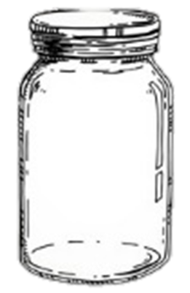
Scientifically, butter is not bad for your health. There is no experimental data that demonstrates any harm to the cardiovascular system, or any other system, from the effects of healthy consumption of butter or cholesterol derived from healthy animals.

Materials
From a healthy (organic) cow get the following:
- 1 pint heavy cream (organic).
- ¼ cup milk (organic).
- +/- ½ tsp Celtic sea salt.
- 1 Large Mason jar with a lid.

Methods
- Instead of going to a gym, fill the large glass Mason jar (shown above) with all of the ingredients listed, put the lid on the jar and start shaking it. That’s all.

- It does require strong and continuous shaking, so hand the jar over to another if you get tired, but keep shaking that jar. Continue to agitate the jar until the mixture begins to thicken. You will see it transform from heavy cream to whipped cream.

- You are not done yet. Keep shaking the jar. It will take some more shaking, the more vigorous, the faster the results.

- Suddenly it will happen. You'll feel something begin to knock around in the jar. You can pop the lid off and take a close look, you'll see two components: Butter and Buttermilk.

- Close the lid and keep shaking!

- Soon the butter will consolidate into one large yellow lump. Then you are ready to separate the butter from the residual milk. Simply open the jar and strain the fluid content off of the butter as you pour it into a cup – this will be buttermilk.

- Transfer the butter from the jar into to a clean container, e.g., a paper cup or a bowl.

- Now firmly press the butter with a spoon for a few minutes to remove any excess milk - your butter will spoil quickly if you skip this step!

- Stop pressing when there is no more milk weeping out.

- Rinse the butter with cold water and form into a block and pat dry.

- Congratulations - Your butter is done!

You will not believe how delicious real hand-made organic butter actually tastes.

The Reality Regarding Butter
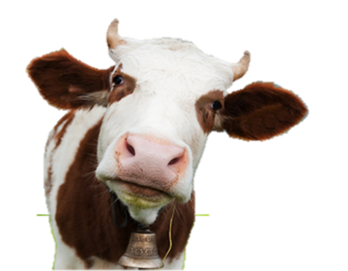
For many decades butter has been blamed for everything from obesity to heart disease. However, more recently butter has been making a very well-deserved comeback as a “health food” because as you will find out if you investigate, there are many health benefits derived from eating butter. In addition, it’s delicious!

This statement can be supported by numerous scientific studies, cited in the paper “7 Reasons Why Butter is Good for You” that can be found on the course website (https://sdmiramar.edu/faculty/marie-mcmahon) under “Assorted Articles”.

Questions to Consider
After reading the above-mentioned article, or any scientifically substantial article on the health benefits of butter, please answer the following questions.

- List the Fat-Soluble Vitamins that butter contains: ____________________________________.

- Does butter contain saturated fats? _______. Does butter contain medium chain fats? _______.

- According to research, which is better for health, eating Butter or Margarine?

- Do you have any idea how Margarine is manufactured? _______.

- Please read the paper “Margarine vs Butter” under Assorted Articles on the course website and make the following assessments:
  - Could you make margarine at home? _______.
  - Would you ever eat it after reading how it is made? _______.

- In studies cited, did eating the fatty acid Butyrate prevent weight gain? _______.

- What are some other benefits of eating butyrate?

- Does healthy butter contain butyrate? _______. Where does butter get its name from?

- What are some properties of Conjugated Linoleic Acid (CLA)? Does butter contain this?

- Is butter difficult to make at home? ______. After knowing it’s benefits, would you make it? ______.
Student Presentations of a Scientific Article for Physiology
Objectives
1. To search for scientific articles directly related to human physiology.
2. To read and understand the details and the findings of the study.
3. To explain this paper to everyone in class and answer questions about its content.

1. Finding an Article
- Each person must find their own article, students can choose a similar subject or the same author, but the papers must be different.

- The topic of the paper selected must be related to human physiology. This may include studies that examine animal models, as they make extrapolations of their data to humans. For example, the rats testing the effects of saccharin were used to examine the implications on human health.

- It is suggested that you look for a topic that you find interesting, as long as it is relevant. The minimum length of the paper should be about 1,500 words.

- It is useful to know how to identify a Scholarly or Peer Reviewed Journal from other sources of information. There are very good resources on the college website. The useful “Library Research: Tools & Assistance” link is: https://sdmiramar.edu/services/library (e.g., it has PROQUEST)

- Please show me the article you have selected beforehand so we can confirm its suitability. I can help you if you are unsure about a topic, or how to find a paper - please ask me, I am happy to assist.

2. Reading the Article
- It is sometimes difficult and confusing when first reading an involved scientific paper. It may require several readings and it is also very useful to make notes while reading it.

- After you have read it and think you understand it, try explaining it to someone else, preferably before your presentation. One of the best ways to understand an issue is to try to explain it to someone else.

- Critically evaluate the content of the paper. This means examine the strengths and potential weaknesses of the article. You must train yourself to ask questions about the article you have read. Get into the habit of questioning all aspects of it. For example, for a hypothetical paper you could ask the following: Why only young or old subjects? What were the subject’s background? Could that be important? Why was 50 mg of caffeine the only dose used? Why was walking chosen as an exercise and not running? Etc.

- By asking many questions, you can make an assessment of what you think the researchers actually achieved in the study you have read. It is good to think critically of these papers.

3. Presenting the Article
- When presenting information to anyone, it is most effective when the presentation is clear and well organized. This is not a formal speech, however, it is a presentation exercise for which you will be evaluated and awarded points for this presentation. Therefore, I encourage every student to be prepared for it.

- There is no written paper or presentation to be handed in. If you want to create written work in order to prepare for this exercise, that is fine, but it’s not required and will not be graded.

- The talks will be spread over the lab sessions in the same week. These presentations cannot be made up at any other time and students who do not show up will receive a zero for the exercise.

- Talk: Your presentation should be 5 minutes in duration. You will be timed with a stopwatch and you will have a maximum of 5 minutes. Points will be deducted for exceeding or falling too short of the time limit. Please try not to read the paper to the class. This is not an exercise in public reading! It is an opportunity for you to inform the class and guide a discussion on a topic that is of interest to you.

- Accessories: Think of how visual or other material has helped you to understand issues in the past. You can use pictures, slides, examples, or graphs etc. to better explain the paper, or use nothing at all, this option is entirely up to the individual. Also remember that the best type of preparation for a talk is knowing the material.

- Question Time: During the course of the paper presentation, and especially at the end of it, there will be times when I will ask questions of the presenter. There will also be an opportunity for any other student to ask questions regarding the article and topic.
- Evaluation: This assignment is worth 20 points.

Each student presentation will be evaluated for the following:
1) The quality and suitability of the article/topic selected.
2) Comprehensible explanation and presentation of the material.
3) Appropriate use of the set time frame.
4) The ability to answer questions posed by those in attendance.
5) Participation during other talks by asking questions.

Appendix A - Laboratory Exercises and Concepts Related to Lecture Exams

In Human Physiology, the laboratory component is designed to reinforce concepts that have been presented in lecture. There are no lab exams in physiology, however, some of the exercises and experiments in lab will be included in lecture exams. Listed below are the essential concepts covered in lab for each unit, and these may be included on the corresponding lecture exams. There may be some changes to these questions, depending on what has been covered in lab and ultimately, what will be included in lecture exams will be determined by your instructor.

LAB CONCEPTS RELATED TO EXAM I:
1. Define diffusion, osmosis, hyper-, iso- and hypotonic solutions, molarity, osmolarity and % solutions.
2. What are enzymes? Define the roles of urease, amylase, bromothymol blue and ammonia.
3. In lab, how did pH, temperature, competitive and non-competitive inhibitors affect enzymes?
4. What are sensory receptors? Describe baro-, chemo-, thermo-, photo-, mechano- and nociceptors.
5. Describe receptor adaptation in terms of phasic and tonic. What is olfaction and gustation?
6. Describe the five (5) steps of the scientific method.

LAB CONCEPTS RELATED TO EXAM II:
1. Define cranial and spinal reflexes. Compare monosynaptic and polysynaptic spinal reflexes.
2. Describe the reaction time ruler experiment (voluntary action) as a reflex arc.
3. How can: a) temporal summation and b) spatial summation be tested in the skeletal muscle lab?
4. Explain muscle fatigue using the handgrip experiment performed in lab as an example.
5. How does heart rate change with body position, why? How might regular exercise affect the heart?
6. Blood cell analysis: Functions and lifespan. Describe the ABO Blood Type grouping system used.

LAB CONCEPTS RELATED TO EXAM III:
1. What is an ECG? What are some deleterious conditions that can be identified on an ECG?
2. Explain blood glucose testing. How is MAP calculated and how can it be changed?
3. Describe the role of low density lipoproteins (LDL’s) and high density lipoproteins (HDL’s).
4. Describe the effects of various drugs on the heart as discussed and examined in lab.
5. Discuss the lung volumes and capacities measured on the spirometers in the lab.
6. Compare total pulmonary ventilation to alveolar ventilation. Give typical values and units.

LAB CONCEPTS RELATED TO EXAM IV:
1. Describe the roles of pepsinogen and HCl in digestion. What do the pancreatic juices do?
2. How was urine affected by the four different solutions consumed in the renal lab?
3. What is specific gravity? What are some of pathologies that can be detected using urinalysis?
4. Compare diabetes mellitus type 1 and 2, how might you test a subject for each one clinically?
5. Interpret information presented in graphs. What is a control group? A placebo? Nocebo? What is N?
6. Describe the functions and control of sweat glands in the body. How can sweat gland activity vary?.
Appendix B – Additional Review Exercises and Activities

① Exercise for Review in Calculating Osmolarity from % Solutions
Introduction to Intravenous Solutions
There are many reasons someone might receive an intravenous (I.V.) solution. For example, to relieve dehydration and electrolyte loss (from prolonged exertion), or to relieve shock, or replace fluids lost after suffering burns. The I.V. solution is going to mix with the blood, thus affecting the composition of the extracellular fluid (plasma) surrounding red blood cells. If the wrong solution is used, it could cause the red blood cells to either shrivel up (crenate) or to burst (lyse) due to osmosis. In addition, dealing with solutions in terms of molarity and osmolarity, another common way to describe the concentration of a solution is as a percentage (the percent of solute in the solution).

Definition: 1% glucose solution (w/v) = 1g of glucose (100 ml = deciliter, or dl)
100 ml of solution

It is often easier to describe solutions that are made with large solutes (e.g., proteins or starch), in terms of percentages because their molecular weights are very large and awkward to calculate.

Remember that when given the % solution, you are being told how many grams of a solute there are in a 100 ml volume of given solution. If the percentage solution is “a 0.45% NaCl Solution”

Think of it this way: a 0.45% NaCl Solution (saline solution) = 0.45 g NaCl
100 ml of Solution
Calculating Osmolarity from % Solutions
Here is an example of converting a % Solution to Molarity and finally to Osmolarity.

e.g., Please convert a 0.45% NaCl solution to Osmolarity and comment on its Tonicity.

Step 1: Convert the % Solution to Molarity

0.45 g NaCl x 1000ml = 4.5 g NaCl ; 4.5 g NaCl x 1 mole NaCl = 0.077 mole = 0.077M NaCl 100 ml sol^{n} 1 liter 1 liter sol^{n} 1 liter sol^{n} 58.5 g NaCl liter

Step 2: Calculate Osmolarity
NaCl will break up into Na⁺ and Cl⁻ in water. Thus, the osmolarity will be 0.154 Osmolar
0.077 moles of Na⁺
0.077 moles of Cl⁻
0.154 moles of dissolved material or 0.154 Osmoles (OsM) [x 1,000 for mOsM]

Step 3: = 154 mOsM (This solution is hypotonic and water would move out of the cell.)

Below, make the same calculations (converting to molarity and osmolarity) for the following:

- 0.33% NaCl
- 1.25 % NaCl
- 0.9 % NaCl
② Exercises for Review of the Plasma Membrane Lecture
- List and briefly Describe the 4 roles of the Plasma Membrane (with specific examples if possible):
1)
2)
3)
4)
- With regard to Protein Channels and Protein Carriers:
a) What are the 3 gated Protein Channels described in lecture? Give examples of their ‘triggers’.
1) 2) 3)

b) What are three characteristics of Protein Carriers listed and described in lecture?
1) 2) 3)

- With regard to Surface Area and Rate of Diffusion:
What are two regions of the body given as examples of having an enormous surface area for absorption?

Answers: The ________________________ and the ________________________.

- Philosophical Question: With regard to the Na⁺/K⁺ pumps, what is the purpose of the Na⁺/K⁺ pump?

- What the hormone (and gland) that has an effect on the number of Na⁺/K⁺ pumps? Describe the effect this hormone has on the pumps and then on the body as a consequence?

- On the topic of Water: About how many liters of water are there in a typical 150 lbs person? _________.
- In terms of the 3 Tissue Compartments, where is most of the water in the body located? ____________.
- What are the 3 Tissue Compartments and state briefly how they differ?
1)
2)
3)
- Name the examples of vesicular transportation given in lecture.

- What’s with Transcapillary Fluid Dynamics? How/why are HP and COP balanced in the capillary?

From Neurophysiology Lecture
- Name the 2 “long distance” control systems in the body: ________________ and ________________.

- Briefly describes how these two control systems in the body differ?

- Semi-Philosophical Question: How is the Neuron the microcosm of the Nervous System reflex loop?

- What is the point of talking about Equilibrium Potentials for Na⁺ and K⁺?

- Draw an Action Potential for a Neuron on the grid below. Include all labels, values and phases, etc.
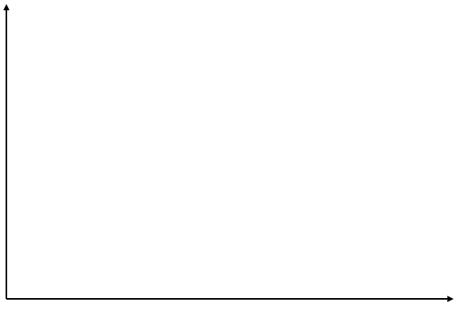

- List 6 ways that Graded Potentials are different from Action Potentials.
1)
2)
3)
4)
5)
6)

- Philosophical Question: What are the purposes of Graded Potentials and Action Potentials?

- In very simple terms, a graded potential is: _______________________________________________.
- Why is it not possible to trigger another AP during the absolute refractory period?

- Why is it possible to trigger another AP during the relative refractory period?

③ Exercise for Review of Myocardiocytes
1) Draw an Action Potential for an Autorhythmic Myocardiocyte. Include all labels, values and phases.

2) Draw an Action Potential for a Contractile Myocardiocyte. Include all labels, values and phases.

