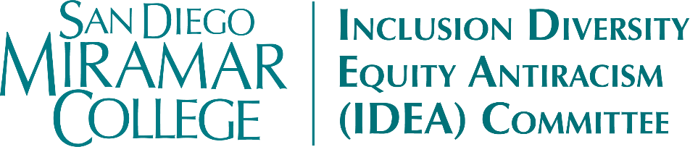
Meeting Minutes
Friday, April 17, 2026
11:15am-12:30pm, Zoom

Members Present: Tsekani Browne, Carmen Carrasquillo, Claudia Estrada-Howell, Joseph Hankinson, Nessa Julian, April Koch, Khaliah-Yasmeen Mangrum, Dianika Moore, Heather Paulson, Sharilyn Wilson, Bear Wolf

Members Absent: Sara Agonafer, Lily-Grace Balilo, Kyla Bertel, Angela Boyd, Veronica Dayag, Adrian Gonzales (ex officio), Ali Gonzalez, John Kim, Bill Pacheco, Marcia Sawyer, Liana Wong

Guests & Support: Janina Moretti (Proxy for Kim)

- Call to Order
  - Meeting called to order at 11:18am by co-chair Carrasquillo
- Approval of Agenda
  - MSC (Koch/Wolf) to approve the agenda as presented. (0-N; 0-Abstain)
- Approval of the March 27, 2026 Meeting Minutes
  - MSC (Koch/Wolf) to approve the minutes as presented. (0-N; 0-Abstain)
- Land Acknowledgment
- Action Items
  - SDMC Strategic Goals & Directions (Draft)
    - The Committee reviewed and discussed Goal #5 - Diversity, Equity, and Inclusion (DEI)
    - In place of “build”, the Committee suggested: Continue to build, strengthen and empower an environment…
      - MSC Wolf/Mangrum (0-N; 0-Abstain)
    - The Committee suggested adding an A for Accessibility, and possibly another A for Antiracism, to the goal title and acronym. After discussion, the group decided to move forward with DEIA – Diversity, Equity, Inclusion, and Accessibility.
      - MSC Wolf/Paulson (0-N; 0-Abstain)
    - Addition of accessibility and decolonization to Strategic Direction #2
      - MSC Wolf/Koch (0-N; 0-Abstain)
    - Addition of accessibility to Strategic Direction #3
      - MSC Wolf/Koch (0-N; 0-Abstain)
    - Carrasquillo mentioned that the literature around culturally responsive teaching and learning has evolved to culturally sustaining. She suggested updating the language in Strategic Direction #3 accordingly.
      - MSC Wolf/Koch (0-N; 0-Abstain)
    - Wolf highlighted the need for a full-time accessibility coordinator to ensure accessibility is integrated into all activities and practices campus- and district-wide. Potential agenda/discussion item for next meeting.
    - Final version of IDEA’s proposed language for Strategic Goal #5 is as follows (yellow indicates additions, red indicates deletions):
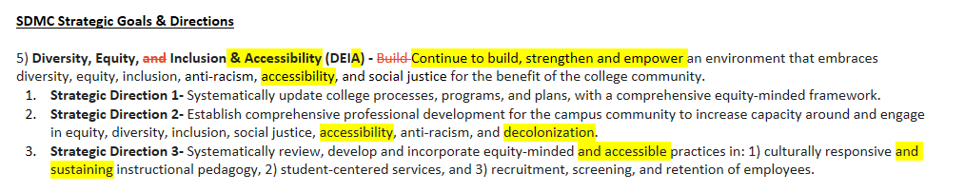
- Discussion Items
  - Affinity Groups: Potential Collaboration
    - The Committee discussed potential ways that IDEA, and faculty/staff in general, could collaborate more with our identity-based affinity groups.
    - Some suggestions included: a mixer/social event; “Community Hours” where faculty and staff could casually interact with the student groups in the affinity group spaces and the future Kaleidoscope space; supplemental activities during Convocation; “open houses” during Flex week; events in coordination with student clubs (e.g., Table Top Gaming Club).
    - Events will have to be well-coordinated and planned to ensure adequate space and participation. The general consensus is that students want to get involved; we just need to provide the opportunities for connection and community building.
    - The Committee decided to collaborate with the LEAD Office on an Affinity Group Mixer in the Fall, potentially timed to coincide with the Kaleidoscope Center’s opening.
  - GAIA Statement: Gender Equity in Public Naming Decisions
    - Carrasquillo provided an update from the Special Board Meeting held on Monday, April 6. The Board decided to temporarily revert the name of the César Chávez Campus to the Harbor View campus. The Board will also engage with stakeholders across the district and the community to select a new, permanent, name for the campus.
    - At the April 6 meeting, Carrasquillo read a statement from the GAIA group advocating that the campus be named in honor of Dolores Huerta.
  - Campus Safety
    - The presence of the TPUSA group on campus has diminished.
    - Other outside groups on campus – most are generally understanding and will comply with campus rules and regulations around free speech zones, etc. Some of the white religious group members are more aggressive and will follow/stop students, even when asked not to.
    - The Committee will keep this topic as a standing item on the agenda.
  - Cohort-Based Learning: Committee Goal
    - One of the goals we committed to at the start of the AY was to support cohort-based learning in connection with the 25-28 Student Equity Plan.
    - The Committee discussed ways we can continue towards this goal, including advocating for and offering more linked classes. Members also suggested that faculty can serve as “guest speakers” for each other. This minimizes the need for the paperwork associated with outside guest speakers, and promotes cross-disciplinary learning opportunities.
  - Equity Summit Fall 2026
    - A flyer went out to the campus DL – if you’re interested in being a part of the planning group, please contact Dean Julian.
    - Committee feedback on potential topics/structure: Current events (connect with local anti-ICE groups), workshop on Veterans/Service members rights, workshop on historical precedents (13th Amendment), “mini-lectures”, more student voices.
  - Puente Recruitment for Fall 2026: Interest Form
    - Please share!
  - Igniting Change Fall 2026 Conference Planning
    - We’ll dedicate most of our May meeting to planning.
- Reports & Updates
  - Taskforces – No report
  - Events
    - Koch reported on her presentation of the documentary Into the Arms of Strangers: Stories of the Kindertransport. There were nine attendees, and the screening was followed by a good discussion around the film and its connection to current events.
    - Mangrum reported on the Black Student Success Summit, held just prior to this meeting. The event was very well-attended (100+), and participants loved hearing from so many of our students during the presentation.
    - Julian promoted Black Student Success Week, April 20-24. The LEAD Office will be hosting webinar watch parties throughout the week. On April 21, there will be a mentoring program kick-off event. More info to come on the PEARL program. Miramar’s new NASSSP Director is on track to start in May.
    - Mangrum reported that Black Professionals Day is on May 8, from 9:00am-2:00pm. More info to come soon.
- Other
  - Carrasquillo mentioned that some members’ terms on this committee are up in June. Watch out for a call for committee participation if you’d like to serve another term.
  - Our next meeting would usually fall on May 15th, but that date is our Commencement. The Committee decided to meet the following Friday (May 22nd) instead. This will be our last regular meeting of the Academic Year
- Adjourn

Next Meeting: May 22nd, 11:15am-12:30pm, Zoom

