International Education Committee Agenda

San Diego Miramar College

10/27/25 Zoom 3 pm - 4 pm

- Call to order
- Approval of agenda and previous minutes
- Reports
  - Update on Study Abroad programs (Australia FIRE120; tabled)
  - International Students update (Patty)
  - Global Studies ADT Progress (tabled)
  - Upcoming International Professional Development Programs: Oaxaca and Ireland (Laura)
  - Committee goals reviewed and approved for 2025-27
  - Grant project updates (Patty, Gary, Dawn)

- New Business

# | Item | Strategic Goal | Accreditation Standard | Initiator
1 | International Education Week Planning (Nov 17-21)  Fair: Thursday Nov 20, K-107  College Hour | 2,5 | II.c | Laura
2 | Ireland Day - Feb 25, 2026  Planning  Patricia Rose Irish Dance - performance or class (budget) | 2,5 | II.c | Laura

- Announcements/Open Forum
- Adjourn

Next meeting: November 17, 2025

College Mission
San Diego Miramar College's mission is to prepare students to succeed by providing quality instruction and services in an environment that supports and promotes success, diversity, inclusion, and equity with innovative programs and partnerships to facilitate student completion for degrees/certificates, transfer, workforce training, and/or career advancement.

SDMC Strategic Goals and Directions – Fall 2020-Spring 2027
CEC Approved: 12.08.20

1) Pathways – Provide student-centered pathways that are responsive to change and focus on student learning, equity, and success.

2) Engagement - Enhance the college experience by providing student-centered programs, curriculum, services, and activities that close achievement gaps, engage students, and remove barriers to their success.

3) Organizational Health -Strengthen Institutional Effectiveness through planning, outcomes assessment, and program review processes in efforts to enhance data-informed decision making.

4) Relationship Cultivation - Build and sustain a college culture that strengthens participatory governance, equity efforts, and community partnerships.

5) Diversity, Equity, and Inclusion (DEI) - Build an environment that embraces diversity, equity, inclusion, anti-racism, and social justice for the benefit of the college community.

GOALS OF INT'L ED COMMITTEE
- To increase the college's engagement with international institutions and organizations of higher ed through programs for students and campus employees (4)
- To internationalize and promote global awareness at Miramar College through programming, curriculum, and professional development (5)
- To provide study abroad opportunities through Miramar College with our students' needs in mind (1,2)
- To promote study abroad in ways that align with the desires, challenges and obstacles of our students; to increase the diversity of students who study abroad; and to increase accessibility of these programs (2,5)
- To develop a social structure for our International Students with programming and support (2,5)
- To provide a vehicle by which educators will have opportunities to teach and engage in experiences abroad (2,4)

Addenda:
- Ollin Tlahtoani Center - Oaxaca City, Mexico
Professional Development Program Spring Break 2026
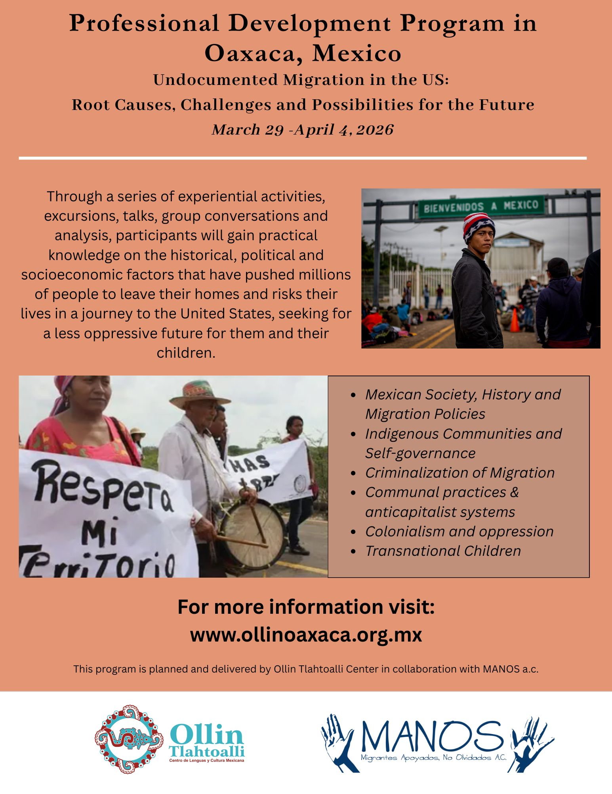

- ISAI - Ireland Professional Development Program, Spring Break 2026

