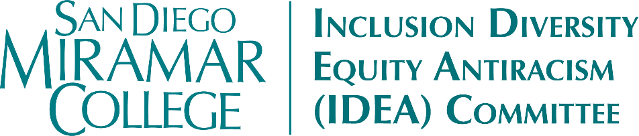
Meeting Minutes
Wednesday, February 4, 2026
12:45pm – 1:45pm, I-127 + Zoom

Members Present: Sara Agonafer, Carmen Carrasquillo, Claudia Estrada-Howell, Nessa Julian, John Kim, April Koch, Khaliah-Yasmeen Mangrum, Dianika Moore*, Heather Paulson, Marcia Sawyer, Sharilyn Wilson (proxy for Boyd and Pacheco), Bear Wolf

Members Absent: Lily-Grace Balilo, Kyla Bertel, Angela Boyd, Adrian Gonzales (ex officio), Ali Gonzalez, Joseph Hankinson, Bill Pacheco, Liana Wong

Guests & Support: Lilia Davis*, Maribel Flores, Gloria Carranza*, Teresa Naval*, Brenda O’Connor*

*Attended Virtually

- Call to Order
  - Meeting called to order at 12:51pm by Carrasquillo.
- Approval of Agenda
  - MSC (Koch/Agonafer) to approve the agenda as presented. (0-Nays; 0-Abstentions)
- Approval of the November 19, 2025 & December 17, 2025 Meeting Minutes
  - MSC (Wolf/Koch) to approve the minutes as presented. (0-Nays; 0-Abstentions)
- Land Acknowledgment
- Action Items
  - Spring 2026 Meeting Schedule (Carrasquillo & Wilson)
    - The Committee voted via paper ballot to meet once a month on the 3rd Friday from 11:15am-12:30pm, via Zoom.
  - Campus Security & Political Climate (Sawyer & Carrasquillo)
    - Committee discussed issues of safety and security on campus.
    - Members express a strong need for campus-wide trainings on conflict de-escalation and similar skills.
    - Employees are encouraged to be aware and record/document observations and/or concerning interactions.
    - Concerns about retaliation for reporting or complaining (experienced by students and employees)
    - Student Code of Conduct
      - Members suggested reviewing and updating the Code. Can be brought to Academic Senate for discussion, and also a potential IDEA project.
      - The Code is especially vague around online conduct and contacts. Needs to be updated to reflect how much student communication is mediated through virtual means.
    - When it comes to complaint channels and reporting structures, what do we already have in place? How are reports being tracked and handled? Are there avenues for anonymous complaints or some kind of “alert system” to flag issues that have not yet risen to the level of formal inquiry?
  - IDEA Workgroup: “Igniting Change: A Day for Diversity, Inclusion, Equity and Accessibility” (Carrasquillo & Wilson)
    - At our December 17 meeting, the Committee approved $3,000 for a proposal for an on-campus IDEA Conference in the Spring.
    - The proposal was intentionally broad in its focus. The next step is to form a smaller workgroup to plan the event.
    - The event could also incorporate a focus on campus security and safety, as discussed in the previous item.
    - Since we hope to make this an annual event, it will be crucial to gather feedback and data from participants.
    - Please let Carrasquillo know if you are interested in being a part of the workgroup.
  - Additional Funding Requests (Wilson)
    - The Committee has additional funds available, so we’re opening up another call for proposals.
    - If you are interested in requesting IDEA funds for an event, please submit your proposal via the Request Form by Tuesday, February 17th.
    - Timeline
      - February 17th: Proposals due
      - February 20th: Proposals distributed to members
      - February 27th: Scores due
      - March 4th: Virtual Vote
- Discussion Items
  - LEAD Updates (Julian)
    - Please feel free to reach out to Deans Julian and Estrada-Howell if you ever want an issue brought up at Deans’ Council or President’s Cabinet
    - February is Black History Month – Kick-off event on Thursday, February 5th.
    - The Resource Centers in the I-Building are focusing on creating community and engagement. A lot of services and resources are available in these spaces! The IDEA team is also preparing a slide deck highlighting all the different offerings.
    - Upcoming PD Opportunities
      - A2Mend
      - APAHE
      - HACU (Fall, in San Diego)
      - Pathways to Equity Conference (San Diego)
    - Powwow – Saturday, March 21st at Miramar – volunteers needed!
    - Advisory groups – reach out to Julian if interested.
  - Puente Recruitment Essentials (Carrasquillo)
    - Miramar is targeting a Fall 2026 launch of our Puente program.
    - Carrasquillo and M. Gonzalez will be lead faculty; attended PD over the winter break. Carrasquillo shared slide deck.
    - Please email Carrasquillo with feedback or suggestions
  - Black Excellence Workgroup Updates (Mangrum)
    - SDCCD Town Hall with Chancellor Gregory Smith – February 19th, 2:00pm L-105
    - Will feature panels focused on: programs & support services that uplift Black students, Black Serving Institution (BSI) state designation for City and Mesa colleges, and a short video about the All-African Diaspora Education Summit (ADES) Conference in Ghana
    - Submit questions in advance. Live questions will also be taken during the event.
- Reports & Updates
  - Events
    - Women’s History Month
      - March 18, 12:00-2:00pm, Women's Empowerment Event
      - April 29, Denim Day, Poster-making event
      - Koch will hold a Medical Spanish workshop
  - Puente & Umoja
  - ECHO Conference
- Adjournment
  - Adjourned by consensus at 1:57pm.

Next Meeting: Friday, March 20th, 11:15am-12:30pm, via Zoom

