San Diego Miramar College
Academic Standards Subcommittee
December 11, 2025; 9:30 a.m. – 11:00 a.m.
Zoom

Meeting Notes

Members Present: Paul Chlapecka, Barbara Clark, Jamie Hammond, Edwin (Tali) McLemore Meredith Morris, Jeffrey Orgera (proxy for Odu), Laura Pecenco, Mara Sanft, Robert Sojourner Worlds, Sharilyn Wilson

Members Absent: Evelyn Escalante, Michael Odu

- Call to Order
  - Meeting called to order by Chair Sanft at 9:42am.
- Approval of Agenda
  - Agenda approved as presented by consensus.
- Approval of October 9, 2025 Meeting Minutes
  - Minutes approved as presented by consensus.
- Adjunction of Student Petitions
  - None
- Old Business
  - Academic Standards Subcommittee Role & Charge (Action Item)
    - The Committee reviewed the proposed changes to the Academic Standards Subcommittee description in the College Governance Handbook. Proposed updates include: changes to Committee Purpose/Charge, Committee Responsibilities, and Committee Procedures (membership terms)
    - VPI Odu and Dean Orgera are working to move the Interdisciplinary Awards under the School of Academic Services.
    - MSC (Clark/McLemore) to approve all changes. (0-Nays; 0-Abstentions)
- New Business
  - CA Title 5 Regulations & the Course Outline of Record (Information Item)
    - Under new Title 5 provisions, all CORs required to incorporate a DEIAA (Diversity, Equity, Inclusion, Antiracism, Accessibility) component. This change started with pandemic-era call to action from Statewide Academic Senate.
    - At Miramar, the Curriculum Technical Review Subcommittee has been already been looking for DEIAA in proposals and making suggestions to originators.
    - Now that this requirement is officially chaptered in Title V, it will be a part of the Curriculum Committee’s duties to check for DEIAA components.
    - There may be potential future impacts for this Committee when it comes to equivalencies, especially for out of state course work.
  - Proposed Revisions to CA Title 5: Credit for Prior Learning (Information Item)
    - Not yet chaptered in legislation.
    - Current CPL “umbrella” encompasses five types: Credit by Exam, Portfolio, Military, Industry Certification, AP Course
    - Currently, credits acquired by CPL are not counted in determining the 12 semester hours of credit in residence required for an Associate degree. This proposed revision would change that and allow CPL credits to count towards credit in residence.
  - SDCCD Administrative Procedure: GPA Requirements for CE (Information)
    - As an FYI, the 2025-2026 Catalog Addendum included the following GE updates:

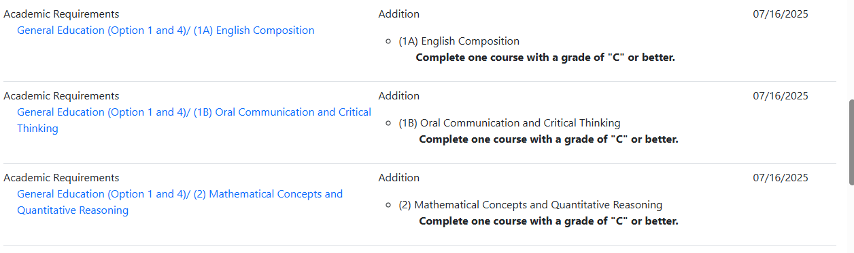
- FYI
  - None
- Standing Reports
  - VPI or Administrator Designee – No report
  - Evaluators – No report
  - Articulation Officer – No report
- Roundtable
  - Thank you to everyone for all your hard work and for being a part of this committee!
  - Please let Mara know if you are not able to continue as a member for any reason
  - Our next meeting will be February 12, 2026
- Adjournment
  - Adjourned by consensus at 10:19am.

