Technology Committee Meeting Agenda
San Diego Miramar College
Tuesday, November 4th, 2025, Teams
Co-Chairs: Kurt Hill, Jeffery Orgera

Minutes
Members: Kurt Hill, Jeff Orgera, Joseph Carletello, Todd Williams (Absent), Carlos Pelayo, Michelle Pasag, Jeanette Moore, S. Kelly (Absent), Judy Wu, Danish Kahn, Caleb Varela Johnson, Jim McElree
Vacancies: Liberal Arts Designee, ASG Designee #1, #2
Guests: Maria Battisti, Pablo Martin, Temmy Najimy, Sarah Laue, Brenda O’Connor

- Call to Order – 1:02pm
- Approval of Agenda and Minutes, 10/8 - Tabled to the next meeting.
- New Business:

# | Item | Strategic Goal* | Accreditation  Standard** | Initiator
1 | Review of Membership – Added District IT representative, Jim McElree (new member).  Vacancies include: Liberal Arts Designee (Lisa E. Muñoz’s term ending), Public Safety Designee, MBEPS Designee, and two ASG Designees. | III, IV |  | Hill, Orgera
2. | Meeting Calendar – Discussion to move meetings earlier in the day to accommodate ACS representation. Proposed schedule: 2nd and 4th Tuesday of the month from 1:00–2:00pm. The website will be updated with current meeting dates and times. Next meeting scheduled for December 9, 2025 from 1–2pm) in L-108. The first and second meetings of the Spring 2026 semester will be in-person on February 10 and February 24, 2026 in L-108. | III, IV |  | Hill, Orgera
3. | Meeting Format- The next meeting will be held in-person in L-108. | III, IV |  | Hill, Orgera
4. | BRDS/Ranking Process – VPA Maria inquired about the committee’s role in the BRDS ranking process. In the past, Brett provided a spreadsheet, and AV/ICS flagged technology-related items. The committee’s role is to focus on technology-related requests rather than adjusting school rankings. For example, if Academic Services ranked computers as their top priority, the committee would review commentary and context instead of reprioritizing.  It was noted that the process should be revisited, as the previous method was pre-pandemic. The committee discussed reassessing how to support BRDS and VPA Maria in refining this process. The committee’s charge is to “Provide technology expenditure recommendations to appropriate departments and the Budget and Resource Development Subcommittee.”  VPA Maria will send the spreadsheet to Kurt Hill, who will distribute it to the committee for review and comments. The IT representative and committee members will provide feedback. Jeanette emphasized the importance of meeting the BRDS deadline and reconvening quickly. Kurt will send the spreadsheet to the committee by Thursday, November 6, 2025, for review and comment.  Link to spreadsheet: Final Nuventive Spreadsheet 10.22.2025-Departments_Tech  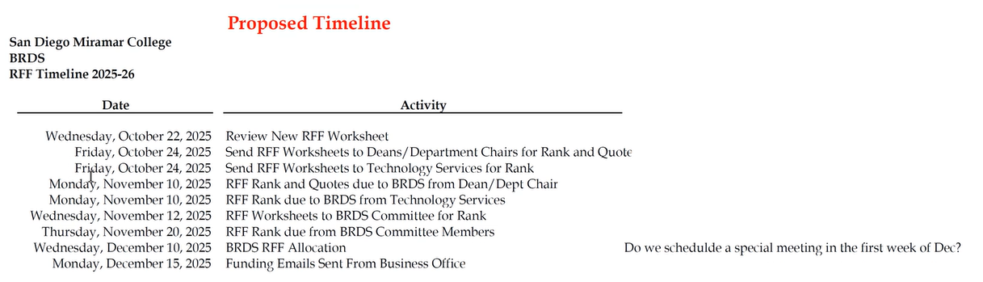  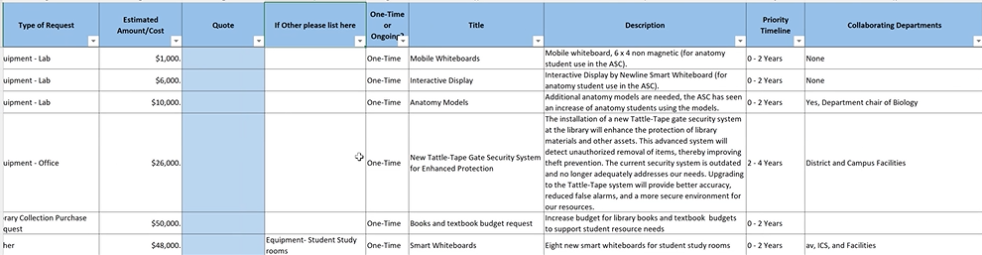 | III, IV | 3.9, 3.10 | Hill, Battisti

- Old Business:
# | Item | Strategic Goal* | Accreditation  Standard** | Initiator
 | Technology Plan – Process & Status –  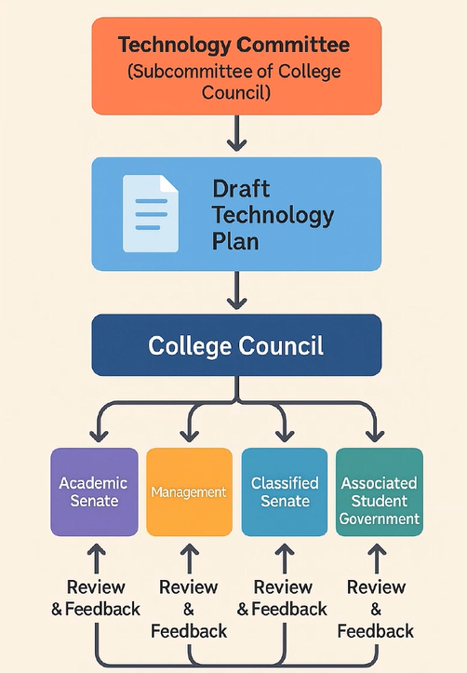  Kurt Hill recommended forming a workgroup to draft the Technology Plan rather than completing it during full committee meetings.  Pablo Martin will present the plan to Academic Senate for approval. Classified Senate has approved the plan and will forward comments to the committee. Kurt also presented the plan at the ASG meeting on October 31, 2025, to gather student feedback. | III, IV | 3.9, 3.10 | Hill, Orgera, Martin

- Announcements (5 minutes)
- Public Comments (5 minutes, 2 minutes per speaker)
- Adjourn – 2:07pm
- Next Scheduled Meeting: December 9, 2025 in L-108
San Diego Miramar College 2020 – 2027 Strategic Plan Goals
I: Pathways – Provide student-centered pathways that are responsive to change and focus on student learning, equity, and success II: Engagement-Enhance the college experience by providing student-centered programs, curriculum, services, and activities that close achievement gaps, engage students, and remove barriers to their success III: Organizational Health-Strengthen Institutional Effectiveness through planning, outcomes assessment, and program review processes in efforts to enhance data-informed decision making IV: Relationship Cultivation - Build and sustain a college culture that strengthens participatory governance, equity efforts, and community partnerships V: Diversity, Equity, and Inclusion (DEI)-Build an environment that embraces diversity, equity, inclusion, Anti-Racism, and social justice for the benefit of the college community
** ACCJC Accreditation Standards (2023): 3.9:The institution implements, enhances, and secures its technology resources to support and sustain educational services and operational functions. The institution clearly communicates requirements for the safe and appropriate use of technology to students and employees and employs effective protocols for network and data security. 3.10: The institution has appropriate strategies for risk management and has policies and procedures in place to implement contingency plans in the event of financial, environmental, or technological emergencies and other unforeseen circumstances.

