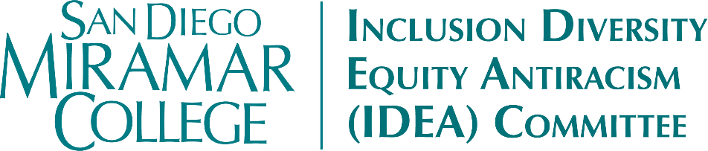
Meeting Minutes
Friday, November 14, 2025
11:30-12:30pm | Zoom

Members Present: Kyla Bertel, Angela Boyd, Carmen Carrasquillo, Joseph Hankinson, John Kim, April Koch, Kya Mangrum, Bill Pacheco, Heather Paulson, Marcia Sawyer, Sharilyn Wilson, Bear Wolf

Members Absent: Sara Agonafer, Lily-Grace Balilo, Veronica Dayag, Claudia Estrada-Howell, Ali Gonzalez, Nessa Julian, Dianika Moore, Liana Wong

Guests: Maribel Flores

- Call to Order
- Approval of Agenda
  - MSC (Wolf/Koch) to approve the agenda as presented. (0-Nays; 0-Abstentions)
- Approval of the October 15, 2025 Meeting Minutes
  - MSC (Koch/Kim) to approve the minutes as presented. (0-Nays; 0-Abstentions)
- Land Acknowledgment
- Action Items
  - Equity Summit Debrief, Feedback, & Next Steps (Carrasquillo)
    - Committee discussed the October 24 Equity Summit. Participants mentioned that they enjoyed the different tracks for different constituency groups, but would have like more time to hear from the other groups. There was also a desire for more action-oriented, goal-setting elements to these kinds of events, and more willingness to have “hard conversations”. This year there is an intentional focus on “connecting the dots” between the Equity Summit, the Planning Summit, and the (potential) IDEA Conference.
    - The Committee also discussed the planning process for the Summit, especially in terms of incorporating more adjunct input. The next Summit may have a larger planning/advisory group and all are encouraged to get involved.
    - Summit Feedback Form is available now – please complete ASAP.
- Discussion Items
  - Land Acknowledgement (Mangrum & NASSSP)
    - Wolf suggested a change to the opening of the Acknowledgement, as follows: “Miramar College apologizes that San Diego Miramar College sits on the ancestral homeland…"
    - Committee will run by NASSSP employees to get their feedback on the proposed change.
    - Recruitment for a new NASSSP Direction will begin soon.
    - A NASSSP plan was submitted as a part of the grant; could we get a presentation on what's in it at a future meeting?
  - Technology Plan & AV Standards
    - Per VPA Battisti, 2024-2027 Technology Plan is done/in motion for final approval. Classified did approve, but it was a split vote.
    - Moving forward, how can we further embed equity into the Technology Plan? What role can IDEA have?
    - Kim - what processes/avenues exist for one committee to influence another?
    - Carrasquillo – The Plan is on the Academic Senate agenda December 2 (second read & vote). All are welcome to attend and provide feedback.
    - Discussion of technology issues encountered by students – where do we raise these concerns? Could possibly bring to ASG, Pablo Martin (Faculty Technology Liaison), &/or Dean Jeff Orgera.
  - Puente & Umoja (Carrasquillo & Mangrum)
    - Umoja
      - Planning group has reviewed the projected budget, facility requirements, and a sample Umoja MOU.
      - Will present the summary of implementation impact at the December College Council meeting
      - Departments are also exploring how to offer classes together to pave the way for Umoja (the organization likes to see that campuses are already doing this kind of work even before the program officially comes to the campus).
    - Puente
      - Also looking at course offering opportunities for Fall 2026 (English + one other)
  - Committee Roundtable
    - Tabled for time, will be first item on the next agenda
- Reports & Updates (tabled for time)
  - Taskforces
  - Events
    - Student Affairs
      - Drum Circle: Monday, November 17
      - Basket Weaving Documentary: Tuesday, November 18
      - “Chill with Us” Event: Wednesday, December 3, Compass Point
    - International Education Week
      - Discussion of Contemporary International Literature: Wednesday, November 19, 2:30-4:00pm, H-105
    - GAIA
      - Currently planning two events in the Spring – one for Women’s History Month and one for Sexual Assault Awareness
    - Native American History Month
      - Flag Raising: Tuesday, November 18, 12:30-1:30PM
      - Presentation on Kumeyaay Language Preservation: Thursday, November 20, 12:30-1:30pm, I-126
- Other
- Adjournment
  - Adjourned by consensus at 12:31pm

Next Meeting: Wednesday, November 19, 12:45 pm in I-127

