Anatomy Practice Questions: Exam IV

1. Blood transported by the pulmonary veins directly delivers blood to the
a) left atrium b) left ventricle c) right atrium d) right ventricle e) none of these

2. Of the three (3) layers of the walls of the heart which one is the thickest?
a) epicardium b) myocardium c) pericardium d) endocardium e) myocardiocytes

3. In the heart, the role of the chordae tendineae is to
a) keep the AV valves closed during ventricular contraction
c) contribute to the force of ventricular contraction
b) pull the papillary muscles upward
d) keep the semilunar valves closed during ventricular contraction
e) open the AV valves

4. The pacemaker that sets the normal heart rate in the body is the
a) Purkinje fibers b) AV node c) SA node d) SV bundle e) atrial bundle

5. Of the cellular component of blood, the RBCs account for approximately what percentage?
a) 55% b) 45 % c) 1 % d) 99% e) 100%

6. Exchange of nutrients and gases between the blood and tissue is the function of the
a) arteries b) arterioles c) veins d) venules e) capillaries

7. to 10. Name the specific vessel indicated at each point of the arrows.
*Also include that structures the blood vessel is supplying.
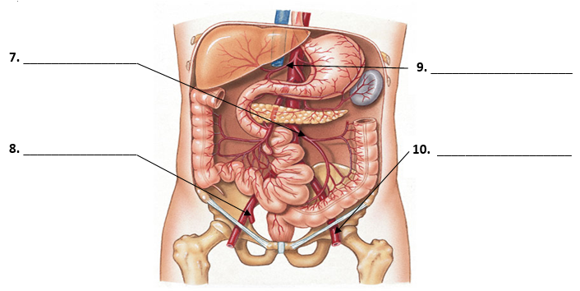

11. Which of the following describes the role of lymph nodes in the body?
a) filters lymph b) large lymph vessels c) filters interstitial fluid d) filters blood e) makes RBCs

12. Which of the following arteries is not a paired branch off of the abdominal aorta?
a) gonadal b) celiac trunk c) lumbar d) inferior phrenic e) suprarenal

13. A thrombus refers to an abnormal
a) weakening of vessels walls
b) hardening of the arteries
c) destruction of blood vessels
d) mobile blood clot
e) stationary blood clot

14. Which of the following arteries arises from the descending thoracic aorta?
1. mediastinal
2. pericardial
3. inferior phrenic
4. suprarenal
5. superior mesenteric
a) 2, 1, 3 b) 5, 4, 3 c) 2, 5, 1 d) 2, 4, 1, 3, 5 e) 2, 1

15. Which type of White Blood Cell (WBC) is the third most abundant in a healthy person?
a) lymphocytes b) basophils c) monocytes d) eosinophils e) mast cells

Answer Key:
- A
- B
- A
- C
- D
- E
- Inferior mesenteric artery
- Right internal iliac artery
- Common hepatic artery
- Left femoral artery
- A
- B
- E
- A
- C

