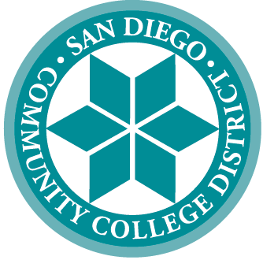 | SAN DIEGO COMMUNITY COLLEGE DISTRICT
3375 Camino del Rio South
San Diego, California 92108-3883
619-388-6500
 | CITY COLLEGE | MESA COLLEGE | MIRAMAR COLLEGE | COLLEGE OF CONTINUING EDUCATION
 | Educational Services

Academic and Progress Standards

The Chancellor’s Office has revised Title 5 Section 55055 Standards for Dismissal and removed local flexibility when setting dismissal standards. By eliminating the flexibility, the District must adhere to standards that are defined in Title 5:

(a) For purposes of this section, semesters or quarters shall be considered consecutive on the basis of the student's enrollment, so long as the break in the student's enrollment does not exceed one full primary term.

(b) A student who is on academic probation shall be subject to dismissal if the student earned a cumulative grade point average of less than 2.0 in all units attempted in each of 3 consecutive semesters (5 consecutive quarters) which were graded on the basis of the grading system described in section 55023.

(c) A student who has been placed on progress probation shall be subject to dismissal if the percentage of units in which the student has been enrolled for which entries of "W," "I," and "NP" (as defined in section 55023 and 55030) are recorded in at least 3 consecutive semesters (5 consecutive quarters) reaches or exceeds fifty percent (50%) in accordance with section 55031.

Given the purpose of dismissal as a direct intervention to alter a student’s behavior toward success and completion, the following is being proposed:

- Students must be on three consecutive primary semesters of probation (academic or progress) to be in a disqualified status.
  - Primary semesters are Fall and Spring only.
  - Summer is not considered for probation and dismissal calculations.
- On the second consecutive primary semester of probation status, a “to-do item” will be added to the student to ask them to make an appointment with counseling (or their program counselor – DSPS, EOPS, etc.)
- On the third consecutive primary semester of probation status, the student will be disqualified, and a registration hold will be placed on the student.
  - Students who meet or exceed academic or progress standards at the end of the semester but not substantially enough to be removed from probation will be granted an automatic waiver to continue their studies.
- For the registration hold to be released, students must meet with a counselor and complete a student academic contract. Upon completion, the registration hold will be released.
- Recommendation: No longer drop students due to disqualification. This will provide students an additional opportunity to make progress.
- Counseling would review subsequent disqualifications where additional restrictions may be applied (e.g., reducing the unit limit, requiring tutoring, etc.)
- Removal of statuses DQ2, DQ3, DQ3+

- Change language from “disqualification” to “dismissal” to align with Title 5

- Until the State Chancellor’s Office amends Title 5 to change the language regarding probation (academic or progress), we will use current language as written in statute until the change is made.

