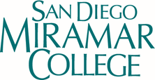

**2024 Accreditation Reference Sheet**

San Diego Miramar College values its diverse student body and is committed to student success. The College has about 21,756 students enrolled annually. The students are registered for classes both full and part time, and are of all ages and backgrounds.

**ACCJC Accreditation Standards**

**College Mission Statement** (<https://sdmiramar.edu/about>)

San Diego Miramar College's mission is to prepare students to succeed by providing quality instruction and services in an environment that supports and promotes success, diversity, inclusion, and equity with innovative programs and partnerships to facilitate student completion for degrees/certificates, transfer, workforce training, and/or career advancement.

**2020-2027 Institutional Goals** (<https://sdmiramar.edu/services/planning/framework>)

The College Mission Statement guides college-wide planning and the development of the Strategic Plan. The Strategic Plan contains the following five Strategic Goals (= institutional goals):

#### Goal 1—Pathways

**Provide student-centered pathways that are responsive to change and focus on student learning, equity, and success**

#### Goal 2--Engagement

**Enhance the college experience by providing student-centered programs, services, and activities that close achievement gaps, engage students, and remove barriers to their success**

#### Goal 3--Organizational Health

**Strengthen Institutional Effectiveness through planning, outcomes assessment, and program review processes in efforts to enhance data-informed decision making**

#### Goal 4--Relationship Cultivation

**Build and sustain a college culture that strengthens participatory governance, diversity, inclusion, and community partnerships**

#### Goal 5--Diversity, Equity, and Inclusion (DEI)

**Build an environment that embraces diversity, equity, inclusion, anti-racism, and social justice for the benefit of the college community.**

**Institutional Learning Outcomes** ([Miramar 2023-2024 catalog.pdf (sdccd.edu)](https://www.sdccd.edu/docs/StudentServices/catalogs/2023-2024/Miramar%202023-2024%20catalog.pdf) p12 )

**ISLO 1:** Knowledge of Human Cultures and the Physical and Natural World

**ISLO 2:** Intellectual and Practical Skills

**ISLO 3:** Personal and Social Responsibility

**ISLO 4:** Integrative and Applied Learning

**Student Achievement Data** Source: Miramar College PREDD 201516-202021

**Miramar College Overall Student Success Rates**

|  |  |  |  |  |  |  |  |  |  |
| --- | --- | --- | --- | --- | --- | --- | --- | --- | --- |
|  | **2015/16** | **2016/17** | **2017/18** | **2018/19** | **2019/20** | **2020/21** | **% Change**  **15/16 - 20/21** | **College Average**  **15/16 - 20/21** | **All Colleges Average**  **15/16 - 20/21** |
| **Average** | 75% | 76% | 74% | 77% | 76% | 77% | 2% | 76% | 71% |

**Miramar College Overall Student Retention Rates**

|  |  |  |  |  |  |  |  |  |  |
| --- | --- | --- | --- | --- | --- | --- | --- | --- | --- |
|  | **2015/16** | **2016/17** | **2017/18** | **2018/19** | **2019/20** | **2020/21** | **% Change**  **15/16 - 20/21** | **College Average**  **15/16 - 20/21** | **All Colleges Average**  **15/16 - 20/21** |
| **Average** | 90% | 90% | 90% | 90% | 88% | 90% | 0.4% | 90% | 87% |

**Miramar College Annual Overall Student Awards Conferred**

|  |  |  |  |  |  |  |  |  |  |
| --- | --- | --- | --- | --- | --- | --- | --- | --- | --- |
|  | **2015/16** | **2016/17** | **2017/18** | **2018/19** | **2019/20** | **2020/21** | **% Change**  **15/16 - 20/21** | **College Average**  **15/16 - 20/21** | **All Colleges Average**  **15/16 - 20/21** |
| **Average** | 1,247 | 1,259 | 1,565 | 1,877 | 1,441 | 1,681 | 35% | 1,512 | 1,594 |

**Annual Planning Process** https://sdmiramar.edu/sites/default/files/2023-08/Miramar_Annual_Planning_Calendar-Cycle_2023-2024.pdf

Through the implementation of the Strategic Plan, the mission guides institutional decision-making, planning, and resource allocation. All instructional programs and service areas develop their goals and annual plans in alignment with the Strategic Plan**.**

**Program Review Process** https://sdmiramar.edu/services/planning/instruction

Miramar uses an online platform to establish core program review requirements and to collect and publish program review data and reports. The process is a three-year cyclical program review and ensures students are achieving their goals of transfer preparation, workforce training and/or career advancement The College is currently working on the 2021-2024 Program Review Cycle.

**Outcomes and Assessment Process** https://sdmiramar.edu/services/planning/outcomes

The three year cycle of outcomes assessment is a continuous process to measure knowledge, skills, and abilities which in turn helps programs, courses, and services focus on continuous quality improvement.

1. Review course, program and service unit outcomes. Make necessary modifications and make updates.
2. Collect assessment data and dialogue with faculty and staff. Design and plan actions to improve student learning and student success.
3. Implement action plans and provide status report to complete cycle for all SLOs. (Spring semester).

Assessment provides answers to the following : (*ASU University Office of Evaluation and Educational Effectiveness*)

* What do students need to know to successfully graduate?
* What do graduates need to know to be successful professionals?
* What programmatic changes can be made to continuously improve quality, increase student success, and build required knowledge and skill sets for program completion?

**Long-term Planning**

The college’s Mission and Vision Statement provide the overall framework and basis for integrated planning college wide. This connection is achieved by the development of Strategic Plan Goals that directly support the mission and are used to guide college wide planning over a 7-year period. Through the implementation of the Strategic Plan, the mission guides institutional decision-making, planning, and resource allocation. All instructional programs and service areas develop their goals in alignment with the Strategic Plan, thus ensuring that the college mission is central to planning at all levels of the College.

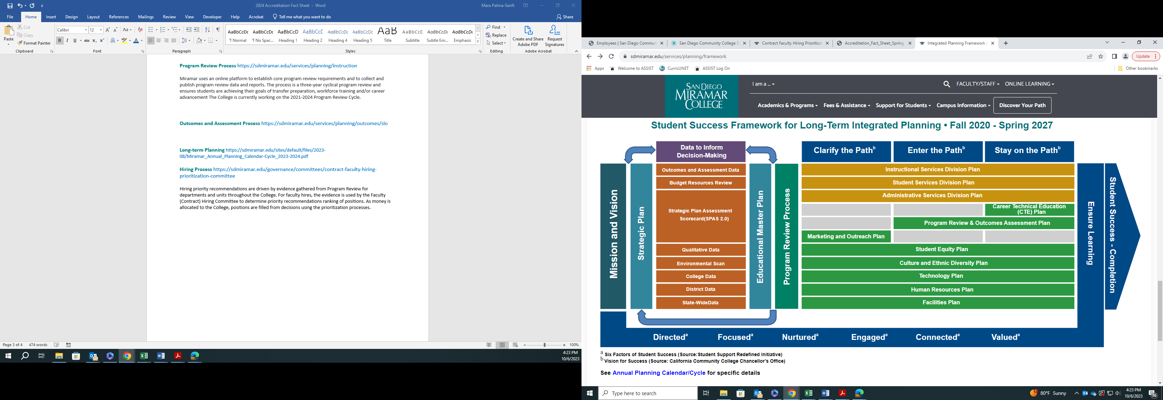

**Hiring Process** https://sdmiramar.edu/governance/committees/contract-faculty-hiring-prioritization-committee

Hiring priority recommendations are driven by evidence gathered from Program Review for departments and units throughout the College. For faculty hires, the evidence is used by the Faculty (Contract) Hiring Committee to determine priority recommendations ranking of positions. As money is allocated to the College, positions are filled from decisions using the prioritization processes.

**College Governance Structure**

