Anatomy Worksheet 9
Name ________________________
The General and Special Senses

Exercise 1. Sensory perception of the general senses include touch, pressure, temperature, pain and itch.
1) The drawing below shows the idea of an incoming pathway for a stimulus on the surface of a finger. The receptors of the body are specialized for an array of different types of stimuli (energy) to detect sensations, and this information is delivered to the central nervous system for the perception of it.
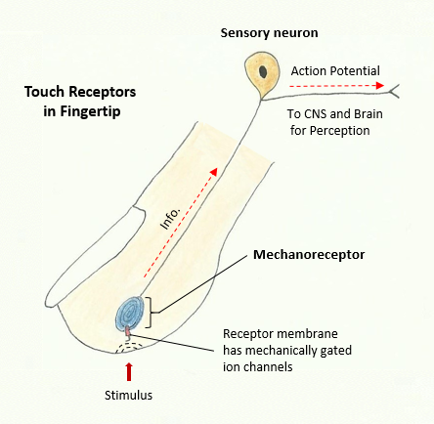

As seen in the drawing above, sensory receptors are most often the specialized endings of sensory neurons and function to detect changes, and then relay a signal if the stimulus is strong enough. Sensory receptors can be classified in many ways, use any resource to help fill in Table 1 below.

Table 1. Briefly state the way that each receptor type is actually stimulated (the adequate stimulus).
Type of Receptor | The Adequate Stimulus (stimulated by)
Chemoreceptors
Mechanoreceptors
Nociceptors
Osmoreceptors
Photoreceptors
Thermoreceptors
2) For sensory sensation (detection) and perception (processing for context), there are several factors involved. Many of the elements are shown in Table 2 below. These factors include the type of stimulus (Sensory Modality), where the original stimulus is coming from (Location of Stimulus), and the specific type of detection (Sensory Receptor) and where in the body the detection occurs (Location in Body).

Use information from any reliable source to help fill in Table 2 below.

Table 2. For the missing element in the table below (*blank cell), fill in with the appropriate information.
Sensory Modality | Location of Stimulus | Sensory Receptor | Location in Body
Cutaneous | Exteroceptors | Meissner’s corpuscles  Ruﬃni's corpuscles  Krause end bulbs  Merkel’s discs  Free nerve endings  Pacinian corpuscles | Epidermis of Skin  Epidermis of Skin  *  Epidermis of Skin  Dermis of Skin  *
Temperature | Exteroceptors  Interoceptors | Thermoreceptors  * | Skin  Hypothalamus
Blood Chemistry | * | Chemoreceptors  Chemoreceptors | Internal carotid artery  Medulla Oblongata
Pain | Exteroceptors  *  Interoceptors | Free nerve endings  Nociceptors  Mechanoreceptors | Skin, tongue, eyes  Internal organs  Hollow organs (lungs)
Vision | Exteroceptors | * | Retina
Sound | Exteroceptors | Hair cells in the Organ of Corti | *
Blood Pressure | * | Baroreceptors | Aortic arch, Carotid Sinus, Right Atrium
Taste | Exteroceptors | Taste buds and olfactory receptors | *
Smell | * | Olfactory Receptors | Nasal cavity
Osmolarity | Interoceptors | * | Hypothalamus
Proprioception | Interoceptors | * | Skeletal Muscles  Tendons, Joints

The Special Senses
Exercise 2. Longitudinal Section of the Eyeball
1) Use the drawing below and label this longitudinal section of the eyeball. Include the following structures: sclera, cornea, iris, pupil, lens, canal of Schlemm, anterior chamber, posterior chamber, ciliary body, suspensory ligament, choroid, retina, fovea centralis, optic disc, optic nerve.
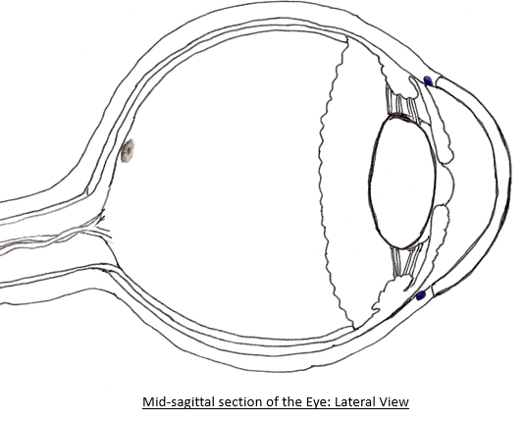

2) Define and indicate the significance of the following terms or structures:

a) Lens –

b) Optic disc -

c) Canal of Schlemm -

d) Aqueous humor -

3) Read about common vision problems and write in the correct term for the missing numbered word in the four statements that follow (fill in below). In farsightedness, the light is focused _1_ the retina. The lens required to treat myopia is a _2_ lens. The "near point" increases with age because the _3_ of the lens decreases as we get older. Astigmatism causes blurred distance and near vision and can occur when the surface of cornea and the lens are _4_.

1. _____________________________________
2. _____________________________________
3. _____________________________________
4. _____________________________________

Exercise 3. Disorders of the Eye
1) Match the muscles in Column A with the actions in Column B.
Column A Column B
A. astigmatism 1. ___ abnormal curvature of cornea or lens
B. myopia 2. ___ eyeball is too long, resulting in nearsightedness
C. glaucoma 3. ___ loss of lens elasticity as a consequence of aging
D. presbyopia 4. ___ clouding of the lens, impairing vision
E. conjunctivitis 5. ___ eyeball is too short, resulting in farsightedness
F. trachoma 6. ___ abnormally high intraocular pressure
G. hyperopia 7. ___ bacterial or viral invasion of conjunctiva
H. cataracts 8. ___ damage or irritation of conjunctiva

Exercise 4. The Eyes
1) Match the terms in with the description or definitions below.
A. sclera F. cornea K. aqueous humor
B. choroid coat G. pupil L. retina
C. optic nerve H. nasolacrimal duct M. blind spot
D. iris I. conjunctiva N. ciliary muscle
E. lacrimal gland J. vitreous humor O. suspensory ligament

1. ___ vascular tunic of the eye
2. ___ the 'whites' of the eye
3. ___ transparent anterior portion of fibrous tunic
4. ___ inner lining of eyelid in direct contact with eye ball
5. ___ secretes tears (containing lysozyme) to protect eyes
6. ___ empties into the nasal cavity
7. ___ fills the posterior cavity of the eye
8. ___ area where the optic nerve originates.
9. ___ controls amount of light entering the eye
10.___ fills the anterior chamber of the eye
11.___ contains the visual receptors
12.___ connects the lens to the ciliary body
13.___ causes lens to change shape
14.___ opening in the iris
15.___ transmits nerve impulse from retina

2) Multiple Choice Questions: select the best answer.

1. The anatomical name for the "whites of the eye" is the
a) cornea b) conjunctiva c) choroids d) fibrous tunic e) sclera

2. Which is not a component of the vascular tunic?
a) choroid b) macula lutea c) iris d) ciliary body e) ciliary muscle

3. The amount of light entering the eyeball is regulated by the
a) lens b) cornea c) iris d) conjunctiva e) optic disc

4. Which region of the eyeball contains the vitreous humor?
a) anterior chamber b) vitreous body c) posterior chamber d) conjunctiva e) the canal of Schlemm

5. The densest concentration of cones is found at the
a) blind spot b) macula lutea c) fovea centralis d) optic disc e) neural tunic

Exercise 5. Examine the drawing of the extrinsic muscles of the eye (below) and determine the nervous control and movement of these muscles.
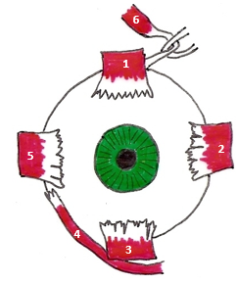

1) Write the names of the 6 extrinsic muscles of the eye in the order they are numbered in the drawing. Also, name the cranial nerve that controls them and the eye movement they produce.

Muscle Cranial Nerve Movement of Eyeball
1. __________________ _______________ ______________________________________
2. __________________ _______________ ______________________________________
3. __________________ _______________ ______________________________________
4. __________________ _______________ ______________________________________
5. __________________ _______________ ______________________________________
6. __________________ _______________ ______________________________________
Exercise 6. The Outer, Middle and Inner Ear Use the drawing of the ear below to label the relevant structures of the outer, middle and inner ear. Include the following structures: pinna, external auditory meatus (canal), auditory (Eustachian) tube, stapes, malleus, tympanic membrane, oval window, round window, tympanic cavity, cochlea, vestibular complex, semicircular canals, , and vestibulocochlear nerve.
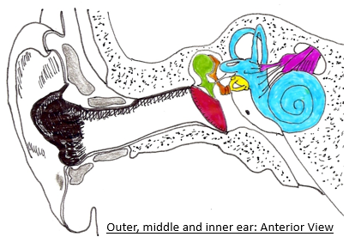

Exercise 7. Section of the Cochlea
Use the drawing below to label the cross section of the cochlea. Include the following structures: basilar membrane, tectorial membrane, organ of Corti, hair cells, vestibular membrane, supporting cells, scala media (cochlear duct), spiral ganglion, scala tympani (tympanic duct), scala vestibuli (vestibular duct), and cochlear nerve.
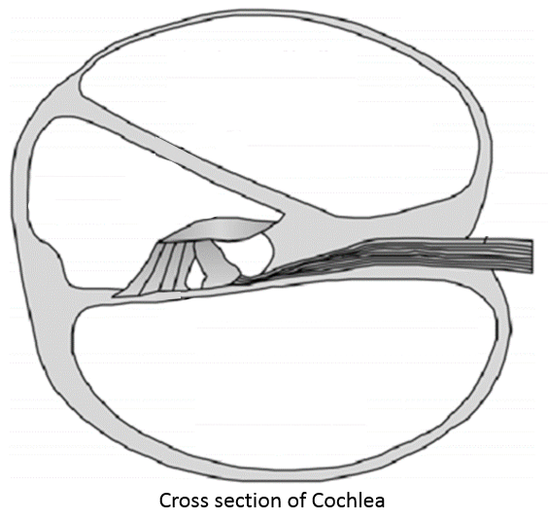

Exercise 8. The Inner Ear
1) Match the terms in with the description or definitions below.
A. oval window F. malleus K. scala media
B. scala vestibuli G. tectorial membrane L. scala tympani
C. tensor tympani H. stapedius M. tympanic membrane
D. vestibular complex I. tympanic cavity N. stapes
E. basilar membrane J. ceruminous gland O. auditory tube

1. ___ connects cochlea and semicircular canals
2. ___ ossicle attached to ear drum
3. ___ an area that contains endolymph
4. ___ air filled space containing auditory ossicles
5. ___ muscle attached to malleus
6. ___ connects the middle ear to the pharynx
7. ___ muscle attached to stapes
8. ___ wax secreting structure
9. ___ contains perilymph and the vestibular membrane
10.___ ossicle attached to oval window

Exercise 9. Hearing and Equilibrium
1. What is conductive deafness?

2. What is nerve deafness?

3. What structures in the inner ear respond to rotational movements of the head?

4. Briefly describe what type of movement of the head each of the following structures detect.

a) Anterior semicircular canal (duct) -

b) Lateral semicircular canal (duct) -

c) Posterior semicircular canal (duct) –

