Anatomy Worksheet 8
Name ________________________
The Nervous System: Brain and Cranial Nerves

Exercise 1. The Brain: 1) Match the terms in Column A with the descriptions provided in Column B.
Column A

A. Central sulcus
B. Cerebral cortex
C. Gyri (singular Gyrus)
D. Corpus callosum
E. Falx cerebelli
F. Hypothalamus
G. Insula
H. Medulla oblongata
I. Midbrain
J. Optic chiasm
K. Pineal gland
L. Pons

Column B
____ 1. Structure formed at the point of the crossing-over (decussation) of the optic nerves.
____ 2. Part of diencephalon that forms the lower walls and floor of third ventricle.
____ 3. This pine cone-shaped structure is attached to the upper posterior portion of diencephalon.
____ 4. Connects the cerebral hemispheres.
____ 5. Ridge-like twists and folds on the surface of the cerebrum.
____ 6. Landmark that separates the frontal and parietal lobes.
____ 7. Part of brainstem between diencephalon and pons.
____ 8. Rounded bulge on underside of brainstem; the name means ‘bridge’.
____ 9. Part of brain stem that is continuous with the spinal cord.
____ 10. A fold of dura mater that separates cerebellar hemispheres.
____ 11. The cerebral lobe located deep within the lateral sulcus.
____ 12. A thin portion of gray matter on the superficial surface of the cerebrum.

2) In which specific areas of the cerebrum would the following functional areas typically be found?
a) amygdala ____________________________ b) Broca's area ______________________________
c) gustatory cortex _______________________ d) primary sensory area _______________________
a) Wernicke’s area _______________________ b) primary motor area ________________________

3) Fill-in: Complete the statements using the most appropriate word or words.
1. The nuclei of origin for cranial nerves IX, X, XI, and XII are found in the__________________________.
2. The portion of the brain containing the cerebral peduncles is the _____________________________.
3. Cranial nerves V, VI, VII, and VIII have their nuclei of origin in the ______________________________.
4. A shallow groove on the surface of the cerebral cortex is called a(n) ___________________________.
5. Together, the thalamus, hypothalamus and the ________________ constitute the _______________.
Exercise 2. The Cranial Nerves: 1) Match the cranial nerves in Column A with the statements in Column B. Also, list the number or name (whichever is missing) next to the nerve and whether it is sensory (S), motor (M) or both (B) (mixed).

Column A

A. Oculomotor -
B. Trigeminal -
C. Vestibulocochlear -
D. Cranial N. I -
E. Vagus -
F. Cranial N. II -
G. Abducens -
H. Accessory -
I. Cranial N. XII -
J. Glossopharyngeal -
K. Trochlear -
L. Facial -

Column B
1. ___ is responsible for taste sensation on the posterior third of tongue.
2. ___ acts to decrease heart rate and plays a role in gastric motility.
3. ___ controls an intrinsic eye muscle that rotates the eye laterally.
4. ___ concerned with balance and equilibrium and damage can lead to nausea, dizziness.
5. ___ if damaged, the levator palpebrae is affected and ptosis (drooping upper eyelid) can result.
6. ___ inflammation of this nerve can result in a painless paralysis of facial muscles called Bell’s palsy.
7. ___ innervates the sternocleidomastoid and controls voluntary swallowing.
8. ___ is responsible for the inferior lateral rotation of the eye.
9. ___ the largest of its three branches is the mandibular branch and controls the muscle of mastication.
10. ___ nerve fibers travel through the ethmoid bone and damaged can lead to anosmia.
11. ___ controls food manipulation and also for tongue movements involved in speech and swallowing.
12. ___ damage to this nerve can lead to defects called anopsia.

2) Label: Find, label and number all 12 cranial nerves in the drawing below.
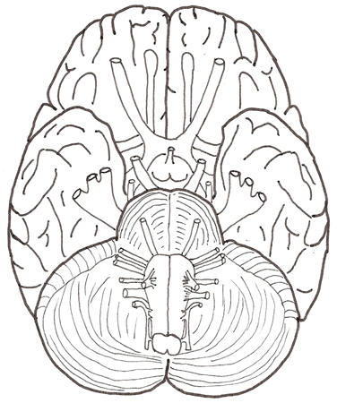

3) Multiple Choice Questions – select the best answer.

1. The vital centers for heartbeat, respiration, and blood vessel diameter regulation are found in the
a) pons b) cerebrum c) cerebellum d) medulla oblongata e) midbrain

2. Reflex centers for movements of the head and trunk in response to auditory stimuli are located in the
a) inferior colliculi
b) medial geniculate nucleus
c) superior colliculi
d) ventral posterior nucleus
e) hypothalamus

3. Which of these thalamic nuclei relays sensory impulses for vision to the occipital lobe?
a) ventral inferior
b) ventral posterior
c) lateral geniculate
d) ventral anterior
e) medial geniculate

4. Integration of the autonomic nervous system (ANS), control of body temperature and the regulation of eating and drinking are functions of the
a) pons
b) thalamus
c) cerebrum
d) hypothalamus
e) cerebellum

5. The left and right cerebral hemispheres are separated from each other by the
a) central sulcus
b) transverse fissure
c) falx cerebelli
d) insula
e) longitudinal fissure
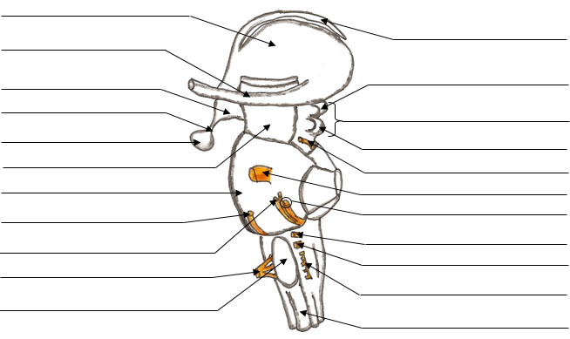
4) Label: List the name of the specific structure at each point (at right).

Table 1. For each of the following structures below, provide the location (brain region, e.g., the diencephalon) and the general function and significance of the structure.
Structure | Location | Function
Hypothalamus

Optic chiasm

Hypophysis

Cingulate gyrus

Corpus callosum

Medullary respiratory center

Intermediate mass

Lateral and
Median apertures

Primary sensory cortex

Arbor vitae

Cerebral aqueduct

Pineal gland or body

Pia mater

Olfactory cortex

Corpora quadrigemina
Superior colliculi -
Inferior colliculi -

