Anatomy Worksheet 7
Name ________________________
Nervous Tissue and Spinal Cord

Exercise 1. Nervous Tissue: 1) Match the terms in Column A by placing the letter for the term in Column B for the best answer in the space provided for the descriptions.
Column A

A. Astrocyte
B. Nissl bodies
C. Axon
D. Motor neuron
E. Dendrite
F. Myelin
G. Neurilemma
H. Sensory neuron
I. Effector tissue
J. Ganglion
K. Interneuron
L. Ependymal cell

Column B
____ 1. Schwann cells create a protective and insulating cover that encloses some axons.
____ 2. Corresponds to rough endoplasmic reticulum in other cells.
____ 3. The individual cables that create a network of fine threads within a nerve.
____ 4. Outermost surface of Schwann cell that is composed of lipoprotein.
____ 5. Neuronal process with many branches receiving impulses and send them toward the cell body.
____ 6. Sends impulses out of the brain or spinal cord to effector tissue.
____ 7. Structure capable of responding to signals from motor neurons.
____ 8. Transmits impulses into brain or spinal cord from receptors in the periphery.
____ 9. Lines the inside spaces of the fluid filled cavities in the brain and spinal cord.
____ 10. Specialized group or cluster of nerve cell bodies outside the brain or spinal cord.
____ 11. Star-shaped glial cells that provide an additional barrier to blood vessels in the brain.
____ 12. Transmits impulses from sensory to motor neuron within central nervous system.

2) Name the structural types of neurons A, B, C and D below. Label the important components of each.
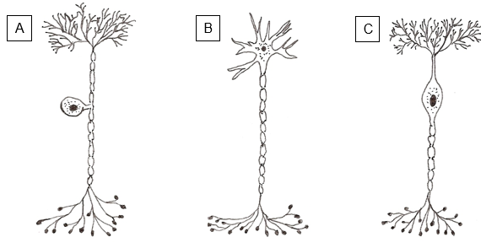

____________________ Neuron ____________________ Neuron ____________________ Neuron
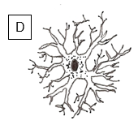
For the 3 Functional categories of Neurons, fill in the following:

Functionally, what could Neuron A be called? ___________________________.

Functionally, what could Neuron B be called? ___________________________.

Functionally, what could Neuron D be called? ___________________________.

____________________ Neuron

3) Multiple Choice Questions – select the best answer.
1. The portion of a neuron that conducts nerve impulses away from the cell body is the
a) dendrite
b) axon
c) receptor
d) effector
e) soma

2. Which glial cell is phagocytic?
a) oligodendrocyte
b) protoplasmic astrocyte
c) satellite cell
d) fibrous astrocyte
e) microglia

3. The component of a reflex arc that responds to a motor impulse is the
a) integrating center
b) receptor
c) sensory neuron
d) effector tissue
e) brain

4. Anatomically, most sensory neurons are _____________ neurons.
a) unipolar
b) sensory
c) bipolar
d) anaxonic
e) multipolar

5. The substance released from vesicles in the synaptic end bulb of neurons are called
a) Nissl bodies
b) hormones
c) axon collaterals
d) neurofibrils
e) neurotransmitters

4) Fill-in: Complete the statements below using the most appropriate word or words.
1. The two types of cells that compose the nervous system are neurons and ___________________ cells.
2. The portion of a neuron that contains the nucleus and cytoplasm is the ________________________.
3. The lipid and protein covering around many peripheral axons is called the ______________________.
4. The part of the neuron that conveys a stimulus toward the nerve cell body is the _________________.
5. The knee-jerk reflex is an example of the _______________________________________ spinal reflex.
- Each of the thirty-one segments of the spinal cord gives rise to a pair of ___________ _____________.
- The cell bodies of motor neurons are found in the _________________ horns of the spinal cord.
- The thickening in the spinal cord giving rise to lower limbs nerves is called the ____________________.
- The_____________________________________ is a groove on the posterior length of the spinal cord.
- In the spinal cord, collectively the dura mater, arachnoid and pia mater are called ________________.
- The thickening in the spinal cord giving rise to upper limbs nerves is called the ___________________.
- The______________________ connects the white matter on the left and right sides of the spinal cord.
- The white matter of the spinal cord is divided into anterior, lateral, and posterior_________________.
- The_________________________________ within the gray commissure of the spinal cord contains cerebrospinal fluid and is continuous with the ventricles of the brain.
- In the spinal meninges model in class, the outer most ligament (not membrane) is the _____________.

Exercise 4. Spinal Meninges.
1) Matching: Match the terms in Column A with the descriptions provided in Column B.

Column A

A. Arachnoid mater
B. Denticulate ligament
C. Dural sinuses
D. Dura mater
E. Epidural space
F. Pia mater
G. Subarachnoid space
H. Falx cerebri

Column B.
____ 1. This follows the irregular contours of the spinal cord surface.
____ 2. Channels through which venous blood flows.
____ 3. Band of pia mater that attaches dura mater to cord.
____ 4. Outermost layer of spinal meninges.
____ 5. Contains cerebrospinal fluid that circulates throughout the brain.
____ 6. A thin, web-like structure in the middle of other membranes.
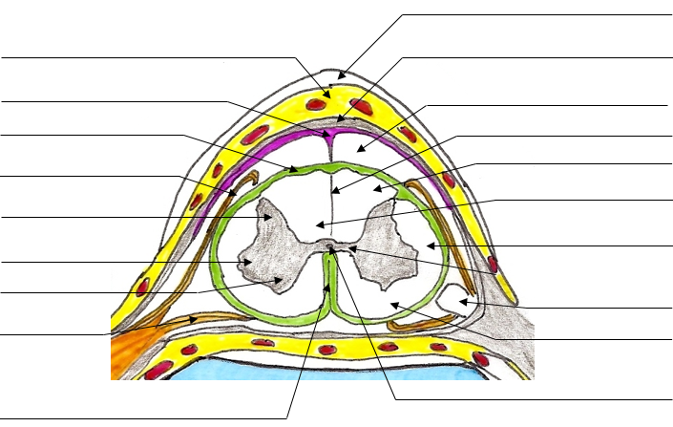
2) Label the Cross Section of Spinal Cord: Name the specific structures at each point.
Exercise 4. Spinal Nerves - Information Processing.
1) Motor information leaves the spinal cord by the ______________ roots of spinal nerves; sensory information is carried to the spinal cord by the ______________ roots of spinal nerves.
2) The central canal is lined with _________________ cells, 1 of 4 types of ___________ cells in the CNS.
3) The fluid filling the central canal and the subarachnoid space is _______________________________.
4) Briefly explain what is meant by the statement "all spinal nerves are mixed nerves".

5) Match the following tests with the nerve involved:
___ biceps jerk a) musculocutaneous nerve
___ triceps jerk b) femoral nerve
___ knee jerk c) radial nerve
___ ankle jerk d) common peroneal nerve

5) A spinal reflex with one synapse is called a: __________________________________________ reflex.

6) A spinal reflex with 2 or more synapses is called a: ____________________________________ reflex.

7) What is the purpose of testing reflexes in the body? What is the Babinski reflex and why is it used?

8) Naming and describing Plexuses and their Components in Table 1 below.

Table 1. For each nerve, identify the plexus and the spinal segments to which each of the nerves belong.
Nerve | Plexus | Spinal Component
Musculocutaneous

Sciatic

Obturator

Phrenic

Femoral

Tibial

Ulnar

Radial

Median

