Anatomy Worksheet 6
Name ________________________
Skeletal Muscular Tissue

Exercise 1. Skeletal muscle tissue is controlled by the somatic nervous system. Axons of somatic motor neurons communicate with individual skeletal muscle fibers to coordinate body movement.

1) Label the drawing below.
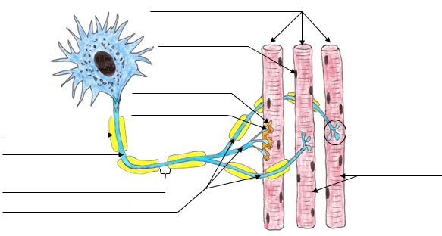

2) Match the terms in with the description or definitions below.
A. Aponeuroses F. Epimysium
B. Endomysium G. Fascicle
C. Fascia H. Ligament
D. Perimysium I. Skeletal Muscle Cell
E. Tendon J. Neuromuscular Junction

1. ___ Layer of connective tissue that separates a muscle into small bundles called fascicles.
2. ___ Layer of connective tissue that surrounds an individual skeletal muscle cell (muscle fiber).
3. ___ A bundle of muscle fibers.
4. ___ A specific layer of connective tissue that surrounds a whole skeletal muscle.
5. ___ Network of connective tissue that binds and extends throughout the entire muscular system.
6. ___ Broad tendinous sheet that may serve as the origin or insertion of skeletal muscle.
7. ___ Dense connective tissue joining bone to bone.
8. ___ Site of nervous innervation of muscle fiber.
9. ___ Cord-like collagenous band that attaches a muscle to an element of the skeleton.
10.___ Contains many nuclei and is long and cylindrical.
Exercise 2. Skeletal Muscles of the Face, Head and Neck. Complete the following statements:

a) The __________________________ causes the lower lip to “pout”.

b) When contracted one at a time, the ________________________ can cause the head to rotate laterally.

c) When both sternocleidomastoid muscles contract, they act to _________________________________.

d) The action of the masseter is to ______________________________________.

e) The kite-shaped muscle the __________________________ can act to hyperextend the head and neck.

f) The flat broad anterior muscle the _______________________________ helps to depress the mandible.

g) The ____________________________ is a muscle that depresses the angles of the mouth into a frown.

Exercise 3. Classification of Skeletal Muscles
1. In class, several criteria were given regarding the naming of muscles. For each muscle name in Column A, choose from the key in Column B, all criteria on which the muscle names are based.

Column A Column B

1. external oblique _____
2. adductor magnus _____
3. biceps femoris _____
4. transverse abdominis _____
5. coracobrachialis _____
6. extensor carpi ulnaris _____
7. rectus femoris _____
8. pronator teres _____
9. gluteus maximus _____
10. sternocleidomastoid _____
a. action of the muscle
b. shape of the muscle
c. location of origin and/or insertion of the muscle
d. number of origins or heads
e. location of the muscle relative to a bone or body
f. direction of fascicles relative to an imaginary line
g. relative size of the muscle

2. Using the information listed here regarding origin and insertion, name the specific muscle.
Origin Insertion Muscle
1. temporal fossa and lines coronoid process of mandible _________________________
2. sternum and clavicle mastoid process _________________________
3. fascia of chest muscles inferior border of mandible _________________________
4. zygomatic arch angle of mandible _________________________
Exercise 3. Skeletal Muscles of the Back, Chest, Shoulder and Arm.
1. Complete the following statements:

a) The large, powerful muscle of the back that adducts the arm is the _____________________________.

b) A muscle responsible for rotating the forearm medially ______________________________________.

c) A muscle that has three heads and acts to extend the arm is the ________________________________.

d) The _____________________________________ occupies the inferior posterior surface of the scapula.

e) The muscles that act on the scapula originate on the ____________________ skeleton.

f) The ______________________________ attaches to the superior portion of the vertebral border of the scapula and is responsible for the teenage-like 'whatever' shrugging of the shoulders.

g) Of the four (4) rotator cuff muscles: 1) name the only one that inserts on the lesser tubercle of the scapula; and 2) why this insertion?
1)
2)

2. Match the muscles in Column A with the actions in Column B. Use each letter only once.
Column A Column B
A. erector spinae 1. ____ rotates arm laterally
B. coracobrachialis 2. ____ flexes and adducts the arm
C. triceps brachii 3. ____ extends vertebral column
D. infraspinatus 4. ____ abducts upper arm
E. pectoralis major 5. ____ elevates and adducts the scapula
F. deltoid 6. ____ flexes forearm
G. rhomboideus major 7. ____ adducts arm and rotates brachium medially
H. pectoralis minor 8. ____ extends forearm
I. brachialis 9. ____ depresses shoulder and draws scapula laterally
J. supinator 10. ____ rotates forearm laterally

Exercise 4. Skeletal Muscles of the Abdomen and Lower Extremities. 1. Complete the following statements:

a) Abdominal muscle with fascicles running inferior and medially (‘hands in pockets’): ________________.

b) The 'tailors' muscle is the _______________________ and is also the longest muscle in the body.

c) The long strap-like abdominal muscle that flexes the vertebral column is the ______________________.
d) The deep and medially located of the hamstring muscles is the _______________________________.

e) The most superficial of the medial thigh muscle is the ________________________________________.

f) Two muscles insert on the iliotibial tract; 1) is responsible for flexion and medial rotation at the hip and 2) is responsible for extension and lateral rotation at the hip.

1) 2)

g) The deep 'calf' muscle that is often termed the “marathon runners” muscle is the __________________.

h) Label the muscles indicated in the drawings below.
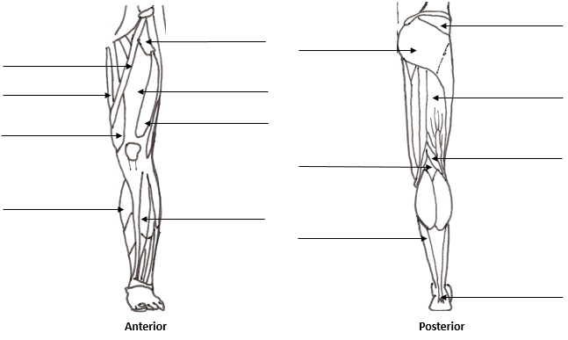

2. Match the muscles in Column A with the actions in Column B. Use each letter only once.
Column A Column B
A. sortorius 1. ___ flexes hip joint and extends knee joint
B. gluteus maximus 2. ___ plantar flexion of the ankle
C. tibialis anterior 3. ___ dorsiflexion and extension of the toes
D. adductor magnus 4. ___ adducts the thigh or flex the leg
E. gastrocnemius 5. ___ dorsiflexes the ankle; inverts the foot
F. extensor digitorum longus 6. ___ powerful extensor of the thigh
G. soleus 7. ___ plantar flexion; flexion of the knee
H. rectus femoris 8. ___ flexes and rotates thigh laterally; flexes leg
I. biceps femoris 9. ___ large muscle for adduction of the thigh
J. gracilis 10. ___ flexes leg; extends and laterally rotates the thigh at hip

