Anatomy Worksheet 5
Name ________________________
Articulations (Joints)

Exercise 1. Classification of Articulations
1. What is meant by functional classification of a joint? ________________________________________.
Describe 3 categories of functional classifications.
1)

2)

3)

2. What is meant by structural classification of a joint? ________________________________________.
Describe 3 categories of structural classifications.
1)

2)

3)

3. Match the actions in Column A with the descriptions in Column B. Each number only used once.

Column A Column B

- Circumduction
- Adduction
- Flexion
- Pronation
- Elevation
- Protraction
- Rotation
- Plantar flexion
- Dorsiflexion
- Inversion
- Hyperextension
- Opposition
___ A. Bending foot in the direction of the dorsum
___ B. Moving a part superiorly
___ C. Movement of thumb toward the fifth digit
___ D. Anterior movement in the transverse plane
___ E. Movement of the sole medially
___ F. Movement toward the midline
___ G. Bending foot in the plantar direction
___ H. Turning the palm posteriorly
___ I. Movement of a bone around its own axis
___ J. Distal end of bone moves in a circle
___ K. Extension beyond the anatomical position
___ L. Decreasing angle between articulating bones

Exercise 2. Structures giving support to Synovial Joints
1. Give a definition for the following and describe its specific roll in a synovial joint:

- synovial fluid

- synovial membrane

- fibrous joint capsule

- bursa (bursae)

- meniscus (menisci)

- articular cartilage

- ligament

- tendon of a muscle crossing the joint

2. Define the 6 categories of Synovial joints and give specific examples in the body for each.

1) Gliding

2) Hinge

3) Pivot

4) Condyloid /Ellipsoid

5) Saddle

6) Ball and Socket

Exercise 3. Select the best answer for each multiple choice question and fill–in below.
Multiple Choice Questions:
1. A joint united by dense fibrous tissue that permits a slight degree of movement is a:
a) suture b) periodontal ligaments c) symphysis d) synchondrosis e) syndesmosis

2. If a joint had a synovial cavity, articular cartilage, synovial membrane, and ligaments what type of joint is it likely to be?
a) suture b) synchondrosis c) syndesmosis d) hinge e) symphysis

3. What type of joint provides triaxial movement?
a) hinge b) ball-and-socket c) saddle d) condyloid e) pivot

4. Which ligament provides strength on the medial side of the knee joint?
a) oblique popliteal b) posterior cruciate c) fibular collateral d) tibial collateral e) anterior cruciate

5. On the basis of structure, which of these joint is fibrous?
a) suture b) synchondrosis c) pivot d) symphysis e) ellipsoidal

Fill-Ins:
6. The thin layer of hyaline cartilage on articulating surfaces of bones is called _______________ cartilage.

7. The shock absorber ‘pads’ of the knee joint are made of ______________________________________.

8. Fluid-filled ‘bags’ that cushion highly moveable points of a synovial joint are called _______________.

9. Make a fist with your hand, the action at the interphalangeal joints (I to V) would be ______________.

10. A _________________ connects bone to bone and a _________________ connects muscle to bone.

Exercise 4. The Knee Joint
1. Write the name of the specific structure indicated in the knee joint below.
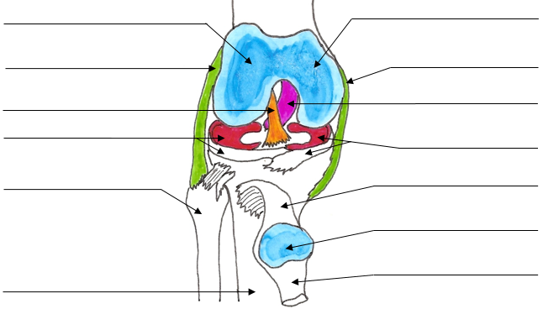

Exercise 5. Special Movements
1. For each of the following, give the definition for these terms with regard to special movements.
1) Arm
Pronation:
Supination:

2) Hand
Opposition:
Reposition:

3) Foot
Dorsiflexion:
Plantarflexion:
Inversion:
Eversion:

2. For the drawings below, answer the numbered questions below regarding the details of articulation at the specific numbers indicated on theses bones.
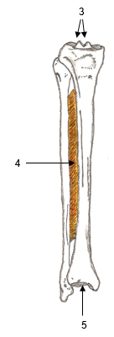
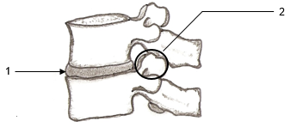

1) Name the structure, the joint and movement permitted.

2) Name the articulating surfaces, the joint and movement permitted.

3) What is the structure called? What attaches to it?

4) Name the structure, the joint and movement permitted.

5) What bone articulates with this structure? What type of joint is created?

Exercise 4. Articulations
Table 1. For each of the following joints list the functional type of joint, i.e., synarthrosis; amphiarthrosis; or diarthrosis. Then give the specific name (e.g., synchondrosis). Also include the important structural features (e.g., specific fibers, cartilage) and the potential movements allowed at that joint. See example.
Joint | Functional Classification;  Specific Name | Structural Features;  Movement Allowed
knee | Diarthrosis;  Hinge | Synovial Fluid; Monoaxial  Flexion/Extension, hyperextension
epiphyseal plate

pubic symphysis

parietooccipital

sternoclavicular

proximal radioulnar

tooth in alveolus

radioulnar (length)

metacarpophalangeal

intervertebral
(at body)

trapeziometacarpal

glenohumeral

