Anatomy Worksheet 4
Name ________________________
The Appendicular Skeletal System
Exercise 1. Matching Columns.
1. Match the structure and bone names in Column A with the descriptions in Column B. Some answers are used more than once.

Column A

A. Acromion
B. Capitulum
C. Carpals
D. Clavicle
E. Coracoid process
F. Coronoid fossa
G. Deltoid tuberosity
H. Glenoid cavity (fossa)
I. Humerus
J. Metacarpals
K. Olecranon fossa
L. Olecranon process
M. Phalanges
N. Trochlea
O. Radius
P. Styloid process
Q. Ulna
R. Sternum

Column B

___ 1. condyle of humerus articulating with ulna.
___ 2. bones that are ‘beyond’ the wrist.
___ 3. scapular region to which clavicle connects.
___ 4. heads of these bones form the knuckles.
___ 5. medial articulation with the clavicle.
___ 6. cavity of scapula articulating with humerus.
___ 7. projection above glenoid fossa.
___ 8. needle-like projection of forearm bones.
___ 9. receives ulna when forearm extended.
___ 10. rough patch for muscle attachment.
___ 11. medial forearm bone anatomical position.
___ 12. the finger bones and toe bones.
___ 13. rounded condyle of humerus; for radius.
___ 14. receives ulna when forearm flexed.
___ 15. bone of the ‘brachium’ or arm.
___ 16. pisiform and capitate.

Exercise 2. Use the space below to write the exact name of each bone in the hand and wrist shown.
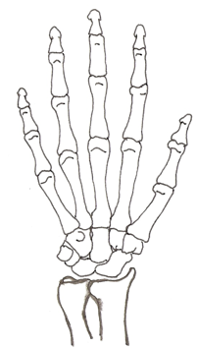

Anterior view Bones of the Hand
Exercise 3. Write the name of the structures indicated by each number on the scapula below.
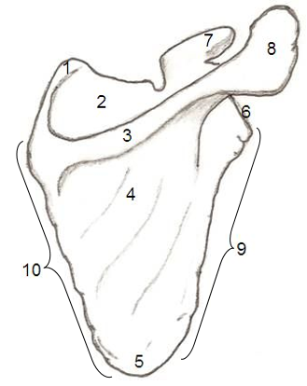

1. ___________________________________.
2. ___________________________________.
3. ___________________________________.
4. ___________________________________.
5. ___________________________________.
6. ___________________________________.
7. ___________________________________.
8. ___________________________________.
9. ___________________________________.
10. ___________________________________.

11. Name the muscle that occupies structure #2 in the scapula above. ___________________________.

12. Name the muscle that occupies structure #4 in the scapula above. ___________________________.

13. Name the structures indicated on the clavicle below. Which side (L or R) of the body is this bone? __.

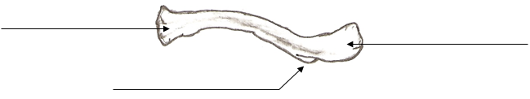

Exercise 4. Complete the following statements:

1. The pelvic girdle consists of two _______ ______________ bones.
2. The head of the _________________ articulates with the ________________________ of the os coxa.
3. The largest bone in the human body is the _________________________.
4. If someone were to ‘break their hip’, typically, what exact structure is broken? __________________.
5. The pubic bones come together anteriorly to form the joint called the _________________________.
6. The___________________ is the superior portion of the ilium that causes the prominence of the ‘hip’.
7. When a person sits, the ________________________ of the ischium supports the weight of the body.
8. The angle formed by the pubic bones below the symphysis pubis is called the ___________________.
9. The__________________ ___________________ is the ‘hole’ within the os coxae.
10. The ilium joins the sacrum at the ___________________________________ joint.

11. For the ulna and radius bones of the forearm (drawn below), find and label all of the structures indicated in your lab manual for these two bone.
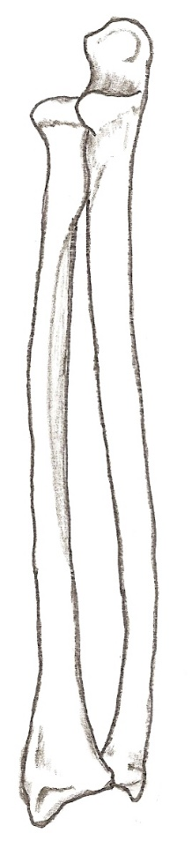

Exercise 5. Comparison of the Female and Male Pelvises.

Use the drawings below of the typical female and male pelvises to help you fill in the information in Table 1 below. You will also need to consult your textbook or notes or websites to fully describe how these two pelvises differ from each other.
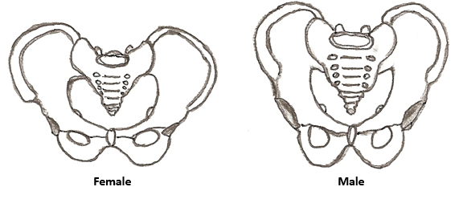

Table 1. Complete the table with information regarding sexual dimorphism of the pelvis.
Characteristics | Female | Male
General Appearance

Ischial Spine

Sacrum

Coccyx

Width of Pelvis

Pelvic Inlet

Pelvic Outlet

Pubic Symphysis

Pubic Arch (Angle)

Greater Sciatic Notch

Obturator

Acetabulum

Exercise 6. Identifying structures on the femur.
1) Match the bones in Column A with the descriptions in Column B. Some answers are used more than once.

Column A Column B
A. femur ___ 1. middle phalanx
B. fibula ___ 2. lesser trochanter
C. metatarsals ___ 3. medial malleolus
D. patella ___ 4. fovea capitis
E. phalanges ___ 5. sesamoid bone
F. tarsals ___ 6. lateral cuneiform
G. tibia ___ 7. tibial tuberosity
___ 8. talus, calcaneus and navicular
___ 9. linea aspera
___ 10. lateral malleolus
___ 11. calcaneus
___ 12. five bones that form the instep

2) Name the structures indicated here that are found in your lab manual for the femur below.

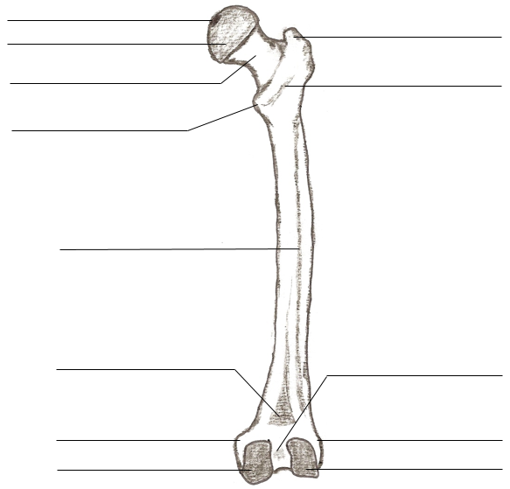
Posterior view of Femur

