Anatomy Worksheet 3
Name ________________________

The Axial Skeletal System (Skull)

Exercise 1. Anatomical Features of Bones
It is advisable to understand the terminology and vocabulary commonly used to describe the anatomical features of bones. Find the definitions for the important terms listed and fill them in below.

Articulations
condyle -
facet -
head -

Extensions and Projections
crest -
epicondyle -
line -
process -
trochanter -
tubercle -
tuberosity -
spine –

Depressions
alveolus -
fossa -
fovea -
sulcus or groove -

Passages
canal or meatus -
foramen (foramina) -
fissure -

Exercise 2.
1) Write the name of the specific structures at the end of each arrow on the lines for each.
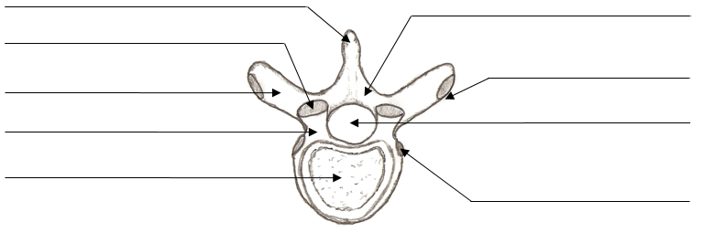

2) Write the name of the specific structures at the end of each arrow.

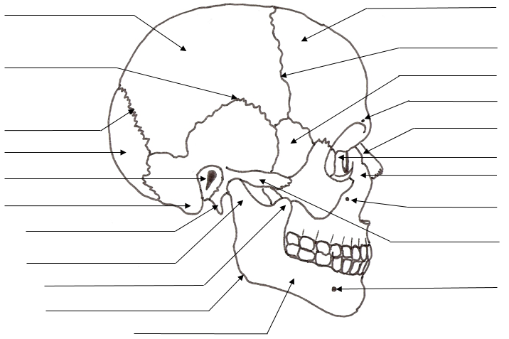
3) Match bone names in Column A with the descriptions in Column B. Some answers are used more than once.

Column A

A. Ethmoid
B. Frontal
C. Hyoid
D. Lacrimal
E. Mandible
F. Maxilla
G. Nasal
H. Occipital
I. Palatine
J. Parietal
K. Sphenoid
L. Temporal
M. Vomer
N. Zygomatic

Column B

____ 1. forehead bone
____ 2. cheekbone
____ 3. lower jaw
____ 4. bridge of nose
____ 5. posterior bones of the hard palate
____ 6. most of lateral and superior cranium
____ 7. most posterior part of cranium
____ 8. Inferior portion of bony nasal septum
____ 9. tiny bones bearing tear ducts
____ 10. anterior part of hard palate
____ 11. superior nasal conchae is a projection
____ 12. site of mastoid process
____ 13. has sella turcica
____ 14. foramen magnum contained here
____ 15. contains the mental foramen
____ 16. has a styloid process
____ 17. contain alveoli that bear teeth
____ 18. condyles here articulate with the atlas
____ 19. has a "cock's comb" or crista galli
____ 20. U-shaped bone, with no articulations

4) Complete the Fill-Ins:
- The 2 _____________ _____________ forms the bridge of the nose.
- This bone creates the prominence of the cheek, inferior and lateral to the eye: __________________.
- The __________________________ of the __________ bone forms superior portion of nasal septum.
- The _______________ is the only movable bone in the skull; it articulates with the _______________.
- Forms anterior portion of zygomatic arch; the __________ ___________ of the_____________ bone.
- This facial bone, the ________________ contains the coronoid process and the mental protuberance.
- The sockets of upper teeth are called _____________. Teeth are held in place by ________________.
- The _____________ canal allows a large artery to travel through the temporal bone.
- Forms posterior roof of mouth and contributes to a small medial part in wall of orbit _____________.
- The incisive fossa is formed by the _____________ bones. It also contains the ______________ canal.

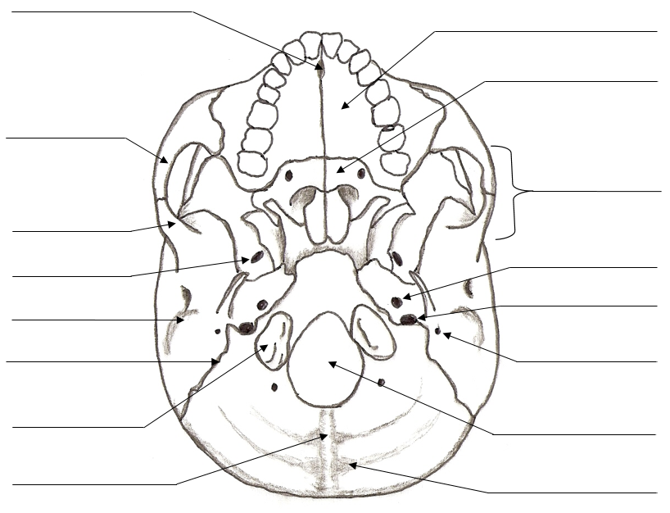
5) For the drawing of the inferior view of the skull below, write the name of the specific structures at the end of each arrow.

Inferior View of the Skull
Exercise 3. Examine the information regarding structures passing the skull foramina, canals and fissures.

Table 1. The ‘holes’ in the skull and the structures that pass through them.
Foramina/Canal | Major Vessels | Major Nerves
Foramen magnum | Vertebral arteries and veins
Foramen rotundum |  | Maxillary branch of Trigeminal N. (Cranial N. V) provides sensation from face.
Foramen ovale | Accessory meningeal artery
Foramen spinosum |  | None
Foramen lacerum |  | None
Supraorbital foramen | Supraorbital artery and vein | Supraorbital N., Ophthalmic N.
Infraorbital foramen | Infraorbital artery and vein
Superior orbital fissure | Superior and inferior ophthalmic veins
Inferior orbital fissure | None | Maxillary branch of Trigeminal N. (Cranial N. V) sensation from face.
Olfactory foramina |  | Olfactory N. (I) for sense of smell.
Jugular foramen |  | Glossopharyngeal N (IX); Vagus N. (X) and Accessory N. (XI).
Hypoglossal canal | None
Carotid canal

Optic canal | Ophthalmic artery
Internal acoustic meatus | None | Vestibulocochlear N. (XIII)

Exercise 4. How many bones create the orbit? _______. Write the names of the bones indicated in the drawing below. The dashed lines ( ) indicate ‘holes’ in the skull, name these structures too.
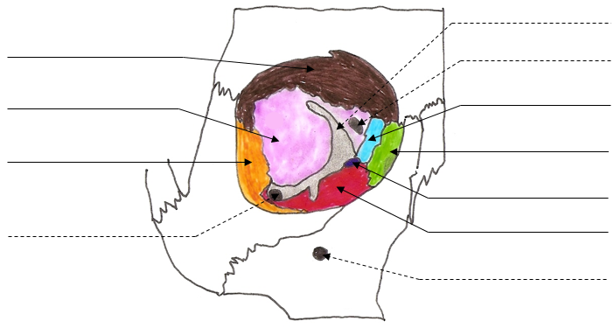

Exercise 5. Multiple Choice and Thoughtful Questions:

1. Which bone does not contain a paranasal sinus?
a) ethmoid b) maxilla c) sphenoid d) occipital e) frontal

2. The suture between the parietal and temporal bones is the
a) lambdoid b) coronal c) squamous d) sagittal e) posterolateral

3. Of the following bones, the one that does not help form part of the orbit is the
a) frontal b) occipital c sphenoid ) d) lacrimal e) palatine

4. Which bone does not form a border for a fontanel?
a) maxilla b) temporal c) occipital d) parietal e) frontal

5. Which bone does not belong with the others?
a) occipital b) frontal c) parietal d) mandible e) temporal

6. What is an important role of the crista galli? _______________________________________________.

7. What bones make up the hard palate? ______________________________. What is the purpose of the hard palate? __________________________________________________________________________.

8. What does the word ‘pterygoid’ mean? ________________. How about ‘petrous’ _________________.

9. How many separate bones make up the vertebral column? ____________.

10. The “wishbone” in a bird is actually the fusions of the ____________________________.

11. Another term for true rib is: ________________________________________________.

12. Another term for false ribs is: _______________________________________________.

13. Another term for floating ribs is: _____________________________________________.

14. In a ‘herniated’ or slipped disc, what does hernia mean in this case? ____________________________. What are the significant potential problems from a herniated disc? _______________________________.

15. Locate one example of each of the following structures or regions listed, in the drawing below:
Intervertebral discs; spinous process; costal facet; intervertebral foramen; coccyx; sacrum; auricular surface of sacrum; transverse process; lumbar vertebra; lumbar curvature; cervical vertebra; cervical curvature; thoracic vertebra; thoracic curvature; sacral curvature.
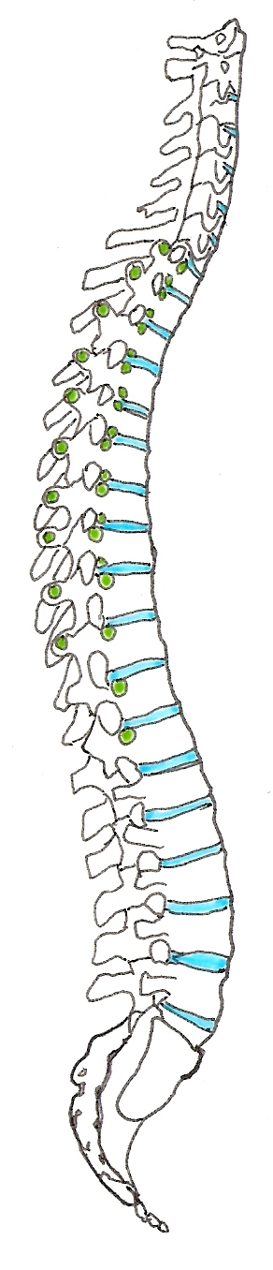

The Vertebral Column

