Anatomy Worksheet 2
Name ________________________
Integumentary System: Skin, Hair and Nails

Exercise 1. The Epidermis
1. The epidermis is __________________________________ epithelial tissue; main role_____________.

2. List the 4 different cell types of located in the epidermis and briefly describe their roles.
1)

2)

3)

4)

3. List the proper names of the 5 layers found in ‘thick’ epidermis from superficial to deep. Give the following details: Type and number of cells in each layer; cell shape in layer; general appearance of layer.

1) __________________________

2) __________________________

3) __________________________

4) __________________________

5) __________________________

4. Can the thickness of the epidermis vary? _____. Give examples of where this may occur in the body.
Thick epidermis is: Thin epidermis is:

Exercise 2. The Dermis
1. List what the 2 regions of the dermis are called and their relative proportions.
Superficial=______________________. This region accounts for approximately _________ of the dermis.
Deep =_______________________. This region accounts for approximately ________ of the dermis.

2. The connective tissue found in the superficial layer of the dermis is: ___________________________.

3. The connective tissue found in the deep layer of the dermis is: _______________________________.

4. The connective tissue found in the hypodermis (subcutaneous) is: ____________________________.
5. A subcutaneous injection is one delivered in the _______________ or _______________ layer. Based on structures found in the hypodermis, and not in the epidermis or dermis, why is this often a preferred area for administering an injection? ________________________________________________________.

Exercise 3. Fill-in Completion

- If body temperature gets too hot, ________________ _____________________ can cool you down.

- If body temperature is too cold, ________________ ______________________ can keep you warm.

- Evaporative cooling involves which specific type of sweat gland? ___________________ sweat gland.

- What is the most common fiber found in connective tissue in the body? _______________________.

- The role of Meissner’s corpuscles is____________; located in the ____________________ of dermis.

- The role of Pacinian corpuscles is _____________; located in the _____________________ of dermis.

- What cell makes a dark pigment responsible for skin color? ____________. Located? ____________.

- The less common sweat glands are called _________________ sweat glands, and act as scent glands.

- Fibers in the dermis are produced by _________________. Suffix ‘-blast’ means _______________.

Exercise 4. Accessory Structures
1. Describe the Sebaceous gland (associated with hair follicle):
Location in body: __________________________; function: ___________________________________.
Structure of gland: _____________________________; mode of secretion: _______________________.

2. Describe the Sudoriferous merocrine gland
Location in body: __________________________; function: ___________________________________.
Structure of gland: _____________________________; mode of secretion: _______________________.

3. Describe the Sudoriferous apocrine gland
Location in body: __________________________; function: ___________________________________.
Structure of gland: _____________________________; mode of secretion: _______________________.

4. Describe the Mammary gland
Location in body: __________________________; function: ___________________________________.
Structure of gland: _____________________________; mode of secretion: _______________________.

5. Describe the Ceruminous gland
Location in body: __________________________; function: ___________________________________.
Structure of gland: _____________________________; mode of secretion: _______________________.
6. Label the drawing of the hair and hair follicle (below), include the following: hair root; bulb; hair papilla; blood vessel cortex; medulla; cuticle; and external & internal root sheath.
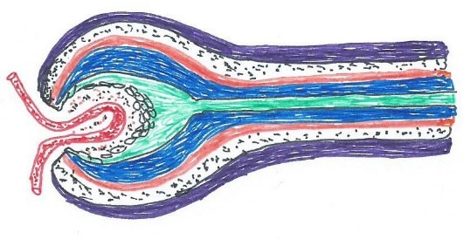

7. What type of tissue are arrector pili? _________ __________. Where is it found and what does it do?

8. A subcutaneous injection is one delivered in the ______________, which can also be called the ____________ ____________. Why is this often a preferred area for administering an injection, rather than the epidermis or dermis?________________________________________________________.

9. Match the structures in Column A with the description and functions in Column B.

Column A

- Dermis
- Arrector pili muscle
- Apocrine sweat gland
- Merocrine sweat gland
- Melanin
- Hair follicle
- Keratin
- Epidermis
- Sebaceous gland
- Sebum
- Stratum basale
- Stratum corneum

Column B
___ 1. The oil that helps to condition the surface of the body
___ 2. Outermost layer of epidermis
___ 3. Become active at puberty
___ 4. Epidermal pigment
___ 5. Inner layer of skin
___ 6. Responds to elevated body temperature
___ 7. General name of entire superficial layer of the skin
___ 8. Gland that secretes an oily substance
___ 9. Hydrophobic lipoprotein found in nails and hair
___ 10. Deepest layer of epidermis where cell division occurs
___ 11. A ‘container-like’ structure for the root of the hair
___ 12. Causes hair to stand on end and goose bumps to appear

10. Can your skin absorb substances that are applied to its surface? ______. Give a specific example to explain your answer:

11. Where exactly in the skin is Vitamin D made? _____________________________________________.
12. Melanin is made by __________________, it is released into the _________________________of skin.
13. What is dermatitis? Explain the difference between a pimple and acne.

14. About how long does it take for a cell in the stratum basale to get to the stratum corneum?________
15. Label the sketch below.
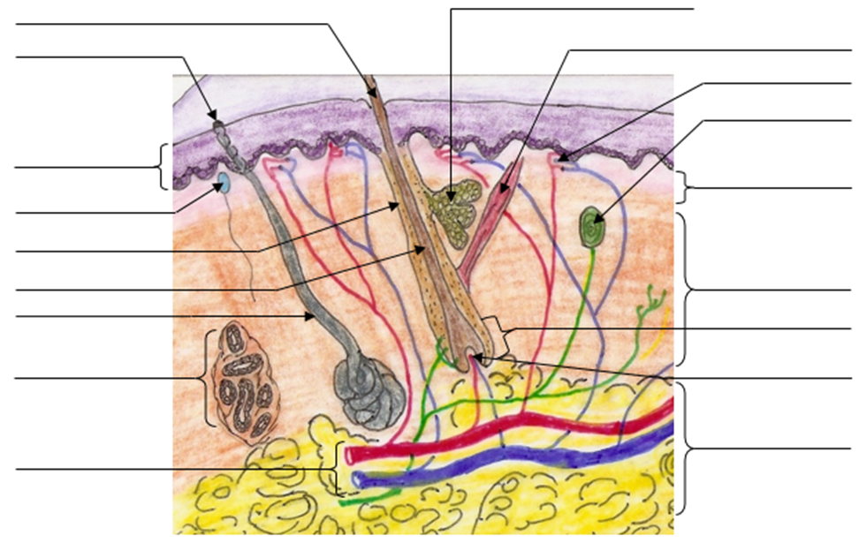

Exercise 5. Multiple Choice Questions: The Integumentary System

1. The waterproofing quality of skin is due to the presence of
a) keratin b) carotene c) melanin d) water-proof receptors e) collagen

2. Sebaceous glands
a) produce a watery solution called sweat b) produce an oily substance that helps protect the skin
c) are associated with mucous membranes d) are part of the subcutaneous layer

3. Skin color is not determined by the presence or absence of
a) melanin b) carotene c) keratin d) hemoglobin in red blood cells in capillaries in the dermis

4. Destruction of what part of a single hair would result in its inability to grow?
a) sebaceous gland b) arrector pili muscle c) matrix d) bulb e) shaft
5. Which of the following is the proper order of the layers of the epidermis in thick skin when going from the free exposed surface toward the deeper underlying tissues?
a) basale, spinosum, granulosum, corneum
b) spinosum, basale, granulosum, corneum
c) corneum, lucidum, granulosum, spinosum, basale
d) corneum, granulosum, spinosum, basale
e) basale , spinosum , granulosum, lucidum, corneum

6. One would expect to find relatively few, if any, sebaceous glands in the skin of the
a) legs b) face c) neck d) upper chest e) palms

7. The attached visible portion of a nail is called the
a) nail bed b) nail root c) nail fold d) nail body e) hyponychium

8. Which of the following sequences for the skin, from superficial to deep, is correct?
a) epidermis, reticular layer, papillary layer, subcutaneous layer
b) epidermis, subcutaneous layer, reticular layer, papillary layer
c) epidermis, reticular layer, subcutaneous layer, papillary layer
d) epidermis, papillary layer, reticular layer, subcutaneous layer
e) epidermis, papillary layer, reticular layer, hypocutaneous layer

9. Nerve endings sensitive to touch are called
a) tactile (Meissner’s) corpuscles b) papillae c) lamellated (Pacinian) corpuscles d) follicles

10. The cuticle of a nail is referred to as the
a) matrix b) eponychium c) hyponychium d) lunula e) nail body

Thoughtful Questions
11. If hair color is determined by pigments in the bulb, explain the likelihood of a person's hair turning white ‘overnight’.

12. If someone gets a permanent tattoo, ink is injected into the skin. What specific region of the skin do you think the ink is injected into? What information can you mention to give support for your answer?

13. Use the sketches (below) to label what can be seen of the following: nail root, nail body, lunula, free edge, nail fold, eponychium, hyponychium. What is the actual nail bed made of? __________________.

