Anatomy Worksheet 15
Name ________________________
The Reproductive System

Exercise 1. Answer the following questions about the structures of the Reproductive systems.

1. Structures of the male reproductive system where sperm cells are produced are the
a) efferent ducts
b) seminiferous tubules
c) seminal vesicles
d) rete testis
e) epididymis

2. The superior portion of the male urethra is encircled by the
a) epididymis b) testes c) prostate d) epididymis e) corpus spongiosum

3. Glands lying over the pectoralis major muscles are the _____________ glands.
a) bulbourethral b) adrenal c) mammary d) greater vestibular (Bartholin's) e) lesser vestibular

4. Weakening of the suspensory ligament would directly affect the position of the
a) mammary glands
b) uterus
c) uterine (fallopian) tubes
d) ovaries
e) a and d

5. In the female reproductive system, the ____________ transports secondary oocytes and ova from the ovaries to the uterus.
a) seminal vesicles
b) uterine tubes
c) inguinal canals
d) ovarian hilus
e) none of these

6. The name of the process that is responsible for the actual production of sperm cells is called
a) cryptorchidism
b) oogenesis
c) spermatogenesis
d) spermatogonia
e) zygotination

7. Fertilization normally occurs in the
a) uterine tubes b) vagina c) uterus d) ovaries e) cervix

8. The portion of the uterus that assumes an active role during labor and childbirth is the
a) serosa b) endometrium c) peritoneum d) myometrium e) endometrial glands

9. Stereocilia are associated with the
a) ductus (vas) deferens b) oviduct c) epididymis d) rete testis e) corpora cavernosa

10. The major portion in terms of the volume of semen is contributed by the
a) bulbourethral (Cowper's) glands b) testes c) prostate gland d) seminal vesicles e) scrotum

11. Which sequence best represents the course taken by sperm cells from site of origin to the exterior?
a) seminiferous tubules, efferent ducts, epididymis, ductus (vas) deferens, ejaculatory duct, urethra
b) seminiferous tubules, efferent ducts, epididymis, ductus (vas) deferens, urethra, ejaculatory duct
c) seminiferous tubules, epididymis, efferent ducts, ductus (vas) deferens, ejaculatory duct, urethra
d) seminiferous tubules, efferent ducts, ductus (vas) deferens, epididymis, ejaculatory duct, urethra

12. Which sequence, from inside to outside, best represents the histology of the uterus?
a) stratum basalis, stratum functionalis, myometrium, perimetrium
b) myometrium, perimetrium, stratum functionalis, stratum basalis
c) stratum functionalis, stratum basalis, myometrium, perimetrium
d) stratum basalis, stratum functionalis, perimetrium, myometrium

MALE REPRODUCTIVE SYSTEM
Exercise 2. Structures of Male Reproduction: 1) Write the names of the specific structures indicated in the mid-sagittal section of the male below.
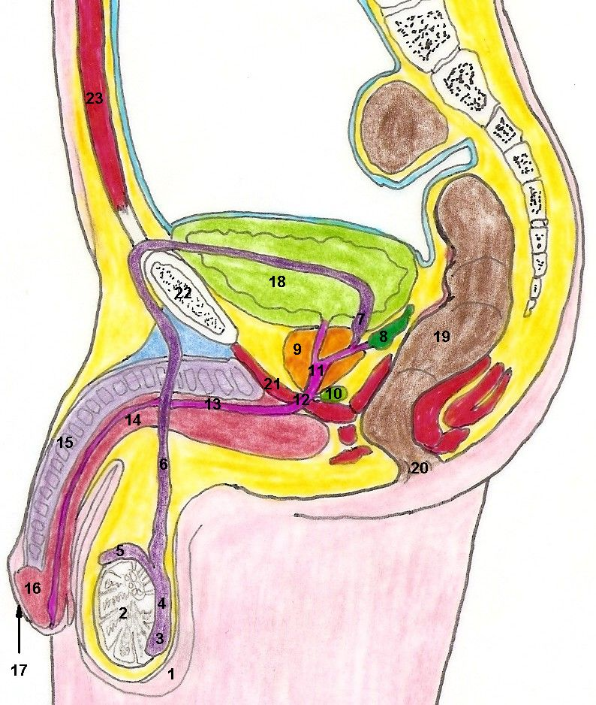

1. _____________________________________
2. _____________________________________
3. _____________________________________
4. _____________________________________
5. _____________________________________
6. _____________________________________
7. _____________________________________
8. _____________________________________
9. _____________________________________
10. ____________________________________
11. ____________________________________
12. ____________________________________
13. ____________________________________
14. ____________________________________
15. ____________________________________
16. ____________________________________
17. ____________________________________
18. ____________________________________
19. ____________________________________
20. ____________________________________
21. ____________________________________
22. ____________________________________
23. ____________________________________

MALE REPRODUCTIVE SYSTEM

Exercise 3. Complete the following statements:

1. The anterior end of a sperm head, called the _______________________, contains enzymes that aid the penetration of an egg cell at the time of fertilization.
2. The secretion of the seminal vesicles is rich in the monosaccharide called _______________________.
3. The descent of the testes is aided by a fibro-muscular cord called the ____________________________.
4. As the testes descend, they pass through the _______________of the abdominal wall into the scrotum.
5. Connective tissue subdivides a testis into many _______________, which contain seminiferous tubules.
6. The _____________________ is a highly coiled tube sitting on the surface of the testis.
7. The _____________________ cells of the seminiferous tubule epithelium lining give rise to sperm cells.
8. The process by which sperm cells are formed is ______________________________________.
9. The pH of seminal fluid is approximately _______ and therefore is slightly ________________.
10. The sensitive, cone-shaped end of the penis is called the _____________________________.

Exercise 4. Fill in the numbered labels for the drawing of the testis and epididymis below.

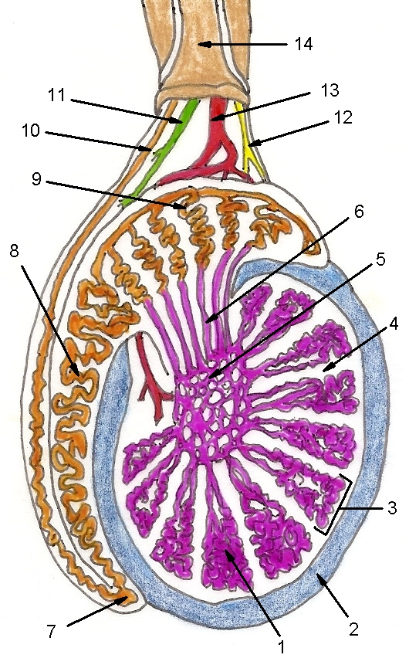
1. ________________________________________
2. ________________________________________
3. ________________________________________
4. ________________________________________
5. ________________________________________
6. ________________________________________
7. ________________________________________
8. ________________________________________
9. ________________________________________
10. ________________________________________
11. ________________________________________
12. ________________________________________
13. ________________________________________
14. ________________________________________

FEMALE REPRODUCTIVE SYSTEM
Exercise 5. Structures of Female Reproduction: Write the names of the specific structures indicated in the mid-sagittal section of the female below.
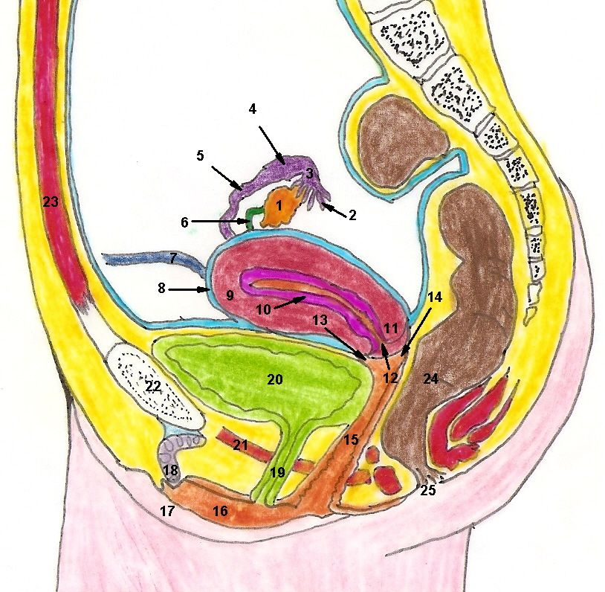

1. _____________________________________
2. _____________________________________
3. _____________________________________
4. _____________________________________
5. _____________________________________
6. _____________________________________
7. _____________________________________
8. _____________________________________
9. _____________________________________
10. ____________________________________
11. ____________________________________
12. ____________________________________
13. ____________________________________
14. ____________________________________
15. ____________________________________
16. ____________________________________
17. ____________________________________
18. ____________________________________
19. ____________________________________
20. ____________________________________
21. ____________________________________
22. ____________________________________
23. ____________________________________
24. ____________________________________
25. ____________________________________

FEMALE REPRODUCTIVE SYSTEM
Exercise 6. Complete the following statements:

1. The ovaries are located in the lateral wall of the________________ cavity.
2. The largest of the ovarian attachments is called the ________________ ligament.
3. The ovarian cortex appears granular because of the presence of________________________________.
4. Uterine tubes are also called ________________ tubes. The vaginal orifice is partially closed by a thin membrane called the________________.
5. The ovary is surrounded by epithelial cells called _______________________________ because initially these cells were thought to differentiate into follicles.
6. The female organ that corresponds to the male penis is the __________________.
7. Primordial follicles are stimulated to develop into primary follicles by the hormone ________________.
8. The process by which a secondary oocyte is released from the ovary is ___________________________.
9. The inner mucosal lining of the uterus is called the __________________ and the myometrium is largely composed of ____________________________ tissue.
10. The mass of fatty tissue overlying the pubic symphysis of the female is called the _________________.

Exercise 7. Fill in the numbered labels for the drawing of the uterus and ovaries below.
1. ______________________________________
2. ______________________________________
3. ______________________________________
4. ______________________________________
5. ______________________________________
6. ______________________________________
7. ______________________________________
8. ______________________________________
9. ______________________________________
10. _____________________________________
11. _____________________________________
12. _____________________________________
13. _____________________________________
14. _____________________________________
15. _____________________________________
16. _____________________________________
17. _____________________________________
18. _____________________________________

