Anatomy Worksheet 14
Name ________________________
The Renal System

Exercise 1. Answer the following questions regarding the structures and functions of the renal system.

1. A nephron can be divided into 2 major parts; they are the ____________ and the ______________.
a) renal corpuscle; convoluted renal tubules
b) renal corpuscle; renal tubules
c) cortex and medulla
d) glomerulus; collecting tubules
e) renal capsule; glomerulus

2. There are approximately _________ nephrons in one kidney.
a) 1.25 million b) 2 million c) 2.5 million d) 3 million e) 4 million

3. The hormone released by the kidney that is responsible for stimulating RBC production is
a) erythropoietin b) plasmin c) albumin d) hemoglobin e) rennin

4. The internal urinary sphincters is made of ?
a) dense irregualr connective tissue
b) longitudinal muscle
c) smooth muscle
d) skeletal muscle
e) a thickening of the outer longitudinal smooth muscle

5. The renal system can function in all of the following except:
a) regulation of electrolyte balance in plasma
b) eliminated of waste products from blood
c) stabilizes pH of blood
d) regulation of blood volume by adding extra water to the plasma
e) produces and releases hormones for RBC production

6. The compact arrangement of capillaries within the Bowman’s capsule in the nephron is called the
a) glomerular capsule
b) Bowman’s space
c) glomerulus
d) renal corpuscle
e) peritubular capillaries

7. The location of the kidneys can be best described as
a) inferior b) retroabdominal c) dorsal d) posterior and inferior to ribs e) retroperitoneal

8. The glomerulus is lined with ________ ________ epithelium.
a) dense irregular b) simple squamous c) simple cuboidal d) stratified squamous b) smooth muscle

Complete the following statements:
9. The amount of filtrate made by the renal system in one day is typically _______ L.

10. The smallest structure that does the job of the entire kidney is the __________________, this is why it is called the “_____________________ “ of the kidneys.

11. The glomerulus is a _______________ capillary bed and it is covered with _______________ that help control the amount of filtrate made at the renal corpuscle.

12. Surrounding the juxtamedularry nephron tubules are the ________________________ capillary beds.

13. The kidneys receive about ____to ____% of cardiac output and their location is __________________.

Exercise 2. Structures of Renal System: The Kidney. 1) Write the name of the specific numbered structures indicated in the drawing of the frontal section of the kidney below. Use lab manual structures as a guide. Place answers on the numbered lines on the next page.
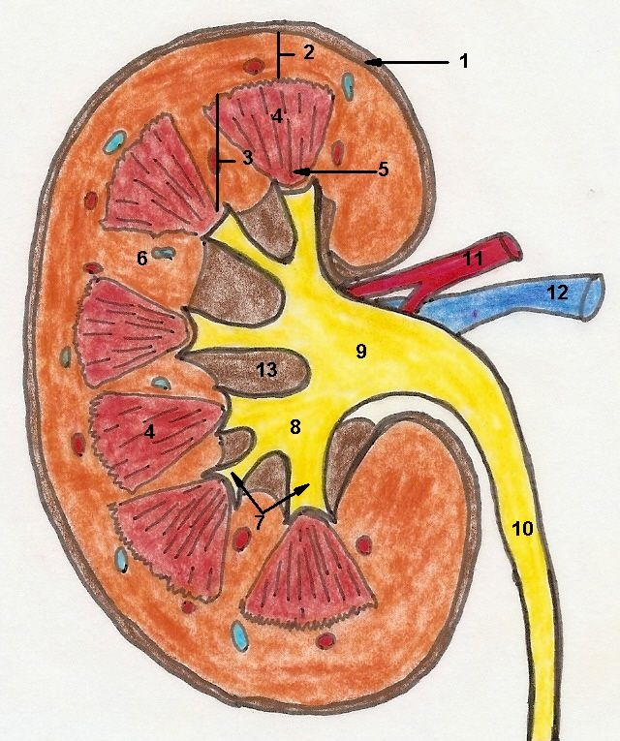

1. _____________________________________
2. _____________________________________
3. _____________________________________
4. _____________________________________
5. _____________________________________
6. _____________________________________
7. _____________________________________
8. _____________________________________
9. _____________________________________
10. ____________________________________
11. ____________________________________
12. ____________________________________
13. ____________________________________
14. ____________________________________

Exercise 3. Structures of Renal System: The Nephron. The nephron is considered the ‘functional unit’ of the kidney because it is the smallest structure which does the job of the whole. 1) Write the names of the specific numbered structures indicated in the diagram of the nephron below.

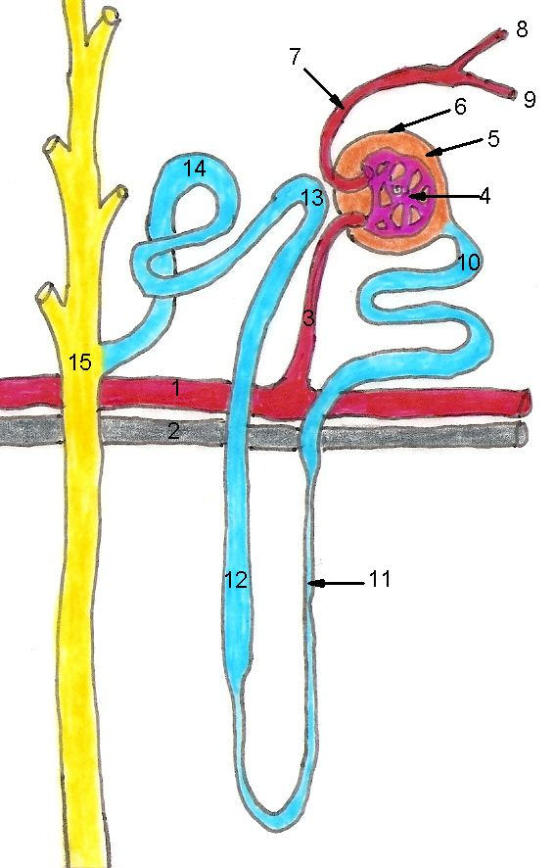

Use lab manual structures as a guide. Place answers on the numbered lines on the next page.

1. _____________________________________
2. _____________________________________
3. _____________________________________
4. _____________________________________
5. _____________________________________
6. _____________________________________
7. _____________________________________
8. _____________________________________
9. _____________________________________
10. ____________________________________
11. ____________________________________
12. ____________________________________
13. ____________________________________
14. ____________________________________
15. ____________________________________

