Anatomy Worksheet 13
Name ________________________
The Digestive System

Exercise 1. Structures of the Gastrointestinal Tract. Complete the following statements:
1. The part of the pharynx above the soft palate is called the ____________________________________.

2. In the digestive system, the process of taking food into the mouth is called ______________________.

3. The total volume of saliva produced by all the salivary glands is from _____ to _____ L per day.

4. Saliva is about 99.4% _________. At what specific location in the mouth do ducts for the sublingual salivary glands enter? _____________________________________. At what specific location in the mouth do ducts for the parotid salivary glands enter? __________________________________________.

5. The esophagus is about _______ cm long and enters the abdominal cavity through the opening in the diaphragm called the ____________________________________.

6. List in order from proximal to distal, the four regions of the stomach:

1) _______________ 2) _______________ 3) _______________ 4) _______________

7. Chief cells in the stomach secrete ____________________ which is converted into _________________ and is for the digestion of ___________________ in the presence of _________________.

8. The outermost muscular layer in the tunica muscularis externa is always _________________________.

9. Along the G.I. tract, the nervous structure called the _____________________________ is located in between the circular and longitudinal muscle of the tunica muscularis externa.

10. The term used to describe the location behind the peritoneal cavity is __________________________.

11. List two structures of the digestive system that are located in the answer for Q 10: 1) ______________ and 2) ____________________.

12. a) liver b) pancreas c) teeth d) spleen e) gallbladder f) thymus g) tongue h) stomach i) esophagus
From the list of letters above, which of following are: 1) part of the G.I. tract: ______________________.
2) Accessory digestive organs: ________________.

13. What is the correct anatomical term for our “baby teeth”? __________________________________.
14. Most of the digestive tract is lined with this: _____________________________________________.

15. The main role of the Large Intestine is the absorption of _________________ and ______________.

Exercise 2. Match the structures of the G. I. tract (letters) with the descriptions (numbers) below.
A. tunica serosa F. common hepatic duct K. tela submucosa P. mucus gland
B. common bile duct G. Brunner's glands L. sphincter of Oddi Q. taenia coli
C. parotid salivary gland H. esophageal glands M. lesser duodenal papilla R. haustra
D. greater duodenal papilla I. tunica mucosa N. myenteric plexus S. gastric gland
E. tunica adventitia J. pyloric sphincter O. chemical digestion T. left bile duct

- ___ structure located deep in the lamina propria of stomach.
- ___ a thickening of the circular muscle layer that controls the movement of chyme.
- ___ collects contents from cystic duct and delivers to main pancreatic duct.
- ___ a strip of longitudinal muscle found in the large intestine.
- ___ found in the submucosa of the duodenum.
- ___ an auxiliary pathway to deliver contents to the initial segment of the small intestine.
- ___ a structure that secretes amylase to aid in the digestion of starches.
- ___ the Peyer's patches of the ilium are found here.
- ___ a pouch that permits distention of the colon wall.
- ___ is made of simple squamous epithelium and areolar connective tissue.

Exercise 3. Some Accessory Organs
1) Labeled the diagram below of the anatomical arrangement between of the gallbladder, pancreas and duodenum.
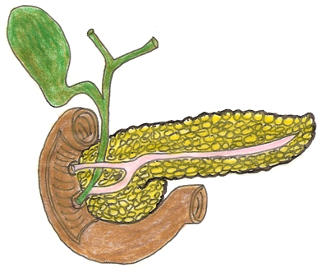

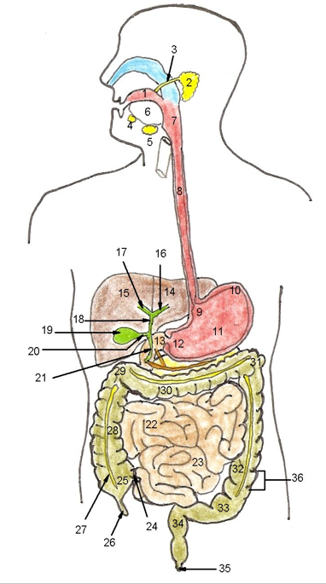
Exercise 4. The Gastrointestinal Tract
Name the structures of the digestive system indicated by the numbers in the drawing to the right.

Use the numbers here below to squeeze in the names of the structures in the drawing!

1 2 3 4 5 6

7 8 9 10 11 12

13 14 15 16 17 18

19 20 21 22 23 24

25 26 27 28 29 30

31 32 33 34 35 36
Exercise 5. Table 1. For each of the following structures below, provide the location (organ and quadrant of abdominal cavity) and the general function or significance of the structure.
Structure | Location | Function
Lesser omentum

Greater omentum

Falciform ligament

Greater duodenal
papilla

Cystic duct

Gastric rugae

Parotid duct

Pyloric sphincter

Fundus

Taeniae coli

Cecum

Mesentery (proper)

Brunner's glands

Islets of Langerhans

Appendix
Exercise 6. The mouth and teeth. 1) Define these terms with regard to the five surfaces to each tooth:
1. Occlusal:
2. Mesial:
3. Distal:
4. Buccal:
5. Lingual:
2) Name the structures identified in this image of the mouth and teeth and fill hem in below.
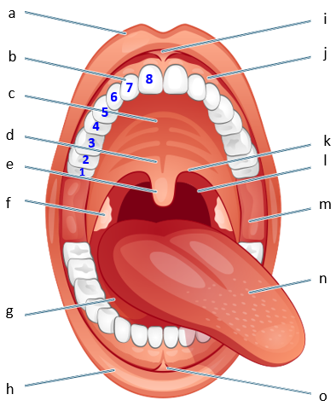

1 ____________________________________
2 ____________________________________
3 ____________________________________
4 ____________________________________
5 ____________________________________
6 ____________________________________
7 ____________________________________
8 ____________________________________

a ____________________________________
b ____________________________________
c ____________________________________
d ____________________________________
e ____________________________________
f ____________________________________
g ____________________________________
h ____________________________________
i ____________________________________
j ____________________________________
k ____________________________________
l ____________________________________
m ___________________________________
n ____________________________________
o ____________________________________

