Anatomy Worksheet 12
Name ________________________
The Respiratory System

Exercise 1. Structures of the Respiratory Tract 1) Multiple Choice Questions: Select the best answer.

1. The overall exchange of gases between the atmosphere, blood, and cells is called
a) inspiration b) respiration c) expiration d) metabolism e) none of these

2. The internal walls of the nasal cavity are formed by the ______ and the ______bones.
a) maxillae; hyoid b) lacrimal; ethmoid c) inferior nasal conchae; palatine d) ethmoid; vomer

3. Of the following structures, the smallest in diameter is the
a) left primary bronchus b) bronchioles c) secondary bronchi d) tertiary bronchi e) alveolar ducts

4. The thyroid prominence has a common term for the
a) thyroid cartilage b) cricoid cartilage c) epiglottis d) the Adam's apple e) the gizzard

5. From superficial to deep, the structure you would encounter first among the following is the
a) bronchi b) parietal pleura c) pleural cavity d) secondary bronchi e) visceral pleura

2) Fill in: Complete the following statements:

1. During inspiration, it’s necessary to condition air before it gets to the alveoli. Most of this occurs in the nasal cavity: What are 3 advantages of this? _______________, _________________, _______________.

2. Improper fusion of the palatine and maxillary bones can cause a condition called a _________________.

3. The surface of the lung that is lying against the ribs is called the ___________________ surface.

4. Groove-like passageways in the nasal cavity formed by the nasal conchae are called ________________.

5. The continuation of the soft palate soft becomes a flap of tissue hanging down called the ____________.

6. The nose, pharynx, and associated structures comprise the ______________________ respiratory tract.

7. The ______________________ cartilage attaches the larynx to the trachea.

8. The_______________________ is a region or cavity in between the two lungs through which bronchi, pulmonary blood vessels, lymphatic vessels, and nerves pass.

9. The broad, inferior portion of a lung that fits over the convex area of the diaphragm is the ________________, and the superior tip of the lung is called the _________________.
10. Phagocytic cells in the alveolar wall are called _______________. One substance these cells release is _______________ which protects the inner surface of the alveoli.
Exercise 2. Structures of the airways: 1) The drawing below starts from the trachea and proceeds down the bronchial tree. The alveoli are not shown in this drawing. Write the names of the specific structures indicated below.
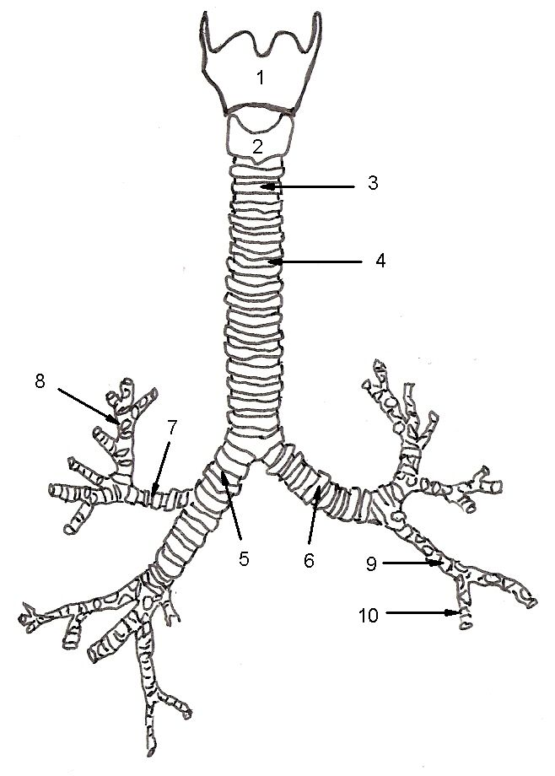

1. _____________________________________
2. _____________________________________
3. _____________________________________
4. _____________________________________
5. _____________________________________
6. _____________________________________
7. _____________________________________
8. _____________________________________
9. _____________________________________
10. ____________________________________

Exercise 3. Structures of the Trachea: 1) Keep in mind that the drawing below represents the histology of a cross section of the trachea. Compare this image with a reference to a histological section of a trachea. From the numbered arrows, write the names of the specific structures that are indicated and fill them in on the numbered list below.
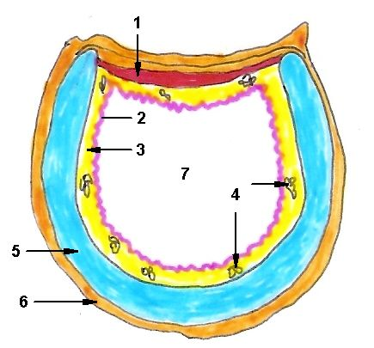

1. Name the muscle: ________________________________________

2. Name the layer: ________________________________________

3. Name the layer: ________________________________________

4. Name the specific structure: ________________________________________

5. Name the specific structure: ________________________________________

6. Name the layer: ________________________________________

7. Name the area: ________________________________________

Exercise 4. The drawing of a mid-sagittal section of the respiratory system below shows the upper respiratory tract. Write the name of the specific structures indicated in the alpha and numbered list below.
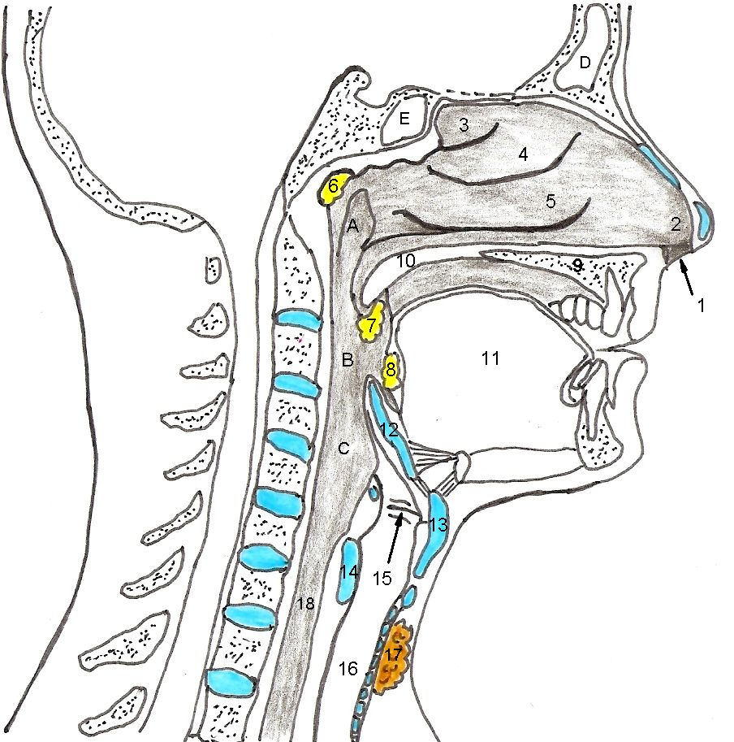

F

A. _________________________ B.________________________ C.__________________________
D. _________________________ E.________________________ F.__________________________

1. _____________________________________
2. _____________________________________
3. _____________________________________
4. _____________________________________
5. _____________________________________
6. _____________________________________
7. _____________________________________
8. _____________________________________
9. _____________________________________
10. ____________________________________
11. ____________________________________
12. ____________________________________
13. ____________________________________
14. ____________________________________
15. ____________________________________
16. ____________________________________
17. ____________________________________
18. ____________________________________

