Anatomy Worksheet 10
Name ________________________
The Cardiovascular System

Exercise 1. Structures of the Heart: 1) Match the structures of the heart (letters in Column A) with the descriptions (numbers in Column B) below.

Column A
A. bicuspid valve F. apex of heart K. trabeculae carneae
B. auricle of atria G. papillary muscles L. epicardium
C. pulmonary trunk H. interventricular (IV) groove M. interventricular (IV) septum
D. tricuspid valve I. coronary sulcus N. coronary sinus
E. endocardium J. aortic semilunar valve O. base of heart

Column B
1. ___ inferior tip of the heart
2. ___ inner lining of the heart chambers
3. ___ drains blood from the coronary capillaries
4. ___ groove separating atrial and ventricular portions of heart
5. ___ structures from which chordae tendineae originate
6. ___ prevents retrograde flow from right ventricle to right atrium
7. ___ can also be referred to as visceral pericardium
8. ___ gives rise to arteries delivering blood to lungs
9. ___ structure separating left and right ventricles
10. ___ small flaps on external surface of atrium

2) Multiple Choice Questions: Select the best answer.

1. The largest of the circulatory routes is
a) systemic
b) pulmonary
c) coronary
d) hepatic portal
e) renal

2. Which of the following are involved in pulmonary circulation?
a) superior vena cava, right atrium, and left ventricle
b) inferior vena cava, right atrium, and left ventricle
c) right ventricle, pulmonary artery, and left atrium
d) left ventricle, aorta, and inferior vena cava

3. From these vessels and structures, trace a RBC returning from the body in the correct order:
1. right atrium 2. left atrium 3. right ventricle 4. left ventricle 5. aorta
6. vena cava (superior and inferior) 7. pulmonary trunk 8. pulmonary vein
a) 1, 2, 7, 8, 3, 4, 5, 6
b) 1, 7, 3, 8, 3, 4, 5, 6
c) 6, 1, 3, 7, 8, 2, 4, 5
d) 6, 3, 1, 7, 8, 4, 2, 5
e) 6, 1, 3, 8, 7, 2, 4, 5

4. The muscular wall of the right ventricle is thinner than the left ventricle wall because the right ventricle
a) holds a lesser volume of blood
b) pumps blood to the lungs
c) pumps blood to the entire body
d) pumps the blood through a smaller valve
e) pumps blood throughout the heart

5. The groove separating the atria from the ventricles is known as the
a) I.V. septum b) AV septum c) interventricular sulcus d) interatrial septum e) coronary sulcus
Exercise 2. Structures of the Heart: 1) Write the name of the specific structure indicated in the drawing of the heart below, list them on the next page.

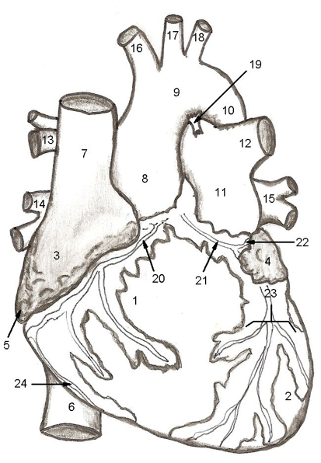

1. _____________________________________
2. _____________________________________
3. _____________________________________
4. _____________________________________
5. _____________________________________
6. _____________________________________
7. _____________________________________
8. _____________________________________
9. _____________________________________
10. ____________________________________
11. ____________________________________
12. ____________________________________
13. ____________________________________
14. ____________________________________
15. ____________________________________
16. ____________________________________
17. ____________________________________
18. ____________________________________
19. ____________________________________
20. ____________________________________
21. ____________________________________
22. ____________________________________
23. ____________________________________
24. ____________________________________

2) Write the name of the specific structure indicated in the drawing of the heart below, list them on the next page.
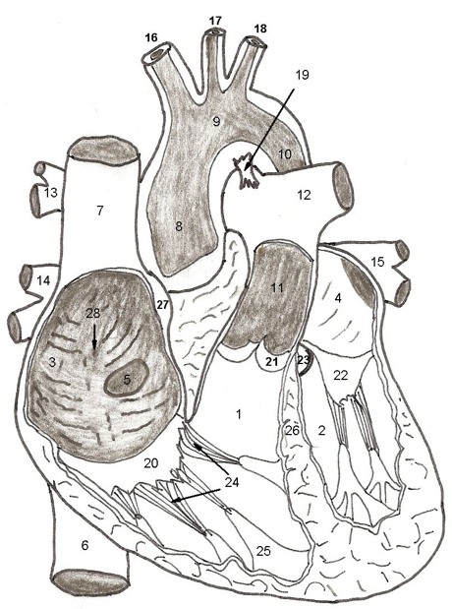

1. _____________________________________
2. _____________________________________
3. _____________________________________
4. _____________________________________
5. _____________________________________
6. _____________________________________
7. _____________________________________
8. _____________________________________
9. _____________________________________
10. ____________________________________
11. ____________________________________
12. ____________________________________
13. ____________________________________
14. ____________________________________
15. ____________________________________
16. ____________________________________
17. ____________________________________
18. ____________________________________
19. ____________________________________
20. ____________________________________
21. ____________________________________
22. ____________________________________
23. ____________________________________
24. ____________________________________
25. ____________________________________
26. ____________________________________
27. ____________________________________
28. ___________________________________

Exercise 3. Arterial System
1) Draw a labeled diagram of the systemic arterial branches coming directly from the aorta, from the heart to the terminal segment of the aorta (Lab Unit 5a structures).

Exercise 4. Arterial Vasculature
1) Match the arteries (letters) with the regions supplied by the arteries (numbers) below.

A. renal F. lumbar K. superior mesenteric P. axillary
B. external carotid G. right subclavian L. internal carotid Q. popliteal
C. inferior mesenteric H. intercostal M. left gastric R. radial
D. splenic I. thyrocervical N. costocervical S. suprarenal
E. common hepatic J. brachial O. femoral T. phrenic

1. ___ larynx, lower jaw and face 9. ___ posterior abdominal wall
2. ___ muscles and skin of neck, thyroid 10. ___ eyes and brain
3. ___ kidney 11. ___ diaphragm
4. ___ upper digestive tract 12. ___ lower colon
5. ___ thigh muscles, to lower limbs 13. ___ adrenal gland
6. ___ spleen 14. ___ lower lateral arm muscles
7. ___ triceps muscles 15. ___ knee joint
8. ___ anterior thoracic wall 16. ___ stomach

Exercise 5. Venous System
1) Draw a labeled diagram of the venous system tributaries on their way back to the heart from the upper limbs. Include deep and superficial veins as they connect and end in the heart (Lab Unit 5a structures).

Exercise 6. Venous Vasculature
1) Match the veins listed with the regions of the body that they drain below.
A. median cubital F. ulnar K. intercostal P. azygos
B. inferior vena cava G. great saphenous L. femoral Q. esophogeal
C. small saphenous H. internal jugular M. radial R. pulmonary
D. basilic I. brachiocephalic N. external jugular S. hepatic portal
E. superior mesenteric J. subclavian O. inferior mesenteric T. cephalic

1. ___ receives blood from the right colic, right gastoepiploic and pancreaticodoudenal veins
2. ___ collects blood from the superficial veins of the foot and leg
3. ___ empties into the axillary vein and drains the deep lateral forearm
4. ___ receives blood from neck, face, salivary glands and scalp
5. ___ interconnects the basilic and cephalic veins
6. ___ receives blood from the medial surface of upper limbs
7. ___ drains blood from the superficial veins of the lower limb
8. ___ receives blood from the left colic and superior rectal veins
9. ___ collects blood from cranium, neck and face
10. ___ collects blood from the hepatic, gonadal, lumbar, phrenic, suprarenal and renal veins

2) Multiple Choice Questions: Select the best answer.
1. All arteries of systemic circulation branch from the
a) superior vena cava b) inferior vena cava c) pulmonary artery d) coronary artery e) aorta

2. Which statement best describes arteries?
a) all carry oxygenated blood to the heart
b) all contain valves to prevent the backflow of blood
c) all carry blood away from the heart
d) only large arteries are lined with endothelium
e) all lack elastic fibers

3. Which statement is not true of veins?
a) they have less elastic tissue and smooth muscle than arteries
b) their tunica externa is the thickest coat
c) most veins in the limbs have valves
d) they always carry deoxygenated blood
e) they are larger than arteries

4. An obstruction in the inferior vena cava would hamper the return of blood from the
a) head and neck
b) upper limbs
c) thorax
d) abdomen and pelvis
e) lungs
5. Which of the following statements about systemic circulation is not correct?
a) its purpose is to carry oxygen and nutrients to body tissues and to remove carbon dioxide
b) all systemic arteries branch from the aorta
c) it involves the flow of blood from the body to the left atrium
d) it involves the flow of blood from the left ventricle to all parts of the body except the lungs

6. Which of the vessels does not belong with the others?
a) brachiocephalic artery
b) left common carotid artery
c) vertebral artery
d) left subclavian artery

7. A thrombus in the first branch of the arch of the aorta would affect the flow of blood to the
a) left side of the head and neck
b) myocardium of the heart
c) left upper limb
d) right side of the head and neck and right upper limb
e) brain and neck

8. The circulatory route that detoxifies blood from the gastrointestinal tract via the liver is called the
a) coronary circulation
b) pulmonary circulation
c) hepatic portal circulation
d) cerebral circulation

9. If a thrombus in the left common iliac vein dislodged, which arteriole system would it first be found?
a) brain b) kidneys c) lungs d) left arm e) coronary

10. Which coat of an artery contains endothelium?
a) tunica interna
b) tunica media
c) tunica externa
d) tunica adventitia
e) mesothelium

3) Fill-in: Complete the statements using the most appropriate word or words.
1. The arteries that branch directly from the aortic arch in order of their origination are the:
a) __________________________, b) __________________________, c) _________________________,
2. Just distal to the elbow, the ____________________ artery divides into the radial and ulnar arteries.
3. The ____________________ artery supplies the stomach and greater omentum.
4. In the skull, the vertebral arteries unite to form the ________________________ artery.
5. Blood is supplied to the pancreas, most of the small intestine, and part of the large intestine by the __________________________________ artery.

