Anatomy Worksheet 1
Name ________________________
Anatomical Landmarks, Epithelial and Connective Tissues

Exercise 1. 1) Anatomical Landmarks: Match each term (letter) once with its description below.
A. Sural D. Antebrachium G. Popliteal J. Gluteus L. Crural
B. Inguinal E. Olecranon H. Cranial K. Axilla M. Manus
C. Antecubital F. Femoral I. Patellar L. Pollex N. Tarsus

1. ___ The forearm region of the body. 7. ___ Refers to the ankle region.
2. ___ Term for the hand. 8. ___ Region of the leg.
3. ___ Region of the back of the knee. 9. ___ Term for the skull and associated structures.
4. ___ Often called the groin region. 10. ___ The back of the leg, or the calf region.
5. ___ Refers to the back of the elbow. 11. ___ The thigh region of the body.
6. ___ The front region of the elbow. 12. ___ The front knee region.

2) Make a quick sketch below of a pencil cut: a) perpendicular to its longitudinal axis, and b) in its longitudinal plane. a) b)

Exercise 2. Epithelial Tissue Descriptions
1. Define the term Tissue:

2. List and describe five common characteristics (not functions) of all epithelial tissue:
1)
2)
3)
4)
5)

Epithelial Tissue Fill-Ins
1) The epithelium found in your mouth is named: _____________________________________________.

2) The entire structure that attaches epithelium to underlying CT is the ____________________________.

3) In serous membranes, the type of epithelium is: ____________________________________________.

4) Multicellular exocrine glands that contain branching ducts are classified as _________________ glands.

5) Endocrine glands, such as the pancreas and thyroid, are made from _______________________ tissue.

6) Cell attachments at apical end to prevent passage of unwanted things are _______________________.
3. For each of these epithelial tissues shown, give details of the following: a) The number of cell layers, shape of exposed cell layer and location and shape of nucleus in (most) cells; b) the major function of the tissue; and c) a specific example of the location of this tissue in the body.
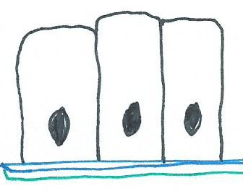

1) Simple columnar epithelium
a)
b)
c)

2) Stratified cuboidal epithelium
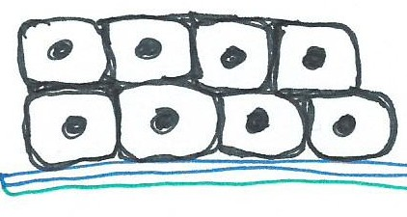
a)
b)
c)

3) Pseudostratified ciliated columnar epithelium
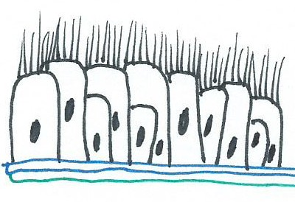
a)
b)
c)

4) Simple squamous epithelium
a)
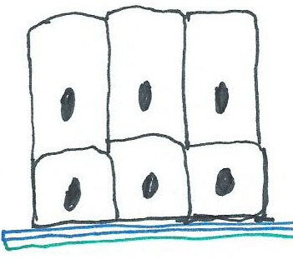
b)
c)

5) Stratified columnar epithelium
a)
b)
c)

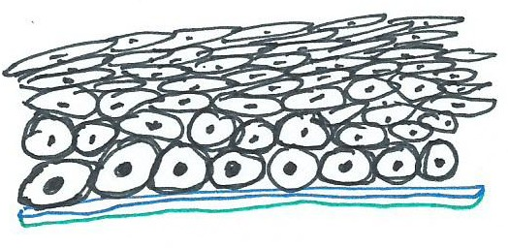

6) Stratified squamous epithelium
a)
b)
c)

a) b)
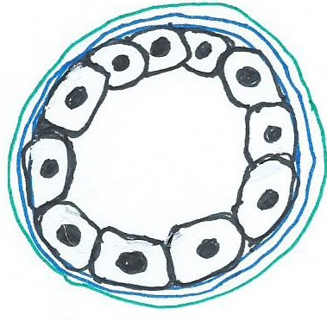
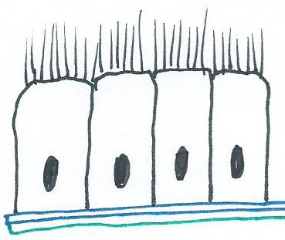
7) Name the tissues a) and b) below and an example of where they would be located

______________________________ ______ ___________________________________

Exercise 3. Connective Tissue Descriptions and Fill-ins
1. List the 3 elements that all connective tissues have in common:

1) _________________________ 2) __________________________ 3) __________________________.

2. Name the two types of fluid connective tissue: 1) _________________ and 2) ____________________.

3. What connective tissue (CT) is found in: 1) the deep layer of the dermis of the skin; 2) the spleen.

1) ____________________________________________ and 2) _________________________________.

4. Histamine, which dilates small blood vessels during inflammation, is secreted by ______________ cells.

5. What is the major distinction between Loose and Dense CT? __________________________________.

6. List the 3 types of Loose CT, 2 places where they’re found in the body (location) and their functions.
1)
2)
3)

7. Name 3 examples of Dense CT, 2 places where they’re found in the body (location) and functions.
1)
2)
3)

8. List and briefly describe the 3 different types of Cartilage and where are they found in the body.
1)
2)
3)

9. For Elastic Cartilage, list the following: 1) specialized cells; 2) fibers; and 3) ground substance in.
1)
2)
3)
Exercise 4. Muscle Tissue
1) The 3 types of muscle in the body are _______________, _______________ and _______________.

2) Fill-in the blank with the appropriate type of muscle tissue for each statement:
a) striated and voluntary ____________________. b) striated and involuntary ____________________.
c) non-striated and involuntary __________________. d) has intercalated discs __________________.
e) has multiple nuclei ______________________. f) found in blood vessels _______________________.
g) what type of muscle makes the hairs on your arm "stand on end"? ____________________________.
h) heart is made of this muscle ________________. i) the stomach has this muscle ________________.
j) what specific type of muscle makes up most of the muscle in your arms? ________________________.

Exercise 5. Epithelial and Connective Tissues: Match each term (letter) with its description below.

A. Transitional Epi.
B. Adipose CT
C. Simple cuboidal Epi.
D. Dense irregular CT
E. Simple columnar Epi.
F. Macrophage
G. Stratified squamous Epi.
H. Fibroblast
I. Pseudostratified columnar
K. Cartilage CT
L. Mast cell
M. Simple squamous Epi.

- ___ Lines inner surface of the stomach and intestine
- ___ Lines urinary tract, as in the urinary bladder, permitting distention when full
- ___ Lines the mouth; present on outer surface of skin
- ___ Single layer of cube-shaped cells; found in kidney tubules and ducts of some glands
- ___ Lines air sacs of lungs (alveoli) where thin cells are required for gases diffusion (exchange)
- ___ Not a true stratified tissue; all cells on basement membrane, but some do not reach surface
- ___ Stores fat and provides energy storage and insulation
- ___ Phagocytic cell; engulfs bacteria and cleans up debris; important during infection
- ___ Produces collagen and elastic fibers in injured tissue
- ___ Cell found in CT and in walls of blood vessels; produces histamine to dilates blood vessels
- ___ Contains lacunae and chondrocytes
- ___ Forms fasciae and dermis of skin

Exercise 6. Multiple Choice Questions for Epithelial and Connective Tissue.
1. Simple squamous epithelial tissue that lines the heart, blood vessels, and lymphatic vessels is “called”
a) transitional b) adipose c) endothelium d) mesothelium e) reticular

2. Stratified epithelium is usually found in areas of the body where the principal function is
a) filtration b) absorption c) secretion d) diffusion e) protection

3. If ciliated epithelium were destroyed by disease, it would cause the biggest problem in which system?
a) digestive b) respiratory c) skeletal d) cardiovascular
4. A gland
a) is either exocrine or endocrine b) may be single celled or multicellular c) consists of epithelial tissue
d) is described by all of the preceding statements

5. Which of the following statements is not correct?
a) Simple squamous epithelium lines blood vessels b) Transitional epithelium is found in the bladder
c) Endothelium is composed of cuboidal cells d) Ciliated epithelium is found in the respiratory system

6. Torn ligaments would involve damage to which connective tissue?
a) dense regular b) reticular c) elastic d) areolar e) dense irregular

7. Which statement best describes connective tissue?
a) It usually contains a large amount of matrix. b) It's always arranged in a single layer of cells.
c) It's primarily concerned with making secretions. d) It usually lines body cavities.

8. A sublingual gland contains a branched duct and flask-like secretory portions, thus it’s classified as
a) simple coiled tubular b) compound acinar c) simple acinar d) compound tubular e) endocrine

9. Which tissue forms articular cartilage and costal cartilage?
a) fibrocartilage b) elastic cartilage c) adipose d) hyaline cartilage e) reticular cartilage

10. Membranes that line cavities that open directly to the exterior are called ___________ membranes.
a) synovial b) serous c) mucous d) cutaneous e) exocrine

Thoughtful Questions: Try to be as comprehensive in your answer as you can.
1. What functional problem might occur if the digestive tract were lined with stratified squamous epithelium instead of simple columnar epithelium?

2. There are always two (2) components to a serous membrane: Identify them below.

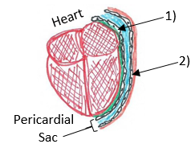

1) ____________________ _______________________.

2) ____________________ _______________________.

3. What if I asked you to tell me the position of the heart in relation to the diaphragm? You might say it’s _____________. Then I’d say, “Nu uh, not when I’m lying in the sun getting my precious vitamin D!” Take this opportunity to explain to me why the anatomical position is used as a frame of reference?

