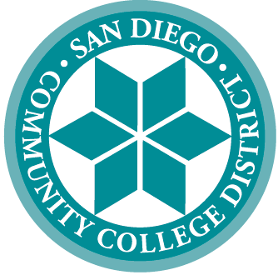 | SAN DIEGO COMMUNITY COLLEGE DISTRICT
3375 Camino del Rio South
San Diego, California 92108-3883
619-388-6500
 | CITY COLLEGE | MESA COLLEGE | MIRAMAR COLLEGE | COLLEGE OF CONTINUING EDUCATION
 | Educational Services

SDCCD Enrollment Processes Workgroup

PURPOSE: The purpose of this workgroup is to review the enrollment processes for the San Diego Community College District with the aim of increasing student access and streamlining the enrollment process, while still complying with applicable federal, state and board policies.

Recommendations will be provided to District Student Services Council for review.

TYPE: Workgroup

Chair(s): TBD

Committee Composition:
- Dean, Student Services
- Dean, Instructional Services
- 6 instructional faculty representatives from a diverse set of disciplines
Examples:
  - CTE Faculty
  - STEM Faculty
  - Language/Communications Faculty
  - Exercise Science
  - Visual/Performing Arts Faculty
  - Faculty with experience with courses held online (sync or async)
- 1 Counseling Faculty
- 1 Special Funded Programs Counseling Faculty
- Admissions and Records Representative
- District Educational Services Business Systems Analyst
- IT Applications Manager

