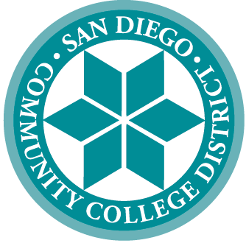 | SAN DIEGO COMMUNITY COLLEGE DISTRICT
3375 Camino del Rio South
San Diego, California 92108-3883
619-388-6500
 | CITY COLLEGE | MESA COLLEGE | MIRAMAR COLLEGE | COLLEGE OF CONTINUING EDUCATION
 | Educational Services

March 9, 2023

TO: Admissions and Records, Counseling, Instructional Faculty

FROM: Victor DeVore, Dean, Student Services

SUBJECT: Repeating an In-Progress Course

This memo outlines a new business process for students who wish to re-enroll in an in-progress class they will not successfully complete. Effective Fall 2023, students will have the opportunity to enroll in the same class in a different semester or session provided they meet the following requirements:

- Student must obtain documentation from their instructor that they will receive a substandard grade (D, F or NP only).
- Student does not have any holds that prohibit enrollment.
- The withdrawal deadline must have passed for the in-progress class.
- Students may only be allowed to repeat an in-progress class during the semester’s open registration period and the add deadline has not lapsed.

Students must submit a General Petition and attach written documentation from the instructor of record that the student will not receive a passing grade in the in-progress class along with the class number they wish to repeat. If approved, the petition will be routed to Admissions for processing.

We believe that this new business process will provide students with additional opportunities to succeed in their academic pursuits.

Thank you for your cooperation.

Sincerely,

Victor DeVore
Dean, Student Services
Educational Services

