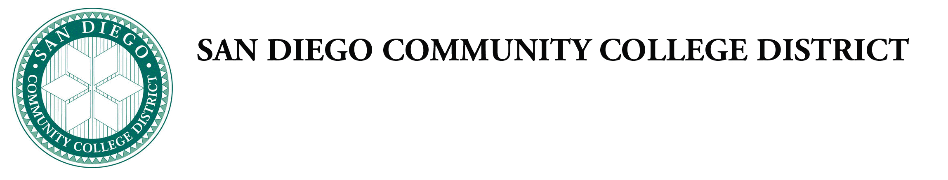
Administrative Procedures

Chapter 4—Academic Affairs

Chancellor’s Cabinet First Reading:
Chancellor’s Cabinet Second Reading:
DGC First Reading:
DGC Second Reading:

The following Board Policies are being put forth for approval as part of the Board’s ongoing 6-year comprehensive review of all Board policies and procedures.

Category 1 Procedures New and/or major revisions to policies and/or procedures that are not required by law or regulation, but are recommended by the respective office of responsibility. This category has the most extensive review process.

AP 4236 Advanced Placement of Credit
New Optional Procedure: AB 1342 amended Education Code to encourage districts to engage in international education as resources permit.

Category 3 Procedures Technical and/or non-substantive revisions to policies and/or procedures, such as reference updates, title changes, or policies and procedures that are being reviewed for currency but not undergoing significant revision.

AP 4021 Program Discontinuance
Minor technical revisions: change number to align with CCLC; update college names

AP 4019 Instructional Program Review
Minor technical revisions: change number to align with CCLC; update college names

