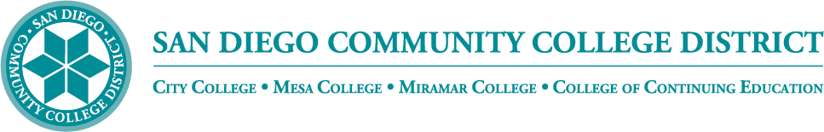
Administrative Procedure

Chapter 4—Instructional Services Academic Affairs

AP 5019 AP 4019– INSTRUCTIONAL PROGRAM REVIEW

Chancellor’s Cabinet First Reading:
Chancellor’s Cabinet Second Reading:
DGC First Reading:
DGC Second Reading:

For the purposes of this procedure, a program shall be defined as a field of study with one or more related certificates and degrees.

A program review process shall be established by the San Diego City College, Mesa College, Miramar College, and College of Continuing Education colleges and Continuing Education which:

- Meets accreditation standards and Education Code, California Code of Regulations, title 5;
- Includes procedures for regular review of instructional programs;
- Ensures career technical education programs are reviewed at least every two years; and
- Ensures all other programs are reviewed at least every five years.

The Board of Trustees shall make the final decision regarding changes to instructional programs.

Reference: Education Code Section 78016; California Code of Regulations, title 5, sections 51022 and 55130; WASC/ACCJC Accreditation Standard II.A.16

<Pending signature>
APPROVED: DATE:
Carlos O. Cortez, Ph.D.

<Once signed>
Approved by
the Chancellor: Month Day, Year

Supersedes: AP 5019 02/10/2017

