**Class Activity #8 (Physiology)**

**Blood Pressure, Resistance and Flow**

Some of the material in this class activity has been covered in lectures already and we will review it to make sure we are confident with it. Some of the other material has not yet been covered in lectures but we will introduce the concepts here to provide an introduction to the upcoming material.

**Review Material**

**1. Blood Vessels:** Let’s go through and briefly review the major blood vessels.

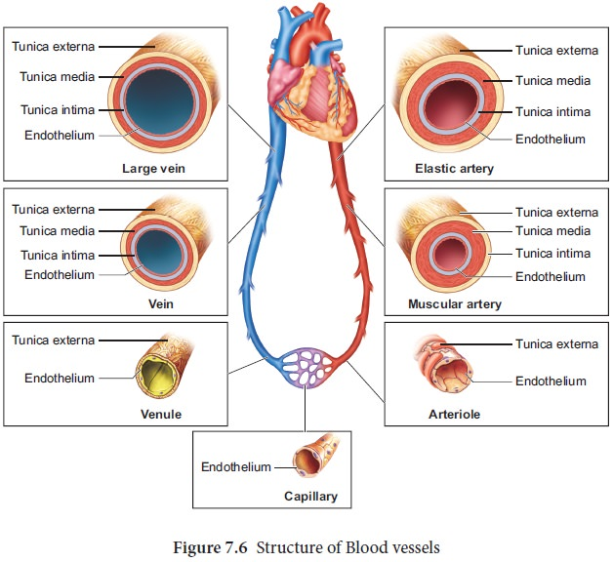

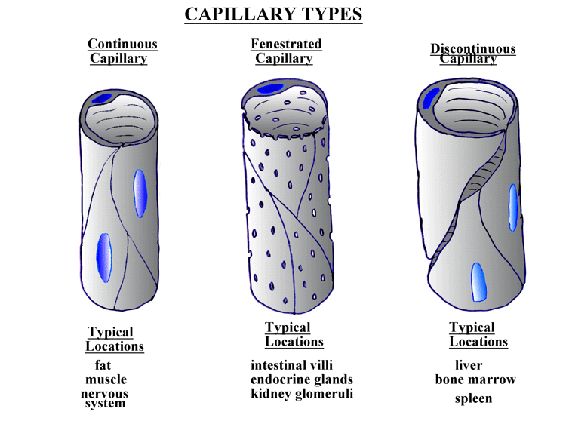

**2.** What is **Mean Arterial Blood Pressure** (MAP)?How is it calculated?

**3.** What determines the direction of **Blood Flow?** What is the Driving Force for blood flow?

**4.** What **Opposes** blood flow?

**5.** In the body, what are **three** factors that contribute to **Peripheral Resistance**? Describe them.

**1.**

**2.**

**3.**

**6.** What is **Poiseuille's Equation** (and how it is pronounced?!); how does it relate to blood flow?

**7.** How can Poiseuille's formula be *simplified* to represent the most critical changes in the body that impact resistance, blood pressures and flow.

**Newer Material**

**8.** What are the 4 main Factors that Affect **Mean Arterial Pressure** (MAP)? *Hint: See* ***SG#3, Q#15.***

**9.** Draw out and describe the **Baroreceptor Reflex.**

**10.** What are someimportant *Endogenous* **Vasoconstrictors** and **Vasodilators** in the Human Body?

**Vasoconstrictors**

**1.**

**2.**

**3.**

**4.**

**Vasodilators**

**1.**

**2.**

**3.**

**4.**