**Class Activity #7**

**½ way there: Re-Grouping and Self-Assessment**

**Blood and Blood Cells**

**A. In Class Discussion Exercises:**

**1)** Projecting Ahead: Studying, Exams, Labs and Assignments.

* As we reach the half way point of this course, it is important to assess the level of content understanding obtained at this stage, and make correlations to exam, labs and assignment scores. With the focus on elements that are under our control to address, suggest 2 constructive activities you could do to have an improved outcome in this course?

**B. In Class Content Exercises:** Blood, Blood Cells and Blood Vessels

**1)** Let’s look at Blood. Think about all of the Components of Blood and their Functions.

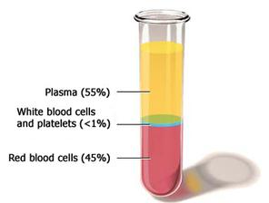

Consider these terms below and expand with details for each:

* **Plasma**
* **Gases**
* **Nutrients**
* **Wastes**
* **Plasma Proteins**

What are the % here?

* **Blood Glucose**
* **Lipids**
* **Cells**
* **Other Solutes?**
* **Color?**

**2)** The Lipids in Blood: They need carriers! Be able to describe this diagram in terms of lipid transport.

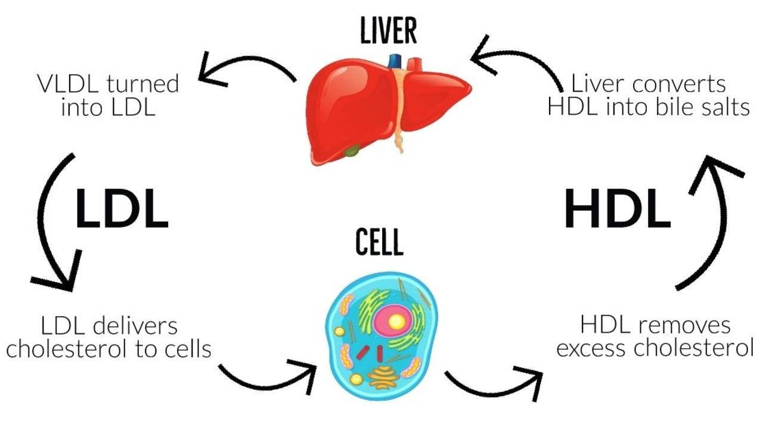

**3)** Ahh the Red Blood Cell. Describes why all of its structures and qualities are PERFECT for its Function.

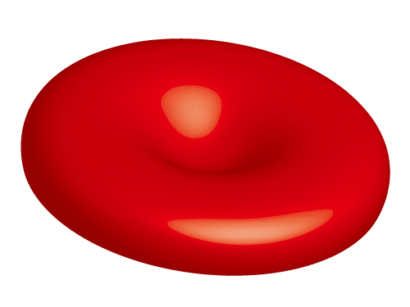

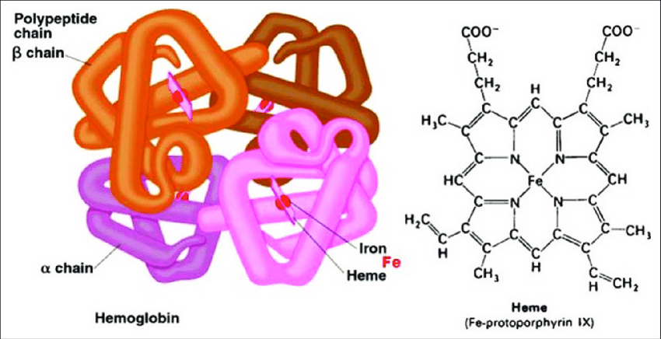

**4)** What is the primary thing (molecule) the RBC contains?

It is shown to the right). Describe it.

**5)** What does this image below show? What is this the consequence of?

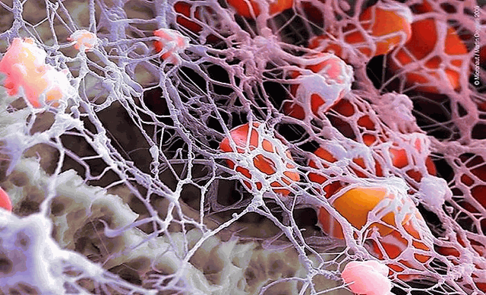

**6)** What are the different White Blood Cells? Identify them below and what they do.

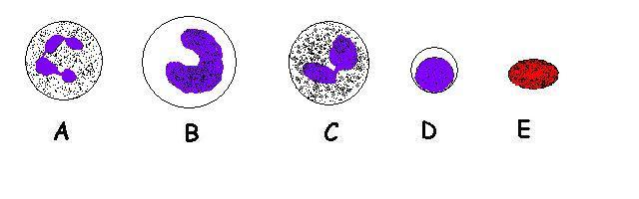

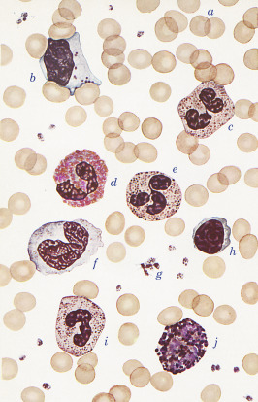

**Some Questions**

**1.** Which of the following statements best describes the role of **high density lipoproteins** (HDL’s)?

**a)** deposits lipids in blood vessel walls **b)** carries and removes cholesterol from the body tissue

**c)** it’s the bad cholesterol **d)** carries and delivers cholesterol to body tissues **e)** it’s the good cholesterol

**2.** Which of the following is **true** about blood?

**a)** at rest there is more blood in the arterial system than in the venous system

**b)** arterial blood is more acidic than venous blood **c)** hematocrit for males and females is about the same **d)** at higher altitudes, there will naturally be lower hematocrit values **e)** none of these are true

**3.** A patient needs 2 units of packed red blood cells. The patient is typed and cross-matched and they have **A+** blood. You need to be aware of what blood type this patient can receive. Select all that apply!

**a)** A- **b)** O- **c)** O+ **d)** A+ **e)** AB- **f)** AB+ **g)** B+ Ans = ________________________

**4.** Which of the following statements about albumin is true?

**a)** It draws water out of the blood vessels and into the body’s tissues.

**b)** It is the most abundant plasma protein.

**c)** It is produced by specialized leukocytes called plasma cells.

**d)** It is an enzyme that is inert in the blood until activated.

**e)** It is a very small protein that can often cross the cell membrane.

**5.** If the walls of a blood vessel are damaged, the vessel ________ in response to the release of ________.

**a)** dilates; ACh **b)** constricts; NE **c)** contracts; ACh

**d)** contracts; endothelin **e)** dilates; nitric oxide (NO)