**Class Activity #5 (Physiology)**

**1. Review and Assorted Discussion Items:**

***During the Class Discussion*** we will have some **Padlet** assignments related to the topics below.

* **Padlet Assignment #1**: For the 3 questions below that many students did not get completely correct on Quiz #3, please take another look at them and suggest why some got other answers.

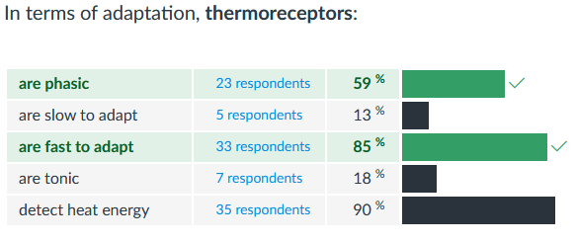

**1**

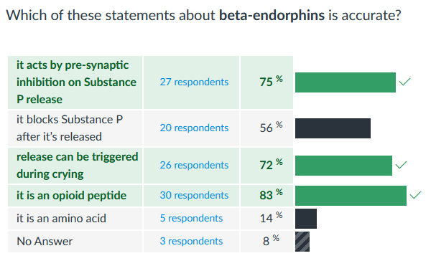

**2**

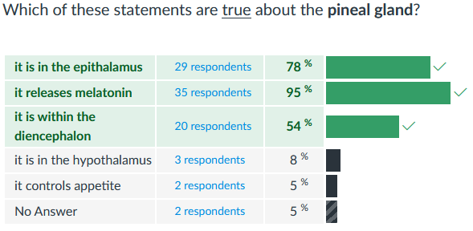

**3**

* **Padlet Assignment #2**: Read the article “9 Things You Can Do to Get Happy in the Next 30 Minutes” provided. Then answers to the following questions: **1)** Which activity/idea in the article was most appealing to you and why? **2)** Is there an idea that is not on that list that you can suggest, and why?
* **Padlet Assignment #3**: Animal Communicator video. Watch the 13 min video about a person with some interesting communication skills. <https://www.youtube.com/watch?v=gvwHHMEDdT0>

Then provide answers to the following questions: **1)** Do you think she can communicate with animals? **2)** If yes, what could explain it (e.g., physiologically) and what might be the benefits of engaging in this type of communication?

**2. Review of the Peripheral Nervous System (PNS)**

**A.** Somatic Nervous System (**SNS**) controls: _______________________________.

**CNS**

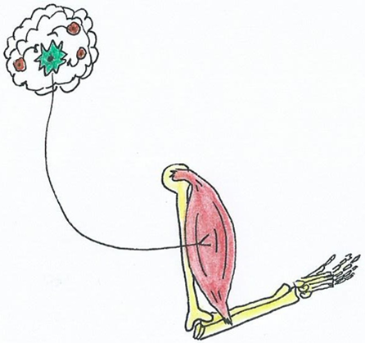In this arrangement there is/are ___ neuron(s) that travels out from the CNS into the PNS, so they are called ___________ neurons. In the SNS this type of neuron only ever effects __ type(s) of effector tissue, and the tissue it innervates is ___________________. This neuron releases the NT _______________ at the effector tissue. And the receptors that bind this NT (on the effector tissue) are always _____________receptors. When this NT acts on the effector tissue it causes that tissue to _________________.

**PNS**

When there is no signal from the ________________ neuron, then the effector tissue _____________________.

**Summary of SNS**:

This neuron below is called a: _________________.

The NT released is __________. Receptors are___________. The effector tissue is ________________________.

**B.** Autonomic Nervous System (**ANS**) controls: _______________________________________________.

The ANS is more complicated. In this arrangement there is/are ___ neuron(s) that travels out from the CNS into the PNS. They are called __________ neurons, but the first one is called the ____________________ neuron and the second one is called the ______________________ neuron.

There are ___ divisions in the ANS, they are **1)** ____________________ and **2)** ______________________.

The neuron that goes from the CNS to the Ganglia is called the:

The neuron that goes from the Ganglia to the Effector Tissue is called the:

No matter what division, at the Ganglion the NT released is: ____________. Receptors are_____________.

No matter what division, the effector tissue is: _______________________________________________.

Where the divisions differ is at the _________________________.

Use the diagrammatic neuronal arrangements provided below to fill in the specific details for each division of the **ANS**. **Label** and **add** to include all of the following:

*Preganglionic and postganglionic neurons (and nerve fibers), ganglion, nicotinic and muscarinic, alpha and beta receptors, acetylcholine, norepinephrine, CNS, PNS and examples of target tissue acted on.*

**This is the _________________ Division:**

target tissue

**This is the _________________ Division:**

target tissue

Use the letters (and acronym) below to list the general differences that exist between the 2 divisions:

PARASYMPATHETIC SYMPATHETIC

*S E*

*L E*

*U E*

*D E*

*D*

Formulate any questions you have about the ANS here:

1)

2)

**3. Getting ready for Skeletal Muscle Lecture and Lab**

Read and use your textbook, lecture notes, slides or internet to **select** best answer. This is to provide preparation for the skeletal muscle section, and for PhysioEx lab sessions and other lab-like materials.

**1.** How many different types of muscle are there in the human body?

**a)** 502 **b)** 206 **c)** 5 **d)** 3 **e)** 2

**2.** What are they and where are they found in the body?

**3.** How are the various types of muscle controlled in the body? Use specific terms that we already know.

**4.** Muscle Tissue that has a striped appearance is described as being: _________ *(What are these patterns?)*

**a)** elastic **b)** non-striated **c)** excitable **d)** smooth **e)** striated

**5.** All muscle tissue has the following properties, except for:

**a)** excitability **b)** intercalated discs **c)** elasticity **d)** contractility **e)** the need for ATP

**6.** List four (4) general Functions of Skeletal Muscle in the body?

**7.** Thin and thick filaments of skeletal muscle are organized into functional units called ______.

**a)** myofibrils **b)** myofilaments **c)** sarcomeres **d)** T-tubules **e)** motor units

**8.** What are the three (3) type of **skeletal muscle**?

**a)** slow, intermediate and fast twitch **b)** smooth, striated and cardiac

**c)** endomysium, perimysium and epimysium **d)** sarcolemma, sarcoplasm and sarcoplasmic reticulum

**9.** What is the cell membrane of a muscle fiber called?

**a)** myofibril **b)** sarcoplasm **c)** myofilament **d)** sarcolemma **e)** motor end plate

**10.** The correct order for the largest to the smallest unit of organization in skeletal muscle tissue is:

**a)** muscle fascicle, filament, muscle fiber, myofibril

**b)** filament, myofibril, muscle fiber, muscle fascicle

**c)** muscle fascicle, muscle fiber, myofibril, filament

**d)** sarcomere, sarcoplasm, sarcolemma

**e)** muscle fiber, muscle fascicle, filament, myofibril