Class Activity #2: Lecture Review and Physiological Solutions
Questions to Consider from Intro Lecture:
- What large structure connects the two cerebral hemispheres in the brain?
About how many axons go across that structure?

- Give the lecture video definition* for a) a Negative Feedback Loop and b) Positive Feedback Loop.
  - ________________________________________________________.
* Not the examples, but the definitions!
  - ________________________________________________________.

- What was the integration center for the specific example given of a positive feedback loop?
Ans:
- What was the effector tissue for the specific example given of a negative feedback loop, (Note: there were 2!) Ans:
- List the 3 types of chemical bonds we need to know about in Physiology.
1) 2) 3)

- Name and briefly describe the 4 properties of Water!
Ans:

- Very briefly describe the 1st and 2nd Laws of Thermodynamics as they relate to Physiology.
Ans:

- Very briefly describe anabolic and catabolic reaction in the body.
Ans:

Questions to Consider from Enzymes Lecture:
9. All enzymes are a) ___________________ that act as biological b) ____________________________.

10. Enzymes increase the a) __________ of a chemical reaction without being b)___________________.

11. Name an enzyme that digests fat?
a) sucrase b) maltase c) lipase d) fructose e) protease

12. In humans, the enzyme salivary amylase breaks down starch in the mouth. What is the optimum pH range for this enzyme?
a) 6 to 7 b) 6.2 to 6.4 c) 7.35 to 7.45 d) 7.0 to 7.35 e) 6.7 to 7.0

13. If an enzyme has a non-competitive inhibitor present, then:
a) the active site is blocked but the reaction will still occur
b) there is a binding away from the active site that increases the activity of the enzyme
c) the active site is blocked and the activity of the enzyme is inhibited
d) there is a binding away from the active site that inhibits the activity of the enzyme

14. Inactive enzymes which are not bound to their cofactors are called:
a) apoenzymes b) coenzymes c) enzyme inhibitors d) holoenzymes e) denatured
Questions to Consider from Cell Membrane Lecture:
15. Define Diffusion:

16. Give 6 important examples of factors that influence the rate of diffusion and how they do so.
1)
2)
3)
4)
5)
6)

17. Define Osmosis:

18. Define Filtration:

19. Define Hydrostatic Pressure:

20. Which of the statements about the role of cholesterol in the plasma membrane is true? It:
a) acts as a chemical messenger b) gives stability to the membrane c) acts as a hydrophilic barrier
d) attaches to the extracellular side for cell identity e) provides pores in membrane for ion transport

21. Which of the following statements are true for a normal healthy plasma membrane?
1. it's impermeable 2. contains glycolipids 3. contains cholesterol 4. is identical in content for every cell
a) 3 and 2 b) 1, 2 and 4 c) 1 and 2 d) 1, 2 and 3 e) 1, 2, 3 and 4

22. Which of the following statements about protein carriers are true?
1. they speed up chemical reactions without changing themselves 2. they span the membrane
3. all are enzymes 4. they are specific 5. all are proteins 6. they do not span the membrane
a) 1, 2, 3, and 5 b) 6, 3 and 1 c) 6 and 5 d) 4 and 5 e) 5, 4 and 2

23. A gated ion channel that is triggered to open by deformation (distention) of the plasma membrane
a) is a type of thermoreceptor b) is a voltage gated channel c) is opened by specific chemicals
d) is a mechanically gated ion channel e) is a ligand (chemically) gated ion channel

24. All of the following statements about ion channels are true except: (i.e., select the false statement)
a) they are present in plasma membranes b) they are formed by membrane spanning proteins
c) some channels are always open d) all channels respond to changes in voltage
e) some channels open and close in response to chemicals

25. What are the 3 Factors that influence the permeability of a molecule moving across a membrane? Describe them and give specific examples for each.
1)
2)
3)
Physiological Solutions
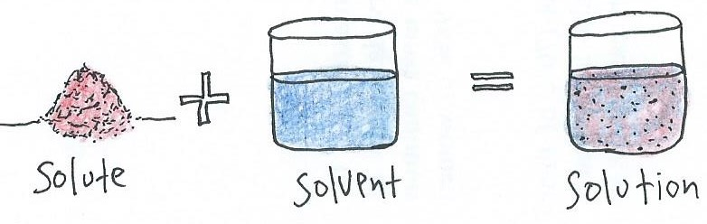

A solute is added to a solvent to make a solution. The solvent is distinguished by being present in greater abundance than the solute. In physiology, the solvent is always water (H₂O).
Concentrations of Solutions: As we study various solutions in human physiology we will examine the conventional methods of expressing concentrations of solutions and use this information to examine how the body responds to these solutions.

All body fluids are electrolyte solutions, meaning they contain ions (charged particles) such as Na⁺, K⁺, and Cl⁻ dissolved in water. Electrolyte solutions help maintain water balance, stabilize pH of body fluids and allow for electrical communication.

Tonicity of physiological solutions is very important because it can impact the direction of water movement. After accounting for all permeabilities, the simplest definition for tonicities are as follows:
- In an isotonic solution, the extracellular fluid has the same osmolarity as the cell. There will be no net movement of water into or out of the cell. (iso = same, tonic = strength)
- In a hypotonic solution, the extracellular fluid has lower osmolarity than the cell’s cytoplasm. The net flow of water will be into the cell. (hypo = lower, tonic = strength)
- In a hypertonic solution, the extracellular fluid has a higher osmolarity than the cell’s cytoplasm. The net flow of water will move out of the cell. (hyper = higher, tonic = strength)

Calculating Osmolarity from % Solutions
Convert these % Solutions to Molarity, then to Osmolarity and comment on Tonicities and how cells would respond. [MW Glucose = 180; MW NaCl = 58.5]

A) 4.5% Glucose

B) 1.4% NaCl

C) 0.9% NaCl

