**Class Activity #12 Physiology**

**Endocrine Systems**

**Review of the Pancreas**

Summarize the **a)** Exocrine and **b)** Endocrine roles of the Pancreas in the body.

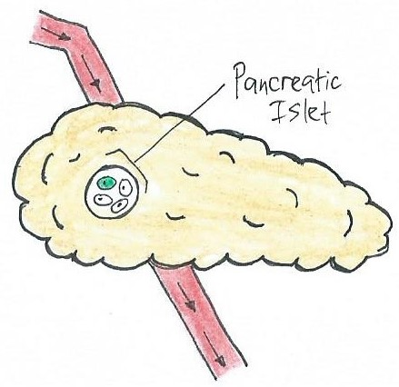

**Review of the Pituitary**

Summarize the role of the **a)** Posterior and **b)** Anterior Pituitary gland in the body.

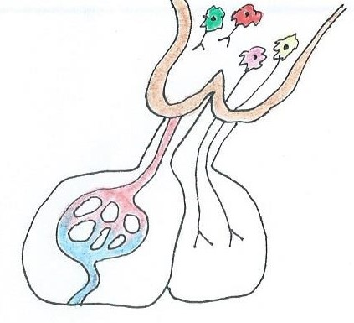

**Complete the information that is missing below regarding the endocrine system.**

**Table 1.** Fill in the information about the hormone, gland or action that is compatible.

|  |  |  |
| --- | --- | --- |
| **Hormone** | **Secreted by** | **Actions** |
| Luteinizing Hormone (LH) |  |  |
|  | Posterior Pituitary (for water regulation) |  |
|  |  | Stimulates cortisol release.  + |
| Melatonin |  |  |
|  |  | Stimulates follicular growth in females; required for sperm production in males. |
|  | Pancreas (α cells) |  |
| Cortisol |  |  |
|  |  | Stimulates release of T3 and T4 and helps regulate metabolic rate. |

Based on the information provided about these endocrine glands and their function, for each hormone in **Column A**, select the appropriate endocrine gland that makes it from **Column B**.

The various endocrine glands in Column B may be used more than once or not at all.

**Column A**

___ 1. LH

___ 2. oxytocin

___ 3. DMT

___ 4. prolactin

___ 5. PTH

___ 6. renin

___ 7. T4/T3

___ 8. FSH

___ 9. thymosine

___ 10. TSH

___ 11. melatonin

___ 12. somatostatin

___ 13. Calcitonin

___ 14. Vasopressin

___ 15. hGH

___ 16. ANP

___ 17. T-cell differentiation

___ 18. Cortisol

**Column B**

**A**. Parathyroid glands **E**. Thyroid gland **I**. Adrenal cortex

**B**. Pineal gland **F**. Heart **J**. Kidneys

**C**. Neurohypophysis **G**. Pineal gland **K**. Pancreas

**D**. Thymus **H**. Adenohypophysis **L**. Adrenal medulla

**Multiple choice questions**. Use notes, lectures and worksheet to complete these questions.

**1.** Which of the following is true about **Cortisol**? It: Select all that apply ____________.

**a)** is released by ACTH **b)** promotes gluconeogenesis **c)** causes vasodilation

**d)** suppresses the immune system **e)** decreases blood glucose **f)** is released by the hypothalamus

**2.** Which of these substances are released by the **anterior pituitary**? Select all that apply ____________.

**a)** PRL  **b)** testosterone **c)** thyroxine **d)** luteinizing hormone **e)** cortisol **f)** CRH

**3.** The hormone **glucagon** stimulates _____ in order to _____ blood glucose.

**a)** gluconeogenesis: decrease

**b)** glycogen synthesis: increase

**c)** glycogenolysis: decrease

**d)** gluconeogenesis: increase

**e)** lipid synthesis: increase

**4.** Along with **growth hormone**, which of the following is also an important regulator of metabolism?

**a)** hGH **b)** thyroxine **c)** ADH **d)** testosterone stimulating hormone **e)** luteinizing hormone

**5.** The **posterior pituitary** gland is not truly considered an endocrine gland because it

**a)** has a rich blood supply  **b)** is not located near the brain  **c)** has no real blood supply

**d)** contains ducts **e)** does not synthesize hormones

**6.** Hormones can fall into two basic categories: __________________ and ______________________.

**a)** stimulator and receptor hormones **b)** proteins and sugars **c)** growth and metabolic hormones

**d)** male hormones and female hormones **e)** non-steroid (peptide) and steroid hormones

**7.** Which hormone is responsible for **ovulation** in females?

**a)** hGH  **b)** TSH  **c)** LH  **d)** PRL **e)** ACTH

**8.** Which of the following produce **testosterone**?

**1)** the adrenal medulla  **2)** interstitial cells of Leydig  **3)** the adrenal cortex  **4)** the hypothalamus

**5)** the posterior pituitary gland **6)** the anterior pituitary gland

**a)** 2 only  **b)** 2 and 4  **c)** 4, 3 and 6  **d)** 3 and 2 **e)** 2, 6 and 3

**9.** The hormone __________ is made by the thyroid gland to regulate Ca2+ in the blood; It is released when Ca2+ in the blood is too ________.

**a)** Thyroxine; low

**b)** Calcitonin; high

**c)** Calcitriol; low

**d)** parathyroid hormone; low

**e)** parathyroid hormone; high

**10.** Which of the following hormones can elevate blood glucose levels?

**1)** epinephrine  **2)** glucagon  **3)** insulin  **4)** cortisol **5)** thyroxine **6)** calcitonin

**a)** 1, 3 and 5  **b)** 2 and 4  **c)** 1, 2 and 4 **d)** 4, 6 and 5  **e)** 2 and 3