**Class Activity #11 (Physiology)**

**The Renal System and Renal Failure**

**Review of the Nephron**

For each **nephron region** describe **renal process** that occurs there and the mechanisms involved.

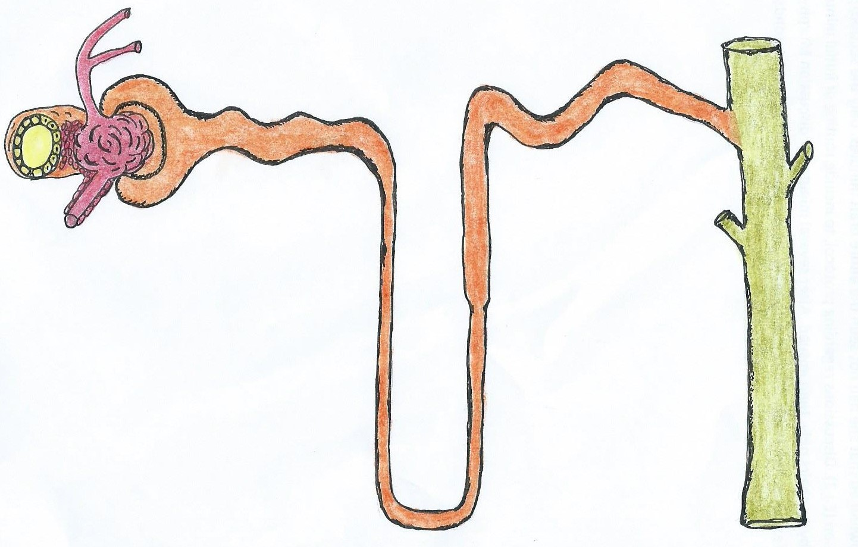

**E**

**B**

**D**

**A**

**F**

**C**

**G**

**Multiple choice questions**. Use notes, lectures and worksheet to complete these questions.

**1.** The portion of the nephron that attaches to (leads into) the collecting duct is the

**a)** loop of Henle **b)** proximal tubule **c)** distal tubule **d)** collecting duct **e)** minor calyx

**2.** Which of the 4 kidney process always requires energy to occur?

**a)** filtration **b)** reabsorption **c)** secretion **d)** excretion

**3.** The blood flow through the kidney includes a feature seen in only a few organs. What is it?

**a)** a portal system **b)** arterial shunts **c)** vascular sinuses **d)** highly oxygenated veins **e)** anastomoses

**4.** The Bowman's capsule, the Bowman's space and glomerulus make up the

**a)** renal pyramid **b)** loop of Henle **c)** renal corpuscle **d)** renal papilla **e)** collecting system

**5.** Which structure is not part of the blood circulation through the kidney?

**a)** vasa recta **b)** loop of Henle **c)** glomerulus **d)** renal corpuscle **b)** peritubular capillary

**Urinalysis and Renal Failure**

**6.** Give two (2) examples of what the **a) Color, b) Clarity:** and **c) Odor** of a urine sample can indicate:

**a)**

**b)**

**c)**

**d)** The normal range of Specific Gravity for urine can be from as low as_________ to as high as _________.

**e)** The normal range of the pH for urine can be from as low as_________ to as high as _________.

**7.** In reference to urinary sediment, the three (3) major groups are found in urine are:

1) _________________; 2) _________________; and 3) _________________.

**8.** Give an example of each of these 3 categories (by specific name) for urine samples of various pH’s:

**a)** Acidic (more than normal) urine:

**b)** Normal (closer to neutral) urine:

**c)** Alkaline (more basic) urine:

**Multiple choice questions**. Use notes, lectures and worksheet to complete these questions.

**9.** The most common systemic disease causing end-stage renal failure in the Western countries is:  **a)** Amyloidosis **b)** Diabetes Mellitus **c)** Hypertensive Nephrosclerosis

**d)** Polycystic Kidney Disease (PKD) **e)** Renal Vasculitis (ANCA glomerulonephritis)

**10.** **Diabetes insipidus** is characterized by the excessive excretion of _______ urine.

**a)** concentrated **b)** dilute **c)** sugary **d)** dark **e)** cloudy

**11.** Characteristic urine **odors** are associated with all of the following diseases except:

**a)** Phenylketonuria (PKU) **b)** Maple syrup urine disease **c)** Alkaptonuria

**d)** Isovaleric acidemia **e)** Diabetes Mellitus

**12.** If a patient has **glycosuria**, what test would confirm **Diabetes mellitus type 1**?

**a)** a blood test of hyperglycemia **b)** a blood test showing elevated insulin levels

**c)** a urine test showing proteinuria **d)** a blood test showing deficient insulin levels

**13.** All of the following descriptions apply to **orthostatic proteinuria** (postural proteinuria) except:

**a)** Urinary proteins are excreted only when the patient is lying down.

**b)** Most commonly appears in young adults.

**c)** Usually occurs without apparent disease.

**d)** It is considered to be a functional, transitory proteinuria.

**14.** Which of the following statements about myoglobin is **false**?

**a)** It is freely filtered by glomeruli

**b)** It is toxic to renal tubules, especially the PCT

**c)** It is reabsorbed by the proximal tubule

**d)** It colors urine reddish brown

**e)** It is detected by the urine dipstick test for blood

**15.** For these options, which of the following are possible ramifications of **renal failure**?

**a)** hypokalemia

**b)** hyperkalemia

**c)** metabolic acidosis

**d)** uremic toxicity

**e)** glomerulonephritis

**f)** elevated BUN

**g)** depressed RBC count

**h)** insufficient renal blood flow Select all that apply: _______________.

**16.** Which of the following statements about **parathyroid hormone** synthesis/release is **true**?

**a)** It is stimulated by hypercalcemia

**b)** It is stimulated by increased levels of activated vitamin D3

**c)** It is inhibited by hyperphosphatemia

**d)** It is inhibited by the posterior pituitary gland

**e)** It is stimulated by hypocalcemia

**17.** Which of the following statements about hypercalcemia is **false**?

**a)** It reduces GFR due to vasoconstriction of the afferent arteriole

**b)** It can be caused by loop diuretics

**c)** It increases sodium excretion

**d)** It is associated with pituitary gland hyperactivity

**e)** it can cause metabolic alkalosis

**18.** Which of the following statements about angiotensin II is **false**?

**a)** It increases the amount of albumin filtered by the glomeruli

**b)** It causes vasoconstriction of the afferent arteriole

**c)** It is increased in renal acidosis

**d)** It increases aldosterone production

**e)** It is converted from angiotensin I by ACE

**19**. Which of these substances is not reabsorbed from the filtrate in the renal tubules?

**a)** Urea **b)** Glucose **c)** Creatinine **d)** Phosphate **e)** Sulfate

**20.** Patients with progressive chronic renal failure typically develop: **a)** Hemolytic anemia **b)** Aplastic anemia **c)** Hypochromic, microcytic anemia

**d)** Normochromic normocytic anemia **e)** Macrocytic anemia