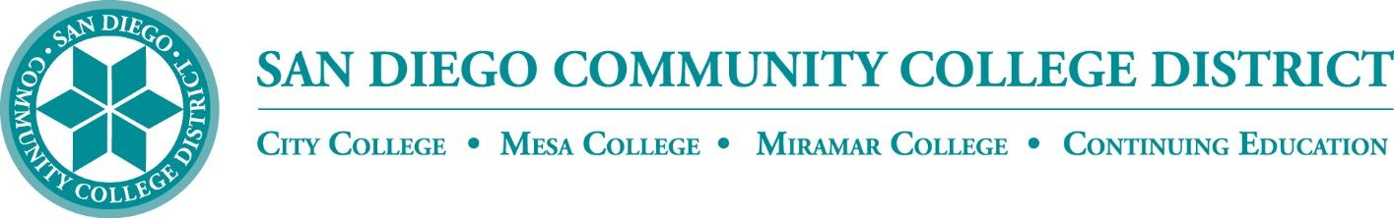

CURRICULUM TECHNICAL REVIEW SUBCOMMITTEE

AGENDA

San Diego Miramar College
Curriculum Technical Review Subcommittee
February 8, 2023 – 2:30-4:30 PM - https://sdccd-edu.zoom.us/j/96691399291

Members: Isabella Feldman; Mardi Parelman; Mara Palma-Sanft; Alex Stiller-Shulman

- Introductions
- Approval of agenda
- Approval of minutes from last meeting
- Course proposals
  - BIOL 210B
- Program proposals
- Other business
  - ASCCC Resolution 09.01 F22: “Removing Barriers to the Adoption of Open Educational Resources
    - https://asccc.org/resolutions/removing-barriers-adoption-open-educational-resources
- Roundtable & Next Steps
- Next Scheduled Meeting:
  - 2/22/22 at 2:30 PM
- Adjournment

